Round barns becoming more rare in Indiana
Tori Fater, tori.fater@courierpress.com
0:18
1:36
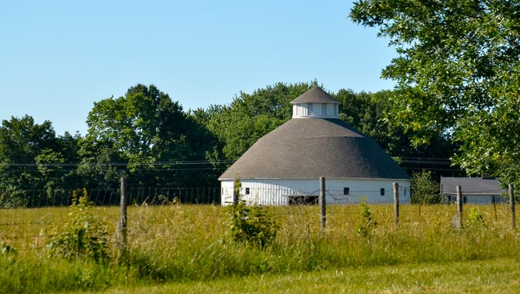
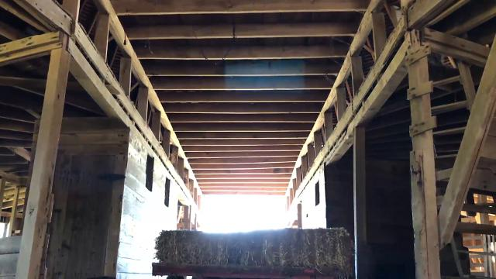
WASHINGTON, Ind. -- A picturesque century-old barn off Indiana 57 is part of a dwindling style of architecture that’s inspired books, road trips and at least one retirement project.
The Thomas C. Singleton barn, built in 1908, is one of 73 historic round barns remaining in Indiana, which used to have more structures in that classic style than any other state. According to the Indiana Department of Natural Resources, there used to be 219 round and polygonal barns in the state -- three times as many as remain standing today.
The style was popular between 1874 and 1936 and offered a more open floor plan, according to the DNR, since roofs were self-supporting and didn’t require posts in the middle of a barn floor. The shape meant farmers could lead horses into the barn and then around, rather than backing a cart out the door.
The Singleton barn, at the intersection of Indiana 57 and 450 South just south of Washington, has been in Cindy Barber’s family for four generations. Her husband Tony Barber’s family has been involved since the beginning too, he said: His grandfather delivered the wood his great-grandfather cut to make the barn.
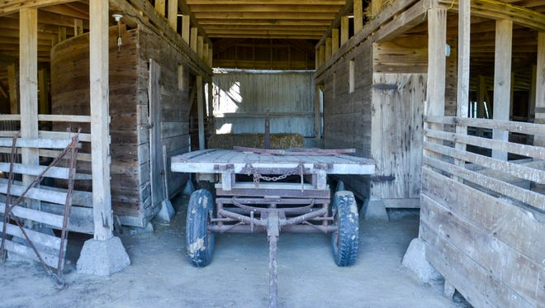
It’s linked to Indiana’s history for more reasons than its style -- documents hidden in the barn exposed elected officials’ connections to the Ku Klux Klan hate group in the 1920s.
Former Indiana KKK leader D.C. Stephenson reportedly leaked two black boxes of records hidden in the barn to the Indianapolis Times after the governor did not pardon Stephenson for a murder conviction.
The Indianapolis mayor and six city councilmen were convicted of corruption-related crimes and resigned, according to the Indiana Historical Bureau. Then-governor Ed Jackson was indicted for conspiracy to bribe an official, but the charge was later dropped because the statute of limitations had passed. The KKK’s power in Indiana began to collapse after the investigation.
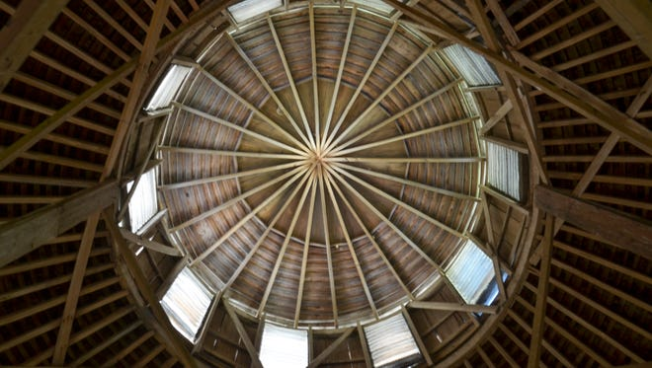
The Singleton family did not have KKK connections, Cindy Barber said, and Singleton was surprised to see investigators combing the barn for the records. The family thinks the barn was selected to hide the boxes because it was easily recognizable and accessible from Indiana 57.
And it wasn’t just a landmark for drivers.
“There were pilots out of Evansville that talked about using it as they would go between Evansville and Chicago or Detroit,” Barber said. “They could see it from the air and would use it as kind of a guiding point.”
The Barbers have met people who traveled all over the state to visit historic structures like the Singleton barn, Tony Barber said. When visitors drive up to take photos, the family will sometimes show them around -- though they ask people not to climb the fence, since cows and calves graze in the field around the barn.
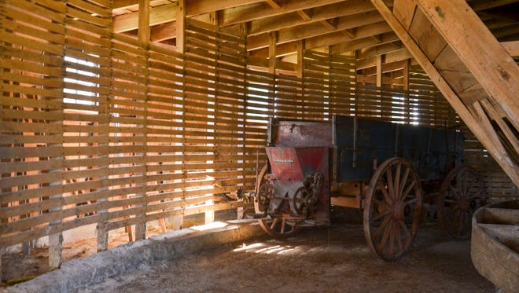
“Lots of times when people stop, they mention that they’ve driven by it all their lives but never been inside,” Barber said.
A manure spreader that belonged to Cindy Barber’s great-grandfather -- the Thomas C. Singleton whose name is on the outside of the barn -- sits inside it still. The barn is part of the Barbers’ working farm and stores hay bales and two sheep (Max and Rosie) that their 6-year-old sons will show at the 4-H fair.
The Singleton barn was selected as one of Indiana’s top ten historic barns last year during the state bicentennial, for its aesthetic, condition and because it’s still used for its original purpose. In the last few years, it’s also hosted a wedding, receptions and an art show.
More historic buildings:
Historic, tiny house finds new home at UE
HISTORY LESSON: Post Office in Santa Claus, Indiana
HISTORY LESSON: Municipal Market
It was almost sold in 2003 when Cindy Barber’s grandmother died, she said, but fate intervened.
Barber lived in Dallas, Texas, then but decided to come back to Indiana for a short time, partly for the sake of the barn. She and Tony were married a few years later.
“We would have sold it… because we didn’t have any family living here at all,” she said, sitting on the porch of her farmhouse with the barn behind her. “I took a year off from the city and fell in love and stayed.”

