FOR IMMEDIATE RELEASE

Liberty Township Volunteer Fire Department Receives Emergency Drinking Water Donation from Anheuser-Busch and Mid America Beverage Inc. to Support Wildfire Response Efforts
Water provided through partnership with the National Volunteer Fire Council

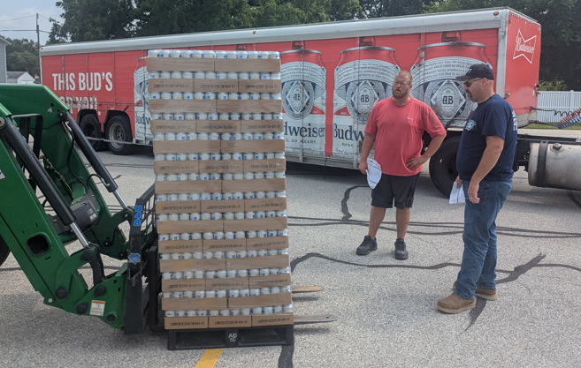
Liberty Township Volunteer Fire Department of North Liberty, IN. has received a donation of emergency drinking water from Anheuser-Busch to help keep its firefighters hydrated during wildfire response efforts. The donation, made in partnership with the National Volunteer Fire Council (NVFC), will provide critical hydration to first responders working long hours in extreme conditions.

On 7/28/2026, 2,300+ cans of water were delivered by Mid America Beverage, Inc., Anheuser-Busch’s local wholesaler partner. The donation will help ensure firefighters have access to clean, safe drinking water while responding to wildfires and other emergencies where proper hydration is essential for safety and performance.

Wildfires can have a significant impact on our community, especially during periods of dry weather, high temperatures, and strong winds. Even a small spark from outdoor burning, equipment, or discarded smoking materials can quickly spread, threatening homes, businesses, farmland, and natural resources. Our firefighters remain prepared to respond, but preventing wildfires starts with the public. By practicing fire safety, following local burn regulations, and reporting fires early, we can work together to protect lives, property, and the landscapes that make our community home.
“Extended emergency responses, especially during wildfire season, place significant physical demands on our firefighters,” said Chief Litteral. “Having access to emergency drinking water helps protect their health, maintain their endurance, and keep them mission-ready when our community needs them most. We’re grateful to Anheuser-Busch and the National Volunteer Fire Council for providing resources that directly support firefighter safety and operational readiness.”

Anheuser-Busch has a longstanding tradition of providing support for disaster relief efforts dating back to 1906. Each year, its breweries in Cartersville, Georgia and Fort Collins, Colorado periodically pause beer production to produce emergency drinking water for times of need. Since 1988, Anheuser-Busch has donated more than 100 million cans of clean, safe drinking water for communities impacted by or preparing for disaster.

With an increased focus on disaster preparedness, Anheuser-Busch partnered with the NVFC in 2019 and, together with its wholesaler partners, has supported volunteer fire departments with nearly 12 million cans of emergency drinking water through over 3,700 deliveries across almost all 50 states.

The NVFC is the leading nonprofit association representing the interests of volunteer fire, EMS, and rescue services across the U.S., with a mission to support volunteer responders and the communities they serve.

To learn more about the Emergency Drinking Water for Wildland Firefighters program, visit www.nvfc.org/water.

