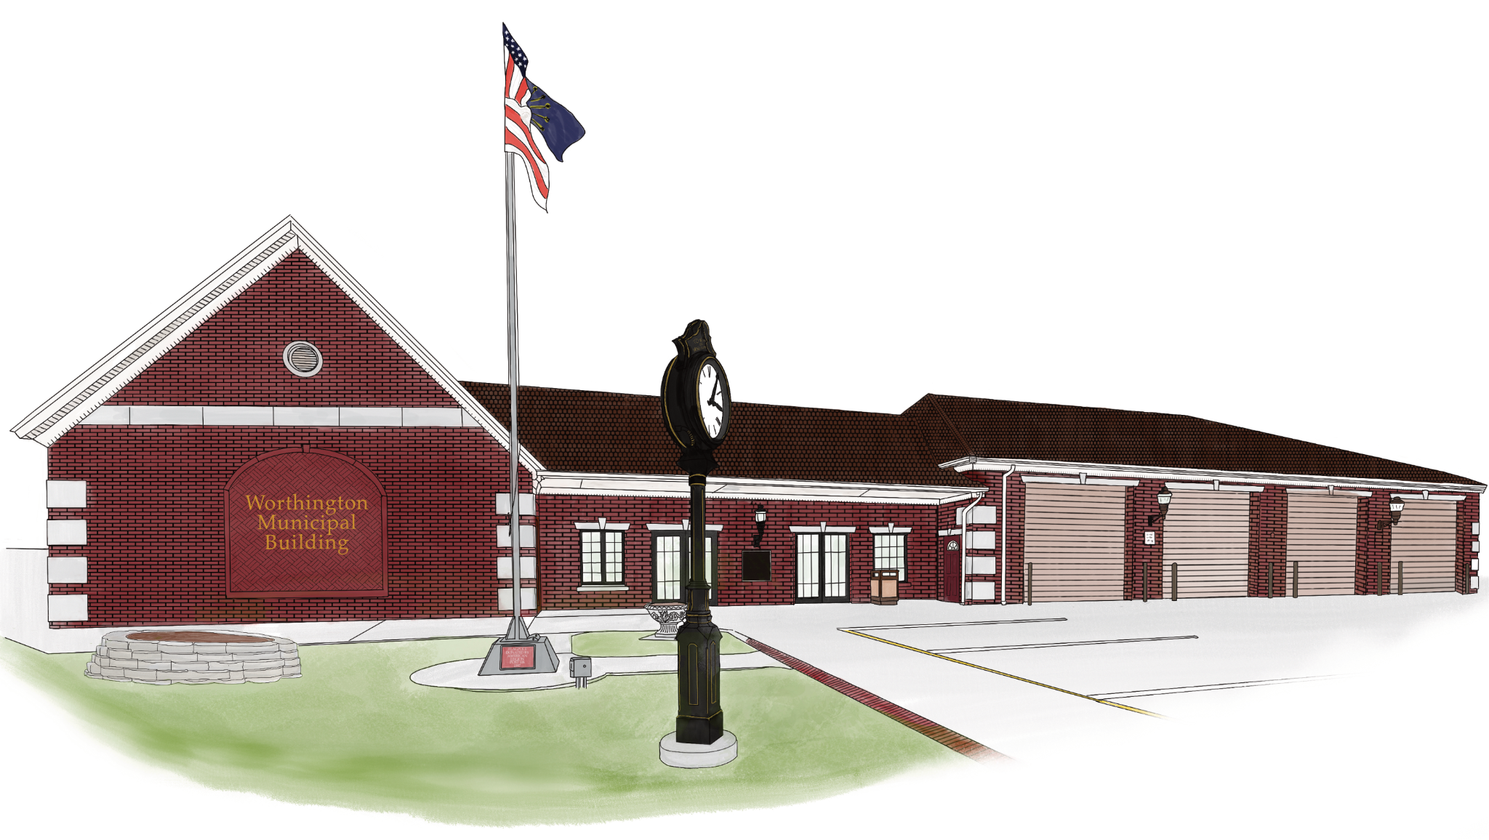

Town of Worthington Park Rental Rules and Guidelines Only

Please come to Town Hall located at 20 S. Commercial Street to fill out proper rental application. Payment must cash or check.

Rules of Use:

1. No alcoholic beverages are permitted inside the building.
2. Buildings should not be used for commercial business for profit, including all types of sales, markets, or bazaars whether for business purposes or personal gain.
3. Buildings may be used by the Town Council, Park Board, Police Department, and Fire Department for meetings, dinners, or fundraisers, provided that the building(s) are cleaned at the conclusion of the event.
4. Buildings may be used by any non-profit organization for meetings, dinners, or fundraising events, provided that the building(s) are cleaned at the conclusion of the event.
5. Buildings may be used for public meetings held by local, county, state, or federal officials free of charge provided that the building(s) are cleaned at the conclusion of the event.
6. Any other person, group, or organization not described above that wishes to rent one of the park buildings must make a reservation through the Clerk-Treasurer’s Office. The building rental fee must be paid within 2 weeks of the date the reservation is made to be considered official, otherwise, the reservation will be considered canceled. Reservations will be available for up to 1 year in advance if the previous criteria are met.
7. If the reservation is canceled, the person, group, or organization that made the reservation must notify the Clerk-Treasurer’s Office at (812) 875-2641 at least two (2) weeks prior to the reserved date or else forfeit the rental fee. Exceptions to this provision are at the discretion of the Clerk-Treasurer or Utilities Deputy.
8. Any other person, group, or organization that reserves and then uses the building(s) must clean the building(s) and leave it in its original condition at the conclusion of the event. Failure to do so will result in the Town billing the person, group, or organization for the cost of cleaning.
9. Violation of any of the above guidelines may result in the person, group, or organization being prohibited from future use of any town buildings and may result in monetary charges.

Keys for the building(s) you have reserved will be available the day before your rental (or Friday for Sunday’s rental) at Town Hall. In the event of a holiday or scheduled Town Hall closure, your key will be available the day before closure. You may not enter the building until the day of your event unless prior permission is granted. When the building is clean and restored to its original condition, please drop off the key in the drop box at Town Hall.

