Town of Worthington
Peddler’s Permit
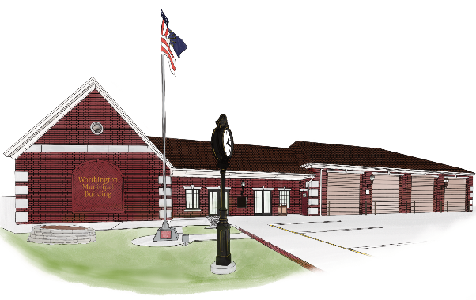
Please complete the form and return to the Clerk-Treasurer at Town Hall, 20 S. Commercial St., Worthington, IN 47471

Date of Application Expiration Date

Name of Business:

Name of Business Owner:

Phone Number:

Business Address:

Email Adress:

Types of Goods/Services Offered:

Individual Applying For Permit:

Phone Number:

Driver’s License Number: State:

Permit Fee Per Individual $10.00 (X) Number of Individuals = Total

Pay: by cash only

Signature of Applicant:

Issued by: Date:

This permit is good for 5 business days only. No weekend solicitations.

