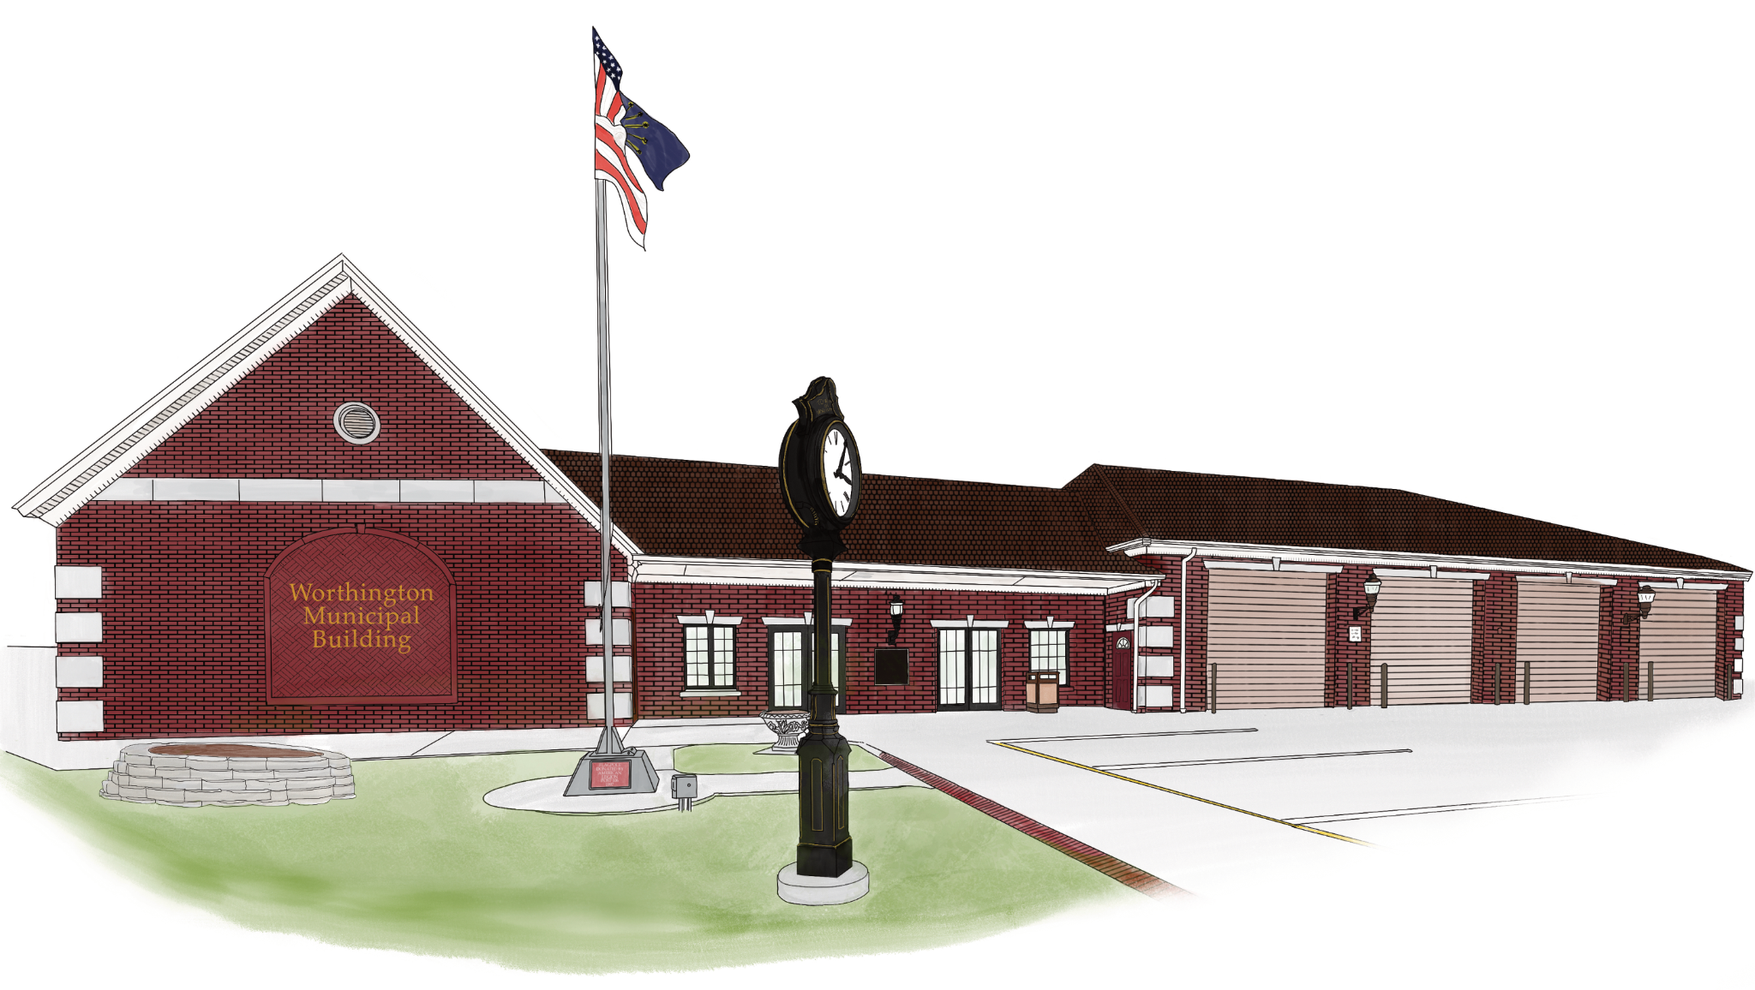

Town of Worthington Clerk-Treasurer
Matthew W. Baker
Email – clerktreasurer@townofworthington.in.gov
Worthington, IN 47471
Ph: 812-875-2641 Ext. 3

Town of Worthington
Change/Stop Service Request

Please print the form and return with final payment to the Utility Clerk at Town Hall. Call the Utility Office at (812) 875-2641, Ext. 2, for the final payment amount.

Date to stop service:

Name on account:

Account number (If known):

Address of Property:

Contact phone number:

Forwarding address:

I am the owner and have sold the property Yes No

Requester’s Name (Typed or Printed) Date

Signature

