Title VI Public Involvement Survey
As a recipient of federal funds, the Town of Culver is required to develop a procedure for gathering data regarding participants and beneficiaries of its programs and activities (23 CRF §200.9(b)(4)). The Town is distributing this voluntary survey to fulfill that requirement to gather information about the populations affected by proposed projects. You are not required to complete this survey; participation is voluntary. This form is a public document that the Town of Culver will use to monitor its programs and activities for compliance with Title VI and the Civil Rights Act of 1964, as amended and its related statutes and regulations. If you have any questions regarding the Town of Culver’s responsibilities under Title VI of the Civil Rights Act of 1964 or the Americans with Disabilities Act, please contact Bob Porter, ADA Coordinator, or Jonathan Leist, Title VI Coordinator. You may return the survey by folding it and returning it to the Title VI Survey Mailbox or by mailing or e-mailing it to the address below.

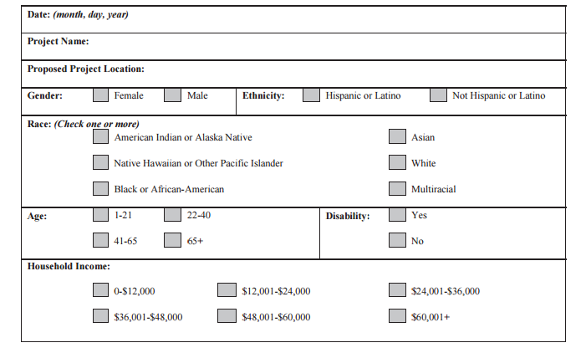
Jonathan Leist, Title VI Coordinator
jleist@townofculver.org 200 E Washington St, Culver IN 46511 842-3140

