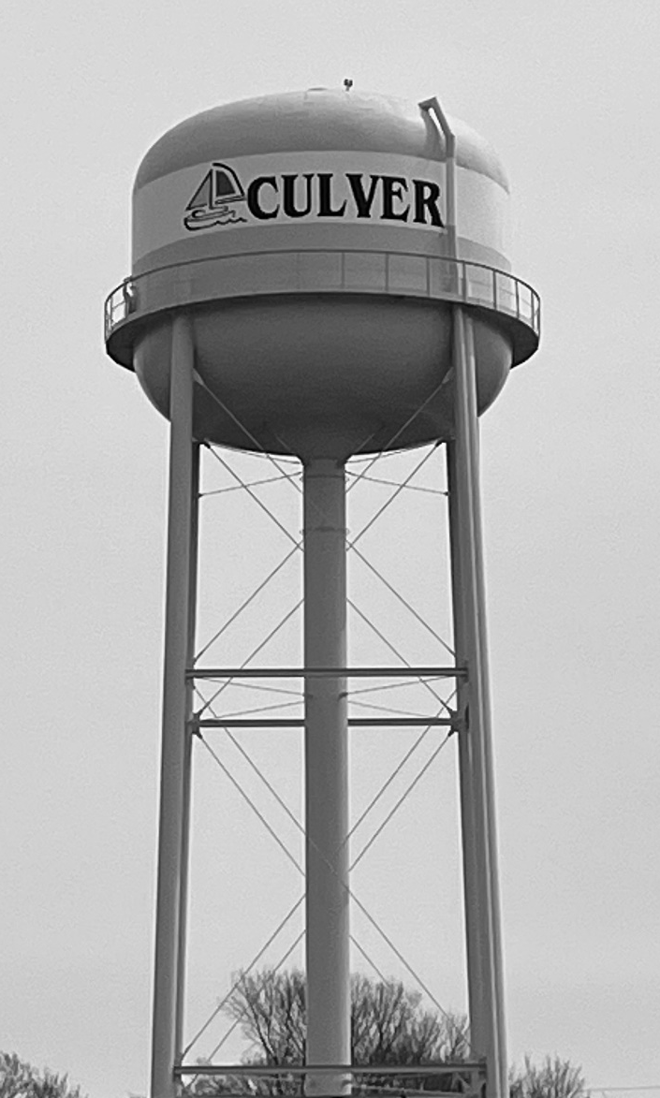

Contaminants that may be present in source water include:
- Microbial contaminants, such as viruses and bacteria, which may come from sewage treatment plants, septic systems, agricultural livestock operations, and wildlife.

- Inorganic contaminants, such as slats and metals, which can be naturally-occurring or result from urban stormwater runoff, industrial or domestic wastewater discharges, oil and gas production, mining, or farming.
(C) Pesticides and herbicides, which may come from a variety of sources such as agriculture, urban stormwater runoff, and residential uses.
(D) Organic chemical contaminants, including synthetic and volatile organic chemicals, which are by-products of industrial processes, and petroleum production, and can also come from gas stations, urban stormwater runoff, and septic systems.
(E) Radioactive contaminants, which can be naturally-occurring or be the results of oil and gas production, and mining activities.
In order to ensure that tap water is safe to drink, EPA prescribes regulations which limit the amount of certain contaminants in water provided by public water systems. FDA regulations establish limits for contaminants in bottled water which must provide the same protection for public health.
Contaminants may be found in drinking water that may cause taste, color, or odor problems. These types of problems are not necessarily causes for health concerns. For more information on taste, odor, or color of drinking water, please contact Town Hall.
2024 ANNUAL CONSUMER REPORT
On Tap Water Quality
We encourage public interest and participation in our community’s decisions affecting drinking water. Regular meetings take place at 6:30 p.m., on the second and fourth Thursdays of each month
at Culver Town Hall, 200 E Washington St.
The public is welcome. In addition, the town welcomes emails, phone calls,
or letters sent to Town Hall.
www.culver.in.gov
This report was provided with the technical assistance of Consumer Confidence Services, a division of environmental Health Laboratories.
For more information, call Bob Porter with the Culver Water Department at 574-842-3410 or bporter@townofculver.org
MEMBER OF:
American Water Works Association (AWWA)
Indiana Rural Water Association (IRWA)
PWSID #5250005
CULVER WATER DEPARTMENT
As a community providing a public water supply (PWS), the Town of Culver is mandated by the 1986 Act (IC 13-18-17-6) and the Indiana Water Pollution Control Board (327 IAC 8-4.1) to complete a Wellhead Protection Program. Culver provides approximately 850 residents with drinking water placing it in the “small-sized” PWS category, and therefore requiring Phase I of the Wellhead Protection Program to be submitted to the Indiana Department of Environmental Management (IDEM) by March 28, 2002.
Culver formed a Local Planning Team (LPT) in August 2001 to guide the development of the Culver Wellhead Protection Plan, which was submitted in March of 2002. The Town of Culver received final approval of their Wellhead Protection Plan from IDEM, August 26, 2004.
Culver completed Phase II of the Wellhead Protection Program in August 2014, which requires updating and revising of pertinent information in the original plan.

STATUS OF TOWN OF CULVER
WELLHEAD PROTECTION PLAN
IMPORTANT HEALTH INFORMATION
The Culver Water Department is supplied by groundwater pumped from two wells near the water treatment plant located at 509 South Ohio Street, Culver, Indiana.

WATER SOURCE
We are pleased to present to you the Annual Water Quality Report (Consumer Confidence Report) for the year, for the period of January 1 to December 31, 2024. This report is intended to provide you with important information about your drinking water and the efforts made by the water system to provide safe drinking water.
This brochure explains the quality of drinking water provided by Culver Water Department. Included is a listing of results from water quality tests as well as an explanation of where our water comes form and tips ton how to interpret the data. We’re proud to share our results with you. Please read them carefully.
We are proud to report that the water
provided by Culver Water Department meets
or exceeds established water quality standards.
The sources of drinking water (both tap water and bottled water) include rivers, lakes streams, ponds, reservoirs, springs, and wells. As water travels over the surface of the land or thorough the ground, it dissolves naturally-occurring minerals, and in some cases, radioactive material, and can pick up substances resulting from the presence of animals or from human activity.
Drinking water, including bottled water, may reasonably be expected to contain at least small amounts of some contaminants. The present of contaminants does not necessarily indicated that water poses a health risk. More information about contaminants and potential health effects can be obtained by calling the Environmental Protection Agency’s (EPA) Safe Drinking Water Hotline (800-426-4791).


No deficiencies were identified during this period.
DEFICIENCIES
Our water system tested a minimum of two (2) samples per month in accordance with the Total Coliform Rule for microbiological contaminants. With the microbiological samples collected, the water system collects disinfectant residuals to ensure control of microbial growth.
Disinfectant | Date | Highest RAA | Unit | Range | MRDL | MRDLG | Typical Source
CHLORINE | 2024 | 1 | ppm | 0.2 – 3.4 | 4 | 4 | Water additive used to control microbes

REGULATED CONTAMINANTS
In the tables below, we have shown the regulated contaminants that were detected. Chemical sampling of our drinking water may not be required on an annual basis; therefore, information provided in this table refers back to the latest year of chemical sampling results.
Lead and Copper | Period | 90th Percentile: 90% of water utility levels were less than | Range of Sampled Results  (low – high) | Unit | AL | Sites over AL | Typical Source
Cooper, Free | 2021 - 2024 | 0.262 | 0.01 – .0.271 | ppm | 1.3 | 0 | Corrosion of household plumbing systems; erosion of natural deposits; Leaching from wood preservatives
Lead | 2021 – 2024 | 1.74 | 1.74 – 2.1 | ppb | 15 | 0 | Corrosion of household plumbing systems; Erosion of natural deposits

Disinfection  By-Product | Sample Point | Period | Highest LRAA | Range | Unit | MCL | MCLG | Typical Source
Total Haloacetic Acids (HAAS) | 200 E Washington | 2023 - 2024 | 20 | 19.5 – 19.5 | ppb | 60 | 0 | By-product of drinking water disinfection
Total Haloacetic Acids (HAAS) | 509 S Ohio | 2023 – 2024 | 13 | 12.9 – 12.9 | ppb | 60 | 0 | By-product of drinking water disinfection
Total Trihalomethanes (TTHM) | 200 E Washington | 2023 – 2024 | 27 | 26.8 – 26.8 | ppb | 80 | 0 | By-product of drinking water disinfection
Total Trihalomethanes (TTHM) | 509 S Ohio | 2023 - 2024 | 13 | 12.7 – 12.7 | ppb | 80 | 0 | By-product of drinking water disinfection

Regulated Contaminants | Collection Dates | Highest Value | Range | Unit | MCL | MCGL | Typical Source
Arsenic | 10/7/2024 | 3.5 | 1.4 – 3.5 | ppb | 10 | 0 | Erosion of natural deposits; Runoff from orchards; Runoff from glass and electronics production wastes
Barium | 4/3/2023 | 0.145 | 0.145 | ppm | 2 | 2 | Discharge of drilling wastes; Discharge from metal refineries; Erosion of natural deposits
Fluoride | 4/3/2023 | 0.15 | 0.15 | ppm | 4 | 4 | Erosion of natural deposits; Water additive which promotes strong teeth; discharge from fertilizer and aluminum factories

Radiological Contaminants | Collection Dates | Highest Value | Range | Unit | MCL | MCLG | Typical Source
Gross Alpha, Excl. Radon & U | 6/4/2018 | 2.2 | 2.2 | pCi/L | 15 | 0 | Erosion of natural deposits
Radium-228 | 6/4/2018 | 1.6 | 1.6 | pCi/L | 5 | 0

Some people may be more vulnerable to contaminants in drinking water than the general population. Immuno-compromised persons such as persons with cancer undergoing chemotherapy, persons who have undergone organ transplants, people with HIV/AIDS or other immune system disorders, some elderly and infants can be particularly at risk from infections. These people should seek advice about drinking water from their health care providers. EPA/CDC guidelines on appropriate means to lessen the risk of infection by Cryptosporidium and other microbial contaminants are available from the Safe Drinking Water Hotline (800-426-4791).
Some people who drink water containing Haloacetic acids in excess of the MCL over many years may have an increased risk of getting cancer.

There is no safe level of lead in drinking water. Exposure to lead in drinking water can cause serious health effects in all age groups, especially pregnant people, infants, (both formula-fed and breastfed), and young children. Some of the health effects to infants and children include decreases in IQ and attention span. Lead exposure can also result in new or worsened learning and behavior programs. The children of persons who are exposed to lead before or during pregnancy may be at increased risk of these harmful health effects. Adults have increased risks of heart disease, high blood pressure, kidney or nervous system problems. Contact your health care provider for more information about your risks. Lead in drinking water is primarily from materials and components associated with service lines and home plumbing. We are responsible for providing high quality drinking water, but we cannot control the variety of materials used in plumbing components.
It is possible that lead levels at your home may be higher than at other homes in the community due to materials used in your home's plumbing. The town’s lead service line inventory is available at https://pws-ptd.120wateraudit.com/townofculverin. When water your water has been sitting for several hours, you can minimize the potential for lead exposure by flushing your tap for 30 seconds to 2 minutes before using tap water for drinking or cooking. If you are concerned about lead in your water, you may wish to have your water tested. Information on lead in drinking water, testing methods, and steps you can take to minimize exposure is available from the Safe Drinking Water Hotline by calling 800-426-4761 or online at www.epa.gov/safewater/lead.

HEALTH EFFECTS
HOW TO READ THE WATER QUALITY TABLE
In the tables to the left, you will find many terms and abbreviations you might not be familiar with. To help you better understand these terms, we’ve provided the following definitions:
ACTION LEVEL (AL) -The concentration of a contaminant which, if exceeded, triggers treatment or other requirements which a water system must follow
ACTION LEVEL GOAL (ALG) -The level of a contaminant in drinking water below which there is no known or expected risk to health. ALGs allow for a margin of safety.
LEVEL1 ASSESSMENT - A study of the water system to identify potential problems and determine (if possible) why total coliform bacteria have been found in our water system.
LEVEL 2 ASSESSMENT A very detailed study of the water system to identify potential problems and determine (if possible) why an E. coli MCL violation has occurred and/or why total coliform bacteria have been found in our water system on multiple occasions.
MAXIMUM CONTAMINANT LEVEL (MCL) - The highest level of a contaminant that is allowed in drinking water. MCLs are set as close to the MCLGs as feasible using the best available treatment technology.
MAXIMUM CONTAMINANT LEVEL GOAL (MCLG) The level of a contaminant in drinking water below which there is no known or expected risk to health. MCLGs allow for a margin of safety.
MAXIMUM RESIDUALDISINFECTANT LEVEL GOAL (MRDLG) -The level of a drinking water disinfectant below which there is no known or expected risk to health. MRDLGs do not reflect the benefits of the use of disinfectants to control microbial contaminants.
MAXIMUM RESIDUAL DISINFECTACT LEVEL (MRDL) - The highest level of a disinfectant allowed in drinking water. There is convincing evidence that addition of a disinfectant is necessary for control of microbial contaminants.
TREATMENT TECHNIQUE (TT) - A required process intended to reduce the level of a contaminant in drinking water.
VARIANCES AND EXEMPTIONS - State or EPA permission not to meet an MCL or a treatment technique under certain conditions.
AVG - Average - Regulatory compliance with some MCLs are based on running annual average of monthly samples.
LRAA - Locational Running Annual Average
mrem - millirems per year (a measure of radiation absorbed by the body)
ppb - micrograms per liter (ug/L) or parts per billion - or one ounce in 7,350,000 gallons of water.
ppm - milligrams per liter (mg/L) or parts per million - or one ounce in 7,350 gallons of water
picocuries per liter (pCi/L) - picocuries per liter is a measure of the radioactivity in water.
na - not applicable.

