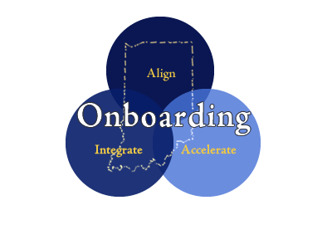

Discussion Form
- Use these sample questions for formal onboarding discussions
Employee Name | Employee Title | Manager Name |  | Mentor Name |  | Date of discussion
Questions For New Hire / Comments |  |  | Questions From New Hire |  | Concerns About New Hire
How did your orientation go this week?
Comments:

What has been the best and most challenging part of the job for you so far?
Comments:

Is there anything we could be doing better for you?
Comments:

What additional questions can I answer for you at this time?
Comments:

Do you feel welcomed and part of the team?
Comments:

Do you have concerns about anything so far?
Comments:

How am I doing for you so far? Are you getting the support you need?
Comments:

What has been the most challenging part of the job so far?
Comments:

Is there anything that you need from me?
Comments:

Is there anything we could have done better for you?
Comments:

What is going well?
Comments:

Do you have an understanding of our agency strategies and our objectives?
Comments:

Do you feel like you are developing the knowledge/skills to do your job?
Comments:

Has the agency met your initial expectations?
Comments:

What are you finding the most rewarding? Where have you been the most successful?
Comments:

How did your job shadowing/observations go?
Comments:

How are your meetings going (business unit rotations) with the other divisions/departments? What are you learning? How can you apply it?
Comments:

What are your largest accomplishments thus far?
Comments:

What have been your largest challenges?
Comments:

How is your training/onboarding going?
Comments:

Is there anything that needs more explanation?
Comments:

What additional questions can I answer for you at this time?
Comments:

On a % basis, what do you feel is your current level of productivity (100% is fully productive)?
Comments:

Additional questions you added….

