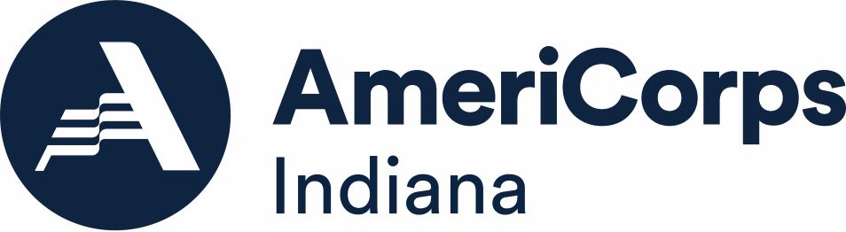
Instructions: Please review the information below and complete the form after completing the CNCS Core Curriculum. Please complete this and submit it to info@serveindiana.gov by December 18, 2020.
New Program Staff Certification:
- (YOUR ORGANIZATION) is new to AmeriCorps State funding in the 2020-2021 Program Year. I, (YOUR NAME), am the main contact for my program and have completed the core curriculum trainings around Evaluations and Performance Measures
Name: ______________________________
Signature: ___________________________
Date: _______________________________

