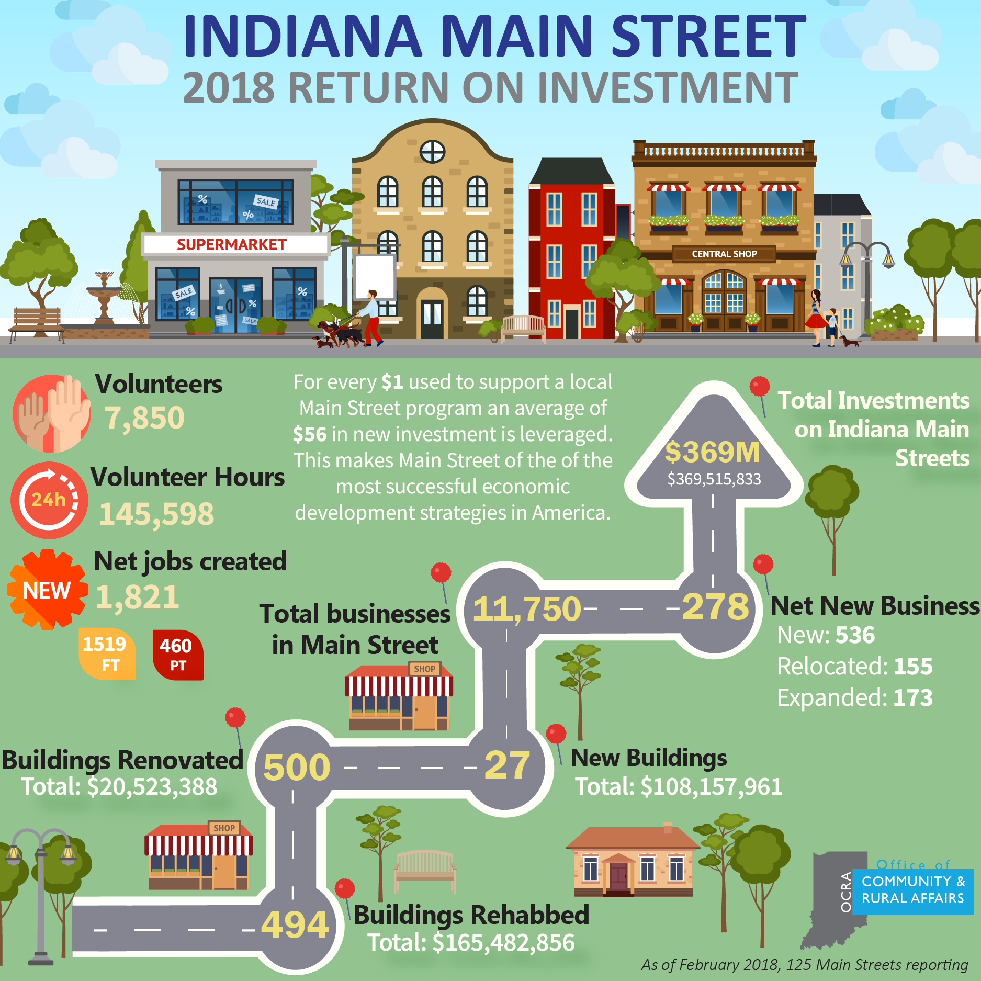

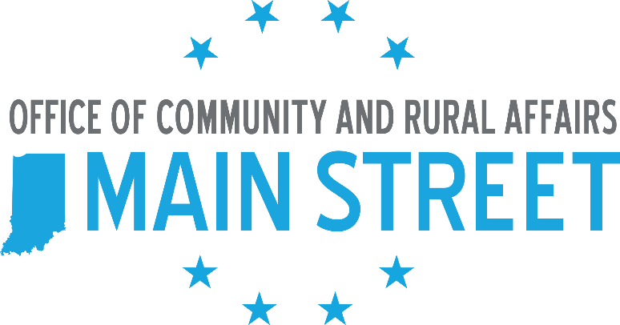

WHAT YOUR MAIN STREET IS DOING FOR THE COMMUNITY



yourmainstreetinsta

yourmainstreettwitter

yourmainstreetfb

## CONNECT

## UPCOMING EVENTS:

* Example 1
* Example 3
* Example 3
* Example 4
* List upcoming events or possibly a general calendar timeline

## OUR VISION

General information about your Main Street program, tying it to economic development in your community. Be sure to include your mission/vision statements.

## OUR IMPACT

Input information on your Main Street’s impact to the community. Possibly refer to your 2017 ROI data for possible numbers. Incorporate other statistics or improvements that you've seen over the last several months.

## SPONSORS

* Example 1
* Example 2
* Example 3
* Example 4
* Detail information for your volunteers and memberships/ sponsors.

Insert photo from Main Street event

WWW.YOURMAINSTREET.COM