HISTORIC RENOVATION
GRANT PROGRAM
Application

Indiana Office of Community and Rural Affairs
One North Capitol, Suite 600
Indianapolis, Indiana 46204
(317) 233-3762, (800) 824-2476

July 2022

Indiana Office of Community and Rural Affairs
Community Affairs Division
One North Capitol, Suite 600
Indianapolis, Indiana 46204
(800) 824-2476

APPLICATION COMPLETION CHECKLIST

For proper staff consideration, the grant proposal MUST include ALL of the following parts, forms, and documentation.

State Form 52889: Response letter from Division of Historic Preservation and Archeology for the Certificate of Approval

Cover Sheet
Is Local Match at least 50% of the Total Eligible Project Cost?
All fields completed

Project Summary

Project Narrative, all questions answered

Project Completion Timetable

Project Budget, NOTE: The grant award is considered taxable income in the year that it is used. Awardees should consult with their legal counsel or accountant for more information.

Scope of Work (be as detailed as possible)
Line Item Budget (be as detailed as possible)
Description of Matching Funds
Estimates for all work to be completed (estimates must be from a qualified professional on their letterhead)

Site Control Certification

Site control

Attachments:

Attachments should be submitted as separate attachments in an email with clear and appropriate naming conventions.
Attachments should follow the naming convention: HRGP_ProjectName_AttachmentName (example: HRGP_SpeakmanHouse_Roof1)

Photographs: All photos in application must be in color
Budget using the provided Excel template
Maps
Historic District map with property clearly identified in district (if applicable)
Site Plans
Estimates
Drawings/other plans/specifications (drawings must be done by a licensed architect, professional)
Proof of available local match funds (i.e. bank letter – do not provide bank account information)
Proof of not-for-profit status (Indiana Secretary of State, IRS), if applicable
Other supporting documentation (i.e. letters of support, if applicable)

HISTORIC RENOVATION GRANT APPLICATION
(COVER SHEET)

PROPERTY NAME OR PROJECT NAME:
PROPERTY ADDRESS:
CITY: COUNTY:
ZIP+4:
NATIONAL REGISTER LISTING # (NR-______)

GRANTEE:
CONTACT ADDRESS:
CITY: COUNTY:
ZIP+4:
PHONE: FAX:
E-MAIL:

PRIMARY POINT OF CONTACT, IF DIFFERENT THAN GRANTEE (NAME):
CONTACT ADDRESS:
CITY: COUNTY:
ZIP+4:
PHONE: FAX:
E-MAIL:

PROPERTY OWNER (IF DIFFERENT THAN ABOVE):
PROPERTY OWNER ADDRESS:
CITY: COUNTY:
ZIP+4:
PHONE: FAX:
E-MAIL:
FEDERAL I.D. /TAX NUMBER:

If property is currently occupied by someone other than the property owner, please provide the following:

TENANT’S NAME
PHONE: FAX:
E-MAIL:
What actions have been taken to notify tenant of proposed project and the potential, if any, for loss of business or displacement that may arise during the projects proposed work?

PROJECT FUNDING SUMMARY (Ensure lead applicant match equals 50% of overall eligible costs.)
All grant request amounts need to be rounded to the nearest dollar.
Amount
Grant Request
Lead Applicant Match
Other Private Sources
List sources:
TOTAL MATCH
TOTAL PROJECT COST
In what Indiana Senate District(s) does this project fall under?
State Senator(s) representing this district:
In what Indiana House of Representatives District(s) does this project fall under?
State Representative(s) representing this district:
In what US Congressional District(s) does this project fall under?
PROJECT SUMMARY

Please enter a brief description of your project. This description will be used in print materials and press releases. The description should be no more than 4 sentences describing the overall project and what specifically the grant funding will be used to purchase.

Example:
Mark Banschbach is awarded $100,000 to preserve the Speakman House. Located in Aurora, the Greek Revival residence has 17 rooms stretching across 7,000 square feet. In 1846, Stephen Speakman built this house on the banks of Laughery Creek, overlooking the Ohio River. The property is planned to be a social gathering place to host tours, special events and possibly a bed and breakfast.
Fill in project summary here.

PROJECT NARRATIVE

Historic Preservation & Project Oversight

- Describe the scope of work for the project and how it aligns with the Secretary of the Interior’s Standards for Rehabilitation of Historic Properties (The Standards). How will the applicant ensure The Standards are being met? Does the project include oversight by an architect/engineer/general contractor with experience working on projects that are required to meet The Standards? If so, please summarize that experience.

- Are there any local approvals, such as a local preservation Certificate of Approval that needs to be obtained? If so, please either include that approval with this application or summarize the timeline for receiving that approval.

- Is this project part of a larger project? Describe additional work (if any) that needs to be done following the completion of this project. Additionally, what is the plan for routine maintenance and long-term preservation of the building?

Community & Public Sector Support

- Describe the value of this project for Community Revitalization. How will this project enhance community revitalization efforts? Include projected business, employment and quality of life improvements both through the project completion and following completion.

- Provide a detailed overview of prior planning efforts for the project. If you reference any comprehensive documentations from locally adopted plans or meeting minutes, please include those as separate attachments and reference the file name in the narrative below. If applying on behalf of a non-profit organization, how does the project fit into the work plans of the organization or meet the organization’s mission statement?

- Please indicate any plans to showcase the final project to state representatives, local elected officials, and the local community.
Private Sector Support

- Indicate how these state funds, if awarded, would leverage a higher percentage of private investment either related to this project or others within the immediate area.

- Please indicate the expected number of full-time jobs, part time jobs, new businesses and new housing units that will be created in regards to this project.

Building Use

- What is the planned use of the building following this project?

- Is the planned use of the building a change from the current use? Describe exterior changes that will be made to the building to accommodate this new use. Will these changes impact historic features? Refer to the Secretary of the Interior’s Standards for Rehabilitation in evaluating your project.

- How is this project important to the long-term community and economic development activities of the area? Please include excerpts of plans if possible as a separate attachment.

- Is the project located in an Indiana Main Street district? If so, please name the organization and describe how the project fits in as part of the group’s overall strategy. If the project is within a commercial/downtown district, how does the project/building contribute to the character and business mix of the area? (If located within a designated IMS district, including a letter from the Main Street organization is highly encouraged.)
Historic Impact

- Briefly describe the building and the historic significance of the property. What was the original use of the building and what is the building’s current use? Is the property especially valuable as an important landmark in the community? (It may be necessary to consult a local history text, the interim report of local historic sites and structures inventory, the county historian, or a local historical or historic preservation organization for this information.)

- Provide an overview of any educational elements and/or opportunities for the public to engage with its history.

- If OCRA were to host a workshop on historic preservation and interpretation, would the project lead and/or appropriate representative commit to attending and participating?

Case Statement/Need

- Describe the need for the project on the property. What is the need in relation to the current condition of property, the historical significance of the property, the community value of the property, etc. How will this project address the needs of the property?

- Describe the goals of the project. Explain the MEASURABLE products or outcomes of the work. This may include needs to meet, making a building usable, making a building stable, standards to be met, methods to be tested, etc. At least three goals and corresponding measurable outcomes should be included.

- Describe how the project will provide the community with essential and impactful efforts related to downtown revitalization, if applicable, in addition to how the project would increase the community’s quality of life.

- If the property is within a commercial historic district, explain the need for rehabilitation of properties within the district. Include the ratio of buildings in good repair to those in disrepair on the block of the project. Will the project increase the ratio of rehabilitated properties on the block? How?

- Provide any other additional information that would be useful for grant reviewers to understand or have an awareness of, if not previously addressed.

PROJECT COMPLETION TIMELINE

Beginning with the application submission date, outline a reasonable timeline for project completion. Include all significant milestones, emphasizing those related to grant award, drawdown of funds, final plans submission and completion. (All projects awarded funding must be completed within 24 months of contract execution.) See example below, then delete table to create your own:
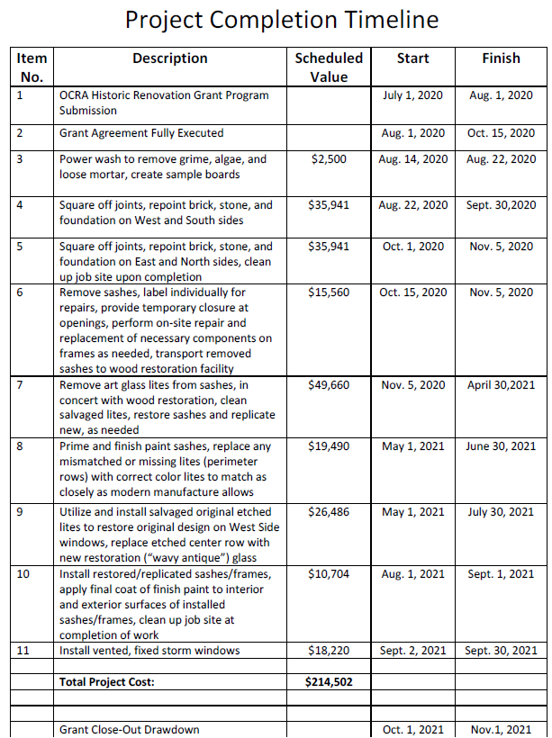
PROJECT SCOPE OF WORK

The project Scope of Work (SOW) is a key component to this grant application. A well-written SOW clearly defines the tasks/work that will be accomplished during the grant period. During the grant application process, the SOW can demonstrate to grant reviewers whether or not the grant applicant is aware of all the requirements a project may have, as well as the appropriate priority and planning involved.

Clearly provide a detailed project SOW and include any necessary related items. Refer to the Secretary of the Interior’s Standards and National Park Service Preservation Briefs for technical assistance, which can be found on OCRA’s HRGP webpage: https://www.in.gov/ocra/hrgp.htm
Sample Scope of Work Example
West Façade - Portico–Scope of Work
1. Repoint and repair cracks in the masonry at windows. Repair the masonry around the HVAC unit after HVAC replacement occurs. Match all surrounding masonry and mortar in composition, color, size, and shape. Match existing wall pigmented wash. (Refer to any attached photographs or renderings of windows)
2. Remove all loose paint, scrape windows, door, and wood trim. Lightly sand painted surfaces. Apply a primer and two finish coats of paint to all painted surfaces. Follow all applicable laws and regulations concerning lead paint.
3. Remove paint and finish down to bear metal at rusted areas of fluted columns. Remove all surface rust. If rusted areas have significantly pitted the metal, or have rusted through areas, fill those areas with an epoxy sheet metal patching system. Sand smooth to match adjacent surfaces so that the patch is not detectable. Apply corrosion inhibiting primer and two coats of finish paint to the columns. Apply texture to match existing finish. (Refer to any attached renderings of work to be done)

PROJECT BUDGET

HRGP applicants should complete and submit the Historic Renovation Grant Program Budget Table separately. See an example of a completed budget here. The Historic Renovation Grant Program Budget Table can be downloaded by double-clicking the icon below:

Blank Budget Example Budget
Budget Directions:

- Review all prepopulated items listed under the column titled Category and determine which apply to your grant program. Once this is determined, enter the total amount of funding for each of these line items. For example, if your program focuses on Window Replacement, please list the cost of windows and any associated costs on this line. If your project does not fit the category listed, please log that cost under Other Exterior Work and then provide details under the Comments column.
- Please ensure that the total under the column titled State Grant equals your grant dollar request.
- The Cost Share should reflect the match your community is contributing to this project. Cost share may exceed the grant amount for a line item, but the grant amount should not exceed the cost share for a line item.
- As you enter numbers under the State Grant and Cost Share columns, you will notice the Total Costs and % of Project will auto-populate and therefore no information will need to be entered in these columns.
- The Comments column has been made available to enter additional information and provide clarification. Please include notes such as quantity, if purchasing windows or doors, or roof type.
- The Additional Explanation box is an area to provide a more in-depth explanation, if needed.
- The State Grant Share % and Cost Share % boxes at the bottom automatically calculates the percentage of grant funds and match dollars. As this is auto-generated, there is no need to enter information in these fields.
- Please itemize all scope of work budget details. Application will not be approved if budget does not add up.
- All grant request amounts need to be rounded to the nearest dollar.
- Please assure your amounts are accurate and consistent throughout the application
NOTE: The grant award is considered taxable income in the year that it is used. Awardees should consult with their legal counsel or accountant for more information.

DESCRIPTION OF MATCHING FUNDS

In order to be considered for this grant, the applicant must provide a letter or statement confirming adequate funds to cover their portion of the budget OR include a letter of commitment from an external source (grant, community match, etc.) This letter must be on official letterhead. Confirmation must be, at a minimum, the total of the local match funds. Please do not include bank account number.

Please include a description of where local match funds are coming from for the project with corresponding documentation.

PROJECT ESTIMATES

(Attachments)
All estimates shall be on the letterhead or forms used by a qualified contractor, tradesperson, or building product supplier. The property owner is encouraged to select the contractor, subcontractor or tradesperson(s) most qualified to perform the work planned. The choice of the contractor used is at the sole discretion of the property owner. Applicants are encouraged to ask contractors for references of projects that they have completed on historic buildings. A change from the companies or individuals originally submitting estimates for your application is acceptable as long as the approved scope of work is completed. Selection of the lowest price is not required. In fact, a higher bid that utilizes more appropriate materials or provides evidence of skilled workmanship may increase your chance of being selected for funding.

SITE CONTROL CERTIFICATION

As Applicant, I hereby certify that the following activities have been completed respective to all interests in real property which are related or involved with the project:
Yes N/A
All project-related sites, parcels, easements and other real property interests have been identified.
All subject parcels, easements or interests are unencumbered to the extent that the same
may be dedicated to the project by the owner(s) of title.
All options and easement agreements completed and fully executed by owner(s) of record.
All subject parcels are current on tax payments. Proof will be required upon award announcement.
Site has a lien on property (liens may include voluntary or involuntary
Please describe any voluntary liens on the property:
Please describe any involuntary liens on the property:

Applicant

I certify to the best of my knowledge and belief that the information presented in this application are true, complete and accurate. I am aware that any false, fictitious or fraudulent information or the omission of any material fact may subject me to penalties under applicable law(s).

_______________________________
Typed Name and Title Signature

Date: , 20

