Coastal Watershed Hazards Resiliency Needs Assessment
A self-assessment tool for Indiana’s coastal watershed communities to evaluate vulnerability to natural hazards and increase resilience
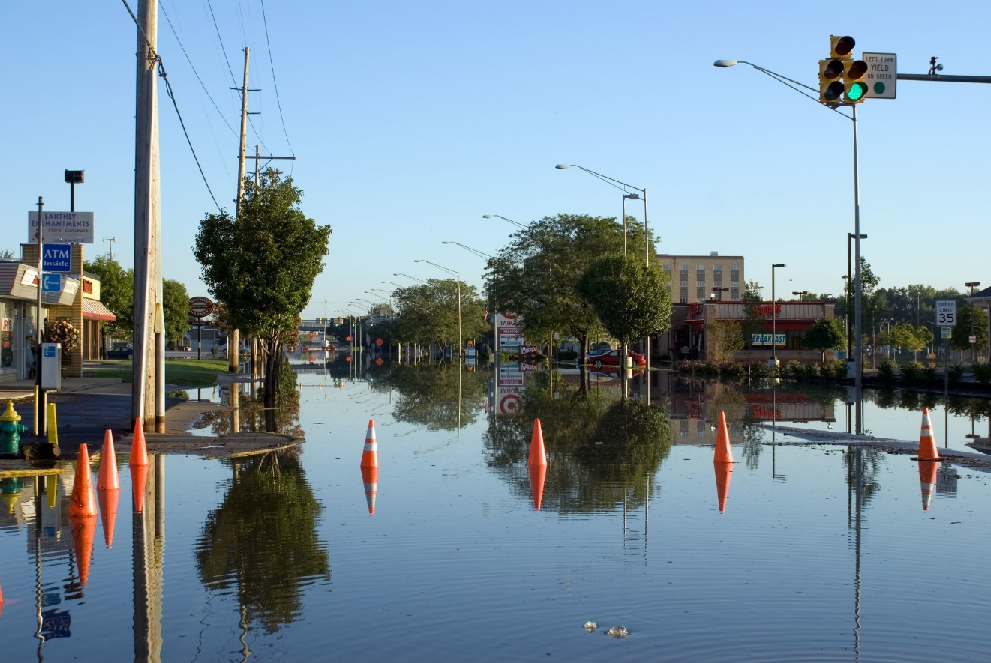

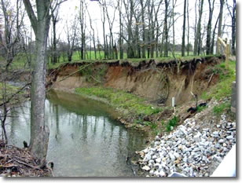
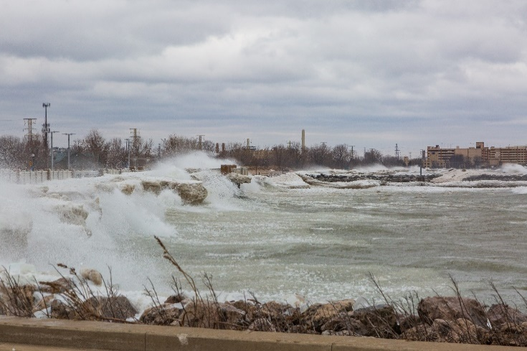

Top: Little Calumet River flooding in Munster (Credit: John Lucito, Flickr; Bottom left: A coastal storm on Lake Michigan (Credit: Joe Exl); Bottom right: Fluvial erosion (Credit: Indiana Geological and Water Survey)
Funding was provided by the Indiana Lake Michigan Coastal Program and the National Oceanic and Atmospheric Administration, Office for Coastal Management under Grant # NA21NOS4190081.

Why should my local government complete this self-assessment?
This self-assessment is intended to help local government (municipal and county) staff and decision-makers of Indiana coastal watershed communities evaluate potential impacts of natural hazards and consider planning and mitigation actions to increase resilience. Resilience, in the context of this self-assessment, is the ability to respond to, withstand, and adapt to the impacts of natural hazards.
This self-assessment will assist the Indiana Lake Michigan Coastal Program (LMCP) in identifying, developing, and delivering the technical resources needed by coastal watershed communities to reduce or prevent natural hazard risks. LMCP has contracted with the Northwestern Indiana Regional Planning Commission (NIRPC) to help communities complete the self-assessment and conduct listening sessions.
This self-assessment is not a complete vulnerability assessment nor is it intended to rank communities against each other. Rather, this is an exercise to help communities consider actions that can build their resilience to coastal watershed hazards while also informing LMCP enhancement strategies.

Coastal Watershed Counties & Communities
The LMCP is based on a watershed approach and operates within Northwest Indiana’s Lake Michigan watershed, the area of land that drains to Lake Michigan. Figure 1 shows the incorporated and county areas located within the program boundary and covered by this needs assessment. 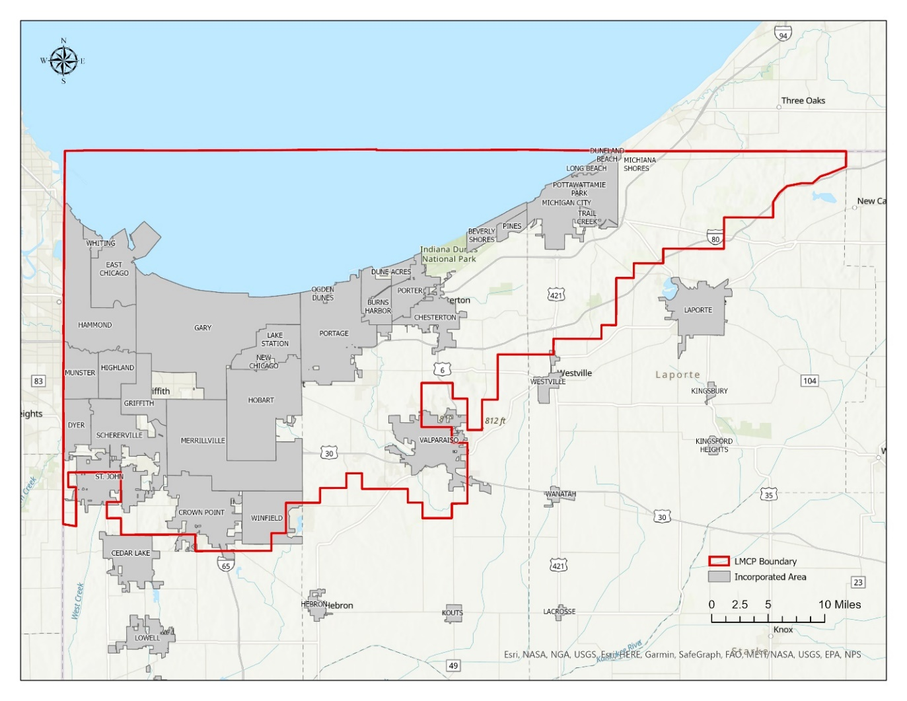
Figure 1. The Lake Michigan Coastal Program boundary.

Who should use this self-assessment?
This self-assessment tool is intended for use by local government staff and decision-makers. Interdepartmental coordination is an important aspect of community resilience and is vital for ensuring your local government is prepared for potential natural hazard events. LMCP and NIRPC recommend that your local government convene a team of staff, elected officials, and board or commission members with diverse knowledge about local conditions, plans, policies, and operations and complete one assessment together.
This page can be used to coordinate your local governments’ resiliency assessment team. You may share the contacts with LMCP and NIRPC for communication purposes but are not required to. Names of local government units and their staff or representatives will not be shared or listed in any reports.
Local Government Unit: ________________________________________________________________
Assessment Team Lead/Coordinator Name: ________________________________________________
Title: _________________________________________________
E-mail: ________________________________________________
Department | Title | Name | e-mail
Emergency Management/Floodplain Administrator
Engineering

Environmental

Marina/Harbor

Parks and Recreation

Planning and Zoning

Public Works

MS4/Stormwater

Transportation

Department | Title | Name | e-mail

What is in the self-assessment?
Part 1: Identifying Coastal Watershed Hazard Risks - This tool will help prioritize coastal watershed hazards issues in a local government by rating:
(1) Frequency of occurrence
(2) Impact to the community
(3) Level of preparedness.

Part 2: Resilient Practices Questionnaire - This series of yes/no questions will help identify common planning and mitigation actions that the local government can implement to address coastal watershed hazard issues.
How do I complete the self-assessment?
The self-assessment can be completed either by hand with a printed version of the form or electronically using the fill-in capabilities of this PDF form (requires Adobe Reader). Questions about the self-assessment or results may be directed to:
Northwestern Indiana Regional Planning Commission
Jen Birchfield, Natural Resources Planner
Jbirchfield@nirpc.org
(219) 254-2511

Natural Hazard Descriptions

Coastal Flooding - Coastal flooding occurs when low-lying coastal land is flooded by lake water. Coastal flooding is primarily caused by storm surge and waves but many other factors have an influence. On the Great Lakes shorelines, flooding is dependent on local lake levels, which vary due to precipitation, evaporation, and other natural processes, as well as anthropogenic activities.

Riverine Flooding- Riverine flooding occurs when streams and rivers exceed the capacity of their natural or constructed channels to accommodate water flow causing water to overflow the banks, spilling out into adjacent land.

Coastal Erosion - Coastal erosion is the process where wave energy moves material from the shore out to greater water depths. Coastal erosion is caused mainly by storms and winds. While coastal erosion occurs even during low water levels, it is exacerbated when lake levels are high.

Fluvial Erosion - Fluvial erosion refers to the in-stream erosion of the bed and banks. Fluvial erosion includes bed erosion, meaning lowering of the bed of a stream, as well as bank erosion, meaning the retreat of stream banks that occurs as a stream widens or migrates laterally.
Lake Level Change - Great Lakes water level changes result from cyclical changes in rainfall, evaporation, and river and groundwater inflows. These factors work together to raise and lower the water levels of the Great Lakes in small increments daily and larger increments seasonally and over the course of years and decades. Long-term water levels fluctuate by multiple feet.
Coastal Storms – Coastal storms can cause large waves and storm surge, or “piling up” of water along the coast due to storm winds and atmospheric pressure gradients. Coastal storms can increase coastal flooding and erosion.

Part 1: Identifying Coastal Watershed Natural Hazard Risks
This matrix will help your team to identify what coastal watershed hazards pose the most critical risks to your local government. Risk is the potential for negative impacts or damage due to a hazard event, a combination of (1) the probability that a hazard event will occur, (2) the consequences that the hazard would have, and (3) the actions that have been or should be taken to mitigate those consequences.

Instructions
For each coastal watershed hazard issue described on Page 4, you will assign a score of Low, Moderate, High, or NA (Not Applicable) for your perception of each of the following criteria:
- Probability- The likelihood that an issue is expected to occur.
- Impact- The extent to which a given coastal watershed hazard issue can cause death or injury, property damage, or service interruption.
- Preparedness- The level of effective planning or action that has taken place to reduce the overall impact of a hazard to your community.
If your local government would like to learn more about an issue to inform your response, please provide a short explanation.

Hazard Issue | Probability | Impact |  |  | Preparedness | We have questions and/or want to learn more about this issue (Explain)
Hazard Issue | Likelihood this issue will occur | Possibility of death or injury | Property  loss or damage | Interruption of services | Level of planning for issue
Coastal Flooding
Riverine Flooding
Coastal Erosion
Fluvial Erosion
Lake Level Change
Coastal Storms

Part 2: Resilience Practices Questionnaire
The following series of yes/no questions will help to identify opportunities to strengthen your local government’s approach to planning for and mitigating the impacts of coastal watershed hazards and may reveal vulnerabilities not previously considered.
Instructions: Answer each question by checking “Yes”, “No”, “NA”, “?” (meaning “not sure”) or other listed options. More detailed answers or explanations can be entered in the “Comments” section of each question. For instance, it may be useful to reference specific portions or pages of a plan or strategy that addresses the question or to identify what information is needed to resolve a “?” response.

Understanding Coastal Watershed Hazard Impacts
Knowing the locations, populations, and properties that are vulnerable to coastal watershed hazards is the starting point to developing resilient strategies to reduce risk and avoid losses.
- Has your local government identified and documented the historical geographic extent and impacts of coastal watershed hazards?
Hazard | Yes, No, NA, ? | Comments
Coastal Flooding
Riverine Flooding
Coastal Erosion
Fluvial Erosion
Lake Level Change
Coastal Storms

- Has your local government identified and documented the damage and/or cost of past coastal watershed hazards?
Hazard | Yes, No, NA, ? | Comments
Coastal Flooding
Riverine Flooding
Coastal Erosion
Fluvial Erosion
Lake Level Change
Coastal Storms

- Has your local government assessed potential future coastal watershed hazard risks?
Hazard | Yes, No, NA, ? | Comments
Coastal Flooding
Riverine Flooding
Coastal Erosion
Fluvial Erosion
Lake Level Change
Coastal Storms

- Does your local government staff have access to Geographic Information System (GIS) mapping and analysis?
Yes, No, ? | Comments

- If yes, is GIS mapping and analysis done by staff, external consultants, or both?
Staff, Consultants, Both, ? | Comments

- Does your local government have maps or spatial data that identify areas at risk to coastal watershed hazards?
Hazard | Yes, No, NA, ? | Comments
Coastal Flooding
Riverine Flooding
Coastal Erosion
Fluvial Erosion
Lake Level Change
Coastal Storms

- Is your local government aware of potential risks of contamination of waterways due to coastal watershed hazards, such as flooding or erosion of infrastructure or contaminated land?
Hazard | Yes, No, NA, ? | Comments
Coastal Flooding
Riverine Flooding
Coastal Erosion
Fluvial Erosion
Lake Level Change
Coastal Storms

Hazard Mitigation Planning
It begins with governments identifying natural disaster risks and vulnerabilities common in their area. After identifying these risks, they develop long-term strategies for protecting people and property from similar events. A current, approved Multi-Hazard Mitigation Plan is required to be eligible for certain types FEMA funding assistance.
- Does your local government have a FEMA-approved Multi-Hazard Mitigation Plan?
Yes, No, ? | Comments (If yes, please include year approved)

- Does your local government participate in a county level FEMA-approved Multi-Hazard Mitigation Plan?
Yes, No, ? | Comments

- If “Yes”, how often does your local government consult the county plan and consider it in planning and zoning decisions?

- Has your local government adopted the county level FEMA-approved Multi-Hazard Mitigation Plan?
Yes, No, ? | Comments

- The Federal Disaster Mitigation Act of 2000 requires that FEMA approve Multi-Hazard Mitigation Plans every five years to main eligibility for federal mitigation assistance grants. Is your local Multi-Hazard Mitigation Plan approved and not expired?
Yes, No, ? | Comments

- Does the Multi-Hazard Mitigation Plan document past coastal watershed hazard mitigation efforts, along with their costs and effectiveness?
Hazard | Yes, No, NA, ? | Comments
Coastal Flooding
Riverine Flooding
Coastal Erosion
Fluvial Erosion
Lake Level Change
Coastal Storms

- Does the Multi-Hazard Mitigation Plan identify strategies to address all the coastal watershed hazards that you identified in Part 1: Identifying Coastal Watershed Natural Hazard Risks?
Hazard | Yes, No, NA, ? | Comments
Coastal Flooding
Riverine Flooding
Coastal Erosion
Fluvial Erosion
Lake Level Change
Coastal Storms

- Have the strategies from the Multi-Hazard Mitigation Plan been implemented as described in your local jurisdiction?
Fully, Partially, No, NA, ? | Comments

- Does the Multi-Hazard Mitigation Plan identify opportunities to integrate hazard mitigation with other planning mechanisms, such as land use, capital investment, economic development, or other local jurisdiction plans?
Yes, No, ? | Comments

- Is your local government aware of FEMA’s Hazard Mitigation Grant program and the types of coastal projects that may be eligible for funding?
Yes, No, ? | Comments

- Is your local government aware of the Building Resilient Infrastructure in Communities (BRIC) program and the types of coastal projects that may be eligible for funding?
Yes, No, ? | Comments

- Does your local government have a disaster response and recovery plan that includes short- and long-term actions and policies? (If yes, please list plan name and date in comments)
Yes, No, ? | Comments

- If yes, does your disaster response and recovery plan identify personnel responsible for those actions?
Yes, No, ? | Comments

Local Government Planning
Local government planning efforts, such as comprehensive, land use, capital investment, and economic development plans, guide development and other investment actions by the local government. Integrating strategies to mitigate the effects of coastal watershed hazards into these plans can help reduce the exposure of development and other local assets to risk.
- Does your local government address resiliency (the ability to respond to, withstand, and adapt to the impacts of natural hazards) in your plans?
Yes, No, ? | Comments

- Does your local government have a shared vision of ‘community resilience’ documented in plans?
Yes, No, ? | Comments

- Does your local government include climate mitigation goals and objectives in the comprehensive plan or other policy document?
Yes, No, ? | Comments

- Does your local government have a land use plan that makes recommendations to reduce coastal watershed hazard vulnerabilities?
Hazard | Yes, No, NA, ? | Comments
Coastal Flooding
Riverine Flooding
Coastal Erosion
Fluvial Erosion
Lake Level Change
Coastal Storms

- Do planning horizons incorporate potential long-term coastal watershed hazards?
Hazard | Yes, No, NA, ? | Comments
Coastal Flooding
Riverine Flooding
Coastal Erosion
Fluvial E23.rosion
Lake Level Change
Coastal Storms

- Do plans for public infrastructure, such as buildings, roads, water, sewer, and other utilities include recommendations for relocation, abandonment, or protection of infrastructure at-risk to coastal watershed hazards?
Yes, No, or ? | Comments

- Does your local government update its plans in consideration of and/or have joint plans with nearby municipalities’ plans for future development?
Yes, No, ? | Comments

- Did your local government conduct a natural resource inventory or assessment and incorporate protection of priority natural systems through the subdivision or development process?
Yes, No, ? | Comments

- What are your local government’s highest priorities or major initiatives planned to improve resiliency?

Local Ordinances
Local zoning ordinance provisions can reduce the risk that new development is exposed to and limit adverse impacts.
- Does your local government use zoning regulations to reduce natural hazard damages to the built environment?
Yes, No, ? | Comments

- Has your local government adopted codes and ordinances to support sustainable development and conserve natural resources?
Yes, No, ? | Comments

- Do existing ordinances require new development to be set back some distance from shorelines and streambanks?
Yes, No, ? | Comments

- Do existing ordinances require new development in the 1% annual chance (100-year) floodplain to take measures that reduce flood impacts such as elevating buildings a certain height above the base flood elevation?
Yes, No, ? | Comments

Implementing Best Practices
The National Flood Insurance Program works with communities required to adopt and enforce floodplain management regulations that help mitigate flooding effects. The Community Rating System (CRS) is a voluntary program for communities participating in the National Flood Insurance Program. The Community Rating System offers National Flood Insurance Program policy premium discounts in communities that develop and execute extra measures beyond minimum floodplain management requirements to provide protection from flooding.
- Does your local government participate in the National Flood Insurance Program?
Yes, No, ? | Comments

- If your local government participates in the National Flood Insurance Program, does your local government also participate in the Community Rating System?
Yes, No, ? | Comments

- If no, has your local government considered participating in the National Flood Insurance Program’s Community Rating System?
Yes, No ? | Comments

- Would your local government be interested in participating in a regional Community Rating System program?
Yes, No, ? | Comments

- Does your local government know how many flood insurance policy holders are within your jurisdiction?
Yes, No, ? | Comments

- Has your local government considered relocation or voluntary acquisition of repetitive loss structures or those structures which are at high risk to coastal watershed hazards?
Yes, No, ? | Comments

- Do permitting processes review practices that could have adverse impacts on shoreline stability, such as vegetation removal, stormwater management, and on-site waste disposal?
Yes, No, ? | Comments

Public Education & Engagement
Properties can frequently change hands, leaving property owners unaware of or unprepared for hazards. On the other hand, residents and business owners may have local knowledge of hazards that can inform resilience strategies. Educating and engaging residents can help to manage coastal watershed hazards.
- Does your local government routinely conduct public outreach and education focused on coastal watershed hazards?
Hazard | Yes, No, NA, ? | Comments
Coastal Flooding
Riverine Flooding
Coastal Erosion
Fluvial Erosion
Lake Level Change
Coastal Storms

- Does your local government have hazard information, such as maps and guidance on management practices, available to residents and property owners upon request?
Hazard | Yes, No, NA, ? | Comments
Coastal Flooding
Riverine Flooding
Coastal Erosion
Fluvial Erosion
Lake Level Change
Coastal Storms

- Has the public been involved with identifying historic coastal watershed hazard impacts, areas that are at risk, or strategies to address coastal watershed hazards?
Hazard | Yes, No, NA, ? | Comments
Coastal Flooding
Riverine Flooding
Coastal Erosion
Fluvial Erosion
Lake Level Change
Coastal Storms

Shoreline and Fluvial Erosion Protection
Structural shoreline and fluvial protection measures are commonly used to protect property from erosion and flooding. To achieve the expected level of protection, these structures need to be engineered, monitored, maintained, and replaced when necessary. Alternative hybrid-structural options (nature-based, living shoreline, or engineering with nature approaches) or non-structural options (slope stabilization, vegetation, beach nourishment, or asset relocation) may be considered due to cost, aesthetics, public access, habitat, or adverse impacts to adjacent properties.
- Has your local government documented the location of erosion protection structures?
Yes, No, ? | Comments

- Does your local government routinely inspect and maintain erosion protection structures?
Yes, No, ? | Comments

- Has your local government documented the condition, effectiveness, and life expectancy of erosion protection structures?
Yes, No, ? | Comments

- Has your local government documented instances where erosion protection structures adversely impact adjacent shoreline or downstream areas?
Yes, No, ? | Comments

- Does your local government consider hybrid-structural options (nature-based, living shoreline, or engineering with nature approaches) or non-structural options (slope stabilization, vegetation, beach nourishment, or asset relocation)?
Yes, No, ? | Comments

- Does your local government have internal expertise and capacity for maintenance of hybrid-structural options?
Yes, No, ? | Comments

Stormwater Management
Stormwater management practices on the landscape can mitigate or exacerbate coastal watershed hazards, such as flooding and erosion. Your community may or may not be a Municipal Separate Stormwater System (MS4). MS4s are defined as “a conveyance or system of conveyances owned by a state, city, town, or other public entity that discharges to waters of the United States and is designed or used for collecting or conveying stormwater”. If your community is an MS4, your MS4 coordinator should contribute to this section.
- Is your local government an MS4 community?
Yes, No, ? | Comments

- Has your local government adopted stormwater infiltration/management strategies to reduce or mitigate runoff from impervious surfaces?
Yes, No, ? | Comments

- Does your local government consider projected increases in precipitation intensity in its stormwater management plans? Please include what timeframe you use for projected increases (20, 30, 50 years, etc.).
Yes, No, ? | Comments

- Does your local government manage stormwater infrastructure to mitigate risk from future climate change?
Yes, No, ? | Comments

- Does your local government have a flood management plan?
Yes, No, ? | Comments

Natural Areas, Open Space, and Public Access
Open space and natural areas can buffer against coastal watershed hazards and also provide for public access, recreation, and tourism. Open space means there are no buildings, storage, fill, significant pavement, or other encroachments to flood flows. Open space can include green space (land that is partly or completely covered with grass, trees, shrubs, or other vegetation). Open space can also include natural areas, such as forests or wetlands.
- Has your local government mapped and documented the following natural floodplain function related resources?
 | Yes, No, NA, ? | Comments
Beaches
Dunes
Wetlands
Riparian areas
Threatened and/or endangered species habitat
Open space
Recreational uses

- Does your local government inventory open space?
Yes, No, or ? | Comments

- If yes, have you developed plans and ordinances to protect open space, particularly in areas where it is lacking (e.g. park master plan, comprehensive plan, redevelopment plan)?
Yes, No, ? | Comments

- Does your local government have a plan, such as a beach management plan or park master plan, that details strategies for beach management operations during periods of high lake levels or shoreline erosion?
Yes, No, NA, ? | Comments

- Does your local government have a plan that details strategies for public beach or river public access during periods of high lake levels or shoreline erosion?
Beaches | Rivers
Yes, No, NA, ? | Yes, No, NA, ?
Comments:

Marinas
Marinas are centers of commerce and recreation. The ability for these facilities to withstand coastal hazards is important to the economic security of communities that rely on them.
- Does your local government have a public marina?
Yes, No, ? | Comments

- Is your marina included in community hazard planning efforts?
Yes, No, NA ? | Comments

- Does your marina use information related to historic water level trends, past extreme weather events, and future climate conditions in facility planning?
Yes, No, NA ? | Comments

- Has your marina performed risk assessments to identify the property upgrades necessary to limit damage and maintain function for the following hazards?
Hazard | Yes, No, NA, ? | Comments
High water level
Low water level
Ice
Coastal storms
Extreme precipitation
Flooding

- Have you invested in property upgrades that limit damage and maintain function during varying lake levels, ice, coastal storms, extreme precipitation, and flood events? If so, please identify investments in Comments box
Yes, No, ? | Comments

Additional Questions or Comments:

The Great Lakes Coastal Flood Study. (2022, July 7). Wave Hazards and VE zones on the Great Lakes. https://www.greatlakescoast.org/pubs/factSheets/Region_V_VE_Zone_FS_V7_012219_FINAL.pdf
Federal Emergency Management Agency. (2022, July 7). National Risk Index: Riverine Flooding. https://hazards.fema.gov/nri/riverine-flooding
Wisconsin Department of Natural Resources. (2022, July 7). History and geology of the Great Lakes. https://dnr.wisconsin.gov/topic/Waterways/shoreline/greatLakesProcesses.html
U. S. Geological Survey. (2022, July 7). Fluvial erosion hazards primer. https://wim.usgs.gov/geonarrative/FEHprimer/
Resilient Michigan. (2022, July 7). Northwest lower Michigan coastal resilience atlas. http://www.resilientmichigan.org/nw_atlas.asp
Wisconsin Coastal Resilience. (2022, July 7). Waves and coastal storms and erosion, oh my! https://wicoastalresilience.org/waves-coastal-storms-erosion/
Indiana Department of Environmental Management. (2022, August 17). Municipal Separate Stormwater Systems. https://www.in.gov/idem/stormwater/municipal-separate-storm-sewer-systems-ms4/
U. S. Environmental Protection Agency. (2022, July 8). What is open space/green space? https://www3.epa.gov/region1/eco/uep/openspace.html

