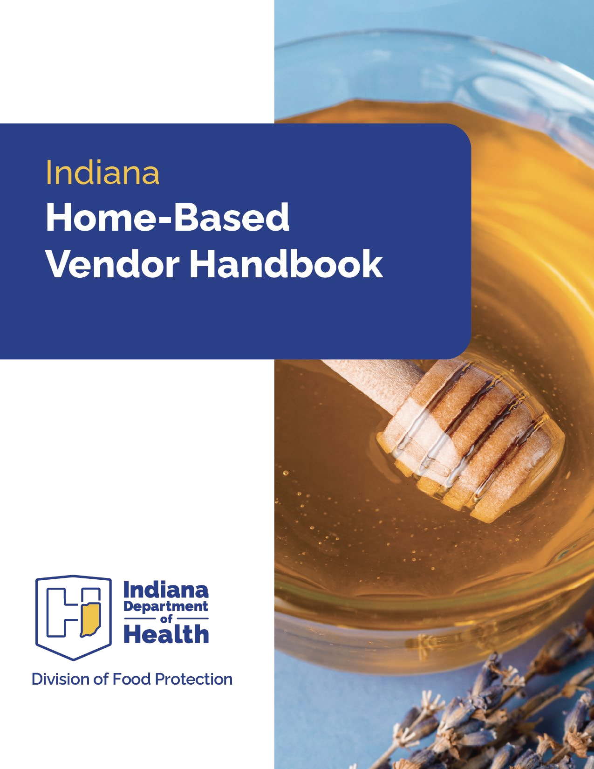

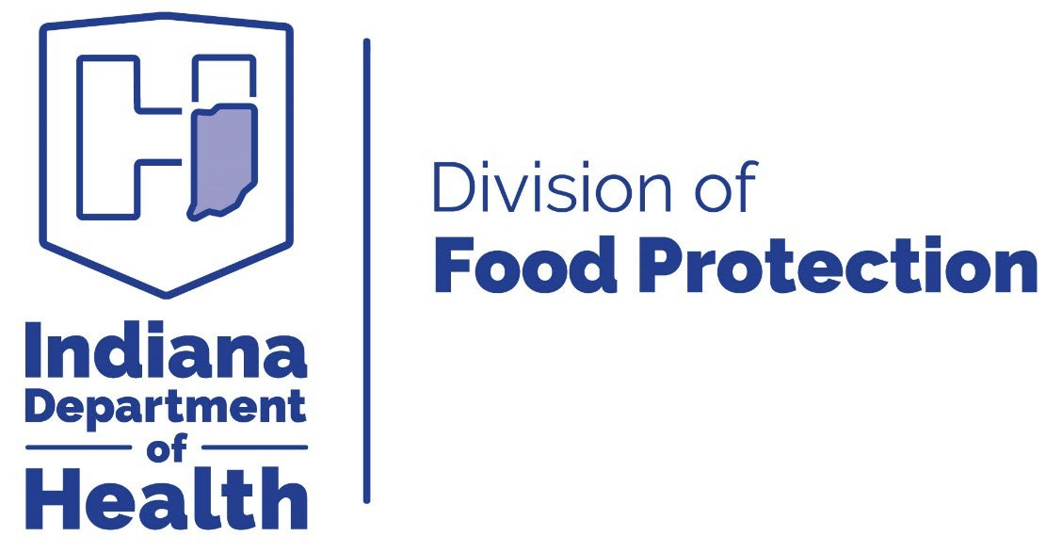



Funding for this publication was made possible by Health First Indiana.


Table of Contents

Last updated Spring 2025
Contents
Introduction 5
Home-Based Vendor (HBV) History and Regulations 6
Definitions 6
General Requirements for Home-Based Vendors 8
Inspections 9
Non-TCS HBV Food Products 11
Determining the Shelf-Stability of HBV Products 17
TCS and Non-HBV Food Products 18
pH Values of Common Raw Commodities and Food Ingredients 22
Which Home Producers Are Not Considered Home-Based Vendors? 24
Approved Methods and Materials for Final Product Packaging 25
Packaging Permeability Results 26
HBV Experiments Conducted by Purdue University Food Entrepreneurship and Manufacturing Institute (FEMI) 28
Product Decision Trees 34
Frequently Asked Questions 35
Home-Based Vendor Best Practices 42
Current Home-Based Vendor Regulations 43
Science-Based (Academic) Resources Available 46
Contact Us 47

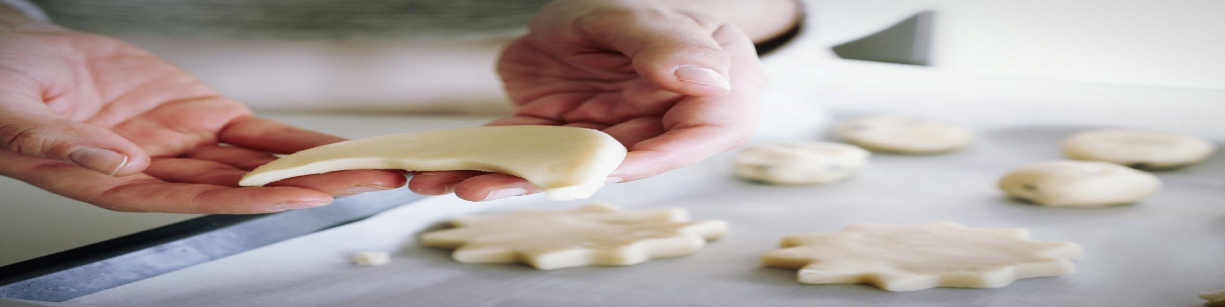
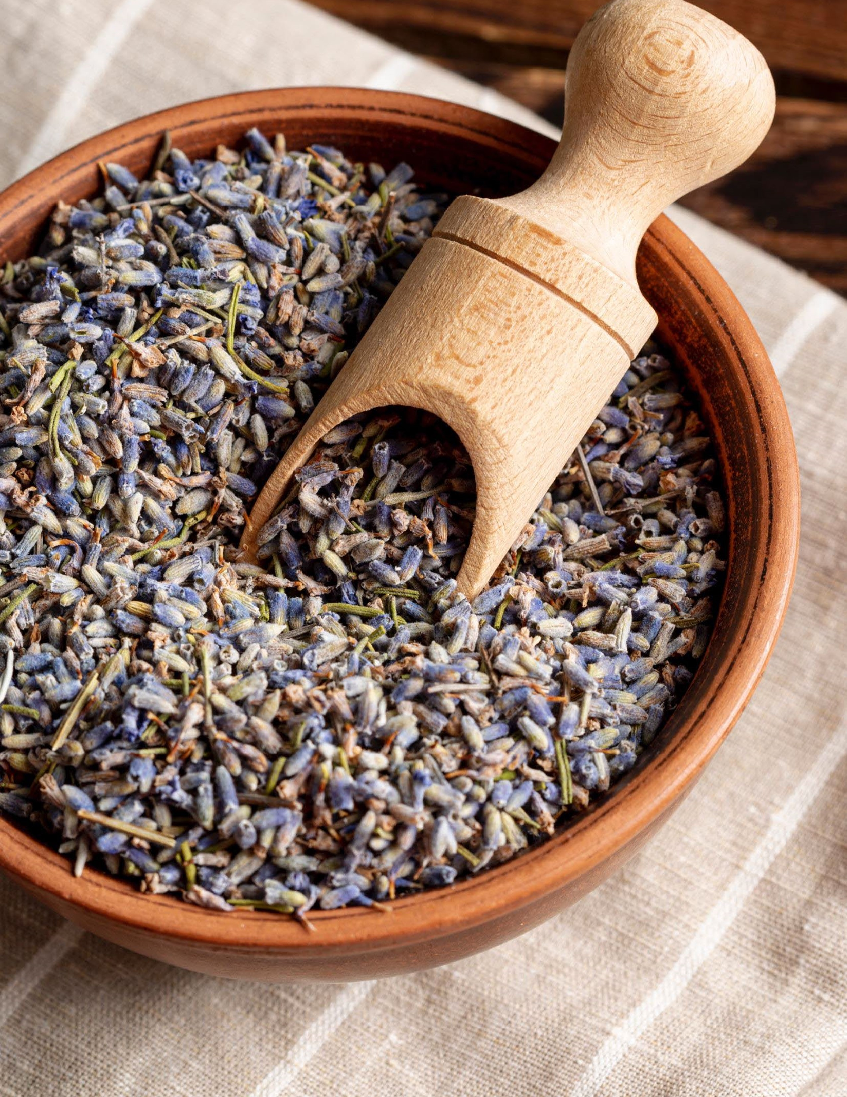

4

Introduction

Introduction
This handbook was developed by the Indiana Department of Health in partnership with the Food Entrepreneur and Manufacturing Institute (FEMI) at Purdue University. The
recommendations provided in this document are science-based, supported by data collected by Purdue University, designed with industry best practices in mind, and aligned with regulatory requirements for home-based vendors (HBVs) operating within the State of Indiana.
HBVs and local health departments may utilize this handbook to determine what food products can be safely prepared and sold within the State of Indiana under HBVs regulations. This handbook is not all-inclusive.
HBVs are strongly encouraged to contact their local health department to confirm that a certain food product can be produced under IC 16-42-5.3. HBV regulations (IC 16-42-5.3) are overseen by the Indiana Department of Health Division of Food Protection and enforced by local health departments.
Maintaining a safe food system requires all food producers, including HBVs, to take precautionary measures. HBVs who prepare and sell food to the public have the immense responsibility of following food safety regulations and good practices to ensure they produce safe products for their end consumer.
While Indiana has previously identified foods as time/temperature control for safety (TCS) or non-TCS, there are many food products that are not clearly defined, creating confusion surrounding which products are approved for HBV production. To provide clarity and scientific support on this topic, Purdue University conducted a study on a series of commonly produced HBV products to determine their food safety profile. The focus of the study was based on several survey responses from county health departments and Purdue Extension Educators to understand questions that are commonly asked by HBVs. Fifteen products were tested, hermetic seal conditions were identified, and safe product packaging was determined. The study was conducted in Nelson Hall of Food Science at Purdue University.
A team of Purdue researchers prepared food products and investigated the intrinsic properties of finished potential HBV products – specifically to identify its water activity and pH – to determine if pathogen growth was supported. In food science, it is recognized that pathogens cannot grow in a food if the water activity (Aw) is less than 0.85 or the pH is below 4.6. For some products that undergo a kill step, internal temperature data was collected and compared to lethality temperatures for the microbes of concern. The team also looked at properties which may impact legality, such as the alcohol content in applicable foods.
5

During the study, researchers aimed to capture the pH and Aw variabilities that could result while using certain ingredients or different recipes. For example, researchers were interested in whether fruits such as apples of different varieties or ripeness could impact the final product’s pH.
The findings and recommendations from this research are detailed on subsequent pages of this document. Recommendations follow the assumption that HBVs will follow all other HBV requirements and regulations.

Home-Based Vendor (HBV) History and Regulations
In 2009, the State of Indiana passed House Enrolled Act (HEA) 1309, which created regulations permitting HBVs to prepare select food products in the kitchen of their primary residential home and sell those food products directly to the end consumer.
In 2022, the regulations were updated with the passing of HEA 1149. HEA 1149 expanded ways to sell HBV products, identified select product exemptions, and incorporated training requirements for individual HBVs.
HBV food products are regulated under IC 16-42-5.3 and are enforced by local health departments within the State of Indiana. HBV regulations permit the sale of food products that are not time/temperature controlled for safety (TCS) foods. Foods in this category do not require refrigeration for food safety and pose little food safety concern when prepared in a clean environment using good hygienic practices.

Definitions

Term | Definition
Academic/science-based resource | Science-based journals, articles, books, reports or educational resources written by experts in the field.  NOTE: As it pertains to this handbook, referenced resources have undergone appropriate testing to ensure that the product is safe if the recipe is prepared exactly as written.
Acidification | The process of adding acid (e.g., vinegar) or acid foods to a low-acid food to lower its pH.
Acid food | Foods that have a natural pH of 4.6 or below.
Advisory statement | An advisory statement is required on each label in 10-point type to indicate that:

 | “This product is home produced and processed, and the production area has not been inspected by the State Department of Health. NOT FOR RESALE.”
Canning | The preservation process in which foods are processed and sealed in an airtight container (e.g., utilizing heat to create suction for airtight seal).
Commercially prepared/processed | Food that was processed and packaged in a licensed food processing plant which a regulatory authority inspects and holds jurisdiction.
GRAS | Generally Recognized as Safe by FDA standards.
End consumer | A person who makes the final purchase of a product or service for personal use.
Hermetically sealed container | An airtight container that is completely sealed to prevent the entry or escape of oxygen, therefore securing the product against the entry of microorganisms during and after thermal processing.
Home-based vendor (HBV) | An individual who prepares and sells food products prepared solely in their primary residence.
Home kitchen | The kitchen of a vendor’s primary residence.
Ingredient | A food component of a greater whole.
Personal hygiene | A set of practices that keep and maintain bodily cleanliness:  - Handwashing: Wash hands thoroughly before and after handling food  - Hair: Keep hair restrained  - Clothing: Wear clean protective clothing  - Cuts and wounds: Cover all cuts, wounds, or sores with a waterproof dressing  - Illness: Do not handle food if you are sick or have open/exposed wounds
pH | A measure of the acidity and alkalinity of a solution or substance. A food with a pH below 4.6 does not allow for the growth of pathogenic bacteria.
Process authority | A person or organization with expert knowledge which is acquired through appropriate training and experience.
Product assessment | A comprehensive description of a food product that entails the value of factors such as water activity (Aw), pH, shelf-life, etc.
Regulatory authority | A state or local government agency that sets and enforces regulations to protect the public interest.
Quick bread | Bread is made without yeast. Baking powder/soda can be added as a leavening agent.
Retail food establishment | An operation that “stores, prepares, packages, serves, vends or otherwise provides food for human consumption.” A home-based vendor is not a retail food establishment.
Term | Definition
Standards of identity (SOI) | The FDA standards of identity are the necessary information required to call a product by its given name. SOI identifies what proportion of ingredients and processing methods are required for specific products (e.g., noodles, sweeteners, vanilla extract, etc.).
Third-party carrier | Also known as a third-party logistics provider, third-party carriers are couriers that offer logistics services between the shipper and the consumer.
Time/temperature controlled for safety (TCS) | TCS foods, as stated in IC 16-18-2-351.7, require time or temperature control to limit the growth of pathogenic bacteria or formation of toxins. TCS foods were previously referred to as “potentially hazardous foods” in Indiana Code. The following products and/or ingredients are examples of TCS:  - An animal food that is raw or heat-treated  - A plant food that is heat-treated  - Raw seed sprouts  - Cut melon  - Cut leafy greens  - Cut tomatoes or mixtures of cut tomatoes  - Garlic-in-oil  TCS foods are not permitted to be sold by HBVs.
Vacuum packaging | The process of removing air from a container or bag to create an airtight seal.
Water activity (Aw) | The measure of water available for metabolic processes, such as bacterial growth, in a food. A food with water activity below 0.85 does not allow for the growth of pathogenic bacteria.

General Requirements for Home-Based Vendors
IC 16-42-5.3 requires all HBVs to meet the following requirements:
Sanitary Procedures in the Production Site
All HBVs must use sanitary procedures when preparing food products. The procedures include, but are not limited to:
- Proper handwashing and good personal hygiene
- Storing the product safely in a manner where contamination is not likely
- Producing food in an area where animals are not present
- Cleaning and sanitizing food contact surfaces with cleaning agents that are labeled for cleaning/sanitizing food contact surfaces
Requirements to Sell Home-Based Vendor Food Products
HBVs must only sell their product directly to the end consumer. Products cannot be sold to a warehouse, retail food establishment, wholesaler or another entity that intends to further distribute the product. All HBV products must only be sold and shipped within the State of Indiana. HBVs may sell their products in the following methods:
- In-person, by telephone, through the internet
- Delivered to the end consumer in person, by mail, or via a third-party carrier
Food Safety Training Requirement
All HBVs must obtain a food handler certificate from a certificate issuer that is accredited by the American National Standards Institute (ANSI). There are several companies who offer training courses that meet this requirement, including in-person course offerings through Purdue Extension. Please contact your local health department for additional information on other approved certificate issuers.
Labeling
All food products produced by HBVs must include the following information visible on each product:
- The name and address of the producer
- The common or usual name of the food product
- The ingredients of the food product, in descending order by predominance by weight
- The net weight or volume of the food product by standard measure or numerical count • The date on which the food product was processed
- The following statement in at least 10-point type:
“This product is home produced and processed, and the production area has not been inspected by the State Department of Health. NOT FOR RESALE.” Sample label:

Strawberry Jamming Jams
Address: 2120 Produce Ln., Strawberry, IN 12345 Ingredients: Water, Strawberries, Sugar, Lemon Juice, Pectin
Produced on November 08, 2024
Net Wt. 17 OZ (485g)
“This product is home produced and processed, and the production area has not been inspected by
the State Department of Health. NOT FOR RESALE.”

Inspections
While HBVs are not subject to routine inspections or product sampling, local health departments have authority to inspect production sites, if they have cause, such as receiving a consumer complaint or if a food product is misbranded or adulterated.
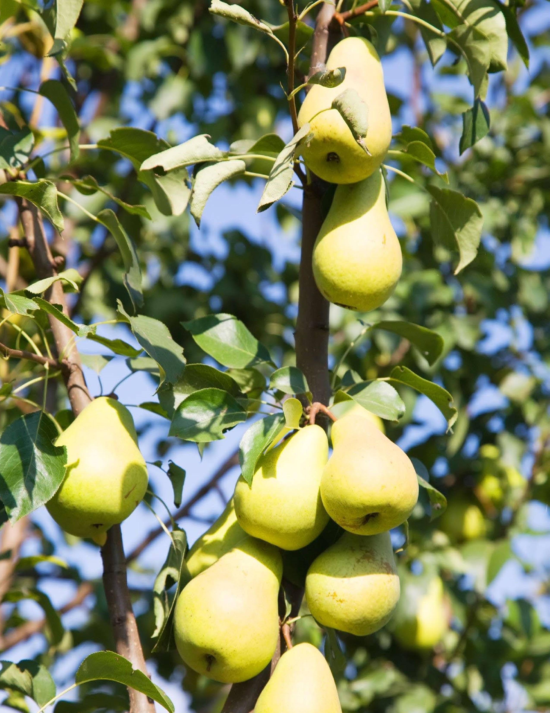

Non-TCS HBV Food Products
Traditional Home-Based Vendor Goods
Traditional HBV items include cakes, cookies, breads, jams, and jellies. Upon further study and consideration, the Indiana Department of Health saw fit to expand this list to account for variations of traditionally prepared HBV goods, and to provide clarity on their public health justifications.

The following list is meant to provide information on non-temperature controlled for safety foods that are compliant with HBV regulations. The list is neither complete nor all-inclusive. If you find a product not covered on the list, please contact your local health department or Purdue University Extension FEMI Office.

Category | Finished product (common name) | Public health comments
Baked goods | Baklava | Non-TCS product
Baked goods | Kolache (select) | Product must not contain TCS ingredients. (excluding: milk and  eggs)
Baked goods | Lamington | Non-TCS product
Baked goods | Scones | Product must not contain TCS ingredients (excluding milk and  eggs)
Baking mixes | Cake, cookies, or bread | Product must not contain TCS ingredients (excluding milk and eggs). Alternative protein flour  must come from a commercially prepared source.
Bread | Bagels | Plain or baked with herbs, or uniformly incorporated cheese
Bread | Cheddar cheese bites | Ensure cheese is uniformly shredded and the final internal  bake temperature of the product is  a minimum of 165F
Bread | Cheese biscuits | Ensure cheese is uniformly shredded and the final internal  bake temperature of the product is  a minimum of 165F

Category | Finished product  (common name) |  | Public health comments
Bread | Focaccia |  | Ensure vegetables are uniformly shredded and evenly incorporated  throughout the batter. Whole and cut  vegetables must not be added in or on top of the bread. (e.g., onions, zucchini,  tomatoes, etc.)
Bread | Jalapeño |  | Yeast-based bread made with commercially prepared, pickled  jalapeños only
Bread | Pretzels |  | Non-TCS product
Bread | Quick bread |  | For added fresh/frozen vegetables, ensure vegetables are uniformly  shredded and the final internal bake temperature of the product is a minimum of 165F
Bread | Sourdough |  | Non-TCS food product
Cakes | Cake pops |  | Icing must be commercially prepared or from a science-based academic recipe and classified as non-TCS
Cakes | Cupcakes |  | Icing must be commercially prepared or from a science-based academic recipe and classified as non-TCS
Cakes | Decorated/wedding |  | Icing must be commercially prepared or from a science-based academic recipe and classified as non-TCS
Cakes | Funnel |  | Icing must be commercially prepared or from a science-based academic recipe and classified as non-TCS
Candy | Candy apples |  | Non-TCS food product
Candy | Caramel Apples |  | Non-TCS food product
Candy | Cotton Candy |  | Non-TCS food product
Candy | Hard Candy |  | Non-TCS food product
Category |  | Finished product (common name) |  | Public health comments
Canned (glass jar) foods |  | Acid fruits |  | Included fruits: peaches, cherries, apricots, plums, apples, pears, citrus fruits, blackberries, blueberries,  raspberries, and strawberries.  No added ingredients outside of high acid fruits and simple syrups
Canned (glass jar) foods |  | Jams, jellies, preserves, and high acid fruit curds |  | Must be made with recipes using only acidic fruits, sugar, and pectin. Must NOT contain low-acid ingredients such as  peppers, fig, mint, elderberry, mulberries, pawpaw, or no/low sugar substitutes or alternatives.  Acidic fruits include peaches, cherries, apricots, plums, apples, pears, citrus fruits, blackberries, blueberries,  raspberries, and strawberries.  Please contact your local health department for additional questions surrounding fruits not listed.
Chips |  | Corn |  | Low Aw food
 |  | Potato |  | Low Aw food
 |  | Vegetable |  | Low Aw food
Chocolate |  | Coating |  | Low Aw food
 |  | Fudge |  | Low Aw food
 |  | Ganache |  | Low Aw food
 |  | Hot chocolate bombs |  | Low Aw food
 |  | Molded |  | Low Aw food
 |  | Tempered |  | Low Aw food
 |  | Truffles |  | Low Aw food

Category | Finished product (common name) | Public health comments
Coffee Beans (whole or ground) | Roasted | Low Aw food
Cookies | Select varieties | Fruit or vegetable puree is allowed if incorporated within the batter. Cookies  should not contain homemade buttercream icing unless Icing is commercially prepared or from a science-based academic recipe and classified as non-TCS (e.g., whoopie pies).
Cookie dough | No-bake | Must be made with commercially heattreated flour, be free of dairy products  (including evaporated milk), and must not require refrigeration
Crackers | All varieties | Low Aw food
Fillings | High acid fruit filling | If filling is used, it must be commercially prepared or homemade with fruits  containing a pH value below 4.6 and placed  in a glass jar with a screw-on lid
Freeze dried | Fruits/pre-manufactured confectionary items | Products cannot be larger than the size of a small marble (e.g., blueberry), or processed further.
Fruit ingredients (select) | Apples, apricots, blackberries, blueberries, cherries, grapes, grapefruit, lemons, limes, loganberries, nectarines, oranges, peaches, pears, pineapples, plums,  pomegranates, prunes,  raspberries, rhubarb, and  strawberries | Approved as a food ingredient if the average pH is below 4.6.  NOTE: Pawpaw and persimmon products require additional testing due to variable pH values based on seasonality and soil pH

Category | Finished product (common name) | Public health comments
Fruits | Dehydrated and dried | All varieties excluding melons (TCS food)
Granola | Trail mix | Low Aw food
Herbs | Dried | Must be dried using GRAS (Generally  Recognized as Safe) ingredients
Honey | Combed | Allowed if extraction, preparation, processing, packaging, storing and distribution occurs in  a home kitchen
Honey | Creamed | Allowed if extraction, preparation, processing, packaging, storing and distribution occurs in  a home kitchen
Honey | Infused | All infused ingredients must be GRAS  (Generally Recognized as Safe)
Honey | Raw | Allowed if extraction, preparation, processing, packaging, storing and distribution occurs in  a home kitchen
Icing/frosting | Buttercream | Icing must be commercially prepared or from a science-based academic resource and  classified as non-TCS
Icing/frosting | Italian buttercream | Icing must be commercially prepared or from a science-based academic resource and  classified as non-TCS
Icing/frosting | Royal | Icing must be commercially prepared or from a science-based academic resource and  classified as non-TCS
Icing/frosting | Swiss meringue | Icing must be commercially prepared or from a science-based academic resource and  classified as non-TCS
Muffins | Select varieties | Must be prepared using a commercially prepared flour base mix. For added fresh/frozen produce, ensure  fruits/vegetables are uniformly shredded and the final internal bake temperature of the product is a minimum of 165F.
Muffins | Filling added | Filling must contain only high-acid fruit filling, a jam that is commercially prepared or made using a science-based recipe from an academic resource.

Category | Finished product name  (common name) | Public health reason
Nuts and seeds | Candied | Low Aw food
Nuts and seeds | Roasted | Low Aw food
Nuts and seeds (continued) | Toasted | Low Aw food
Nut butters | All varieties | Examples: peanut butter, hazelnut butter, almond butter, etc.  NOTE: TCS ingredients must not be added
Pasta | Dried | Low Aw food
Pastries/doughnuts | Filled | Must be filled using a commercially prepared jam, or home-made high acid  fruit jam
Pies | Select varieties | Approved pies include those incorporating high acid fruits/fillings and pecans
Popcorn | Flavored  (e.g. caramel, green apple) | Low Aw food
Popcorn | Salted | Low Aw food
Spices | Dried (air or oven dried without additional additives) | Low Aw food
Teas | Dried (air or oven dried without additional additives) | Low Aw food

Determining the Shelf-Stability of HBV Products
The following charts can be used as a guideline to determine if the final HBV food product can be deemed shelf-stable, as long as the product does not meet the definition of a TCS-food as defined above (e.g., raw or cooked animal food, cut melons, bean sprouts, heat treated plant food, etc.). pH scale
pH | pH less than 7= acidic |  |  | pH equal to 7 = neutral | pH greater than 7 = basic
pH | 2 | 4 | 6 | 7 | 8 | 10 | 12
Source: United States Environmental Protection Agency (EPA): What is pH?
Aw scale
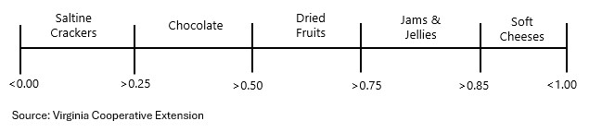
Disclaimer: If pH in conjunction with Aw is considered, the following chart applies.
Interaction table between pH and Aw for control of spores in food heat treated to destroy vegetative cells and subsequently packaged.
Aw values | pH: 4.6 or less | pH Between 4.6-5.6 | pH Greater than 5.6
Less than or equal to  0.92 | Non-TCS food | Non-TCS food | Non-TCS food
Between 0.92-0.95 | Non-TCS food | Non-TCS food | Product assessment
More than 0.95 | Non-TCS food | Product assessment | Product assessment
Source: U.S. Food & Drug Administration (FDA): Job Aid: Time and Temperature Control for Safety Foods.

TCS and Non-HBV Food Products
The following list provides the common names of foods that are classified as “timetemperature control for safety foods” (TCS foods). This is not an all-inclusive list. Please contact your local health department or Purdue University FEMI Office for any additional inquiries.
Time-temperature control for safety foods (TCS) are not permitted to be prepared by HBVs due to the inherent risks of pathogenic microorganism growth associated with water activity and pH interactions as described on page 17.
The following categories of products are not considered HBV products.
- Raw/cooked animal protein (meats & tallow)
- Prepared foods (casseroles, charcuterie boards, fruit salads, lasagna, ready-made meals, etc.)
- Dairy products (excluding commercial dairy products intended to be used only as an ingredient)
- Products using cut leafy greens as an ingredient (kimchi, salad, sauerkraut, etc.)
Foods that are not covered within the scope of the HBV Rule shall be produced by a permitted operator within a Food Establishment inspected by a local health department or the Indiana Department of Health.
It is the responsibility of each HBV to thoroughly read House Enrolled Act 1149 to ensure that that products prepared within their primary residence kitchen comply with Indiana law.

Category | Finished product  (common name) | Public health comments
Beverages | Alcoholic | Products – including solid foods – which contain 0.5% or more ABV are subject to  additional regulations
Beverages | Cold brew coffee | Cold brew coffee is subject to additional regulatory requirements.
Beverages | Fresh-pressed juice | Fresh pressed juice is subject to additional labeling and regulatory requirements
Beverages | Kombucha | Finished product alcohol contents exceed ABV limit of 0.5%.  Reference: IC 7.1-1-3-5
Cakes | Cheesecake | TCS Food Product.
Cakes | Pumpkin roll | All varieties except those using icing which have been commercially prepared or made  with a science-based academic recipe and  classified as non-TCS

Category | Finished product  (common name) |  | Public health comments
Canned/glass jar/plastic container foods | Acidified vinaigrettes or dressings (select) |  | Contact your local health department for approval
Canned/glass jar/plastic container foods | Acidified foods |  | Subject to additional regulatory requirements (Special Process)
Canned/glass jar/plastic container foods | Aluminum canned goods |  | Canning aluminum requires specialized training to render product shelf stable
Canned/glass jar/plastic container foods | BBQ sauce (home-made) |  | Contains low acid vegetables (such as peppers) and other TCS foods that require  refrigeration
Canned/glass jar/plastic container foods | Chow chow |  | Contains low acid vegetables (such as peppers) and TCS foods that require  refrigeration
Canned/glass jar/plastic container foods | Chutney |  | Contains low acid vegetables (such as peppers) and other TCS foods that require  refrigeration
Canned/glass jar/plastic container foods | Fermented foods |  | Contains low acid vegetables (such as peppers) and TCS foods that require  refrigeration
Canned/glass jar/plastic container foods | Fig preserves |  | Contains low acid fruit
Canned/glass jar/plastic container foods | Hot sauce (homemade) |  | Contains low acid vegetables (such as peppers) and TCS foods that require  refrigeration
Canned/glass jar/plastic container foods | Jams, jellies, and preserves  (low-acid or low-sugar) |  | Must not be made if prepared with no sugar, low sugar, sugar alternative recipes, or low  acid ingredients (e.g., peppers, tomatoes,  mint)
Canned/glass jar/plastic container foods | Low-acid vegetables, fruits, dressings, and  sauces |  | Must not be made if prepared with no sugar/low sugar recipes, or low acid ingredients (e.g., peppers, tomatoes, mint)
Canned/glass jar/plastic container foods | Marinades |  | Contains low acid ingredients, then acidified to render shelf stable
Canned/glass jar/plastic container foods | Pepper jelly |  | Contains low acid vegetables (such as peppers)
Canned/glass jar/plastic container foods | Pickles |  | Contains low acid foods (such as cucumbers)
Canned/glass jar/plastic container foods | Relish |  | Contains low acid foods (such as cucumbers)
CBD/ Delta 8/ Delta 9 | All varieties |  | Not an approved ingredient per Indiana and federal regulations
Category |  | Finished product (common name) | Public health comments
Extracts |  | Homemade | Homemade extracts sold and not used as an ingredient are not permitted due to Federal Standards of Identity regulations.
Fillings – pies and pastries |  | Cream | Exceeds allowed pH and Aw values.
 |  | Low acid pie filling (e.g., banana) | Must not contain low acid fruits
Freeze-dried/fermented/ dehydrated/dried |  | Meat | BOAH (Board of Animal Health) regulated product
 |  | Dairy (e.g., cheesecake varieties and ice cream) | Subject to additional regulatory requirements (Special Process)
 |  | Fruit | Products cannot be larger than the size of a small marble (e.g., blueberry), or processed  further
 |  | Vegetables | Subject to additional regulatory requirements (Special Process)
Fruits (select) |  | Bananas, cantaloupe, cucumbers, elderberries, mangoes, melons  (honeydew), mulberries, papaya, pawpaw, peppers, pickles, pumpkins, watermelon | These are low acid fruits with pH ranges above 4.6, and do not meet pH  requirements. Finished products must not contain ingredients from these identified  fruits with the exception of baked bread  (e.g., banana bread)
Fruit tarts |  | All varieties | Includes pastry cream (TCS food product)
Icings (select) |  | Homemade buttercream | If TCS food products are used as an ingredient, buttercream is not permitted to  be used
Meat |  | All varieties including tallow | Outside scope of HBV rule.
Milk |  | Raw (cow, goat, human, sheep, etc.) | Not an approved food/food ingredient and must not be added to food  Reference: IC 15-18-1-21
Mushrooms (processed) |  | All varieties | Must not be processed (cut, sliced, diced, etc.) post-harvest field cut.
Nuts and seeds |  | Boiled peanuts | Cooked plant-food requires temperature control.
Pet treats and animal feed |  | All varieties | Pet food is regulated by the Indiana Office of  State Chemist

Category | Finished product | Public heath comments
Pie (select) | Cream/custard | May exceed allowed pH and Aw values. Requires additional testing.
Pie (select) | Meringue | May exceed allowed pH and Aw values. Requires additional testing.
Pie (select) | Sweet potato/pumpkin | May exceed allowed pH and Aw values. Requires additional testing.
Pie (select) | Vegetable | Cooked plant food requires temperature control.
Repackaged food | Excludes: trail mixes and seasoning packets | Repackaging bulk pre-packaged foods is not allowed as these products were not  produced in the home kitchen. Example: protein powders (not made at your home)
Supplements | All varieties: pills, gummies, capsules, soft gels, liquids and powders and tinctures | Beyond the scope of home-based vendor regulations
Vegetables | Cooked vegetables | Cooked plant food requires temperature control.

pH Values of Common Raw Commodities and Food Ingredients
Source: Clemson University- pH Values of Common Foods and Ingredients
Commodity | Approx. pH  Value | Commodity | Approx. pH  Value
Apple, baked with sugar | 3.20-3.55 | Cauliflower | 5.6
Apple - Delicious | 3.9 | Celery | 5.70-6.00
Apple - Golden | 3.6 | Cherries | 3.80-4.54
Apple - Jonathan | 3.33 | Corn | 5.90-7.50
Apple - McIntosh | 3.34 | Cucumbers | 5.12-5.78
Apricots | 3.30-4.80 | Cucumbers, dill pickles | 3.20-3.70
Apricot Nectar | 3.78 | Cucumbers, pickled | 4.20-4.60
Apricots, pureed | 3.42-3.83 | Maple syrup | 5.15
Artichokes | 5.50-6.00 | Melon, honeydew | 6.00-6.67
Asparagus | 6.00-6.70 | Mint Jelly | 3.01
Avocados | 6.27-6.58 | Mushrooms | 6.00-6.70
Baby Corn | 5.20 | Nectarines | 3.92-4.18
Bamboo Shoots | 5.10-6.20 | Olives | 6.00-7.00
Bananas | 4.50-5.20 | Onions (red, white, and yellow) | 5.30-5.85
Beans | 5.60-6.50 | Papaya | 5.20-6.00
Beans, black | 5.78-6.02 | Peaches | 3.30-4.05
Beans, kidney | 4.40-6.00 | Pears | 3.50-4.60
Beans, lima | 6.50 | Peas | 6.48-6.80
Beans, soy | 6.00-6.60 | Peppers | 4.65-5.45
Beans, string | 5.60 | Peppers, green | 5.20-5.93
Beans, wax | 5.30-5.70 | Persimmons | 4.42-4.70
Beets | 5.30-6.60 | Pickles | 5.10-5.40
Blackberries | 3.85-4.50 | Pineapple | 3.20-4.00
Blueberries, fresh | 3.12-3.33 | Plums (red and blue) | 2.80-4.30
Blueberries, frozen | 3.11-3.22 | Pomegranate | 2.93-3.20
Broccoli | 6.30-6.85 | Potatoes | 5.40-5.90
Brussel sprouts | 6.00-6.30 | Prunes | 3.63-3.92
Commodity | Approx. pH  Value | Commodity | Approx. pH  Value
Cabbage (red and green) | 4.70 | Pumpkin | 4.99-5.50
Cactus | 4.70 | Radish (red and white) | 5.52-6.05
Cantaloupe | 6.13-6.58 | Raspberries | 3.22-3.95
Carrots | 5.88-6.40 | Rhubarb | 3.10-3.40
Eggplant | 4.5-5.3 | Sauerkraut | 3.30-3.60
Figs | 5.05-5.98 | Spinach | 5.50-6.80
Grapes (red, green, and black) | 2.80-3.82 | Strawberries | 3.00-3.90
Grapefruit | 3.00-3.75 | Sweet Potatoes | 5.30-5.60
Horseradish, ground | 5.35 | Tofu | 7.20
Jam, fruit | 3.50-4.50 | Tomatillo | 3.83
Jellies, fruit | 3.00-3.50 | Tomatoes | 4.30-4.90
Ketchup | 3.89-3.92 | Tomatoes, vine ripened | 4.42-4.65
Lemon | 2.00-2.60 | Vinegar | 3.10
Lime | 2.00-2.80 | Watermelon | 5.18-5.60
Loganberries | 2.70-3.50 | Zucchini | 5.8-6.1
Mangoes, ripe | 5.80-6.00
Mangoes, green | 3.40-4.80

Additional common ingredients used in home-based vendor products:
Commodity | Approx. pH  Value | Commodity | Approx. pH  Value
Butter | 6.1-6.4 | Corn Syrup | 5.0
Honey | 3.9 | Sugar | 5.0-6.0
Corn starch | 4.0-7.0 | Flour | 6.0-6.3

Which Home Producers Are Not Considered Home-Based Vendors?
Individual vendors who sell whole, uncut produce:
- Vendors who solely sell whole, uncut produce are not considered HBVs and exempt from certain requirements (e.g., uncut melons, whole berries, microgreens, gourds, etc.).
Individual vendors who solely sell certain poultry, rabbits, or chicken eggs:
While meat and meat products are considered TCS foods, the homebased vendor rule 16-425.3-10 and 11 exempted poultry, rabbits and eggs sales at a farmers’ market or roadside stand. All products must meet the following requirements:
- Poultry and rabbits sold on the farm where the product is produced must be kept refrigerated at the point of sale and through delivery by the producer to the end consumer
•Poultry species and rabbits sold at farmers’ markets and roadside stands must be frozen at the point of sale
- The Indiana State Board of Animal Health (BOAH) regulates the slaughter and processing of poultry and poultry products. A vendor selling poultry should contact BOAH regarding additional requirements and abide by IC 15-17-5-11.
If in-shell chicken eggs are sold off the farm, the vendor should register and follow the rules and regulations set by the Indiana State Egg Board.
All other in-shell eggs (quail, pheasant, duck, turkey, etc.) sold off the farm at a farmers’ market or roadside stand shall follow the rules set forth by IC 16-42-5.3-11.

Approved Methods and Materials for Final Product Packaging
Approved Packaging Method – The primary concern when considering final product packaging is if it has the ability to create an anaerobic (oxygen free) environment. Although this is desirable for some applications (like canning), it also allows dangerous microbes such as C. botulinum to grow and release its potentially deadly toxin into the product. Anaerobic packaging is only advised for approved jams, jellies, and other dry products (e.g., granola, trail mix).
Purdue University tested the oxygen permeability (the ability of oxygen to pass through the packaging itself) of different forms of packaging.
In general:
- Plastic containers: Most of the common plastic containers were observed to be oxygen permeable.
- Snap top containers: Plastic tops, metal containers, and metalized pouches were found to be oxygen permeable.
- Metal packaging: Needs to be tested before being allowed to ensure that it would not create an anaerobic environment, except for dry goods (e.g., herbs, granola, trail mixes, etc.).
- Glass containers: Must not be heat treated during production due to the likeness of hermetically sealing the containing which will likely create an anaerobic environment conducive to Clostridium botulinum. Jams and jellies are permitted to be stored in heattreated glass containers.

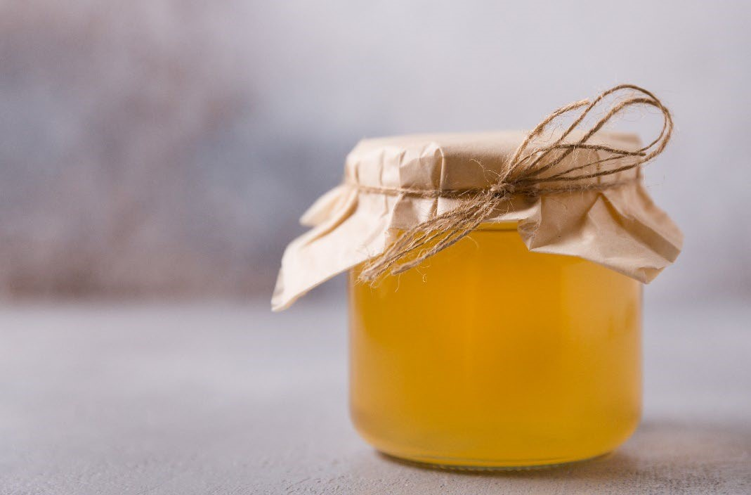

Packaging Permeability Results
Container type: | Photo: | Likelihood of creating an anaerobic environment
Snap top plastic | 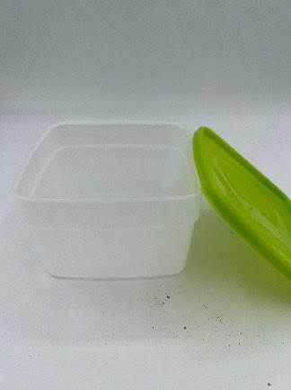 | Low
Screw top plastic | 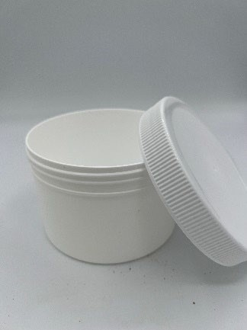 | Low
Snap top metal tin | 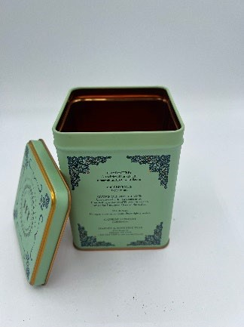 | Depends on seal type

Container type: | Photo: | Likelihood of creating an anaerobic environment
Zippered bag | 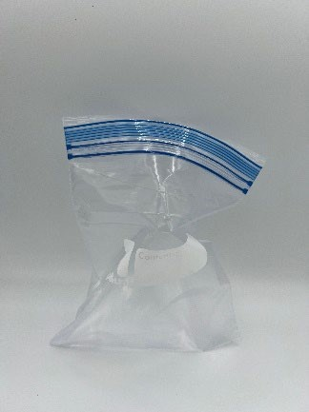 | Low
Glass jar with lid | 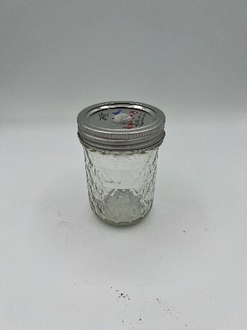 | High
Metalized, heat-sealed pouch | 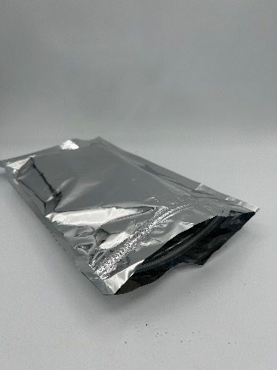 | Depends on packaging makeup.

Based on the oxygen permeability of plastic, glass and metal, we would recommend the use of the packaging materials as described above.

HBV Experiments Conducted by Purdue University Food Entrepreneurship and Manufacturing Institute (FEMI)

Pies: The chart below shows the pH and Aw testing completed by Purdue University on several pie categories. Each recipe pH and Aw will vary based on the ingredients and portion sizes. To ensure shelf-stability, HBV recipes should be individually tested to ensure the pH and Aw meet the definition of a non-TCS food.
Pie type | pH | Aw
Buttermilk | 4.81 | .8932
Peanut butter | 5.91 | .8499
Pecan | 5.89 | .8387
Pumpkin | 5.50 | .9704
Sugar cream | 5.51 | .9363

Floral jelly formula: approved recipe
Source: Food Network Recipe
3.5 cups water
0.5 dried edible lavender flowers
1 lemon, juice of
1 (1 ¾ ounce) box dry pectin or (3 ounce) envelope liquid pectin
4 cups sugar

- In a large saucepan over high heat, bring water to a boil.
- Remove from heat and stir in dried lavender flowers. Cover and let steep for 20 minutes.
- After 20 minutes, strain mixture through a fine mesh strainer in a deep pot, discarding the lavender flowers.
- Stir in lemon juice and pectin; continue stirring until the pectin is thoroughly dissolved. 5) Over high heat, bring the mixture to a hard rolling boil.
- Add sugar. When the jelly solution returns to a hard rolling boil, let it boil for two to four minutes, stirring occasionally.
  - Soft gel – 2 minutes
  - Medium gel – 4 minutes
- After boiling, transfer the jelly into hot, sterilized, half-pint jars. Fill them to within 1/ 4 inch of the top, wipe any spilled jam off the top, seat the lid and tighten the ring around them.
- Process in a water bath for 10 minutes. Remove jars to wire rack and let cool before serving.

Conclusion: In this recipe test, the pH of the pectin was enough to drop the jelly pH below 4.6, and the heating temperature of the flower petals was long enough to kill any bacteria that may have been found on the surface of the “produce.” Therefore, this eliminates the food safety risk from the addition of “cut produce,” or in this case flower petals that may be used fresh from the garden. This means that this specific floral jelly, and likely others as well, would be safe for HBVs to sell.
Apples:
Source: Clemson University Extension
Apple variety | pH | Apple variety | pH
Cosmic | 3.60 | Granny Smith | 3.45
Envy | 3.60 | Honeycrisp | 3.72
Fuji | 3.87 | Macintosh | 3.40
Gala | 3.30 | Pink lady | 3.55
Golden delicious | 3.71
Fruit butter/varieties:
Gala apple butter: Purdue University FEMI
 | Water activity | pH | Water activity after blending | pH after blending
Tested same day as finished | 0.7316 | 3.82 | 0.7493 | 3.76
Envy apple butter: Purdue University FEMI
 | Water activity | pH | Water activity after blending | pH after blending
Tested same day as finished | 0.7067 | 3.98 | 0.7076 | 3.85

Conclusion: While there is some variation in apple pH, all produced apple butters and apples tested fell well below the pH threshold of 4.6. However, it is recommended to test apple butters initially, and to retest after any process changes or apple variety alterations.

Pear butter: Purdue University FEMI
Materials:
4 lbs. pears Saucepan
1/3 cup apple cider ½ pt. jar and lids for canning
- T. lemon juice 2 tsp. salt
2.5 cups brown sugar Process:
  - Wash pears under cold running water and drain. Cut in half lengthwise, core and peel.
Coarsely chop. Place chopped pears, apple cider and lemon juice in a 4-6 qt. crock pot. Set to high and simmer until pears have softened, about 40 minutes. Turn off heat.
  - Process pear mixture using an immersion blender until puree is smooth.
  - Combine pear mixture with brown sugar and salt. Turn heat to high and place lid on a diagonal over the crock-pot allowing steam to escape at both ends. Simmer on high, stirring every 30 minutes or so until puree thickens, darkens in color and holds its shape on a spoon for about 3-4 hours.
  - Prepare boiling water canner. Heat jars in simmering water until ready to use, do not boil.
  - Ladle hot pear butter into a hot jar and leave 1/4” headspace. Remove air bubbles. Wipe jar rim. Center lid on jar and apply band, adjust to fingertip tight. Place jar in boiling water canner. Repeat until all jars are filled.
1. Water must cover jars by 1”. Adjust heat to medium-high, cover canner, and bring water to a rolling boil. Process ½ pt. jars 15 minutes. Turn off heat and remove cover. Let jars cool for 5 minutes. Remove jars from canner. Cool 12-24 hours. Data:
 |  | pH | Aw |  | Brix
Pre-canning | 3.9 |  | 0.9516 | 36.4
Post-canning | 3.93 |  | 0.9486 | 37.6
Less sugar, pre-canning | 3.42 |  | 0.9427 | 35.9
Less sugar, postcanning | 3.64 |  | 0.9391 | 35.4

Conclusion: In this receipt test, it was found that the pH would stay below the required pH of 4.6. This pH is low enough to inhibit microbial growth and keep the pear butter safe. However, it was found that fruit variability is a major factor in all food safety indicators: pH, water activity, and brix. The general recommendation is that each season’s canning be tested for water activity and pH if making a non-apple fruit butter before selling.

Freeze dry data:
Results: This data was compiled from testing done in triplicate of freeze-dried products. The number in each column is the average of the physical triplicate data taken, and the right-hand column, labeled Change in Aw, shows the change in water activity over that time. Red indicates a rise in water activity. All the increase in water activity is within expected ranges.
Product | Day 0 – Aw | Month 3 – Aw | Change in Aw
Skittles | 0.2805 | 0.3106 | 0.0301
Fruit Roll-ups | 0.2848 | 0.2985 | 0.0137
As seen above, a three-month shelf life for freeze-dried candies is very reasonable.

Fruit curd data:
Purpose: Fruit curds were evaluated to test the safety of curds when being used in baked goods and pastries. The goal was to verify that fruit curds have a low pH below the threshold of 4.6.
Results: This receipt test showed that lemon and unripe mango curds had a pH under 4.6. All curds tested had a water activity that was higher than 0.85.
Curd type | Temperature | pH | Water activity
Lemon | Cooked | 2.69 | 0.8982
Mango (unripe, with added lemon juice) | Cooked | 4.17 | .9599
Mango (ripe, no lemon juice) | Cooked | 5.61 | 0.9627

Conclusion: Lemon curd falls well under the pH threshold and is permitted as a HBV food. Other fruit curds may need acid to fall under the pH of 4.6, similar to jams and jellies cited in the Ball canning book.

Zucchini bread:
Recipe used for testing: Approved recipe
2 cups all-purpose flour
1.5 cups granulated sugar
2 tsp. baking soda
1 T. cinnamon
1 tsp. salt
3 large eggs
2 cups grated zucchini
¾ cup vegetable oil
- T. vanilla extract
1.5 cups chopped nuts

- Preheat the oven to 350 F. Grease two 8x4 inch loaf pans or line with parchment paper.
- In a medium bowl, combine flour, sugar, baking soda, cinnamon and salt with a whisk.
- In a large bowl, beat the eggs. Add the zucchini, oil and vanilla. Mix to combine.
- Add the dry ingredients and nuts to the zucchini mixture. Gently stir to combine. 5) Divide the batter evenly between the pans and bake for 50-60 minutes or until a toothpick comes out clean.
6) Cool in the pans for 5 minutes, remove the pan, and cool on a wire rack.

Conclusion: The study showed that the loaves that were properly baked to a tested doneness surpassed the lethality kill step for any microbes of concern. All testing was done with shredded zucchini and all “cut produce” must go through the entire baking kill step and is not allowed to be added later in the process.

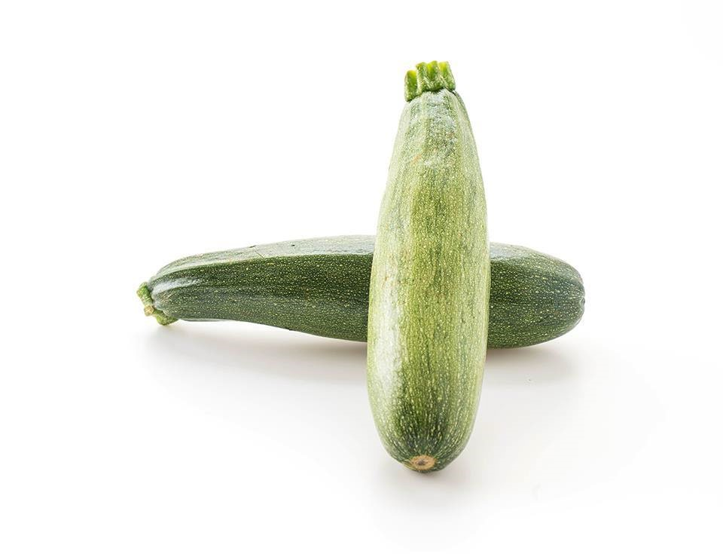

Cheese bread:
Recipe used for testing: Approved recipe
2 cups all-purpose flour
4 tsp. baking powder
½ tsp. salt
1/8 tsp. cayenne pepper
¼ cup cold butter
- cup shredded sharp cheddar cheese
- T. shredded Parmesan cheese
- green onion finely chopped
- eggs
1 cup milk
3 T. granulated sugar

- Preheat oven to 350°F. Grease an 8" x 4" loaf pan.
- Whisk dry ingredients in a medium bowl.
- Using a pastry cutter or a fork, cut in butter. Stir in cheese and green onion.
- In a separate bowl, whisk eggs until foamy. Add milk and sugar.
- Add wet ingredients to the dry mixture and stir just until moistened, do not overmix.
- Pour into prepared pan and bake 50 minutes or until a toothpick comes out clean.

Conclusion: Cheese bread is allowed as long as the cheese is baked into the bread and the cheese is uniformly shredded, not cubed or curds. Additionally, cheese should be used at a rate of less than 10% of the formula by weight.

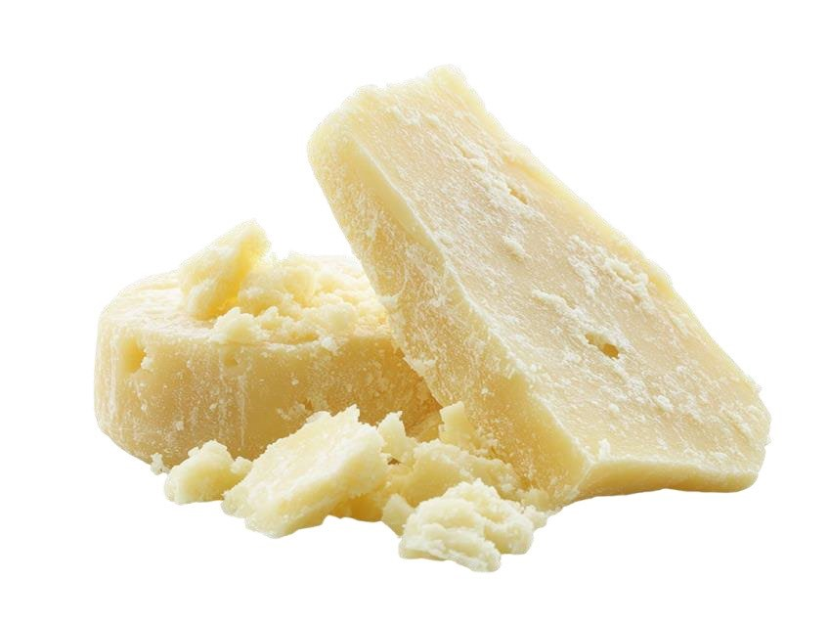

Product Decision Trees
The following product decision trees were created by Purdue University to identify the potential outcomes and safety of select HBV products.
Cream Pies
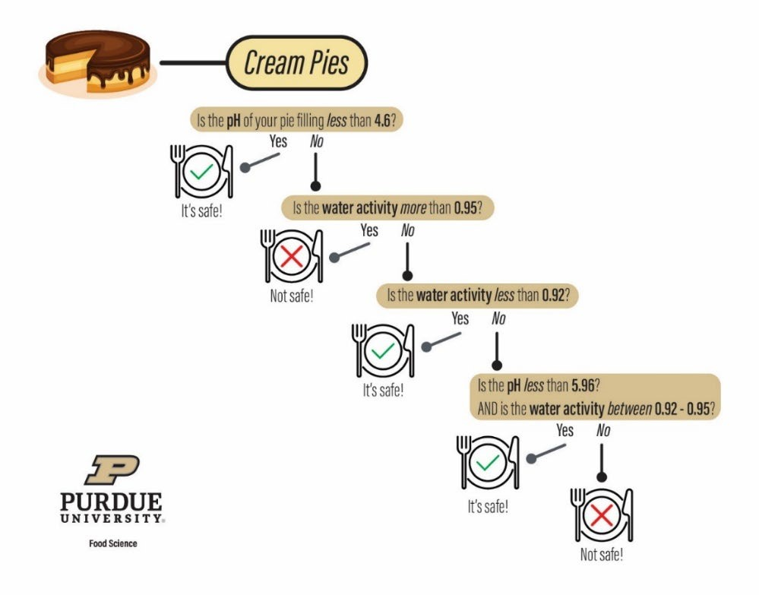
Cheese Bread
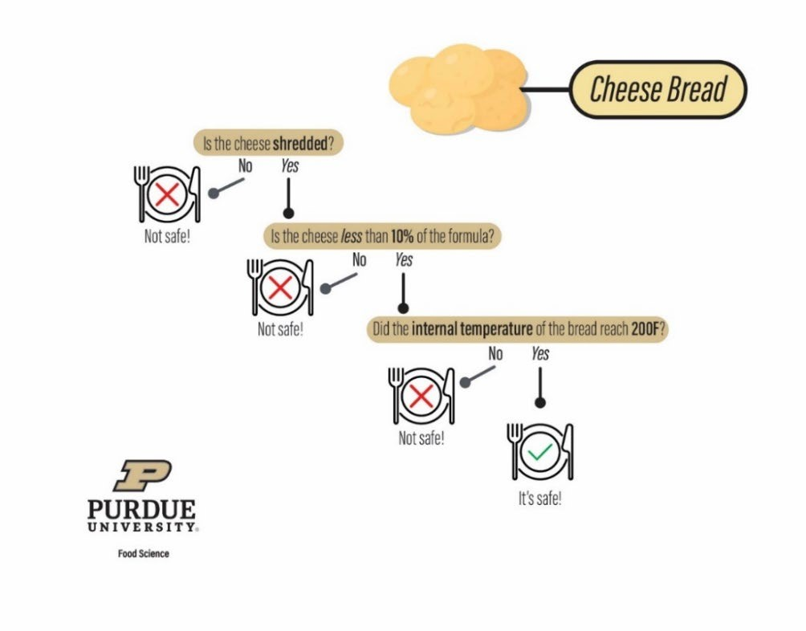
Frosting
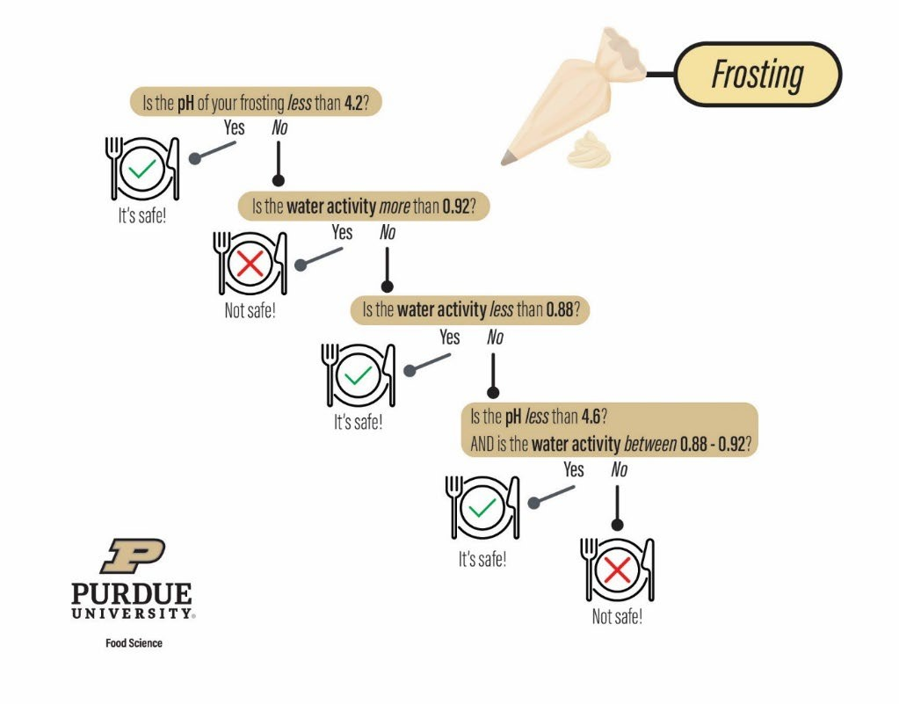

Frequently Asked Questions
Getting Your Home-Based Vendor Business Started:

What is the difference between a home-based vendor and a retail food establishment? A home-based vendor is an individual who prepares and packages non-TCS food products out of the kitchen of their primary home.
A retail food establishment is a licensed and inspected facility with an unlimited scope of product produced and sold directly to the end consumer with the approval of a regulatory authority.

Will I need to meet local zoning or other municipal laws?
It depends; the best practice is to contact your local municipality to verify zoning ordinances and regulations that may limit the operation of home-based businesses. HBV regulations only exempt operators from food related licensing and inspections by local health departments.

Are there any special requirements regarding my private water well?
Since safe water is a foundation of food safety, it is highly recommended to have it tested annually for coliforms, which could indicate if your well water has been contaminated. HBVs that sell ready-to-eat fruits and vegetables may be subject to the Indiana Produce Safety Rule. Please contact the Indiana Produce Safety Program for more information.

What types of home-based vendor products can I produce in my home?
All non-TCS baked goods/snack items. Examples include jams, jellies, spreads, egg noodles, candies, roasted coffee grounds, trail mixes, value added foods such as maple syrup and honey, spice blends, and dried teas.

Can I make and sell sweet breads, muffins, and other baked goods that incorporate fresh fruits and vegetables such as blueberries, zucchini, carrots, and pumpkin?
Yes, if low acid fruits and uniformly shredded vegetables are homogenously incorporated into the product prior to baking and the finished product tests are in line with the above guidelines. Fruits and vegetables must not be used as a garnish on top of the finished product.

Can I use home-grown products in baked goods?
Yes, produce from a HBV’s garden is approved for incorporating into baked goods. All produce should be thoroughly washed prior to use and may not be used as a garnish on top of the final product.

Can I use my own home-canned vegetables in home-based vendor products as an ingredient?
No. Home-canned vegetables are generally low acid products that require pressure canning and are not considered an approved food source. Due to the risk of Clostridium botulinum, these items may not be sold or added into an HBV final product.

What kind of milk can I use in my baked goods?
Pasteurized milk sources are the only approved liquid dairy source for baked products.

Can I make or use buttercream frosting for my baked goods as a home-based vendor? Depends. Buttercream frostings are not allowed unless you purchase commercially prepared, shelf-stable (not labeled "keep refrigerated" or "refrigerate after opening") products or utilize lab-tested recipes (listed in resources below) if they are followed exactly with no changes to ingredient portion sizes, additions, or substitutions.
Can I sell wild or cultivated mushrooms?
Cultivated mushrooms are considered whole produce. As an agricultural commodity, no license or permit is required if intact mushrooms are offered for sale and not further processed past a single harvest (field) cut. However, wild mushrooms must be verified by a certified mushroom identification expert to prevent wild mushroom poisoning.

Are honey and syrups covered under the Home-based vendor regulations?
Yes, if all HBV regulations are followed, including labeling.
Sample label:
Just Maple in Indiana
John Deer-Doe
123 Maple Sugar Shack Lane Maple Syrup, Indiana 12345 Ingredients: Maple Syrup
12.5 FL OZ (370mL)
“This product is home produced and processed. The production area has not been inspected by the State Department of Health.
NOT FOR RESALE.”

Can I roast coffee beans and sell them under the home-based vendor regulations? Yes. Roasted packaged coffee beans are approved HBV products. Products may not be unpackaged and brewed for hot/cold coffee sales on-site.

Can I make peanut butter and other nut butter as a home-based vendor?
Yes. Nut butters made from ground peanut or tree nuts are approved HBV foods.

Can I prepare home-based vendor products in a shared kitchen or outbuilding on my property (such as a shed or barn)?
HBVs are required to use their primary residence. A shared kitchen may not be used because they are regulated establishments not located on the primary residence.

May I hire employees or have other family members sell my home-based vendor products at other events or farmers markets?
All home-based food must be sold in person by the producer, and they must have a Certified Food Handler Certificate. The producer is permitted to sell their products in person, by telephone, or by mail/online to the direct end consumer. Products cannot be sold on their behalf.

Are pet treats included under the home-based vendor regulations?
The HBV rule is limited to human foods. All pet treats/food intended for animal consumption are regulated by the Indiana Office of State Chemist.

Why can’t I make pepper jelly?
Peppers have a pH between 4.8-6.0. They are considered low-acid foods that yield a pH value above the allowed limit. Additionally, the amount of sugar and pectin is not enough to assure that the product is safe to prevent the growth of Clostridium botulinum.

Can I produce pickled or acidified foods?
No. Pickled and acidified foods pose botulism risks if the pH and other critical control points are not controlled during processing. In retail, acidification is considered a special process and is subject to additional regulatory requirements.

Can I sell fermented food?
No. Fermented foods consist of foods that require refrigeration upon processing or are subject to further regulatory requirements.

Is it necessary to include allergen labeling on my HBV product?
While allergen labeling is not required, it is highly encouraged. The nine food allergens recognized in the U.S. are milk, eggs, wheat, soy, tree nuts, sesame, peanuts, fish, and shellfish.

May I sell freezer corn?
No. Freezer corn is considered a cooked plant food which requires temperature control after blanching. Exception: unblanched freezer corn.

Can I make or use supplements in my home-based vendor products? No. Dietary supplements are beyond the scope of the HBV rule.

Can I sell homemade vanilla extract?
No. Homemade vanilla extract production is beyond the scope of the HBV rule due to its alcohol content.

Can I make barbecue or hot sauce from scratch?
No. Only commercially prepared, shelf-stable sauces can be mixed to make barbecue/hot sauces.

Can I serve free samples of my home-based food products?
It depends on the sanitation requirements from the local health department. Please reach out to the local health department in which you wish to provide samples for further information.

The farmers market where I want to sell my products says I need a food license even though I am a home-based vendor. Can the market require a license?
No. HBVs do not require food permitting by law; however, the farmers market manager may request a copy of the food handler’s certificate and support documentation (e.g., liability insurance).

Do I have to use my home address on my product labels? Can I use a PO Box?
Under HBV law IC 16-42-5.3-5(a)(1) the HBV is required to put their name and primary residence address on the product. PO Box addresses do not meet the requirement.

I don’t have room on my labels for all the ingredients. Can I use a table placard? All HBV products should be identified and meet labeling requirements as described in IC 16-42-
5.3-5. Each packaged item shall include a label.

Food sales:

Can I donate my HBV products to a public auction or other giveaway venue (e.g., silent auction baskets, fundraisers, food banks)?

Products may be donated to private events for auction purposes. Food banks are considered retail food establishments and cannot accept donated food products from HBVs.

Can I sell my Indiana HBV product in another state?
A HBV may not ship or deliver a food product to an end consumer who is located outside of Indiana.

Can producers from other states sell their “cottage” products in Indiana under the homebased vendor regulations?
Some states permit “cottage” food products to be sold across the state line. Refer to the individual state regulations to determine approval status.

Can I sell my products at local town festivals, fairs, or at the state fairgrounds?
HBVs are allowed to sell products to the end consumer; however, event organizers may prohibit the sale of HBV goods at their event. Final approval depends on the event policy and is beyond the scope of the HBV rule.

I own/operate a small antique business. Can I sell my home-based vendor goods from my shop under home-based vendor regulations?
Yes, if the HBV is physically present at the time of sale to the end consumer. The products may not be left for sale at a business while the vendor is not present.

Why can’t I sell my home-based vendor foods to local retail food establishments?
Home-based vendor regulations require HBV products to be sold directly to the end consumer.

What oversight do regulatory authorities have over home-based vendor operations? The Indiana Department of Health and local health department regulators are authorized to review HBV products displayed for human consumption to ensure compliance with the law.

Will home-based vendor kitchens be inspected by the local health department or Indiana Department of Health?
It depends; if you follow all HBV regulations, your kitchen will not be subject to regular inspections. However, if a complaint is received about non-compliance or food safety issues, your kitchen may be inspected.
What should I do if my customer said that they got sick from my products?
In the event of a foodborne illness report, you should reach out to your local health department for product testing and illnesses investigation.

Do I need to keep records of all sales or just products that are shipped?
Records for the product shipped/mailed to the end consumer should be maintained for at least one calendar year after the date of sale. These records can be in electronic or paper form.

Product testing:
I need to have my product tested for pH and/or Aw to prove it is a TCS food. Where do I go for that test?
Third party testing laboratories can conduct food testing for you. Additionally, the Purdue University Food Entrepreneur and Manufacturing Institute can test any food product’s pH and water activity upon request. You can find more information and request these tests online by visiting the FEMI website or contacting Purdue Food Science.

How often do I need to have my product tested?
HBVs only need to have their product tested one time, and retest when changes are made to the formulation. Testing is done in triplicate from three different batches to capture natural variation in the process.



Home-Based Vendor Best Practices
The following best practices will help ensure a high-level of food safety oversight in your kitchen, during preparation, sanitation, transportation, and during event set-up.
Home sanitation
- Ensure the water supply comes from a safe source
- Ensure handwashing sinks are easily accessible and supplied with hot and cold running water
- Maintain pets in an area outside of the kitchen during food preparation o Store all foods used for HBV products in a clean, dry location
- Maintain storage and processing areas free of pest activity. Pests can harbor diseases that may contaminate food and equipment.
- Store all chemicals away from food, and packaging materials. Improper contact with chemicals may cause contamination due to toxic interactions with food/equipment.
- Domestic activities such as family meals, and household chores should not be conducted in the same space, at the same time as HBV food preparation.
Hand hygiene o Ensure handwashing occurs before and after changing a task (example: cleaning the kitchen, using the restroom, changing gloves, etc.), or any time hand contamination may have occurred
- Avoid barehand contact with ready-to-eat foods (example: cookies and bread) o Use disposable gloves to avoid product contamination (disposable gloves should be discarded after each use)
Personal hygiene o Wash your hands for a minimum of 20 seconds using soap and hot water. Hand sanitizer is not a substitute for proper handwashing.
- Designate a kitchen hand towel for drying your hands to avoid cross-contamination o Ensure all cuts or other open wounds are covered while preparing and packaging food o Avoid smoking or vaping in the kitchen area during food preparation and packaging o Use a new tasting utensil for each product taste test to prevent product contamination

Equipment sanitation o Ensure cooking equipment is maintained in good, clean condition o Ensure dishes are properly washed prior to use

Refrigeration o For ingredients that require refrigeration prior to preparation (example: milk and eggs), ensure the refrigerator is maintained at least 41 degrees F or lower.
- Maintain refrigerator in clean, and well-organized conditions separating HBV ingredients and personal use items

Transportation and set-up of home-based vendor goods o During transport, maintain the vehicle in clean, sanitary conditions. Dirt, pet hair, insects, and other contaminants must be minimized to protect food items from physical contamination. o During set-up and display, maintain product at least 6 inches off the ground

Current Home-Based Vendor Regulations
Chapter 5.3. Home Based Food Products

Sec. 1. (a) As used in this chapter, "end consumer" means a person who is the last person to purchase any food product and who does not resell the food product.

(b) As used in this chapter, "roadside stand" means a structure, including a tent, stand, vehicle, or trailer that is: (1) visible from a road; and (2) located not more than one hundred (100) feet from the edge of the side of the road; where whole uncut produce, food products that are not potentially hazardous, poultry that is exempt under IC 15-17-5-11, rabbits, or eggs permitted for sale by the state egg board are sold to an end consumer.

Sec. 2. A person may prepare and sell food products as a home-based vendor if the person complies with the requirements of this chapter.

Sec. 3. The production and sale of food products by a home-based vendor in accordance with this chapter are exempt from the requirements of this title that apply to food establishments.

Sec. 4. A home-based vendor shall prepare and sell only a food product that is:
(1) made, grown, or raised by an individual at the individual's primary residence, including any permanent structure that is on the same property as the residence; (2) not a Time/Temperature Control for Safety Food (TCS) product;
(3) prepared using proper sanitary procedures, including:
- proper hand washing;
- sanitizing the container or other packaging in which the food product is contained; (C) storing the food product safely;
- producing the food product in a food preparation or packaging area in which animals are not present; and
- cleaning and sanitizing of surfaces that have contact with the food product;
- not resold;
- sold in person, by telephone, or through the Internet; and
- delivered to the end consumer in person, by mail, or by a third-party carrier.

Sec. 5. (a) A home-based vendor shall include a label for packaged food or a sign for unpackaged food that contains the following information:
  - The name and address of the producer of the food product.
  - The common or usual name of the food product.
  - The ingredients of the food product, in descending order by predominance by weight.
  - The net weight or volume of the food product by standard measure or numerical count.
  - The date on which the food product was processed.
  - The following statement in at least 10-point type:
"This product is home produced and processed, and the production area has not been inspected by the state department of health. NOT FOR RESALE.".
(b) A home-based vendor shall post the label of each food product on the vendor's Internet web site.

Sec. 6. (a) A home-based vendor may not ship or deliver a food product to an end consumer who is located outside Indiana.
(b) A home-based vendor shall do the following:
- Ship or deliver a food product in a sealed package that allows an end consumer to determine whether the product has been tampered with.
- Maintain a record of the shipping or delivery address of each end consumer the vendor sells a food product to for at least one (1) year after the date of the sale.
- Upon request, provide a record described in subdivision (2) to the state department.

Sec. 7. (a) A home-based vendor shall obtain a food handler certificate from a certificate issuer that is accredited by the American National Standards Institute.
- Upon request, a home-based vendor shall provide a copy of the food handler certificate required by subsection (a) to the state department or an end consumer.
- A home-based vendor shall provide a copy of the food handler certificate required by subsection (a) to the local health department int he county where the home-based vendor's residence is located.

Sec. 8. (a) A home-based vendor is subject to food sampling and inspection if:
(1) the state department determines that the home-based vendor's food product is: (A) misbranded under IC 16-42-2-3; or
(B) adulterated; or
(2) a consumer complaint has been received by the state department.
- If the state department has reason to believe that an imminent health hazard exists with respect to a home-based vendor's food product, the state department may order cessation of production and sale of the food product until the state department determines that the hazardous situation has been addressed.
- For purposes of this chapter, the state health commissioner or the commissioner's authorized representatives may take samples for analysis and conduct examinations and investigations through any officers or employees under the state health commissioner's supervision. Those officers and employees may enter, at reasonable times, the facilities of a home-based vendor and inspect any food products in those places and all pertinent equipment, materials, containers, and labeling.

Sec. 9. The state health commissioner may develop guidelines for the requirements described in this chapter, including:
- standards for best safe food handling practices;
- disease control measures; and (3) standards for potable water sources.

Sec. 10. (a)This section applies to the sale of poultry and rabbits by an individual vendor of a farmers' market or roadside stand.
(b) The following products are exempt from the requirements of this title that apply to food establishments:
- Poultry products produced under IC 15-17-5-11. Poultry products sold at a farmers' market or roadside stand must be frozen at the point of sale. Poultry products sold on the farm where the product is produced must be kept refrigerated at the point of sale and through delivery by the producer to the end consumer.
- Rabbits that are slaughtered and processed on a farm for the purpose of conducting limited sales on the farm, at a farmers' market, and at a roadside stand. Rabbit meat sold at a farmers' market or roadside stand must be frozen at the point of sale. Rabbit meat sold on the farm where the product is produced must be kept refrigerated at the point of sale and through delivery by the producer to the end consumer. An individual who sells rabbits under this subsection shall comply with the label requirements set forth in this chapter.
(c) This section does not apply to the distribution of meat from a game animal.

Sec. 11. (a) IC 16-42-11 applies to the sale of eggs under this chapter.
(b) An individual vendor of a farmers' market or roadside stand is exempt from the requirements of this title that apply to a food establishment relating to the sale of eggs, whole uncut produce, or food products that are not potentially hazardous.

Sec. 12. Notwithstanding any other law, a local unit of government (as defined in IC 14-22-31.51) may not by ordinance or resolution require any licensure, certification, or inspection of foods or food products of a home-based vendor or an individual vendor who prepares and sells food products under this chapter.

Sec. 13. (a) For the purpose of enforcing this chapter, the local health officers are food environmental health specialists subordinate to the state department.
(b) To ensure that enforcement of the state laws and rules is uniform throughout the state, the state department shall provide to the local health officers who are food environmental health specialists guidelines concerning the interpretation and of the state department's rules concerning home based vendors. A food environmental health specialist may not enforce the state department's rules concerning home based vendors in a manner that is more strict than the state department's guidelines.

Science-Based (Academic) Resources Available
Academic science-based resources and recipes are those that have undergone appropriate testing and/or research to ensure the product is safe when prepared exactly as written.

Purdue University – Food Entrepreneurship and Manufacturing Institute https://ag.purdue.edu/department/foodsci/femi/

Kansas State University Extension - Non-TCS Buttercream Icing Recipe https://bookstore.ksre.ksu.edu/pubs/food-safety-of-frostings-and-fillings_MF3544.pdf

Iowa State University Extension: Safe Frostings for Iowa 4-H Fairs https://blogs.extension.iastate.edu/answerline/tag/buttercream-frosting/

Contact Us
Indiana Department of Health
2 N Meridian Street, Indianapolis, IN 46204
317-233-1974 https://www.in.gov/health/food-protection/
▫ For foods sold directly to the end consumer please email the Retail Division at retailfoodprogram@health.in.gov
▫ For foods sold directly to a facility for further distribution please email the Wholesale Division at manufacturedfoods@health.in.gov

Indiana Board of Animal Health – Dairy, Meat and Poultry Division
Indiana State Fairgrounds – Discovery Hall Suite 100
1202 East 38th Street, Indianapolis, IN 46205
317-544-2400
https://www.in.gov/boah/

Indiana State Egg Board
Purdue University – Creighton Hall of Animal Science
270 S. Russell Street, West Lafayette, IN 47907
765-494-8510 www.ag.purdue.edu/department/ansc/iseb/

Office of Indiana State Chemist – Commercial Feed Division (Pet Food) Purdue University
175 S. University St, West Lafayette, IN 47907
765-494-1492 www.oisc.purdue.edu

Purdue University – Food Entrepreneurship and Manufacturing Institute
745 Agricultural Mall Dr., West Lafayette, IN 47907
765-494-2766
www.ag.purdue.edu/department/foodsci/femi/

