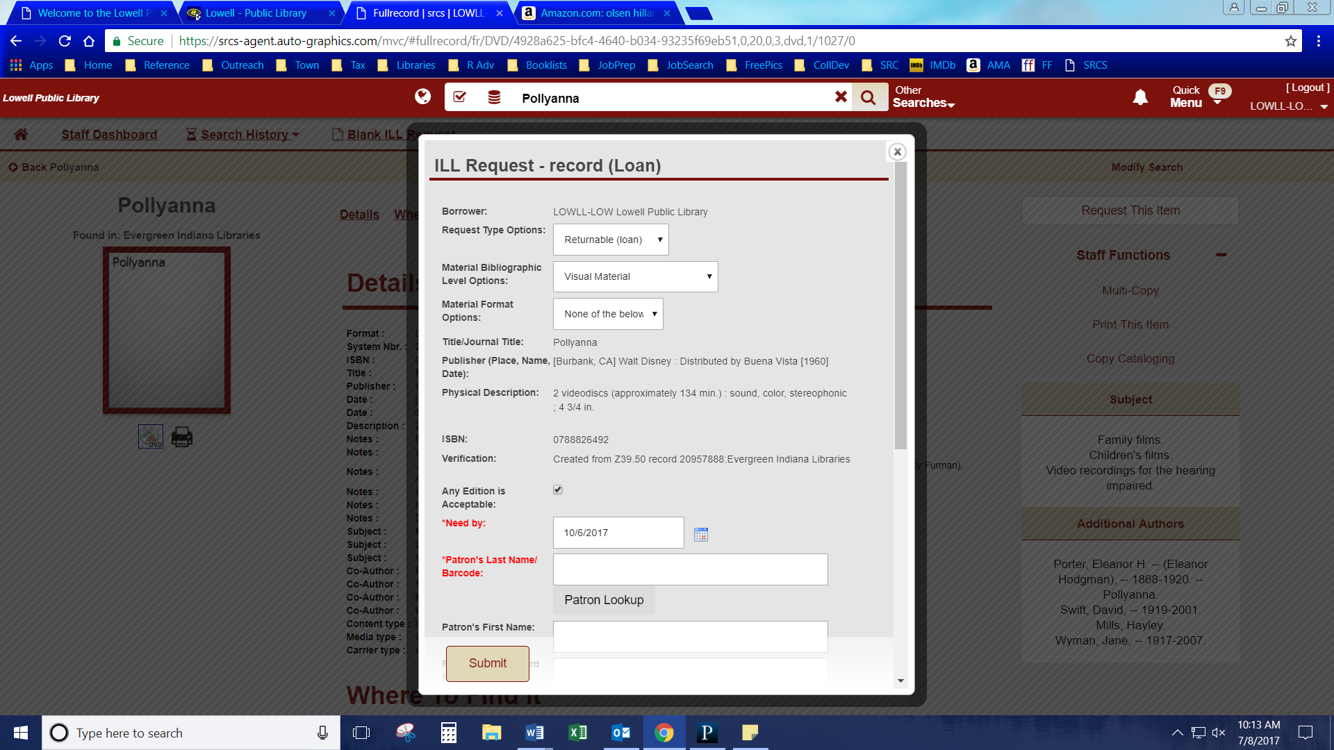

Type in either & hit Patron Lookup.

Choose the correct patron.

It will AUTO-FILL all the Patron information fields

AUTO-FILLED

**IF LEFT CHECKED** a newer/older copy may be sent. The format should still be the same.

AUTO-FILLED

INFORMATION

Verify the default for these options are correct.

**DVD EXAMPLE**

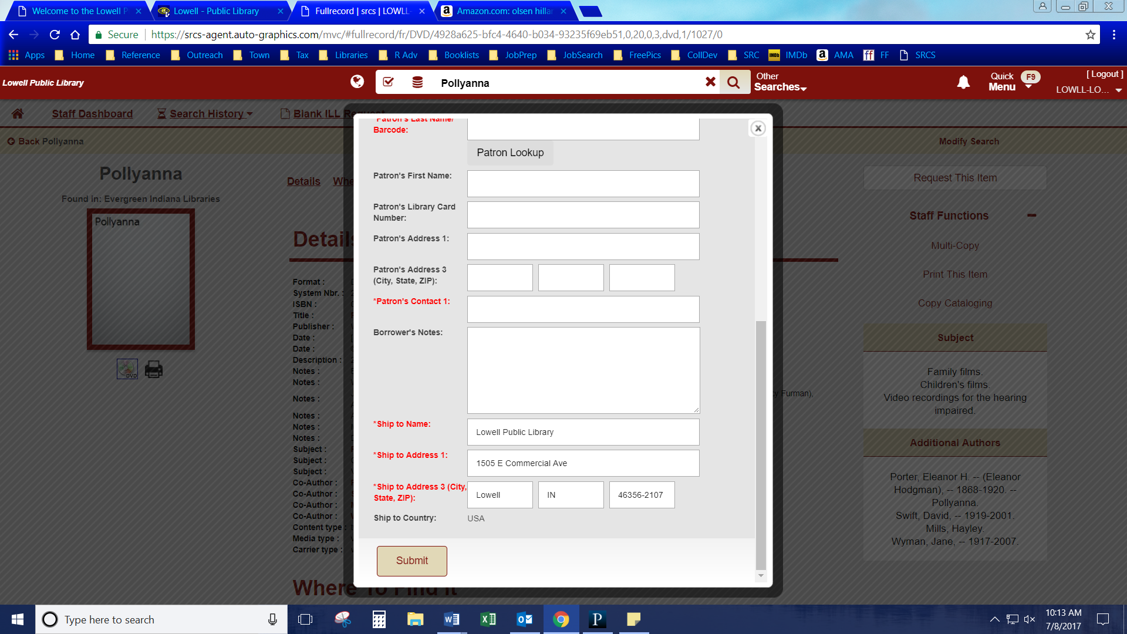

**REVIEW EVERYTHING**

Then hit Submit, Print out form & Highlight title

AUTO-FILLED

INFORMATION

**TYPE IN**

DVD, Season #,

Please check for scratches

& any other special notes

AUTO-FILLED after finding through Patron Lookup.

Can be manually entered if patron not found.

Verify or add in phone number