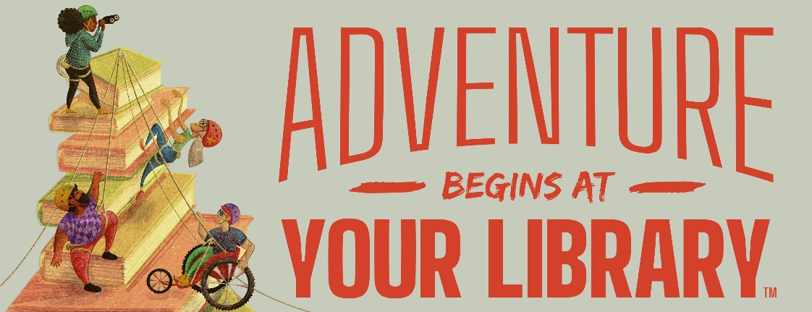

Summer Reading Program Application
(TBBL patrons of all ages are eligible)

Name ___________________________________________________

Address _________________________________________________________________

City ____________________________ State ______ Zip Code _____________________

Phone Number ( )___________________________

Email (if you have one) ____________________________________________

Name of Parent or Guardian (if patron is under 18) ______________________________

Daytime Phone Number ( )_____________________________

Materials in braille? _____Y _____N

List titles and types of books you would like us to send you:

Free Matter for the Blind

Please return to:
Talking Book and Braille Library
140 North Senate Ave
Indianapolis, IN
46204

To return the application, fold the letter in half, tape it shut, and put it in the mail.

