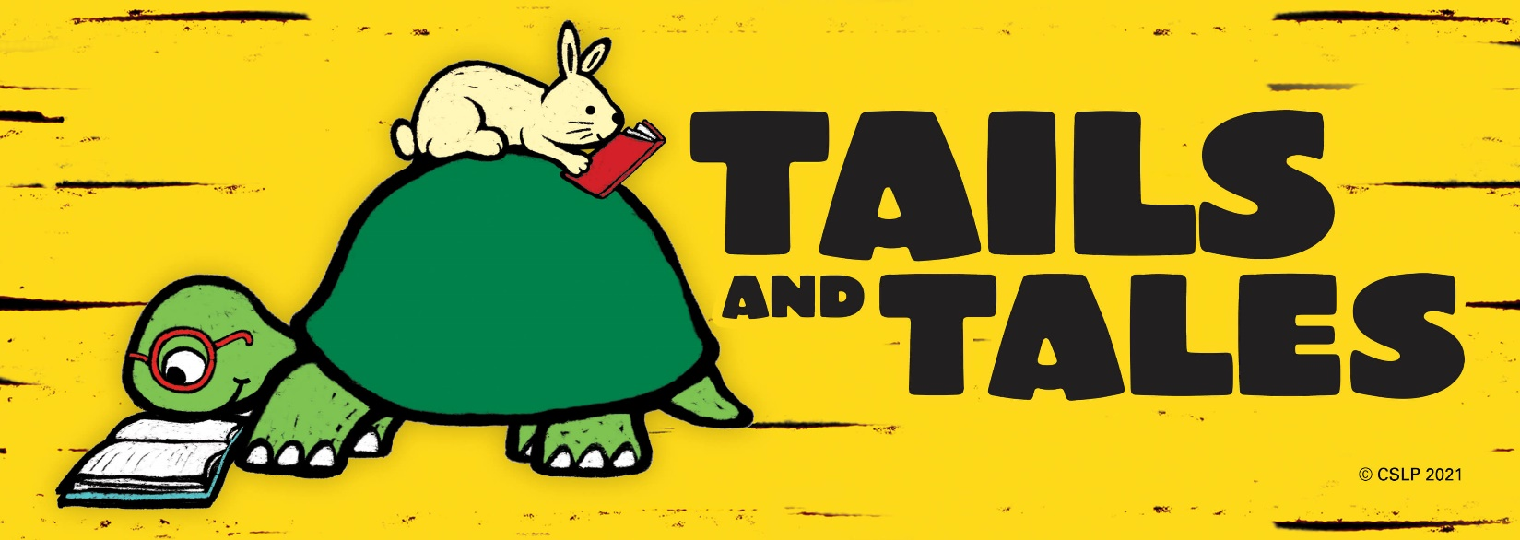

Summer Reading Program Application
Indiana State Library - Talking Book and Braille Library
(TBBL patrons ages 4-18 are eligible to join)
Name ___________________________________________________
Address _________________________________________________________________
City ____________________________ State ______ Zip Code _____________________
Phone Number ( )___________________________
Email ____________________________________________
Date of birth__________ Grade level ______ Reading Level _______
T-Shirt Size: Youth Small__ Youth Medium__ Youth Large__ Adult Small__ Adult Medium__ Adult Large__Adult XL__Adult XXL__
Name of Parent or Guardian ______________________________
Daytime Phone Number ( )_____________________________
Email of Parent or Guardian____________________________________________
Materials in braille? __Y __N
Check the reading media you would like to use this summer:
Digital ______ Braille ______ Large Print ______ BARD______
Do you have a machine borrowed from our library?
Yes ____ No____ Using BARD Mobile Only ____

List titles and types of books you would like us to send you:
________________________________________________________________________
________________________________________________________________________

