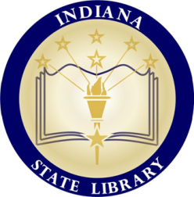 | 2018 PUBLIC LIBRARY  ANNUAL REPORT  AND  BOOKKEEPING  WORKSHOP | Presented by the Indiana State Library  and  State Board of Accounts
Dates: November 20, 2018 and November 29, 2018 (repeat)
Time: 10:00AM ET to 3:00PM ET
Location: Indiana State Library Room 401 –or– Webinar

10:00AM to 12:00PM ET |  | 2018 ISL Annual Report for  Public Libraries  Angela Fox  Library Development Office
12:00PM to 1:00PM ET |  | Lunch on your own
1:00PM-2:45PM ET |  | Todd Caldwell  Susan Gordon  Linda Baker  Online AFR Report  State Board of Accounts
2:45-3:00PM ET |  | State Library News  Jen Clifton  Library Development Office
Up to 4 LEUs available. All times are Indianapolis (Eastern) time.
Visit the LDO Workshops page for workshop materials: https://www.in.gov/library/ldoworkshops.htm

