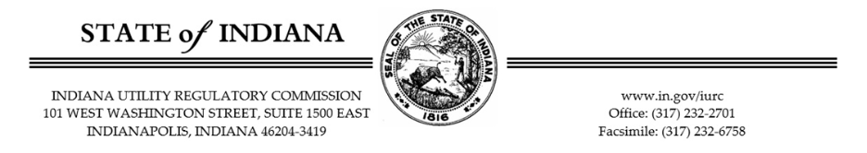

IURC Request to Indiana Electric Utilities
regarding Advanced Transmission Technologies

As you may be aware, Senate Enrolled Act (SEA) 422 from the 2025 legislative session requires the Indiana Utility Regulatory Commission (“Commission” or “IURC”) to conduct a study on advanced transmission technologies (“ATTs”). The Commission is requesting your input, comments, ideas, research, and any relevant information you would like to provide regarding ATTs, including responses to the questions below developed by Electric Power Engineer, LLC (“EPE”) who will be drafting the study report.

Please provide your responses no later than June 3, 2026. Thank you!

Transmission Planning SME
- What are the key challenges the utility faces in its transmission system, such as transfer limits, transmission constraints, load center areas, etc.?

- How does the utility coordinate transmission system upgrades with neighboring utilities in case of affected system?

- How does the utility coordinate transmission system upgrades that are derived from diverse assessments, (e.g., reliability-driven projects based on transmission reliability assessments) and policy-driven projects informed by economic or generation deliverability evaluations?

- When multiple facilities are overloaded, does the utility assess whether the facilities belong to the same corridor before choosing mitigation strategies? If so, how does corridor grouping influence the utility’s solutions?

- How does the utility coordinate and integrate mitigation plans initiated by steady-state, short-circuit, and stability assessments?

- What is the utility’s timeline for conducting transmission assessments to comply with NERC TPL-001-5.1?

- What unique assumptions underpin the reliability assessment base cases, including factors such as load projections, transfer limits to neighboring systems, and transmission constraints?

- For which potential future violations does the utility propose mitigation plans? For example, are plans developed for violations forecasted to occur in 2, 5, or 10 years?

- What methodologies and criteria are used to identify transmission system violations and develop mitigation plans? (e.g., emergency ratings compared to continuous ratings)?

- Are there any documented records of limiting factors for line ratings and transformer ratings, such as jumpers and disconnect switches? If yes, are the limiting factors taken into consideration while developing mitigation plans?

- What is the regulatory process for proposing and approving of the proposed mitigation plan?

- What is the utility’s approach to prioritizing transmission projects?

- What planning restrictions exist within the utility’s system, such as proximity to sensitive facilities and specific areas with or challenging land acquisition?

- Has the utility implemented alternative transmission technologies in the past? If so, what were the outcomes?

- What initial screening criteria or engineering judgment do you use to decide whether an advanced transmission technology (“ATT”) is worth evaluating?

- Do you have preferred or commonly used mitigation technologies (e.g., advanced conductors, tower lifting), or are all options evaluated equally?

- What are the common practices the utility uses to mitigate transient (dynamic) stability issues?

- What are the common practices the utility uses to mitigate voltage stability issues, including post contingency voltage recovery, reactive margin, etc.?

- When voltage issues are identified, are they typically addressed with local reactive support, or do they trigger broader system-level planning studies?

- How does the utility determine the need for additional reactive power support?

- What challenges exist in estimating the costs of ATTs?

- What are the utility’s environmental permitting requirements for transmission upgrades?

- What is the typical timeline for permitting a new transmission project?

- How does the utility handle land acquisition challenges for new transmission corridors?

- Under what conditions does the utility consider RAS as a mitigation strategy?

- What types of facilities or system conditions are considered critical, where topology changes or flow control solutions are restricted?

- How does the utility evaluate the complexity of RAS solutions compared to conventional upgrades?

- Is there flexibility to modify mitigation plans, such as substituting transmission line upgrades with new substations?

- What is the procedure of cost allocation to the interconnection requests in a cluster study?

- What is the procedure of cost allocation for load interconnection requests?

System Protection SME
- How does the utility evaluate the impact of new generation and transmission upgrades on system protection settings?

- What are the protection constraints that should be taken into consideration when implementing alternative transmission technologies?

Future Outlook and ATTs Constraints
- What regulatory or environmental barriers could impact the adoption of ATTs?

- What lessons has the utility learned from past transmission projects that could inform future decisions?

- Please list any initial concern that limits the implementation of the ATTs listed below in the utility’s territory. For instance: (1) transmission switching might not be allowed near certain facilities; (2) tower lifting is not feasible in some areas or voltage levels due to environmental, regulatory, or pole structure constraints.
- Advanced Conductors
- Advanced Power Flow Control Devices (APFC)
- Static Synchronous Compensators (STATCOMs)
- Static VAR Compensators (SVCs)
- Synchronous Condensers
- Transmission Switching Technologies
- Tower Lifting Techniques
- Voltage Source Converters (VSCs)
- Dynamic Line Ratings (DLRs)

