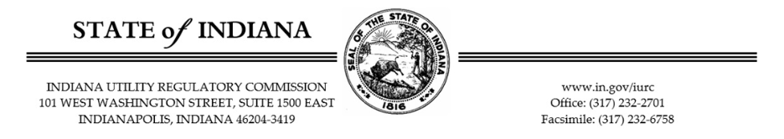
Request for Stakeholder Comments
for the IURC’s Advanced Transmission Technologies Study
As you may be aware, Senate Enrolled Act (SEA) 422 from the 2025 legislative session requires the Indiana Utility Regulatory Commission (“Commission” or “IURC”) to conduct a study on advanced transmission technologies (“ATTs”). The Commission is requesting your input, comments, ideas, research, and any relevant information you would like to provide, including regarding the following from Indiana Code § 8-1-8.5-14. The first round of comments is due no later than June 3, 2026.
- The potential use or deployment of ATTs by public utilities to enable those utilities to:
  - safely, reliably, efficiently, and cost effectively meet electric system demand; and
  - provide safe, reliable, and affordable electric utility service to customers?

- The attributes, functions, costs, and benefits of various ATTs, including grid enhancing technologies and advanced conductors.

- Whether each particular technology does the following:
  - Increases transmission capacity.
  - Increases transmission efficiency.
  - Reduces transmission congestion.
  - Reduces the curtailment of generation resources.
  - Increases system reliability.
  - Increases system resiliency?
  - Increases the capacity to connect new energy generation resources.

- What is the potential of each ATT to be used or be deployed by public utilities to provide safe, reliable, and affordable electric utility service to customers in Indiana, considering existing and planned transmission infrastructure and projected demand growth?

- What potential reductions in project costs and project completion deadlines can be furthered by ATTs compared to traditional transmission infrastructure?

- What are potential ways to streamline the deployment of ATTs, including streamlined processes for permitting, maintenance, and upgrades?

- Are there any other aspects of ATTs that can assist the IURC to understand the potential role of ATTs in Indiana?

