Beginning Date | Ending Date | Event
Wednesday, August 5, 2026 |  | Announcement of 53rd Selection Process
 | Sunday, September 20, 2026 | Application Submission Deadline (6.5 weeks)
Monday, August 24, 2026  Friday, September 25, 2026 |  | 2 Phase Testing – Plainfield, IN  Physical Ability Test (PAT) & Oral Interview
Tuesday, August 25, 2026 | Friday, October 2, 2026 | Polygraph Examinations
Monday, August 31, 2026 | Friday, October 9, 2026 | Background Investigations/Uniform Fitting
Thursday, October 15, 2026 |  | Email Conditional Offers of Employment, Medical, and Psychological
Monday, October 19, 2026 | Wednesday, October 21, 2026 | Written Psychological Test / Toxicology Screening / Psychological Evaluations – Indianapolis, IN
Monday, October 26, 2026 | Wednesday, October 28, 2026 | Medical Evaluations – Indianapolis, IN
Friday, November 13, 2026 |  | Email Recruits Final Reporting Information
Monday, December 7, 2026 |  | Hire-on date - Traditional Recruits Report to CPS
January 2027 |  | Tier II Academy Start Date – ILEA (exact date TBD)
March 2027 |  | ILEA Graduation / Swearing-in Ceremony (exact date TBD)

*NOTE: Dates and testing locations are subject to change.

All testing will be centrally located, in and around the Indianapolis area.

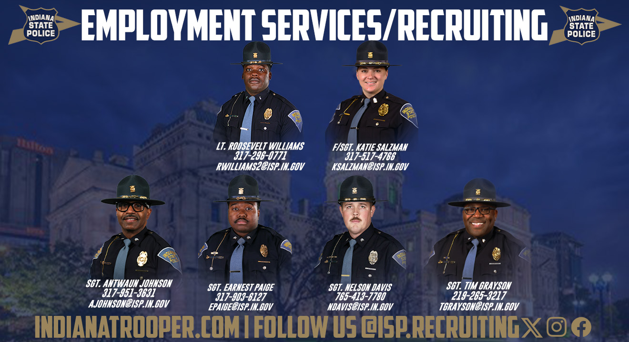

Please follow our social media platforms below for selection process updates.
Facebook, Instagram, and Twitter



