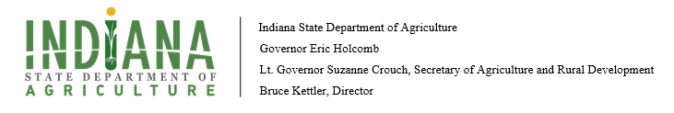

Notice of Funding Opportunity
Specialty Crop Block Grant Program

AWARD INFORMATION

Funding Opportunity Number: To be announced.
CFDA: Not listed yet.
Indiana Available Grant Allocation: Approximately $500,000.00

PERFORMANCE PERIOD

Federal Performance Period: September 30, 2020-September 29, 2023
Recipient Project Performance Period: September 30, 2020-September 29, 2023

PROPOSAL/AWARD TMELINES

Accepting Proposals March 01, 2020
Proposals Due March 22, 2020
ISDA Awards Grants Fall 2020

- FUNDING OPPORTUNITY

- History

The Indiana State Department of Agriculture (ISDA) was established as a separate state agency by the Legislature in 2005. The Director is appointed by the Governor and is a member of the Governor’s Cabinet. Administratively, ISDA reports to Lt. Governor Suzanne Crouch, who also serves as Indiana’s Secretary of Agriculture.

Authorization for this program was established under the Specialty Crops Competitiveness Act of 2004 and continues under authorization from the Agricultural Act of 2014 (commonly referred to as the “Farm Bill”).
- Purpose
Indiana State Department of Agriculture (ISDA) is seeking project proposals from the specialty crop industry in the state to present for funding from the U.S Department of Agriculture (USDA). The proposals must enhance specialty crops throughout the state of Indiana. This is an overview funding announcement, for a complete list of eligible and ineligible commodities and a comprehensive definition of specialty crops, terms and conditions, and guidance, visit https://www.ams.usda.gov/services/grants/scbgp/specialty-crop
Fruit, vegetable and other specialty crop production is very important to the diversity of Indiana’s agriculture industry. While the rapid change in agriculture to a consumer-driven industry creates niches and market opportunities for all of Indiana’s specialty crop producers, the ability to diversify and seek new markets and new product opportunities will be critical to many Hoosier farms. The State of Indiana is looking to help identify viable platforms for these producers and to enhance the competitiveness of Indiana-grown produce.

The Indiana State Department of Agriculture administrates the Specialty Crop Block Grant Program (SCBGP). ISDA encourages programs to develop projects to enhance the competitiveness of specialty crops pertaining to the following issues affecting the specialty crop industry:

- enhancing food safety;
- assisting all entities in the specialty crop distribution chain in developing “Good Agricultural Practices,” “Good Handling Practices,” “Good Manufacturing Practices,”
- and in cost-share arrangements for funding audits of such systems for small farmers; packers and processors;
- investing in specialty crop research, including research to focus on conservation and environmental outcomes;
- developing new and improved seed varieties and specialty crops;
- pest and disease control; and development of organic and sustainable production practices;
- increasing child and adult nutrition knowledge and consumption of specialty crops;
- improving efficiency and reducing costs of distribution systems;
- developing local and regional food systems; and
- improving food access in underserved communities.

- ELIGIBILITY INFORMATION

- Eligible Applicants

Non-profit and for-profit organizations; governments; and public or private colleges and universities are eligible to apply. There is no limit on number of proposals; however, only one (1) project per Funding Priority from each organization, government, public/private college and/ university will be awarded. Individuals are no allowed.

All applicants must have a Data Universal Numbering System (DUNS) numbers when submitting a proposal or it will be rejected. A DUNS number is a unique, nine-character, number regulated by Dun and Bradstreet used to identify an organization. The federal government utilizes the DUNS number to track the allocation of federal funds. A DUNS number can be obtained free of charge at http://fedgov.dnb.com/webform.

- Eligible Projects
Please note that this is an application guideline and not a complete list of SCBGP requirements. Visit https://www.ams.usda.gov/services/grants/scbgp/specialty-crop for a list of eligible and ineligible commodities and a comprehensive definition of specialty crops.
Specialty crops are fruits and vegetables, culinary and medicinal herbs, horticultural, and nursery crops, including floriculture. Eligible plants must be intensively cultivated and used by people for food, medicinal purposes and/or aesthetic gratification. Visit https://www.ams.usda.gov/sites/default/files/media/USDASpecialtyCropDefinition.pdf for a definition of Specialty Crops. Project(s) must enhance specialty crops throughout the state of Indiana.
Each project must identify at least one expected measureable outcome that specifically demonstrates the project’s impact on enhancing the competitiveness of eligible specialty crops. The proposal must describe how it affects and produces measurable outcomes for the specialty crop industry and/or the public rather than a single organization, institution, or individual.

Projects will not be funded if it is determined that the primary benefit is to a particular commercial project or provides a profit to a single organization, institution or individual. In addition, recipients cannot use grant funds to compete unfairly with private companies that provide equivalent products or services. Single organizations, institutions, and individuals, are encouraged to participate as project partners. Projects where one organization specifically attempts to disparage the mission, goals, and/or actions of another organization are unallowable.

- Funding Priorities

Funding Area I: Market Enhancement
Funding Area II: Access, Education, and Training
Funding Area III: Research

- AWARD INFORMATION

- Available Funding and Project Duration

The majority of funds will be awarded to programs through a competitive review process. The review process will include the use of an independent panel of experts and/or qualified individuals overseen by ISDA officials. The panel will review, score and recommend project proposals for selection. Grant awards are for a three (3) year period during which the approved project must be completed and all funds drawn. Proposals that build upon previously funded projects must clearly state how the project complements previous work.

- Timeline

The ISDA is requesting proposals for fiscal year 2021 grant cycle (federal fiscal year 20).

The following is an anticipated timeline and subject to change.

March 1, 2020 – Accepting SCBG proposals in GMS
March 22, 2020 – Full proposals due to ISDA
March 23-April 12th – Scoring process
April 13th – 17th 2020 ISDA review and recommendation
April 20, 2020 - Notification of successful projects
May 2020 – Indiana State Plan due to USDA-AMS
August-September 2019 – USDA notifies ISDA of approval of funding for grant projects included in the state plan
September – October 2020– Notice of Federal Award
October – December 2020 - Grant Agreements/contracts are prepared for grant recipients.

- Proposal Review

The Grant Proposal Application Review Committee will review, score and recommend project proposals for selection. The Committee must have a general knowledge of grant writing and/or SCBGP. Additionally, Committee members must objectively review and assess proposals in order to effectively evaluate project objectives, work plans, budgets, and expected results in determining the potential for project success. Finally, each committee member required to be objective, impartial, and free of organizational, racial, or other biases. ISDA uses a three tiered review process when generating funding strategies.

- Tier One: ISDA will conduct an initial screening of the proposals to check for completeness of the application and costs are allowable.
- Tier Two: ISDA will form a Grant Application Review Committee. The Committee is Grant Proposal applications will be reviewed and scored by the committee using a predetermined set of criteria. The scoring criteria utilized in the review process can be found in Section D. The committee will generate funding recommendations.
- Tier Three: The ISDA Executive Staff will assess the committee’s recommendations and formulate a finalized funding priority.

- Scoring

Applicants must respond to all the grant proposal questions on the grant template. Failure to answer one or more questions, including a scored or non-scored question, may result in a disqualified proposal.

Below is the scoring criteria and point value given for all submissions. Points awarded for each section will be combined to establish a total overview score for the proposal. Total points=170.

Section 1: 20 points
- Required Information
- Criteria: How well is the application written? All required information?

Section 2: 42 points.
- Description of project
- Project Summary
- Criteria: Scoring will be based on how clearly the author describes the project as well as identifies the outcomes.

Section 3: 62 points
- Project issue
- Objectives
- Sustainability
- Criteria: Scoring will be based on how clearly the author identifies the specific issue, problem, or need the project will address, as well as the timeliness, relevance to the specialty crop industry. Is this sustainable?

Section 4: 24 points.
- Outcomes/Indicators
- Scoring Criteria: Scoring will be based on the significance of the anticipated project outcome, the relevance to the project activities, soundness of data collection methods, and likelihood of success.

Section 5: 22 points.

- Budget Narrative

  - Scoring Criteria: Scoring will be based on the extent to which the budget is allowable, reasonable and appropriate to achieve the project goals. A justification is listed and budgeted item. Each item must be calculated properly, and the justification must be justified by the objectives. This will be check prior to scoring for federal requirements.

- Competitive Solicitation Process and Award Notification Process

Phase I: Solicitation Process
Admin Review/Technical Review—GMS and budget questions answered correctly. Proposal technical merit review.

Phase II: Competitive Review
Successful Proposals
  - Applicants will have seven (7) days to respond by accepting or rejecting scoring committee’s review requirements.
Unsuccessful Proposals
  - Applicants will be notified by GMS or email.

Phase III: State Plan submitted to USDA-AMS
  - USDA-AMS reviews for full accuracy
  - Review by USDA June-August

Phase IV: Award Notifications
- USDA-AMS sends NOA fall 2020
- ISDA sends NOA to applicants fall 2020
  - Grant Agreements follow

- Proposal Submissions

- GMS

All proposals must be submitted via Grants Management System (GMS). www.in.gov/isda Before submitting an application, all potential applicants, must become members. The proposal template is located on the website in preparation for submission into the GMS. If you have any questions, please call Grant Program Manager @317-910-4782 for questions/concerns regarding proposal.

- Budget
Complete the budget form (located on proposal template attached Appendix B), showing the uses for the grant funds. Provide sufficient information in paragraph format about each budget category to demonstrate that grant funds are being expended on activities that meet the purpose of the program. Please double check all math. The SCBGP does not have a Federal cost-sharing or matching requirement. Applicants are responsible for presenting direct and indirect costs appropriately and consistently and must not include costs associated with their organization’s indirect cost rate agreement as direct costs. In addition, a cost may not be allocated as an indirect cost if also incurred as a direct cost for the same purpose and vice versa. Budget narrative and/or all expenses described in the budget narrative must be associated with expenses that will be covered by the SCBGP (to ensure items meet requirements, please check https://www.ams.usda.gov/services/grants/scbgp/specialty-crop ).

- Proposal Submission Dates

Proposals must be submitted via email no later than March 22, 2020. The proposal must be submitted via GMS or will NOT be accepted. Use the TEMPLATE provided to prepare the proposal for submission. Incomplete proposals or information may be disqualified.

Appendix A: Example of Outcomes, indicators, and data reporting.

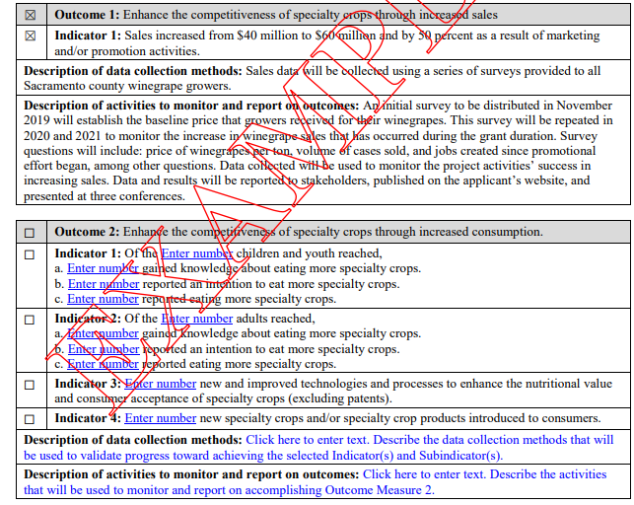

Appendix B: Quick notes to log into GMS.

NOTE: Becoming a member before attempting to submit a proposal is highly recommended.

- www.in.gov/isda
- Go to the Grants/funding
- Scroll down to the Specialty Crop Block Grant Program
- Grants application Portal
- Click “not a Member”
- Fill out ALL the information
- Client name is your organization/school/agency
- Once submitted, you will get an email to change password
- About 24 hours, you will be approved
- Then, log back into GMS
- https://indianaegms.force.com/Grants/s/login/?startURL=%2FGrants%2Fs%2F&ec=302
- User ID and password to log on.

