ISDA Mississippi River Basin Soil Sampling Registration Assistance -
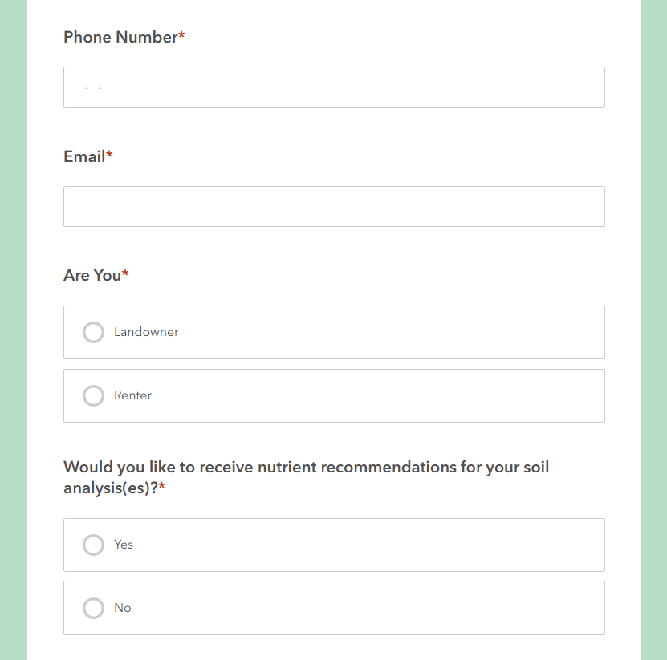
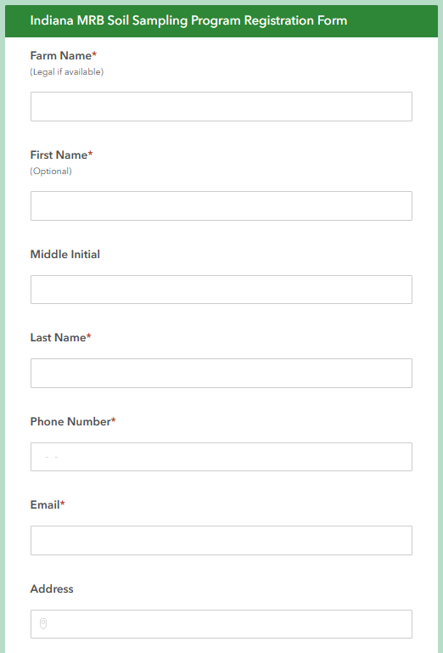
Registration Form #1:
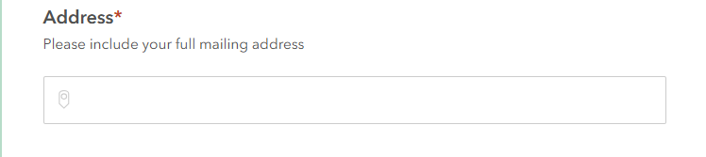

- Fields marked with a (*) are required. Please enter information for the following fields to begin the registration process: Farm Name, First Name, Last Name, Phone Number, Complete Mailing Address, and Email.
- Middle Initial field is not required.
- Select “Landowner’ if you own the acreage being registered.
- Select “Renter” if you rent or lease the acreage being registered.
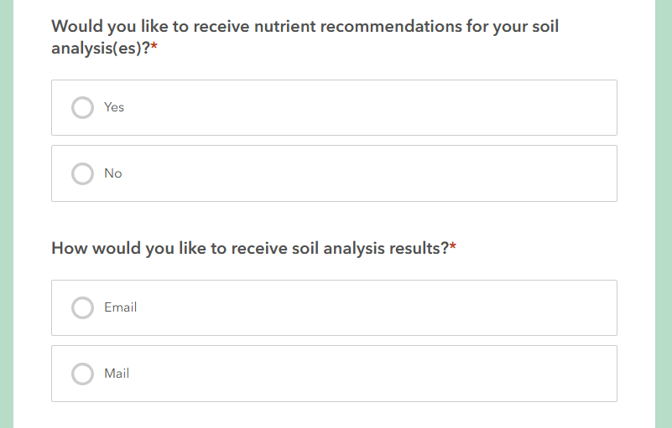
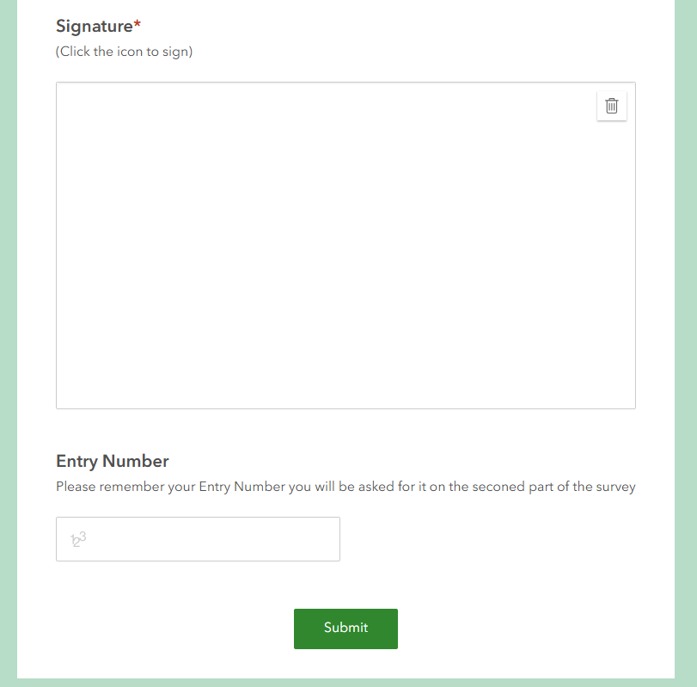
- Click the “Submit” button to proceed to the second part of the registration process now to register individual fields/acreage.
- Click on the link provided for the second part of the registration process.
- If you would like to receive nutrient recommendations back from the testing lab completing your soil analysis, please select “Yes”.
- If you do not want recommendations back, please select “No”.
- Your soil analysis results will be shared either via email to the email address or postal mail to the address given during registration.
- Please select one.
- To complete the first step in the registration process, a signature must be submitted.
- Please click on the box with either your finger or computer mouse.
- Keep your finger pressed on the box, or if using a mouse hold down left button of mouse to complete signature.
- The registration system will automatically assign an entry number. Please WRITE THIS NUMBER DOWN as it will be needed to complete the second portion of the registration process when specific fields/acreage are being registered.
- If you would like to receive nutrient recommendations back from the testing lab completing your soil analysis, please select “Yes”.
- If you do not want recommendations back, please select “No”.
- If you would like to receive nutrient recommendations back from the testing lab completing your soil analysis, please select “Yes”.
- If you do not want recommendations back, please select “No”.
ISDA Mississippi River Basin Soil Sampling Registration Assistance -
Registration Form #2:
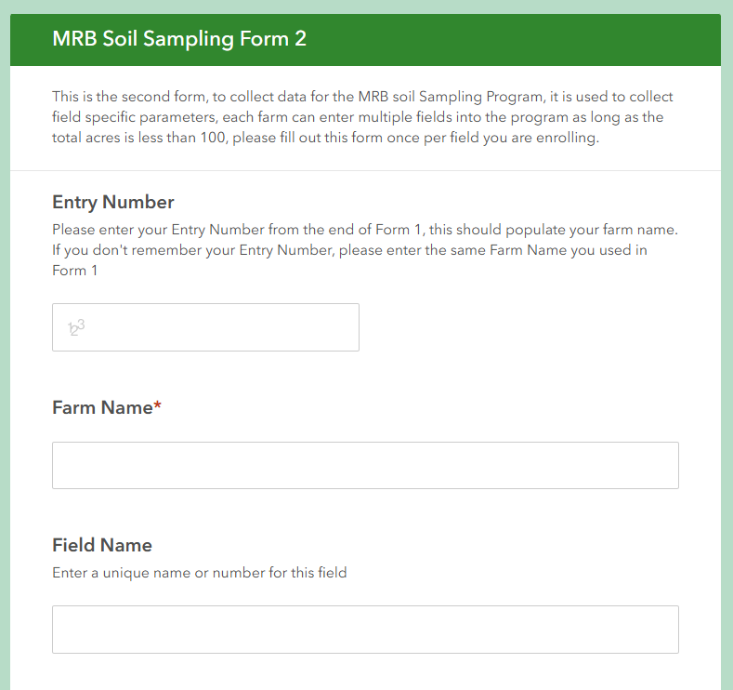
- This form MUST be completed for EACH field that is requesting to be sampled.
- NO more then 100 acres TOTAL amongst all fields.
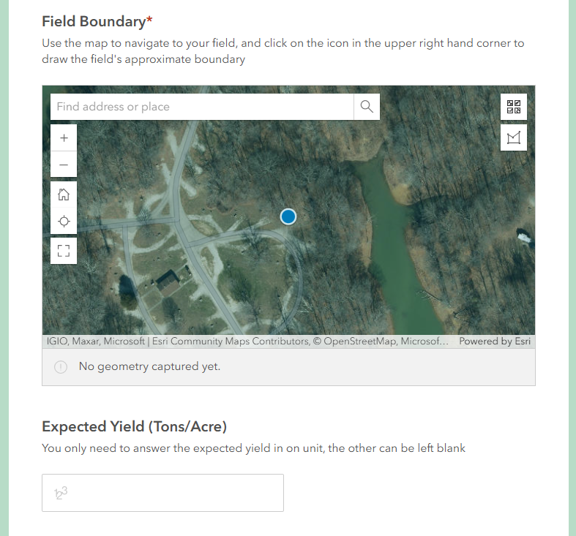
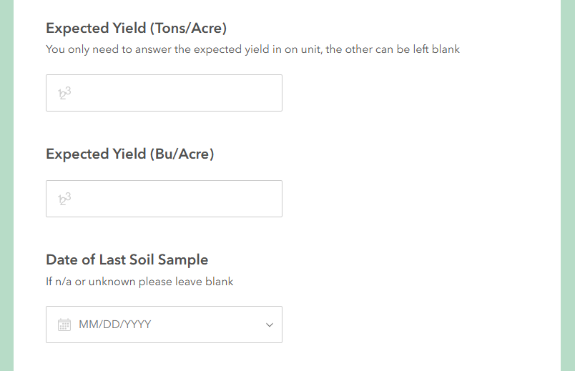

- Enter the “Entry Number” assigned at the end of Part 1 of registration process.

- This box will auto-fill after the “Entry Number” has been entered in box above.

- Enter a unique name/number for the field being registered.

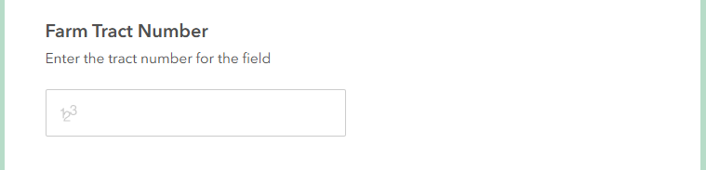
- Enter Farm Tract Number for field if you have one.
- Enter number of acres for the field being registered. Must be <100.
- Additional acres/fields can be added on the next form submission completed.

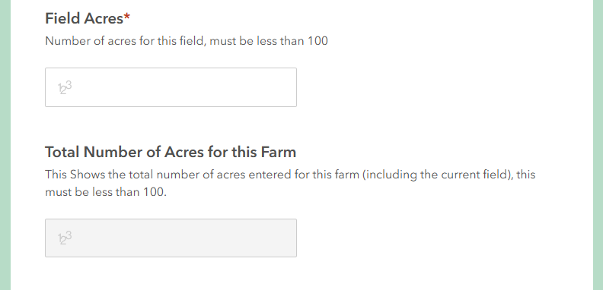

- This box is autogenerated, enter nothing here.
- NOTE: You will NOT be able to register more than 100 acres total.

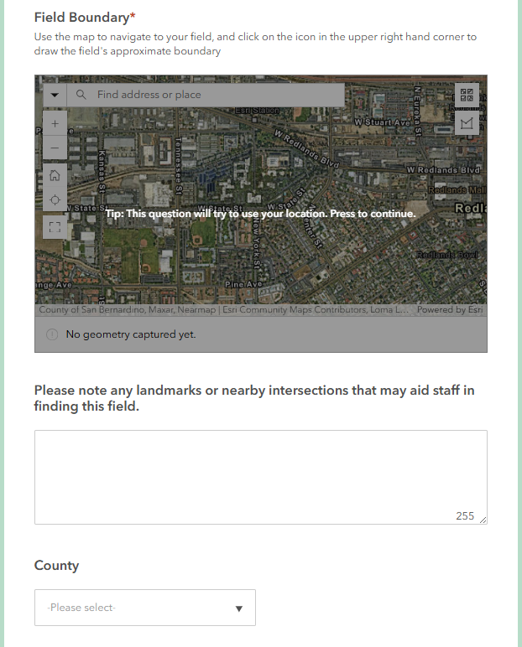
- Use this map to locate the specific location of field.
- Enter field address in the “Find address or place” box.
- Next, click on the icon to places dots around the boundary of field.
- Once the field boundary has been outlined, be sure to click back on original dot placed around field edge to ‘complete’ the field boundary or hit “Enter”.
- Once the boundary has been set, more detail related to acreage size should be displayed in gray box below the map.
- If you receive an error message about location settings this could be because of your device settings, you can still complete the field boundaries despite this message.

- Use this map to locate the specific location of the field being requested to sample.
- Enter field address in the “Find address or place” box.
- Next, click on the icon to places dots around the boundary of field.
- Once the field boundary has been outlined, be sure to click back on original dot placed around field edge to ‘complete’ the field boundary.
- Once the boundary has been set, more detail related to acreage size should be displayed.

- Use this map to locate the specific location of the field being requested to sample.
- Enter field address in the “Find address or place” box.
- Next, click on the icon to places dots around the boundary of field.
- Once the field boundary has been outlined, be sure to click back on original dot placed around field edge to ‘complete’ the field boundary.
- Once the boundary has been set, more detail related to acreage size should be displayed.

- If there are any intersections, obvious landmarks, or other helpful items to help our ISDA staff with field location please list here.

- Enter county where field being registered is located.
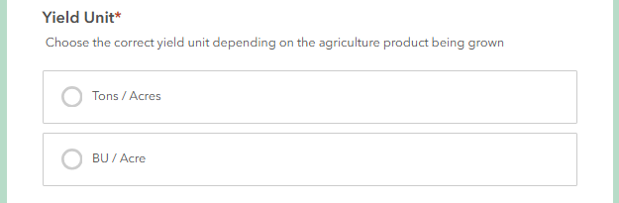
- For crop acreage, please select Bu/Acre, for pasture/hay please select Tons/Acre.
- A prompt will then pop up asking about quantity.

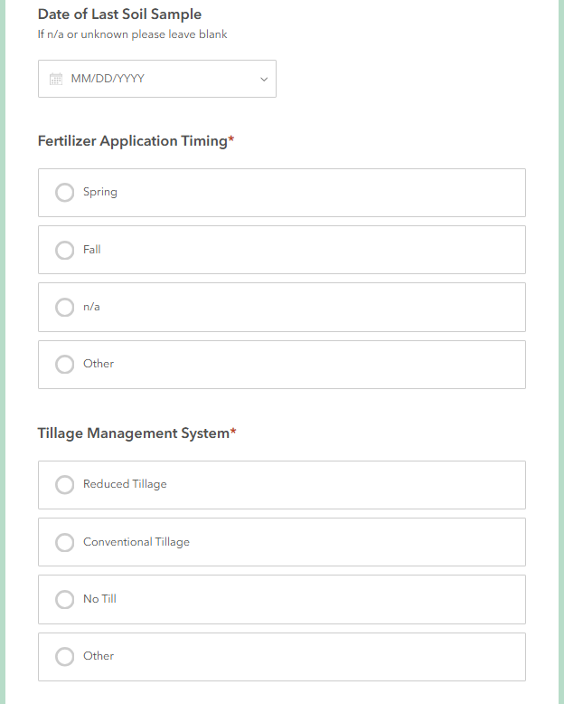
- Please give date of when soil sampling last occurred on this field. If unknown or never sampled, leave blank.

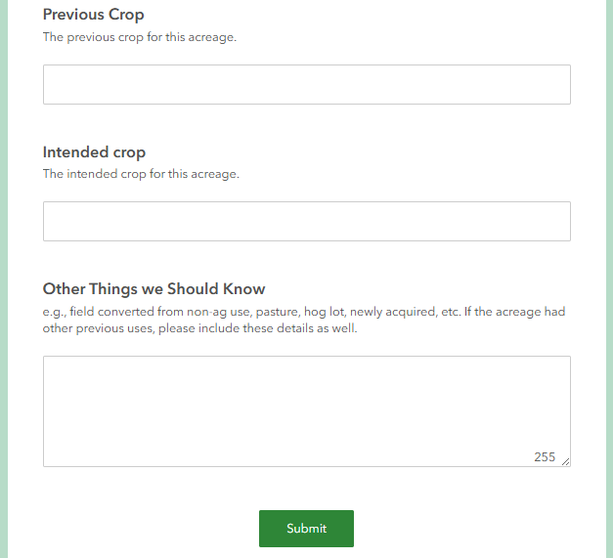
- Please select the option that best fits when fertilizer application may happen on this acreage.

- Please select the option that best describes the tillage management system used for this acreage.

- Please list what previous crop on acres was as well as what intentions are for next crop. This info helps with soil analysis results.

- Please share more information about the specifics of this field that provides background and insight about acreage use.

- Click submit when finished entering details of field.

- Have additional acreage/fields to register? Use this link to enter additional acreage/fields (100 acre max still applies): https://bit.ly/MRBSSPFall25Part2.

