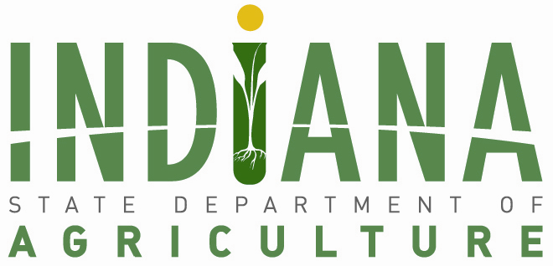

Meeting: Indiana Land Resources Council (ILRC)
Wednesday, May 10, 2023
1:00 – 3:00 p.m.
225 S East St. 7th floor,
Indianapolis, IN 46202

1 to 1:15 p.m. | Welcome and Introductions
Don Lamb, Director, Indiana State Department of Agriculture
1:15 to 1:20 p.m. | Roll Call and Approval of Minutes

1:20 to 1:30 p.m. | Electronic Meeting Policy
1:30 to 1:40 p.m. | ILRC Membership Terms

1:40 to 2:00 p.m. | Indiana Land Use Summit Discussion and Vote
Kara Salazar, Purdue University

2:00 to 2:20 p.m. | Legislative Update
Katie Nelson, Director of Legislative Affairs, ISDA

2:20 to 2:45 p.m. | Strategic Planning Discussion
2:45 to 3 p.m. | Public Comment
3 p.m. | Adjourn

