SAMPLE County Emergency
Communications Plan

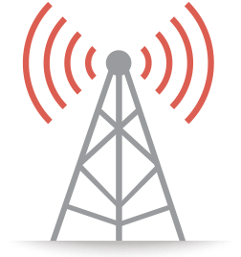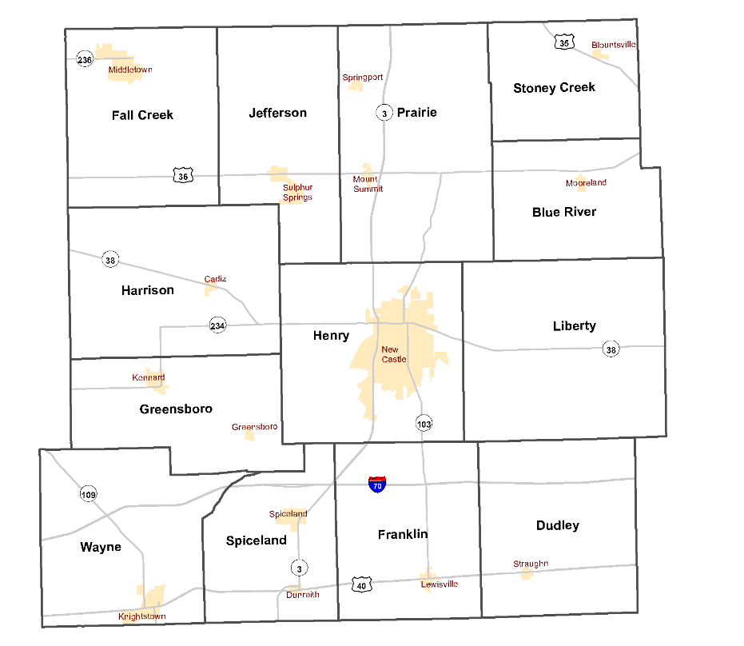

Replace with County map or logo above

Effective Date: ENTER DATE HERE

PLAN DISTRIBUTION
The following individuals, agencies, or departments shall receive a copy of this plan.
- SAMPLE County Emergency Management Agency
- All County Public Safety Agencies
- All Incorporated Cities and Towns
- SAMPLE County Commissioners
- Participating Stakeholders

SAMPLE County Commissioner President  NAME HERE, President |  | Municipal Police, Fire, EMS, and Street Dept. NAME HERE, Mayor City of INSERT CITY
Municipal Police, Fire, EMA, and Street Dept. NAME HERE, Mayor of INSERT CITY |  | Jurisdictional Police, Fire, EMS, and Street Dept. NAME HERE, Mayor, INSERT CITY
SAMPLE County Sheriff's Department  NAME HERE, SAMPLE County Sheriff |  | NAME HERE, President, Town of SAMPLE
NAME HERE, President, Town of SAMPLE |  | NAME HERE, President, Town of SAMPLE
NAME HERE, President, Town of SAMPLE |  | NAME HERE, President, Town of SAMPLE
NAME HERE, President, Town of SAMPLE |  | NAME HERE, President, Town of SAMPLE
NAME HERE, CEO SAMPLE County Hospital |  | NAME HERE, President, SAMPLE County Fire Chiefs Association

RECORD OF CHANGE

Change No. | Description | Change Date | Approved By
001

Table of Contents

PLAN DISTRIBUTION 2
RECORD OF CHANGE 3
1.0 BACKGROUND 5
2.0 STRATEGY 6
3.0 ORGANIZATION AND GOVERNANCE 7
4.0 TECHNOLOGY & SYSTEM LIFECYCLE 8
5.0 COMMUNICATIONS PLAN – COUNTY RADIO PROCEDURE 9
5.1 BACK-UP COMMUNICATIONS PLAN 12
6.0 AGENCY CONTACT INFORMATION 14
6.1 COMMUNICATIONS LIST (ICS 205A) 15
7.0 DATA & CAD SOFTARE CONTACT INFORMATION 16
7.1 BROADBAND WIRELESS DATA – MOBILE DATA CONTACT INFORMATION 17
7.2 PUBLIC SAFETY ANSWERING POINT – 911 CENTER – SOFTWARE 18
7.3 RADIO VENDOR – CONTACT INFORMATION 19
7.4 LOCAL PROGRAMMER – CONTACT INFORMATION 19
8.1 SYSTEM – STANDARD OPERATING PROCEDURES (SOP) 20
9.0 EMERGENCY CONTACTS 21
10.0 APPENDICES 22
APPENDIX A – IPSC P25 Migration [Dec 2016] 22
APPENDIX B – P25 Mutual Aid Interoperability Options 23
APPENDIX C – NPSPAC – National 800MHz Interoperability Sites 24

1.0 BACKGROUND
SAMPLE County is located in the East Central portion of the State of Indiana and encompasses 000 square miles. We are bordered to the North by SAMPLE and SAMPLE Counties, SAMPLE and SAMPLE Counties to the East, SAMPLE and SAMPLE to the South and SAMPLE, SAMPLE, and SAMPLE Counties to the West. The population of SAMPLE County, Indiana was 00,000 as of the 2010 Census and covers an area of 000.00 square miles. SAMPLE County includes the cities of ADD CITY, ADD CITY, ADD CITY, ADD CITY, ADD CITY, ADD CITY, ADD CITY, ADD CITY, and ADD CITY. The county also consists of the following townships: ADD TWP, ADD TWP, ADD TWP, ADD TWP, ADD TWP, ADD TWP, ADD TWP, ADD TWP, ADD TWP, ADD TWP, ADD TWP. SAMPLE County is home to several federal, state, and city/county governmental offices.
The County seat is located in the City of SAMPLE. The County executive body consist of the Board of Commissioners. The County legislative fiscal body consist of the County Council members. There is one hospital within SAMPLE County and a multitude of outpatient healthcare facilities. There are 00 fire departments that cover varies regions of SAMPLE County. SAMPLE County includes a multitude of law enforcement agencies to include the SAMPLE County Sheriff’s Department, SAMPLE City Police Department, Indiana State Police, and several other small police departments for local towns and schools.
SAMPLE County contains a total of 1 Interstate (I-00) and nine state roads (US- 00, SR-0, SR-0, SR-00, SR-00, SR-00, SR-000, SR-000, SR-00, and SR-00) which are routine routes for hazardous material transportation in the State of Indiana. COMPANY NAME and COMPANY NAME railroad companies operate rail lines within SAMPLE County. The City of SAMPLE also has a municipal airport capable of dispatching and receiving small aircraft for air operations if needed.
The purpose of this document is to allow public safety members the ability to integrate daily operations and to promote interoperability during disaster and planned events involving multi-agency and regional All-Hazard incidents. The goal of this plan is to establish guidance to support local emergency communications, Emergency Operations Center activations. This plan also addresses Regional and Statewide Interoperability with local, state, and federal responders.

2.0 STRATEGY
The goal of this plan is to establish assignments and provide guidance to support emergency communications during local emergencies, Emergency Operations Center activations, and/or any countywide emergency. This plan represents input gathered during several planning opportunities engaging numerous public safety and private partners in SAMPLE County. Additionally, this plan is structured to identify the most common utilized communications methods used throughout SAMPLE County and provide suggested guidance on usage during major incidents or countywide events requiring multiple response agencies. This plan does not replace individual agency response plans and can be integrated in conjunction with Regional Tactical Interoperable Plans (TICPs).

3.0 ORGANIZATION AND GOVERNANCE
The development of this plan is based upon district planning seminars and meetings between the following agencies:
- SAMPLE County Commissioners
- SAMPLE County 911 Dispatch
- City of SAMPLE Dispatch
- SAMPLE County Hospital and Affiliates
- SAMPLE County EMS
- SAMPLE County Fire Chiefs Association
- City of SAMPLE Fire Department
- SAMPLE County Sheriff Department
- SAMPLE County Emergency Management Agency
- SAMPLE County Public Schools
- SAMPLE City Dispatch

Ongoing maintenance of the SAMPLE County Communications Plan requires revisions and updates which reflect the evolving technologic needs of emergency communications within SAMPLE County, the State of Indiana and the United States. Additional information shall be incorporated from After Action Reports (AARs) and Improvement Plans developed as a result of public safety exercises or real-world emergency events.
This continual maintenance and review of the SAMPLE County Communications Plan will be accomplished by a group designated by the SAMPLE County Board of Commissioners. In coordination with other local agencies and stakeholders, the review of this plan should occur annually or as needed, to provide revisions and updates.

4.0 TECHNOLOGY & SYSTEM LIFECYCLE
Statewide 800 MHz System
The State of Indiana provides an interoperable and reliable public safety communications system to all Hoosier first responders and public safety professionals for use during routine, emergency and task force situations. The state charges no user fees for this 800 MHz interoperable communications system (SAFE-T), and participation is voluntary. The state pays for ongoing maintenance and biennial technology upgrades to the system, contracted through the year 2036. User agencies are responsible for purchasing and maintaining the equipment used to operate on the system.
More than 64,000 user radios are registered in the SAFE-T system database. This includes first responders in all 92 counties, 17 state agencies, and 13 federal agencies. While some agencies have a radio or small number of radios in order to provide interoperable communications in the event of a natural or man-made disaster, a large number of agencies use the system for their day-to-day communications needs.
PROPRIETARY SYSTEMS (Not all counties, and local jurisdiction utilizes the Indiana Safe-T 800MHz. radio system, locally owned and operated systems are available. This section is provided for local systems.)
VHF SYSTEMS
[INSERT]
UHF SYSTEMS
[INSERT

5.0 COMMUNICATIONS PLAN – COUNTY RADIO PROCEDURE
Purpose:
This section of the Communication plan will provide specific information related to local interoperability; providing talkgroup name, description highlighting agencies that utilize specific talkgroups as well as specific radio programming information including Zone and Channel number. Emergency Responders can refer to chart below to locate specific talkgroups within their radio programming template.
Note – radio templates may differ agency to agency.
Local Interoperability: Talkgroups Used For Daily Operations – SAMPLE County
LE – Law Enforcement
FD – Fire Department
Talk Group Name | Description | Zone and channel # (optional)
SAMPLE LE Disp | County LE Dispatch | Zone 1; Channel 1
SAMPLE Fire Disp | County FD Dispatch | Zone 1; Channel 2

Regional Interoperability: Talkgroups used for Mutual Aid calling - SAMPLE County
MA – Mutual Aid; Letter coincides with regional map found in appendix.
Talk Group Name | Description | Zone and channel # (optional)
J – MA1 | Regional MA | Zone 2; Channel 1
J – MA2 | Regional MA | Zone 2; Channel 2
J – MA3 | Regional MA | Zone 2; Channel 3
J – MA4 | Regional MA use for landing zone | Zone 2; Channel 4

Statewide Interoperability: Talkgroups used for Statewide Interoperability – SAMPLE County
MA – Mutual Aid
SW – Statewide Calling Channel – Monitored by Indiana State Police Regional Dispatch Centers and State Emergency Operations Center
Talk Group Name | Description | Zone and channel # (optional)
SW – CALL | Calling Channel | Zone 3; Channel 1
SW – MA1 |  | Zone 3; Channel 2
SW – MA2 |  | Zone 3; Channel 3
SW – MA3 |  | Zone 3; Channel 4
SW – MA4 |  | Zone 3; Channel 5
SW – MA5 |  | Zone 3; Channel 6
SW – MA6 |  | Zone 3; Channel 7
SW – MA7 | Task Force Convoy | Zone 3; Channel 8
SW – MA8 |  | Zone 3; Channel 9
SW – MA9 |  | Zone 3; Channel 10

5.1 BACK-UP COMMUNICATIONS PLAN
Limited resources (busy of the system) procedures:
Site Trunking Plan:
SITE TRUNKING is a safeguard operating mode common to trunked, multi-site radio system such as the IPSC Statewide 800 MHz system. Users of conventional public safety radio systems will be unfamiliar with this term and may find the concept difficult to understand. To begin with, it is important to understand that SITE TRUNKING DOES NOT MEAN THE SYSTEM IS DOWN! It is critical for users to train to recognize and appropriately respond to site trunking events.
All sites on the statewide system are connected by T-1 telephone lines. When sites are operating normally via T-1 lines, they are operating in a condition known as Wide Area configuration. Wide Area allows users to communicate with users that are both affiliated with the same site as the user and those that are affiliated with sites other than the one where a particular user is affiliated. Hence, users can communicate across cities, counties and even across the State.
However, when T-1 connectivity is broken, the particular site is no longer able to communicate with the system and the other sites on the system. This condition is known as Site Trunking. The site is still up and operational, but not in "wide area" mode. Users/agencies do not need to report the Site Trunking problem to either IPSC or Motorola. The system is monitored 24/7 by either IPSC or Motorola Network Management personnel and any interruption in service is immediately recognized and the proper technicians are dispatched.
Understanding that it is of extreme importance to have a plan in place prior to a site trunking event our agencies will adhere to the following guidelines and procedures in the event of a site trunking event:
Back-up Communications Plan:
In the event of a communication disruption of our current public safety radio system SAMPLE County will utilize the following Radio System UHF/VHF for primary communications.

Conventional Talk Group Name | Description | Programming location: (optional)
SHF DISP | Sheriff Dispatch | VHF radio – channel 1
CO FD DISP | County Fire Dispatch | VHF radio – channel 2
EMS DISP | County EMS Dispatch | VHF radio – channel 3
PT – PT | Point to Point - ISP | VHF radio – channel 4

6.0 AGENCY CONTACT INFORMATION
The following table illustrates communications platforms used by Emergency Response agencies and Stakeholders throughout SAMPLE County:
Note- This table may also be used in conjunction with Incident Command System (ICS) 205a form.
Agency | Name | Contact Number | Primary Radio
SAMPLE Co. Sheriff | Insert Name | 111-111-1111 | 800MHz.
SAMPLE City Police | Insert Name | 111-111-1111 | 800MHz.
SAMPLE Marshal | Insert Name | 111-111-1111 | 800MHz.
SAMPLE Fire Dept. | Insert Name | 111-111-1111 | VHF
SAMPLE Co. EMS | Insert Name | 111-111-1111 | VHF
SAMPLE Co. EMA | Insert Name | 111-111-1111 | 800MHz.
SAMPLE Co. Highway | Insert Name | 111-111-1111 | VHF
SAMPLE Co. Schools | Insert Name | 111-111-1111 | UHF

6.1 COMMUNICATIONS LIST (ICS 205A)

 | 1. Incident Name: |  |  |  | 2. Operational Period: |  |  | Date From: Date |  | Date To: Date
 |  |  |  |  |  |  |  | Time From: HHMM |  | Time To: HHMM
3. Basic Local Communications Information:
Incident Assigned Position |  |  |  | Name (Alphabetized) |  |  | Method(s) of Contact  (phone, pager, cell, etc.)
 | 4. Prepared by: | Name: |  |  |  | Position/Title: |  |  | Signature:
 | ICS 205A |  | IAP Page |  |  | Date/Time: Date

7.0 DATA & CAD SOFTWARE CONTACT INFORMATION
Integrated Public Safety Commission (IPSC) Mapping Analytics and Data Driven Exchange Network (MADDEN) Center (317) 234-9686
CAD | Customer # | After Hours Support | Software Version | Other Info
ENTER Company | 000000-0000000 | 1-111-111-1111 | V00.00 | (example: DO mode, application or web based, hosted/not hosted, etc.

Mobile | Customer # | After Hours Support | Software Version
ENTER Company | 000000-0000000 | 1-111-111-1111 | V00.00

RMS | Customer # | After Hours Support | Software Version
ENTER Company | 000000-0000000 | 1-111-111-1111 | V00.00

Jail | Customer # | After Hours Support | Software Version
ENTER Company | 000000-0000000 | 1-111-111-1111 | V00.00

7.1 BROADBAND WIRELESS DATA – MOBILE DATA CONTACT INFORMATION
Device – MIFI/Aircard | Vehicle or Unit # | Device Wireless (CTN) # | Model/Series | Additional Info
 |  |  |  | (example: Service Provider & TX, IP, device ID

7.2 PUBLIC SAFETY ANSWERING POINT – 911 CENTER – SOFTWARE
Company Name | Customer # | After hours support | Software Version

7.3 RADIO VENDOR – CONTACT INFORMATION
Company | Office Contact # | After Hours Support | Maintenance Contract
ENTER COMPANY | 111-111-1111 | 111-111-1111

7.4 LOCAL PROGRAMMER – CONTACT INFORMATION
Name | Agency | Contact # | Hardware Key Access
ENTER NAME | ENTER AGENCY | 111-111-1111

Note- Talkgroup memorandum of understanding (MOU) blank document located in appendix; additional signed MOU documents from surrounding agency/jurisdiction can be attached to this plan.

IMPORTANT – Programmer must check hardware key expiration date

8.1 SYSTEM – STANDARD OPERATING PROCEDURES (SOP)
SAMPLE County – Standard Operating Procedures – INSERT HERE

9.0 EMERGENCY CONTACTS
Agency | Contact #
Indiana State Emergency Operations Center  Watch Desk | 1-800-669-7362 Ex. 1
State EOC ESF 2 Desk (Communications) | 317-238-1705
Integrated Public Safety Commission  Network Operations Center | 317-234-1540  After hours, weekends and holidays, you will be presented with three (3) choices: 1) On-call pager system. LEAVE A MESSAGE for prompt callback. 2) Voice mail system for next business day callback. 3) Motorola Network Monitoring to speak with a technician about your problem.
Integrated Public Safety Commission  MADDEN Center – DATA/CAD | 317-234-9686 (24/7)
Indianapolis Traffic Management Center (TMC)

10.0 APPENDICES

APPENDIX A – IPSC P25 Migration
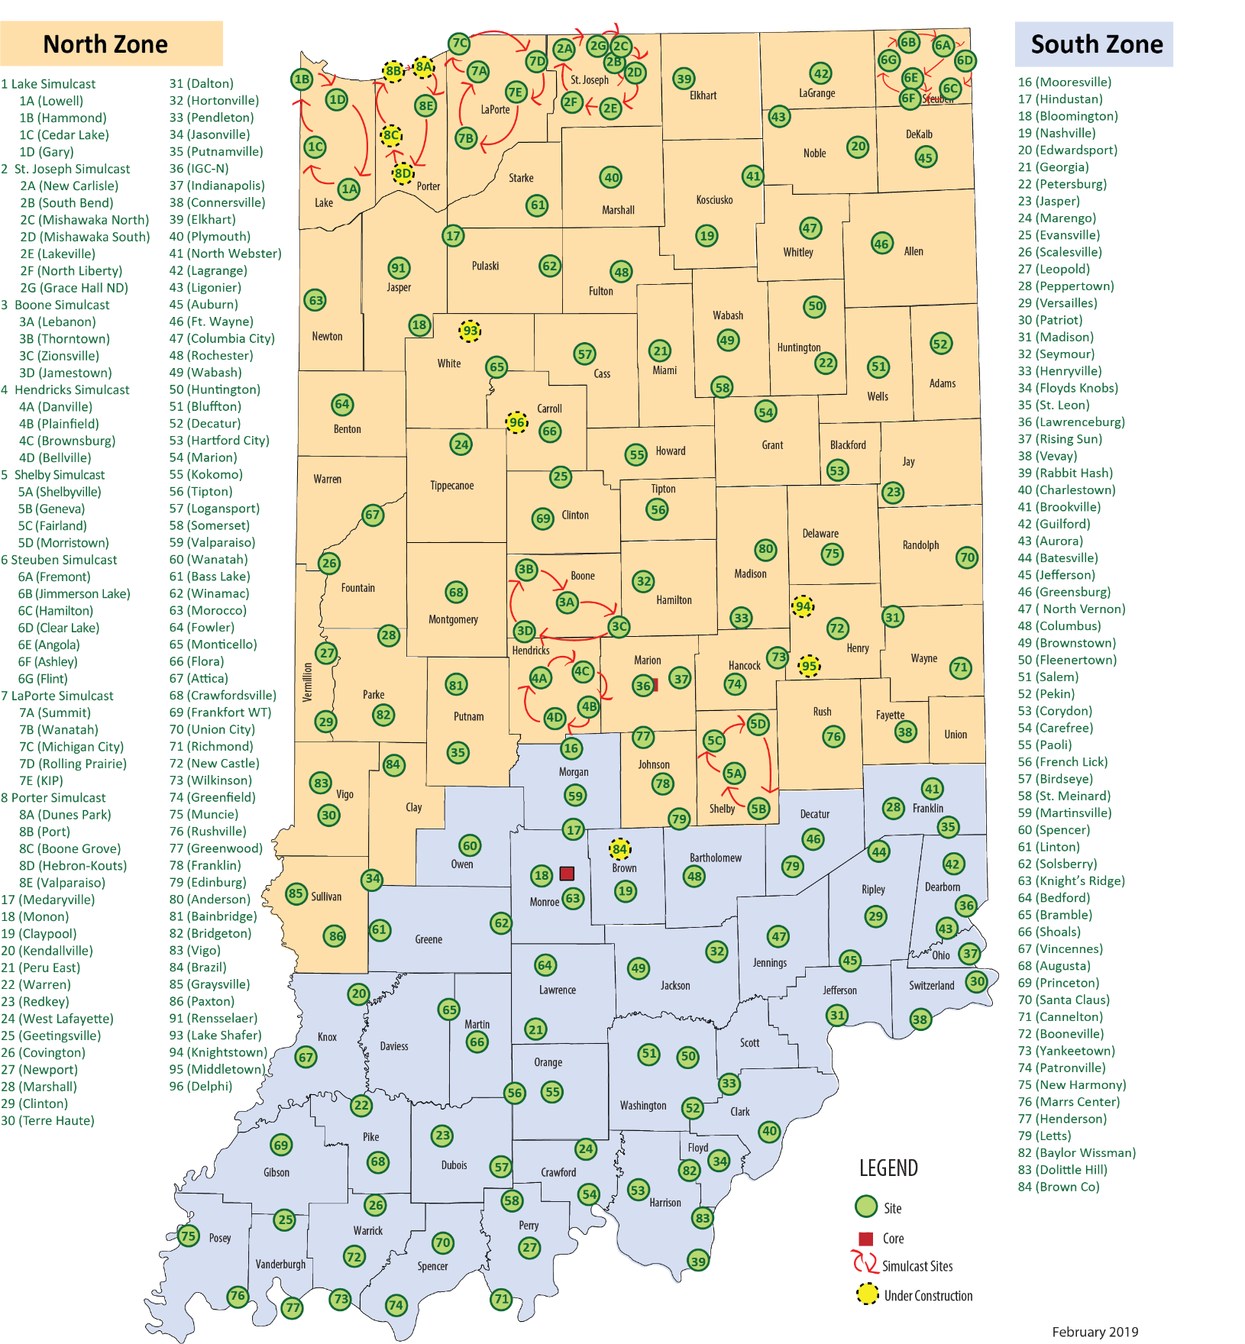

APPENDIX B – P25 Mutual Aid Interoperability Options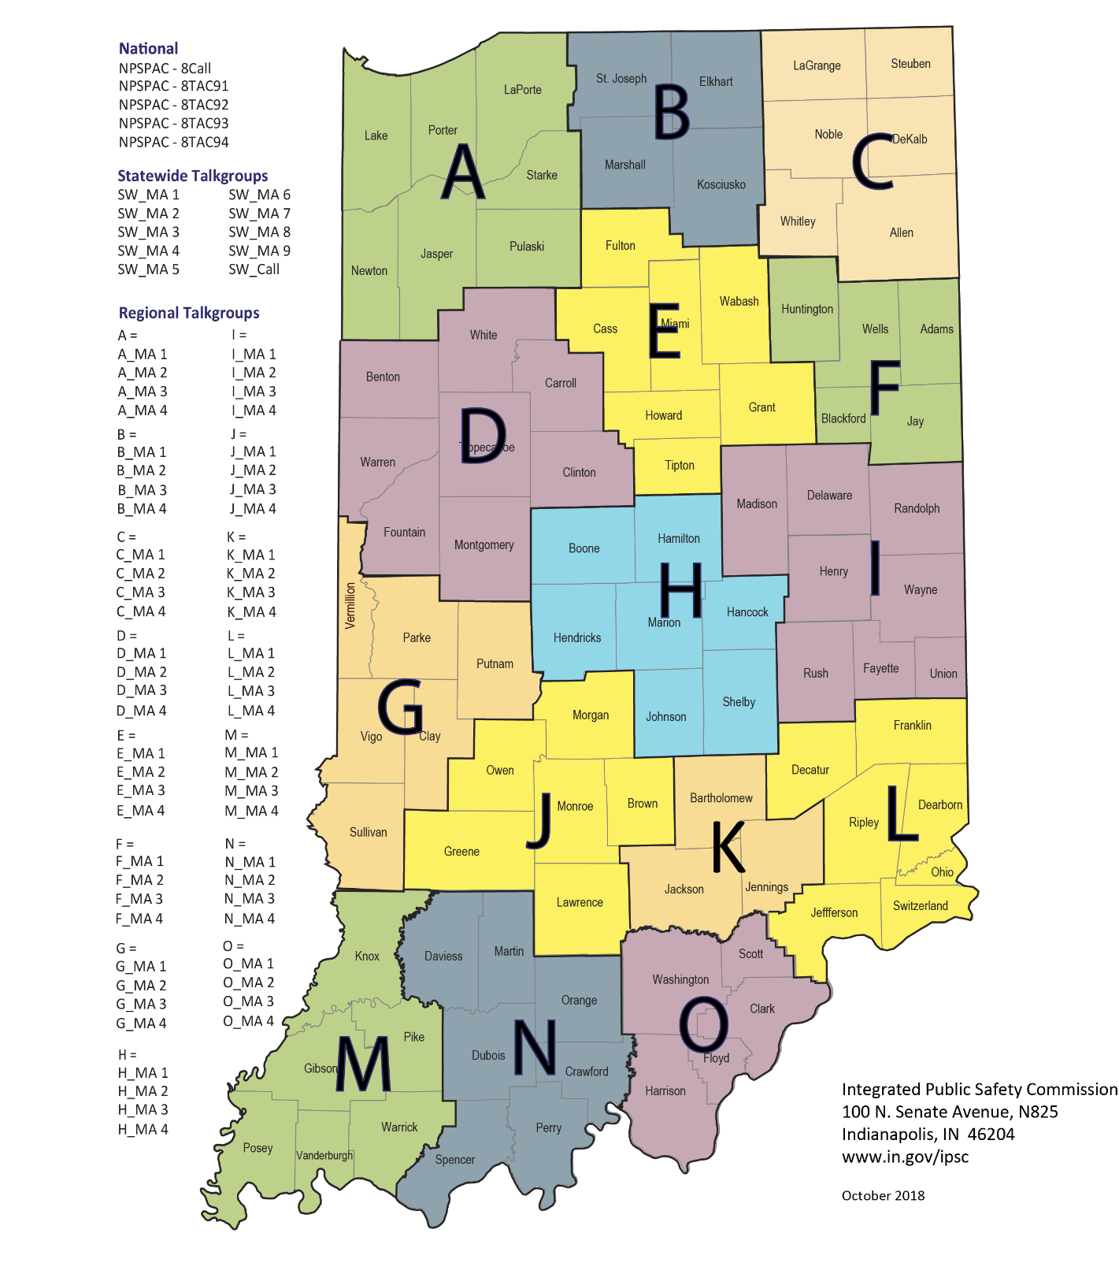

APPENDIX C – NPSPAC – National 800MHz Interoperability Sites