August 15, 2019
Greetings!
Public Safety Stakeholders from your county attended a workshop today to discuss critical communication needs and ways to plan for and adopt new technology into existing routine and emergency response communications plans. During the workshop, attendees reviewed existing public safety communications capabilities and were given tools and a template to create a County Communications Plan. They also discussed future communications needs to include data sharing and the Nationwide Public Safety Broadband Network (FirstNet).
As the state agency charged with promoting interoperable communications between local, state and federal agencies, IPSC is proud of the progress Indiana has made in recent years through partnerships with local first responder agencies. As a result of these partnerships, Indiana is first in the nation in terms of public safety communications interoperability.
I’m writing you today, however, to extend a very important invitation.
Rapidly changing technology means that first responders can and must incorporate data into their public safety plans and response. In the past, first responders have made recommendations and decisions about land mobile radio communications. Today, however, local government leaders and decision-makers must understand new communications technology and the impact that this technology will have on budgets, emergency plans and response.
We’re excited to announce that we’ve scheduled a day-long conference on Friday, September 13, 2019, at the Indianapolis Motor Speedway, to tackle these important topics. A partnership with two other public safety events promise to make this an occasion you simply can’t miss! There’s no cost to attend any or all three events, and we promise that the information/experience you’ll walk away with will far surpass the time investment you make.
Information about the “Need for Speed” Statewide Interoperable Communications Conference and partner events can be found on our website, www.in.gov/ipsc/conference.htm. Better yet, go ahead and register: https://www.surveymonkey.com/r/IPSC_conference !
Please let me know if you have any questions. On behalf of IPSC and first responders across the state, we appreciate your service to the community and look forward to partnering with you as we work to carry out our motto, “Saving Money, Saving Lives.”
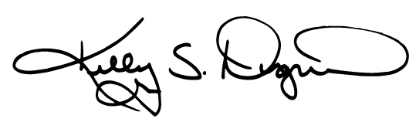
Sincerely,

Kelly S. Dignin
Executive Director
Integrated Public Safety Commission
317.232.8993 (o) 317.430.3617 (c/ePTT)
kdignin@ipsc.in.gov

