Access Secondary Mailbox via Outlook

- From within Outlook, click on File in the upper left corner.
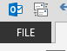
- Select the Account Settings button and then click on Account Settings from the menu that drops down.
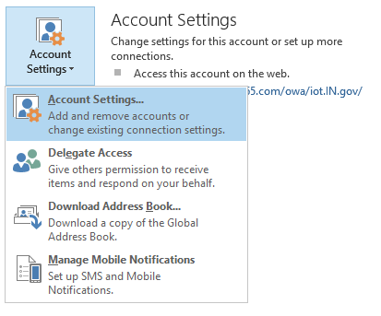
- In the Account Settings window, click on the New… button.
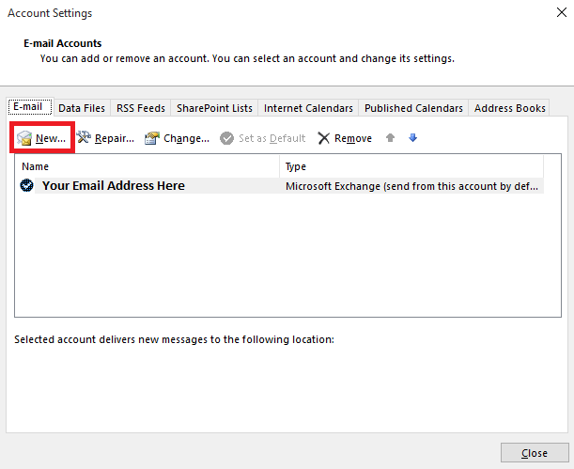

- In the Add Account window, enter the email address of the secondary mailbox in the E-mail Address field. No other information needs to be entered.
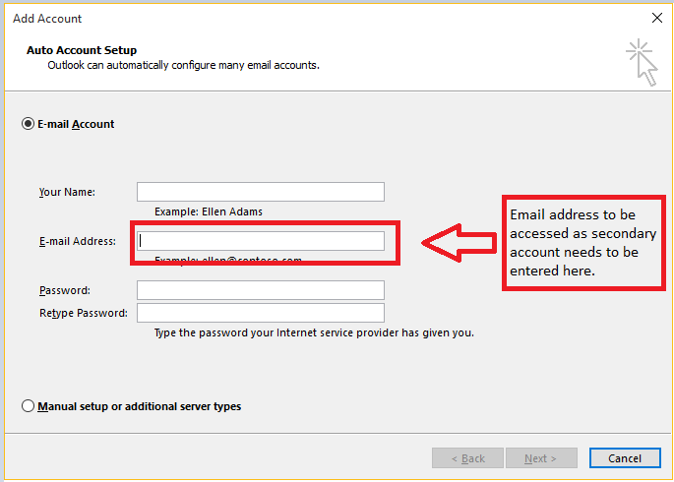

- If prompted for username and password, make sure to use YOUR email address as the username along with your password.

- Click on Next and Outlook should configure access to the additional mailbox.
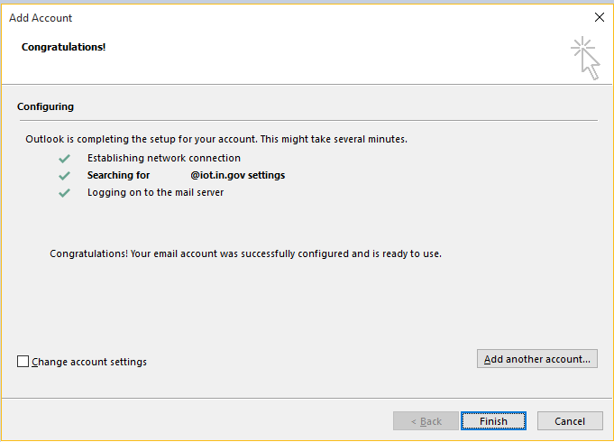

- Check Change account settings and click Next

- Click More Settings … and then select the Advanced tab.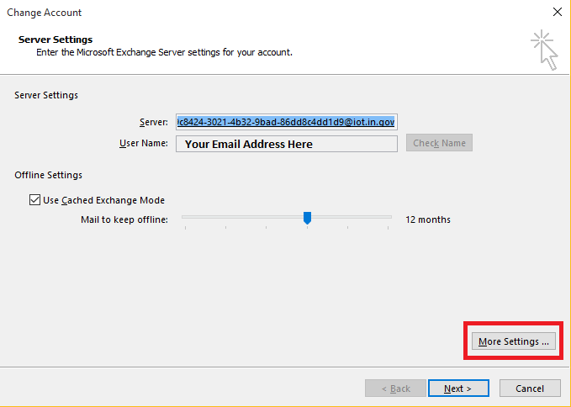

- Make sure only Use Cached Exchange Mode is checked and then click on OK.

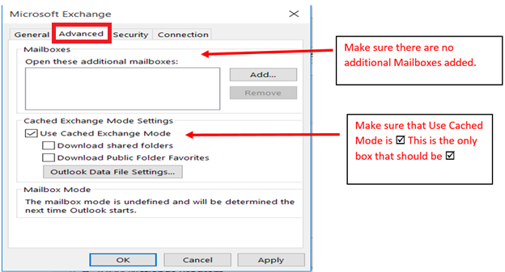

- Click on Finish to close out of the wizard.
- Restart Outlook. The additional mailbox will be displayed on the left side of Outlook below your normal mailbox folders.

