Instructions on How to Complete a Deployment Workbook (DW) for SOI

- For the State of Indiana account, the telecom team at the Indiana Office of Technology will send you an Excel sheet via email known as a Deployment Workbook OR DW for short.
  - They will then set weekly meetings with a CBTS representative; an SOI representative; and the point of contacts also known as POC’s
  - Jean Bauch AKA Beanie from IOT will prepopulate the DW with telephone numbers along with the first and last name that is associated with each TN (she pulls this information from pinnacle, which is their billing system).

- There are a total of 7 tabs at the bottom of our DW
- Summary
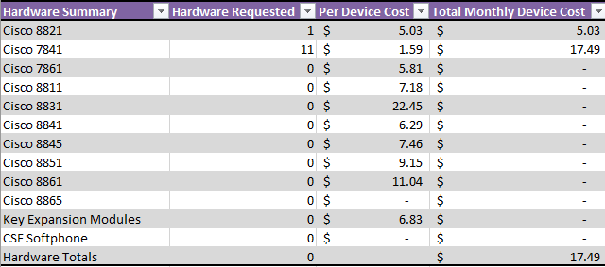
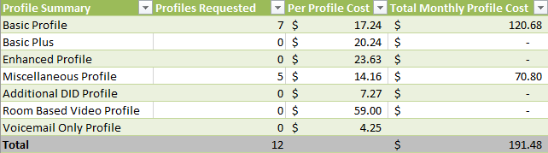
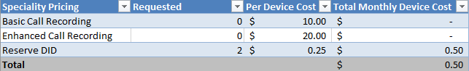
    - It provides an overview of the different profiles; phone models; specialty pricing such as call recording / keeping reserve numbers for their agency. It also provides an estimate on their expected cost based on the profiles; phone models; and any specialty pricing that they choose

- Profile Build Tab
      - The profile build tab is where you will spend the majority of your time working with the agencies.
      - Beanie from IOT will prepopulate the DID column; First Name; Last Name; Bring Your Own Device; Phone Model.
      - A DID is just a fancy name for a telephone number. Beanie will prepopulate this column with what the agency is currently being billed for.
      - It is up to the agency to verify the DID’s / match the DID’s with their correct first and last name. This is most critical!
          - For example: Beanie might have 3175554444 marked as a conference room line. It is up to the agency to verify this. If they go back to their agency and find that 3175554444 is NOT a conference room line and is an actual user then that information needs to be updated on the DW.
      - Most of the time, the Bring Your Own Device column will be FALSE unless it’s going to be a legacy cisco migration.
        - IOT will let you know this and if it is a legacy cisco migration that means the agency will NOT be getting phones from CBTS and will be using their current phones.
        - Beanie also prepopulates the phone model column with the Cisco 7841 as it is our most popular phone model as well as the most cost effective.
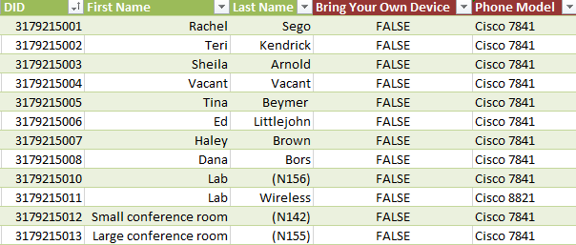

2A. Columns on Profile Build Tab
- When you first meet with the agencies for the very first time, it is important that you go through ALL the columns on the profile build tab so they can successfully fill it out on their own.
      - Column A on the DW is called User Type.
        - There are 4 different dropdowns.
          - User; Voicemail Only; Room Based Video; Miscellaneous.
        - An actual living breathing person is a user.
        - Voicemail Only is if they want a VM only box (no phone). In other words, they can have 3178881111 go to a VM box directly.
        - Room Based Video is a rare request.
        - Miscellaneous stands for no VM.
          - A miscellaneous profile is usually chosen for conference room phones and sometimes an agency will want phones with no VM on them. In those cases, you would pick miscellaneous from the drop-down.
- Columns B-D on the DW consist of the DID; First Name; Last Name.
        - Beanie will prepopulate these columns for you.
        - It’s the agency’s responsibility to verify this information and make sure it’s accurate.
      - Column E on the DW is where we need email addresses. Every user must have an email address.
        - The only exception are miscellaneous profiles.
        - For example: Vacant users and/or conference room phones.
      - Column F on the DW is the billing code.
        - It’s the agencies responsibility to fill this column out. It is a requirement for billing purposes.
      - Column G on the DW is the location.
        - IOT’s deployment team needs this so they know where to deliver the phones.
      - Column H on the DW is class of service.
        - Most of the time, it’s “LD, Local, Internal, 911” but it can change.

      - Column I on the DW is outbound caller ID.
        - Outbound caller ID comes into play when callers place outbound calls. In other words, what number do they want the public to see?
        - Most use their main line; some choose to use their personal line; Some agencies want to hide their number. If they want to hide their number, you would type “RESTRICTED.”
- Column J on the DW is Voicemail.
        - Agency preference.
        - Most of time, all phones will have voicemail. Typically, conference room phones will not.
- Column K on the DW is physical phone #1.
        - Unless it’s a VM only or room based video, it will be TRUE
- Column L on the DW is Bring Your Own Device.
        - This will be FALSE unless IOT states it’s a legacy Cisco migration.
- Column M on the DW is Phone Model.
        - We have an array of different phone models.
        - It’s important to know each model.
        - I would learn and reference our Service Catalog when speaking with the agencies.
        - Showing them our demo phones also helps you and the agency learn what we have to offer.
- Column N on the DW is Mac Address.
        - This only applies if it’s a Cisco Legacy migration.
- Columns O-R on the DW is PC Softphone (laptop or desktop);
I-phone; I-pad; Android.
        - This applies to Jabber.
- Column S is the # of devices column.
        - This applies ONLY if they want Jabber on additional devices.
        - Depending on what you choose, column W (Phone/Specialty Phone) will inform you of what profile they are getting.
        - If they choose false across the board, it will be a Basic Profile, which is 1 device.

- If they choose to have Jabber on their Android, it will be a Basic Plus profile, which gives them Jabber on 2 devices.

        - If they choose TRUE for PC Softphone; I-phone; I-pad; Android, it will be an Enhanced profile, which gives them the capability to have Jabber on 10 devices.

- Column S on the DW is the # of devices column.
        - This calculates based on what they pick in columns O-R.
    - Column T and U on the DW is call recording and Extension Mobility.
        - These are typically “n/a” unless an agency specifically requests these types of features.
    - Column V on the DW is the Zero Out DID.
        - This comes into play if an outside caller calls someone and they are away from the desk. A zero out option gives the caller an option to press 0 and be transferred elsewhere.
          - If they choose to NOT have a zero out option, it forces the caller to leave a VM on whoever’s line they called.
- Buttons Tab
- The buttons tab is an important tab as it has to do with Shared line appearances (SLA’s); speed dials (SD’s); and busy lamp fields (BLF’s).
    - SLA’s mean that a user can pick up the lines of other users in their agency.
    - SD’s mean they can simply transfer to another user.
    - BLF’s are similar to speed dials, but it provides users with the capability to see if the users they want to transfer to are on the phone.
      - In other words, BLF’s provide users with a visual.
- The POC’s are responsible for filling out column A, which is the primary number of the user that wants any of the 3 features.
- They are also responsible for filling out column C, which is the ring settings.
    - There are 4 different ring settings.
      - Flash is most popular.
      - For SD’s / BLF’s, a ring setting is not necessary.
- They need to fill out column J, which tell us if they want SLA’s, SD’s, or BLF’s
- They are also responsible for filling out the columns horizontally of the users that they want to either pick up (SLA) or transfer to (SD or BLF).
  - A lot of the time, I recommend us doing this part together as past experience has shown me that it confuses many and will save you additional time correcting their mistakes =)
- Non-Profile Numbers Tab
  - This tab is used for any numbers that the agency does not want to build a phone for.
  - As you work with agencies, they will tell you that there are DID’s on the profile build that they don’t want to build a phone for.
      - In this case, you would move those type of numbers over to the non-profile numbers tab and mark them as a “reserve DID.”
        - It’s important to ask if they want to keep these reserve numbers specific for their agency for future hires OR if they can go into IOT’s big reserve pool.
        - If they want to keep them, we will charge them 25 cents/month. Be sure to include their state GL billing code so we can bill them for this.
- The other types of numbers that will go under here will be numbers that they identify as auto attendant lead numbers (AA); Call forward always (CFA) numbers / Call Forward No Answer (CFNA) numbers; lead hunt group number (HG).
- Any SLA’s that are NOT under the profile build tab need to be documented under this tab as “additional DID’s.”
  - This is especially important for porting.
- Any numbers that are linked to any toll-free numbers they may have.

- ERL’s for E911 Tab
- This is case-by-case. NOT all agencies will require this feature.

- Analog Tab
- This is also case-by case.

