

Welcome to your FlexPro State of Indiana (SOI) Retirement Medical Benefit Account (RMBA), Consumer Portal. This one-stop portal gives you 24/7 access to view information and manage your RMBA. It enables you to:

- File a claim online
- Upload receipts and track expenses
- View up-to-the-minute account balances
- View your account activity, claims history and payment (reimbursement) history
- Update your personal profile information
- Change your login ID and/or password
- Download plan information, forms and notifications

The portal is designed to be easy to use and convenient. You have your choice of two ways to navigate this site:
- Work from sections within the Home Page, or
- Hover over or click on the four tabs at the top.

HOW DO I LOG ON TO HOME PAGE?  - Go to https://FlexPro.lh1ondemand.com  - Enter your login ID and password.  - Click Login.  The Home Page is easy to navigate:  - Easily access the Available Balance and “I Want To” sections to work with your accounts right away.  - The I Want To…section contains the most frequently used features for the Consumer Portal.  - The Accounts section links to your Accounts and Profile.  - The Tasks section displays alerts and relevant links that enable you to keep current on your accounts.  - The Recent Transaction section displays the last 3 transactions on your account(s).  - The Quick View section graphically displays some of your key account information.  You can also hover over the tabs at the top of the page. | 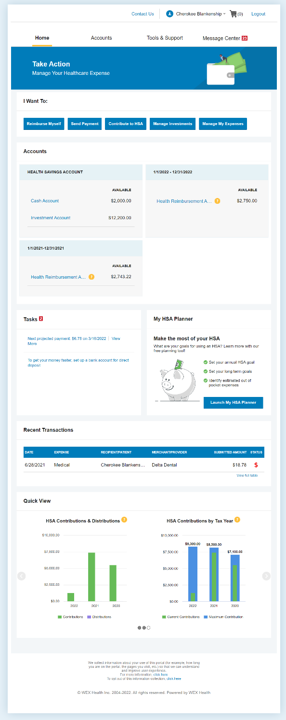
HOW DO I GET ASSISTANCE WITH MY CLAIM?  - From any page you can open the Let’s Chat window from the bottom right icon.  - Asking about claim denial or claims needing receipt will prompt the chat window to help you review your claims and find where you can attach receipts.  HOW DO I FILE A CLAIM AND UPLOAD A RECEIPT?  - On the Home Page, you may simply select “Reimburse Myself”, OR from any page on the portal, expand the Accounts tab on the top of the screen.  - The claim filing wizard will walk you through the request including entry of information, payee details and uploading a receipt.  - For submitting more than one claim, click Add Another, from the Transaction Summary page.  - When all claims are entered in the Transaction Summary, agree to the terms and conditions click Submit to send the claims for processing.  - The Claim Confirmation page displays. You may print the Claim Confirmation Form as a record of your submission. If you did not upload a receipt, you can upload the receipt from this screen or print a Claim Confirmation Form to submit to the administrator with the required receipts.  NOTE: If you see a Receipts Needed link in the Tasks section of your Home Page, click on it. You will be taken to the Claims page where you can see the claims that require documentation. You can easily upload the receipts from this page or use one of your Mobile Quick Receipts. | 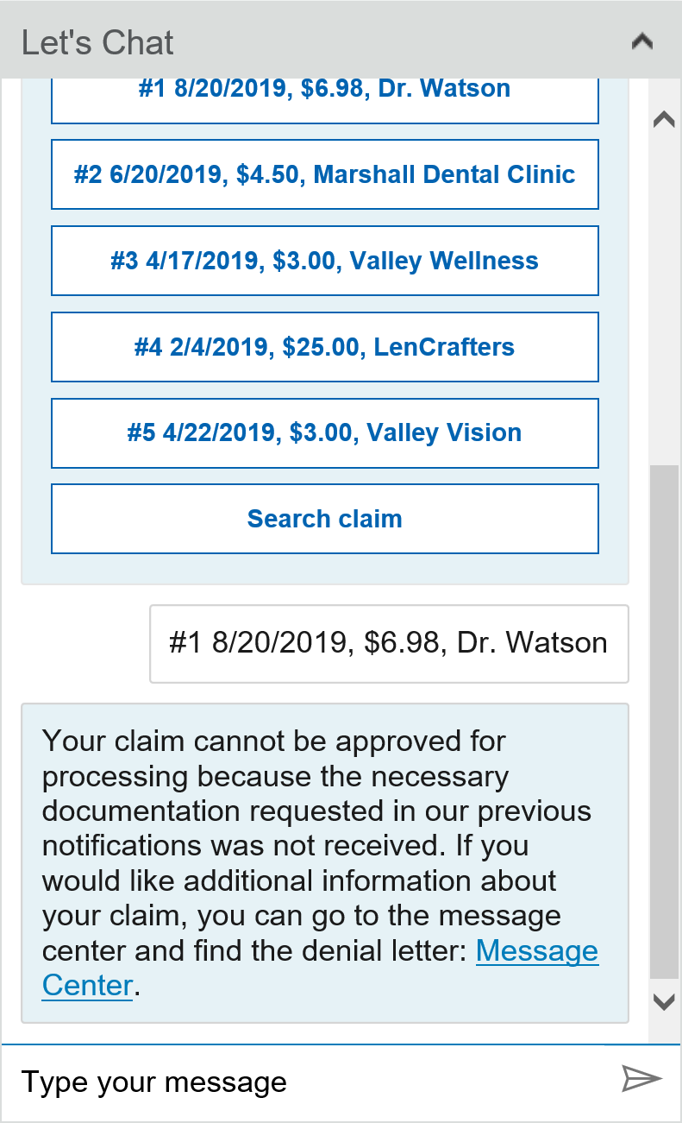  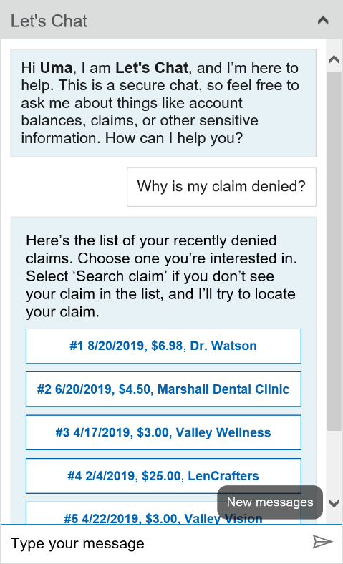  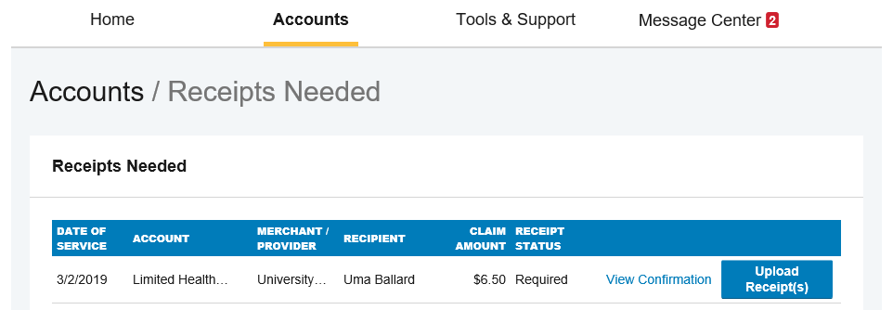
HOW DO I VIEW CURRENT ACCOUNT BALANCES AND ACTIVITY?  - For current Account Balance only, on the Home Page, see the Accounts section.  - For all Account Activity, click on the Accounts tab from the Home Page to bring you to the Account Summary page. Then you may select the underlined dollar amounts for more detail. For example, click on the amount under “Eligible Amount” to view enrollment detail.  NOTE: You can see election details by clicking to expand the line item for each account. | 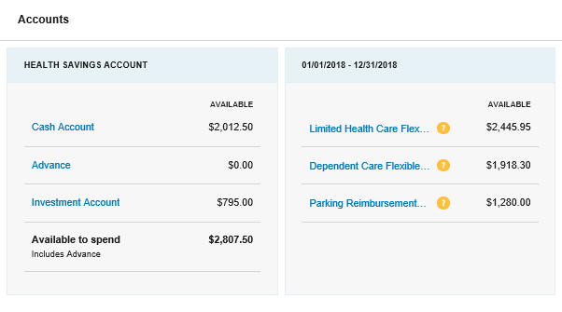  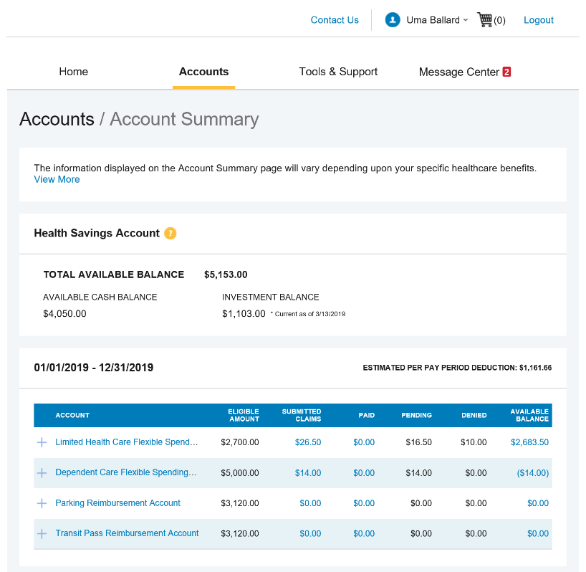
ALL HEALTH CARE EXPENSE ACTIVITY IN ONE PLACE  To view and manage ALL healthcare expense activity from EVERY source, use the Dashboard  - Under the Accounts menu is the Dashboard. The Dashboard provides you with an easy-to-use consolidated view of healthcare expenses for ongoing management of premiums.  - Easily filter expenses by clicking on the filter options on the navigation pane on the left side of the screen or, by clicking on the field headers within the Dashboard.  - Expenses can be exported into an Excel spreadsheet by clicking on the Export Expenses button on the top of the page. | 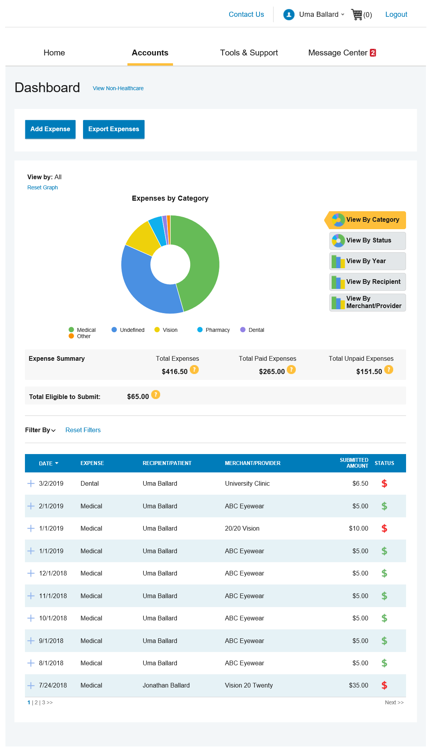
HOW DO I ADD AN EXPENSE TO THE DASHBOARD?
- From the Dashboard click on the Add Expense button on the top of the page.
- Complete the expense detail fields. You can even upload a copy of the receipt and, add notes for your records.
- Once the expense has been added to the Dashboard you can pay the expense, if desired.

HOW DO I PAY AN EXPENSE?

- You may process payments/ reimbursements for unpaid expenses directly from the Dashboard page.
- Expenses will be categorized, and payment can be initiated for unpaid expenses by clicking on the button to the right of the expense details.
- Simply choose which expenses you would like paid and you will be presented with the eligible accounts from which you can initiate payment.
- When you click Pay, the claim details from the Dashboard will be pre-populated within the claim form. Review & edit the claim details as needed.
- You will have the option to request a reimbursement to yourself.

HOW DO I EDIT AN EXISTING EXPENSE IN THE DASHBOARD?  - You can edit expense details for all claim statuses directly from the Dashboard page.  - Expand the claim details visible by clicking on the expense line item from the Dashboard.  - You will be presented with options to add expense notes, update the expense details, mark the expense as paid/unpaid or, remove the expense from the Dashboard. | 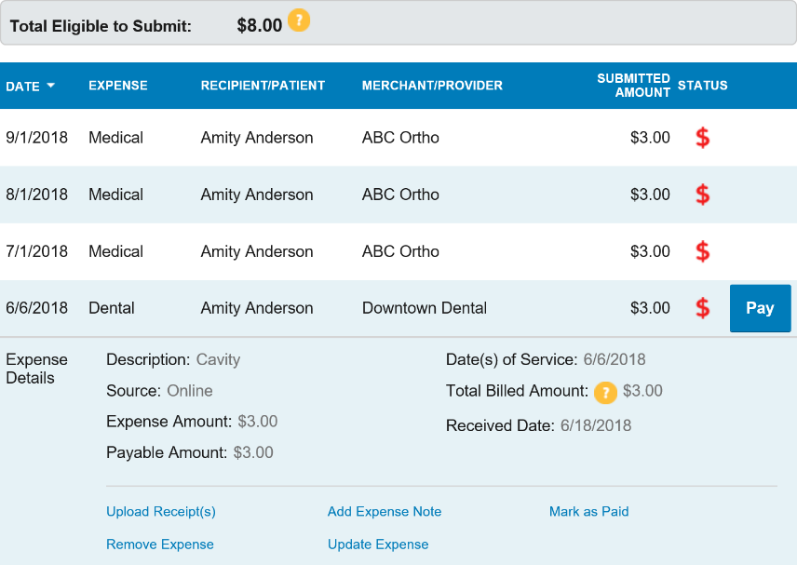
HOW DO I VIEW MY CLAIMS HISTORY AND STATUS?  - From the Home Page, click on the Accounts Tab, and then click on the Claims link to see your claims history. You can apply filters from the top of the screen. You can filter by plan year, account type, claim status or receipt status.  - By clicking on the line of the claim, you can expand the data to display additional claim details.  Did you Know? For an alternative perspective, you may also view claims history and status for all claim types on the Dashboard page. You can apply filters from the top of the screen. Filter options on the Dashboard screen include: expense type, status, date, recipient or merchant/provider. You may also search for a specific expense by entering a description into the search field. | 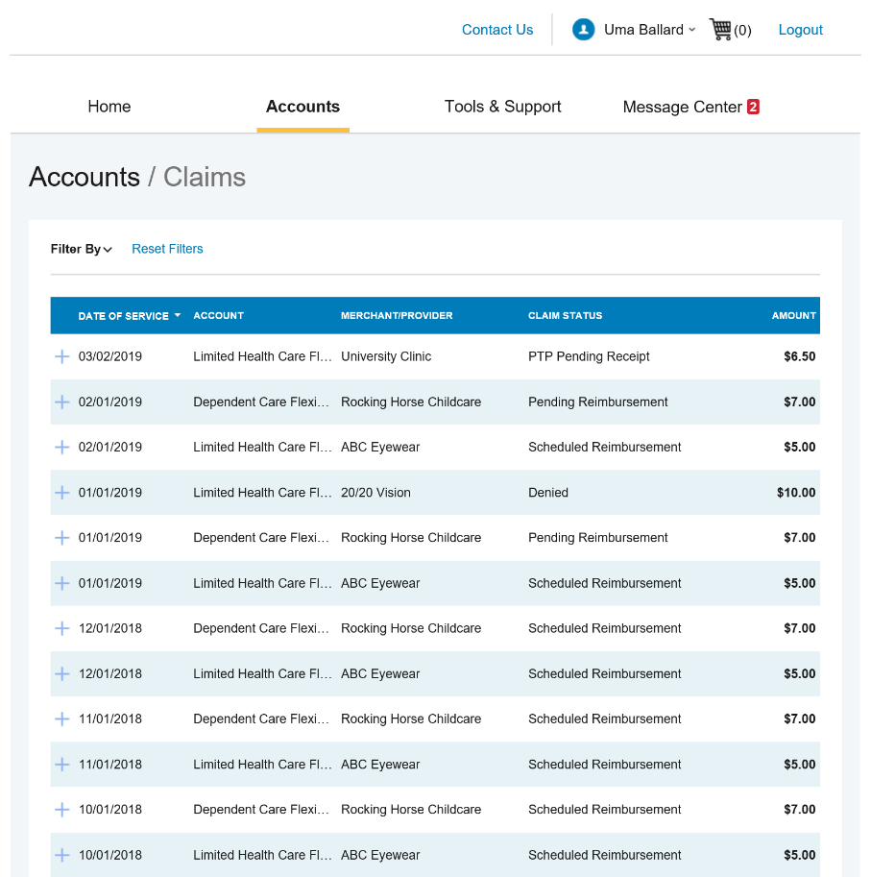
HOW DO I VIEW MY PAYMENT (REIMBURSEMENT) HISTORY?  - From the Home Page, under the Accounts tab, click Payments. You will see reimbursement payments made to date.  - By clicking on the line of a payment, you can expand the data to display additional details about the transaction. | 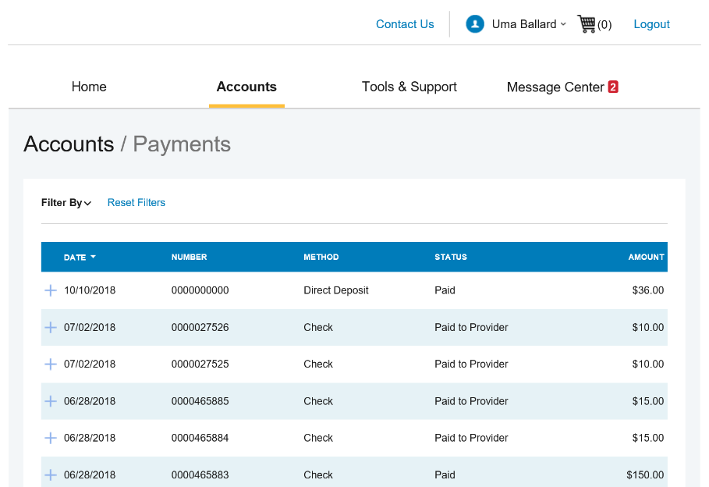
HOW DO I UPDATE MY PERSONAL PROFILE?  - From the Home Page, under the Accounts Tab, you will find links to update profile information including profile summary details and covered dependents.  - Click the appropriate link under Profile for your updates: Update Profile or Add/Update Dependent. Some profile changes will require you to answer an additional security question.  - Complete your changes in the form.  - Click Submit. | 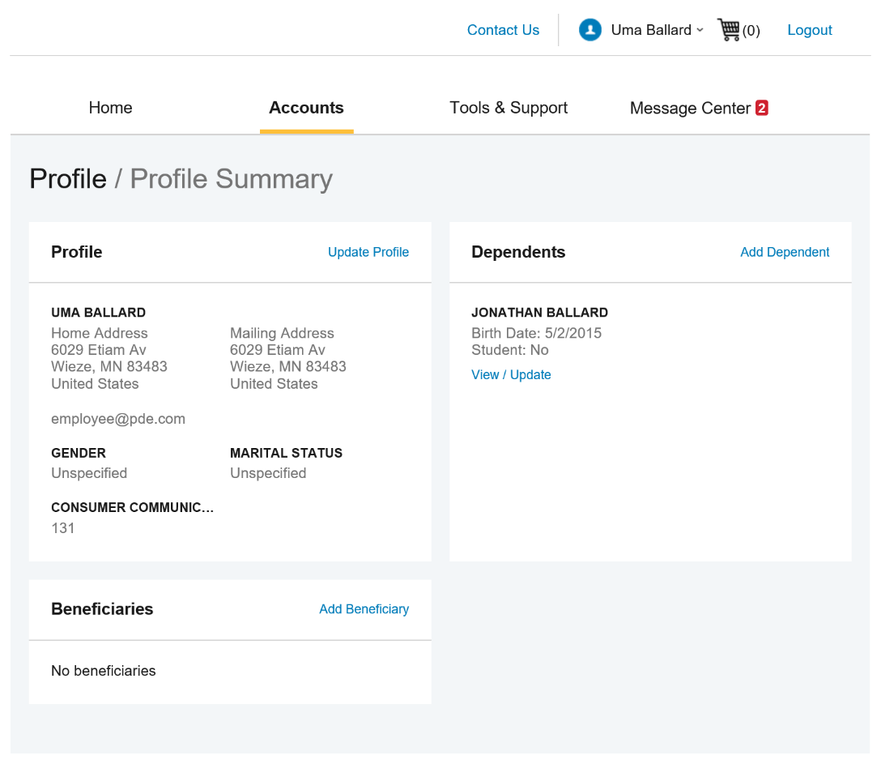
HOW DO I GET MY REIMBURSEMENT FASTER?  The fastest way to get your money is to sign up online for direct deposit to your personal checking account. Before you begin, make sure that your employer is offering direct deposit setup online.  - From the Home Page, under the Tools & Support tab, click Change Payment Method under the “How Do I” section  - Select Update for the appropriate plans. Update the secondary reimbursement method to Direct Deposit.  - Enter your bank account information and click Submit.  - The Payment Method Changed confirmation displays. | 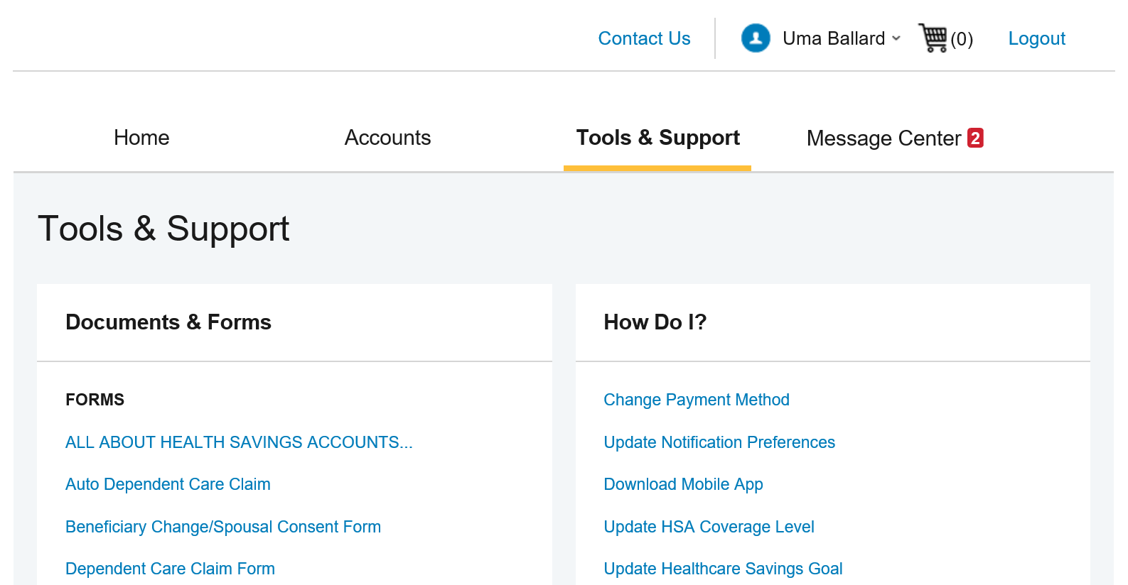
HOW DO I CHANGE MY LOGIN AND/OR PASSWORD?  - From the Home Page, click on the Accounts Tab, and click Login Information.  - Follow instructions on the screen.  - Click Save. | 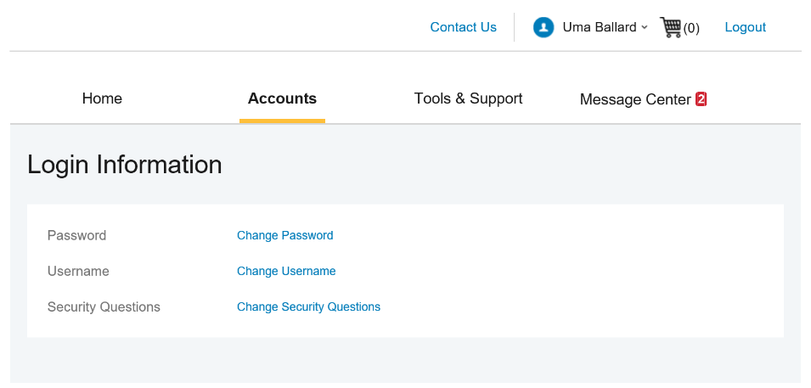
HOW DO I VIEW OR ACCESS:  …DOCUMENTS & FORMS?  - From the Home Page, click the Tools & Support tab.  - Click any form or document of your choice.  …NOTIFICATIONS?  - From the Home Page, click the Message Center tab.  - Click any link of your choice. You will be able to view and archive current documents, as well as reference documents archived previously.  - In addition, you can Update Notification Preferences by clicking on the link next to Notifications.  …PLAN INFORMATION?  - On the Home Page, under the Accounts Tab, you will be directed to the Account Summary page  - Click onto the applicable account name and the Plan Rules will open in a pop-up window.  OR from the Home Page, under the Tools & Support page, you may view Plan Summaries for basic information. Then click each applicable plan to see the plan details. | 