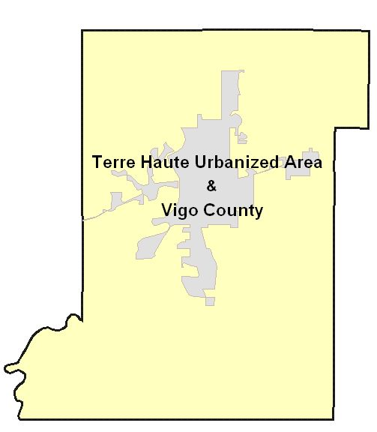

Coordinated
Public
Transit
Human
Services
Transportation
Plan



Prepared By:

Metropolitan Planning Organization
West Central Indiana Economic Development District, Inc.
1718 Wabash Avenue,
Terre Haute, Indiana 47807

Revised: October 3, 2019

The preparation of this document was financed in part by funds from the Federal Highway Administration and the Federal Transit Administration through the Indiana Department of Transportation. Matching Funds were provided by Vigo County and the City of Terre Haute. The content of this document reflects the views of the West Central Indiana Economic Development District. They do not necessarily reflect the views or policies of the Federal Highway Administration or the Federal Transit Administration.
Table of Contents
Adopting Resolution 3
Introduction 4
Background 4
Organization of the Coordinated Plan 5
Plan Adoption 6
Section I - Grant Program Overview 7
Section 5310 - Assistance to the Elderly and Persons with Disabilities Program 7
Section 5316 - Job Access and Reverse Commute (JARC) Program
Section 5317 - New Freedom Program
Section II – Demographics & Existing Services Assessment 8
Metropolitan Planning Area (MPA) Demographics 8
Area Description 8
Population 8
Distribution of Population by Age 9
Disabled Persons 10
Per Capita Personal Income & Poverty Levels 11
Unemployment 13
Methodology for Determining Existing Services 14
Existing Public Transit and Human Services Transportation Providers 15
Provider: Terre Haute Transit Utility 15
Provider: Area 7 Council on Aging and Rural Transit (Operated by WCIEDD) 16
Provider: Trans Care, Inc. 16
Provider: Yellow Cab
Provider: Hamilton Center 16
Provider: Rides Mass Transit District …………………………………………………..17
Section III - Public Participation 17
Section IV - Gaps, Needs, Priorities and Strategies 18
Service Gap 1 – Publication Education 18
Gap Discussion 18
Recommended Strategies 18
Service Gap 2 – Expand Hours 19
Gap Discussion 19
Recommended Strategies 19
Service Gap 3 – Expand Wheelchair Service 19
Gap Discussion 19
Recommended Strategies Make 19
Gap Discussion 20
Recommend Strategies 20
Appendix A - Services Providers for Elderly, Low-Income or Disabled Individuals 21
Appendix B - MPO Telephone Survey Questionnaire: General Questions 22
Appendix C - Transportation Service Provider Listing 23
Appendix D – Coordinated Planning Membership List 25
Appendix E - Public Meeting Minutes 26

List of Figures

Figure 1 - Vigo County Metropolitan Planning Area Map 5
Figure 2 - 2010 MPA Population Estimate 9
Figure 3 - 2010 Census Population Distributions by Census Tract 9
Figure 4 - 2010 Distribution of Population by Age 10
Figure 5 - 2010 Census Distribution of Older Population by Census Tract 10
Figure 6 - 2010 Census Distributions of Individuals with Disabilities by Census Tract 11
Figure 7 - 2010 Census Distributions of Local-Income Individuals by Census Tract 12
Figure 8 - 2010 Census Distribution of Low-Income Families by Census Tract 13
Figure 9 - 2010 Census Distribution of Worker by Age and Census Tract 14

List of Tables

Table 1 - Allocation of Program Funds for Indiana
Table 2 - Indiana FFY-07 Apportionment of Funds by Population
Table 3 - Per Capita Income & Federal Assistance Programs 12
Table 4 - Public Transportation Needs Summary 18

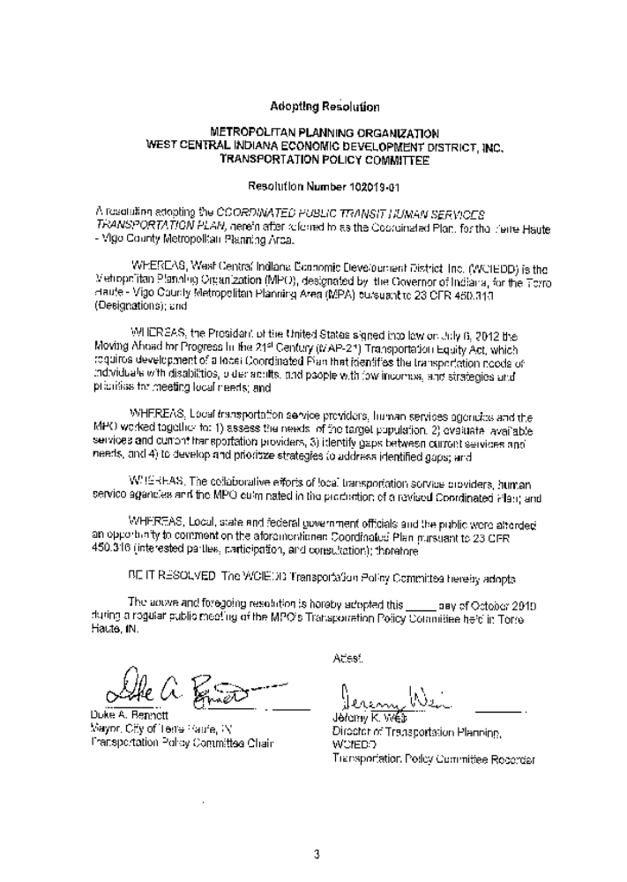

Introduction

Background
Public transportation is a long-term and growing concerning for many residents of Terre Haute and Vigo County. For many low-income, elderly, and disabled individuals (sensitive populations), public transportation is the only means for accessing essential services, including medical care, social services, vital retail needs (such as grocery stores), government centers and educational facilities. Additionally, public transportation provides a means for those individuals without access to a car to reach employment and job-training opportunities.

Federal, state, and local governments, private and public non-profit organizations, and commercial operators must recognize the importance of public transportation services for low income, elderly and disabled individuals. In recognition of this need, there is a growing demand for both financial support and assistance in delivering critical transportation services.

Through legislative action governing the distribution of transportation funds, the federal government has made it clear local organizations need to improve transportation for sensitive populations in order to remove barriers between individuals and the services necessary to help them maintain productive and independent lives. Historically, a major obstacle in efforts to improve services has been a lack of effective coordination between public transit providers, employers and human service program providers. Therefore, in the federal transportation bill passed on July 6, 2012 (the Moving Ahead for Progress in the 21st Century), Efficient Transportation Equity Act: A Legacy for Users, or MAP-21), Congress established a new requirement for the funding of projects under the Federal Transit Administration’s (FTA) Special Needs of Elderly Individuals and Individuals with Disabilities (5310), Job Access and Reverse Commute (JARC) (5316), and New Freedom (5317) programs.

As a result of the new MAP-21 legislation, designated recipients of these grants can now only approve funding for those projects that are derived from a locally developed, Coordinated Public Transit-Human Services Transportation Plan (hereafter called the Coordinated Plan). Projects identified through the coordinated planning process, and selected for FTA funding, must be incorporated into both the Transportation Improvement Program (TIP) and Statewide Transportation Improvement Program (STIP).

The aim of the Coordinated Plan is to aid in creating unified transit services for the targeted populations by helping to guide funding for projects that maximize the area-wide goals and eliminate redundancy in services offered by various transportation and human service entities. The targeted populations are those transportation dependant individuals having inadequate access to private vehicles or those unable to operate private vehicles.

This plan will be developed through a process that includes consultation with representatives of public, private, and non-profit transportation and human service providers, as well as the public.

At a minimum, this Coordinated Plan will be updated on a four year cycle. However, the plan may be amended or updated at any time to meet local identified needs.

As the Metropolitan Planning Organization (MPO) for Terre Haute and Vigo County, West Central Indiana Economic Development District (WCIEDD) serves as the lead agency for development and maintenance of the Coordinated Plan. The plan covers the entire Terre Haute – Vigo County Metropolitan Planning Area (MPA), which includes all of the Terre Haute Urbanized Area (City of Terre Haute, Town Seelyville, Town of West Terre Haute, urbanized portions Vigo County), rural Vigo County, and part of Clay County which includes Brazil, Harmony and Knightsville.

Figure 1 – Terre Haute - Vigo County Metropolitan Planning Area Map

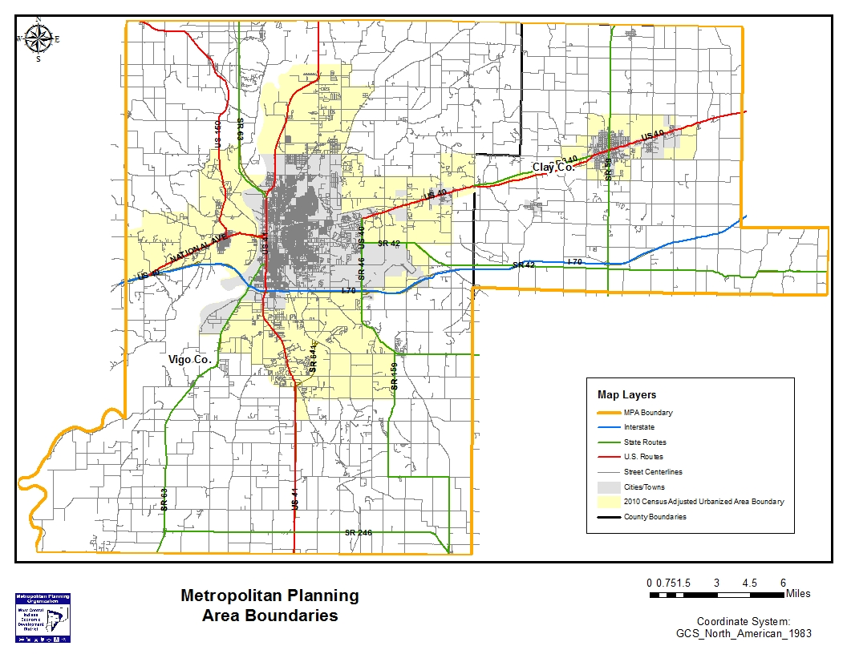

Organization of the Coordinated Plan
This plan follows general recommendations for organization and content issued by the FTA. Therefore, it addresses the following mandatory elements:

- An assessment of transportation needs for individuals with disabilities, older adults and people with low incomes;
- An assessment of available services that identifies current transportation providers (public, private, and non-profit);
- Strategies to address the identified gaps between current services and needs, as well as opportunities to improve efficiencies in service delivery; and
- Priorities for implementation of strategies.

The remaining portion of this plan is organized into three sections:

Section I – Provides a list of currently available transportation services for the populations previously identified. In addition, this section presents an overview of the MPA’s demographic distributions for the elderly, disabled, and low income.

Section II – Describes the actions and activities used to help promote public and community involvement in the creation and continued development of the Coordinated Plan.

Section III – Summarizes existing gaps/needs in transportation services and lists the strategies/activities and priorities to address the identified gaps in service.

Plan Adoption
In order to ensure coordination and consistency between the coordinated planning process and the metropolitan planning process, the MPO’s Transportation Policy Committee serves as the local agency responsible for adoption and approval of this plan.

Section I - Grant Program Overview

Section 5310 - Assistance to the Elderly and Persons with Disabilities Program

Section 5310 funds are a form of financial assistance for transportation services planned, designed, and carried out to meet the special transportation needs of the elderly and persons with disabilities in all areas—urbanized, small urban, and rural. In Indiana, the current designated recipient for the Section 5310 Program is the Indiana Department of Transportation (INDOT). INDOT evaluates and awards Section 5310 funds to sub-recipients statewide. The MPO assists INDOT in the application and evaluation process for grants under this program.

Congress establishes the allocation levels for the Section 5310 Program through a formula based on the population of elderly and disabled in each state. Funds are available to private non-profit organizations, or public bodies the state approves to coordinate services for the elderly and persons with disabilities, or public bodies which certify to the governor that no non-profit organizations or associations are readily available in an area to provide the service. Local public bodies eligible to apply for Section 5310 funds as coordinators of services for elderly persons and the disabled are those that the state designates to coordinate human service activities in a particular area.

Section 5310 Program Federal funds can fund no more than 80% of the total eligible capital and program administrative costs for approved projects. There is an exception to this ratio for vehicle related equipment required by the Clean Air Act Amendments of 1990 (CAAA) or the Americans with Disabilities Act of 1990 (ADA). The federal share is 90% for vehicle related equipment required by CAAA or ADA. Only the incremental cost of the equipment required by the ADA or CAAA may be funded at 90%, not the entire cost of the vehicle, even if the vehicle is purchased for use in services required by the ADA or CAAA.

Under FTA guidelines, Section 5310 Program funds are available for capital expenses to support the provision of transportation services to meet the special needs of elderly persons and persons with disabilities. Examples of capital expenditures include, but are not limited to:

- Vehicles,
- Radios,
- Vehicle shelters,
- Wheelchair lifts and restraints,
- Vehicle rehabilitation, manufacture, or overhaul,
- Preventative maintenance, defined as all maintenance costs,
- Extended warranties which do not exceed the industry standard,
- Microcomputer hardware and software,
- Initial component installation costs,
- Vehicle procurement, testing, inspection and acceptance costs,
- Lease of equipment when lease is more cost effective than purchase,
- Acquisition of transportation services under a contract, lease, or other arrangement. Eligible capital expenses may also include, at the option of the sub-recipient, the acquisition of transportation services under a contract, lease or other arrangement. Both capital and operating costs associated with contracted service are eligible expenses. User-side subsidies are considered one form of eligible arrangement. The state, as recipient, has the option to decide whether to provide funding for such acquired services. Funds may be requested for contracted services covering a time period of more than one year,

- The introduction of new technology, through innovative and improved, products, into mass transportation, and

- Transit related intelligent transportation systems.

The INDOT Public Transit Section manages the Section 5310 Program.

Section II – Demographics & Existing Services Assessment

Metropolitan Planning Area (MPA) Demographics

Area Description
The MPA encompasses all of Vigo County (403.3 sq. miles). As of the 2012 Census, the urbanized area includes the City of Terre Haute, Town of West Terre Haute, Town of Seelyville, Town of Riley and part of Clay County which includes the Town of Brazil, Harmony, and Knightsville. Terre Haute is the largest city in the MPA.

Population
According to the Census Bureau, the estimated 2010 population of the MPA was 107,848. Although this amounts to a 4.7% increase in population since the last census was conducted in 2010.

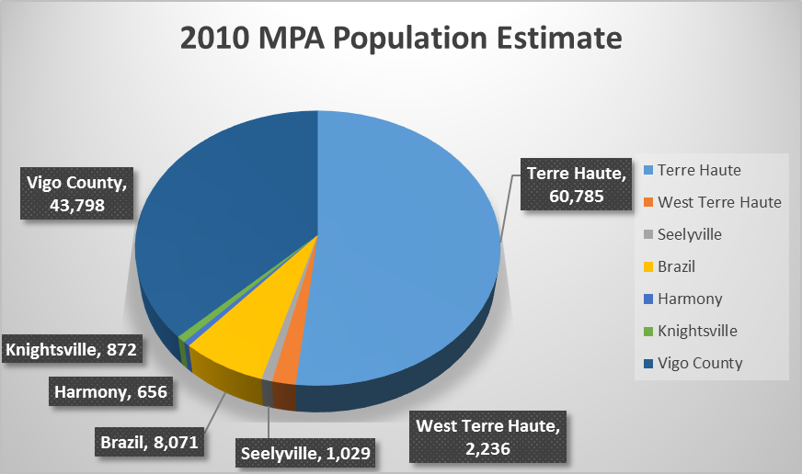

Figure 2 - 2010 MPA Population Estimate

Figure 3 below depicts Census Tract population distribution within the MPA according to the 2010 Census.

Figure 3 - 2010 Census Population Distributions by Census Tract

Distribution of Population by Age
The following chart describes the Census Bureau’s estimate of the distribution of population by age in the MPA for 2010. The bureau defines elderly as any individual age 65 years or older.

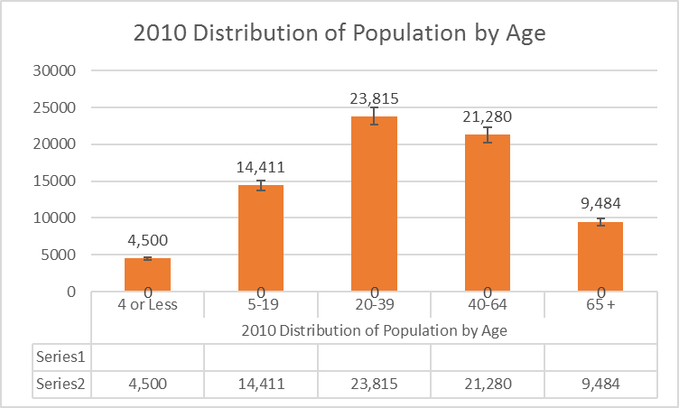

Figure 4 - 2010 Distribution of Population by Age

The following map illustrates where older adults (65 plus) reside in the MPA according to the 2010 Census.
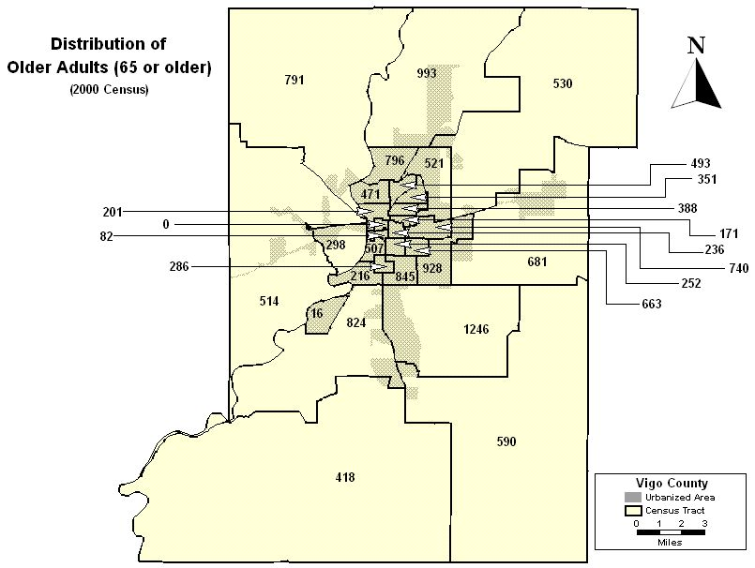
Figure 5 - 2010 Census Distribution of Older Population by Census Tract

Disabled Persons
During the 2010 Census 19,901 individuals in the MPA identified themselves as being disabled. The Census Bureau defines a disable person as a person, five years of age or older, having a long term physical, sensory, and mental or self-care disability. Additionally, the definition includes anyone 5 years or older who reported they had difficulty leaving their home because of a physical, sensory, mental, or self care disability and anyone between the ages of 16 and 64 who reported having difficulty working because of a physical, mental, or emotional condition that lasted 6 months or more were considered disabled.

The next map depicts the distribution of disabled persons by Census Tract in the MPA as a result of the 2010 Census.

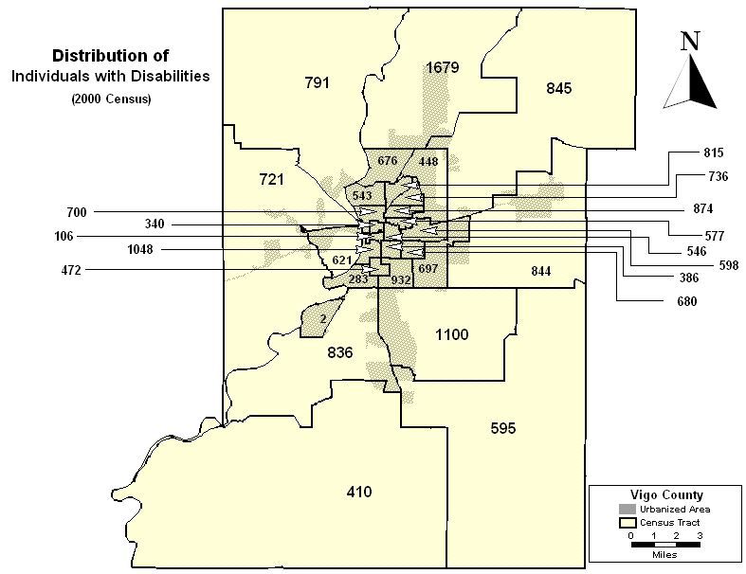
Figure 6 - 2010 Census Distributions of Individuals with Disabilities by Census Tract

Per Capita Personal Income & Poverty Levels
Per Capita Personal Income (PCPI) is the most commonly used tool employed by economists to measure an area’s economic strength. The following table provides a snapshot of PCPI within the MPA and information related to participation in federal assistance programs in relation to Indiana’s 92 counties.

Income and Poverty | Number | Rank in State
Per Capita Personal Income (annual) in 2005 | $27,425 | 47
Median Household Income in 2004 | $35,736 | 89
Poverty Rate in 2004 | 15.40% | 1
Poverty Rate among Children under 18 | 21.30% | 3
Welfare (TANF) Monthly Average Families in 2005 | 1,008 | 9
Food stamp Recipients in 2005 | 11,997 | 9
Free and Reduced Fee Lunch Recipients in 2006 | 7,730 | 8
Sources: U.S. Bureau of Economic Analysis; US Census Bureau; Indiana Family Social Services
Administration; Indiana Department of Education
Table 1 - Per Capita Income & Federal Assistance Programs

The following maps show the distribution of low-income individuals and families by Census Tract according to the 2010 Census.

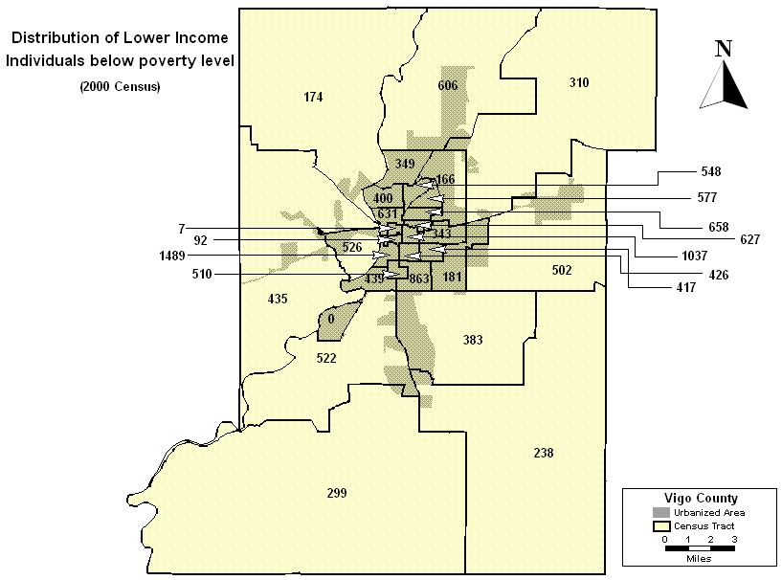
Figure 7 - 2010 Census Distributions of Local-Income Individuals by Census Tract

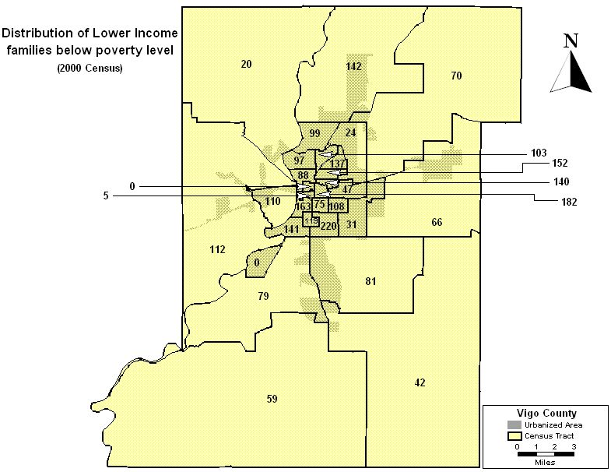
Figure 8 - 2010 Census Distribution of Low-Income Families by Census Tract

Unemployment
According to the Bureau of Labor Statistics and the Indiana Department of Workforce Development, the 2006 unemployment rate for the MPA was 6.3%. As of June 2007 the rate dropped to 5.7%. Figure 9 depicts distribution of workers as of the 2000 Census.

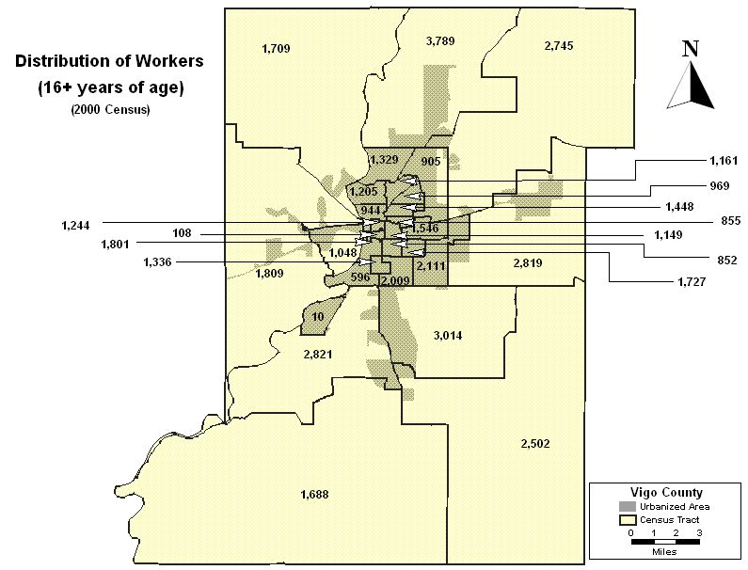
Figure 9 - 2010 Census Distribution of Worker by Age and Census Tract

Methodology for Determining Existing Services
Several sources were used to gather information on existing transit services providers in the service area.

The Indiana Statewide Public Transportation Needs Assessment Study, produced by INDOT, provides an overview of transit services in each county in the state.

The Statewide Needs Assessments identifies demographic conditions in each county, existing services, and highlights potential areas to improve services to sensitive populations. Comparisons among similar counties are also provided. The MPO encountered some difficulty in using this data though, as INDOT uses different definitions for classifying individuals as elderly, disabled, and low-income than the U.S. Census Bureau. Differences in data collection methodology may also account for variations between information in this INDOT report and U.S. Census Bureau data sets.

The 2004 Annual Report on Indiana Public Transit provides summaries of existing public transit systems throughout the state, as well as an annual review of public transit programs and services, including the Section 5310 and JARC programs. The report also lists Section 5310 transportation providers and other transit partners and advocates throughout the state. In 2004, INDOT recognized two public transit systems in this MPA.

Social service organizations also maintain additional information on potential transportation providers for the elderly, disabled or individuals with limited income.

The Transportation Advisory Committee (TAC) serves as the coordinated group of local providers whose members assist and partner with each other to maintain information on community needs for the MPO and surrounding counties. The TAC maintains a current listing of transportation service providers, which was used to identify providers in the MPA. A copy of this listing is included as Appendix A.

Finally, the MPO searched telephone directories, on-line directories and websites for previously identified partners and service providers, and for information on any additional transportation providers not yet identified.

The MPO identified a total of 20 unique providers who offer some form of transportation or transportation funding assistance for elderly, low-income, or disabled individuals in the MPA. The MPO could not reach 10 of these providers by either telephone or mail, and two providers never responded to voice mail messages to please contact the MPO. The MPO made repeated attempts to contact those providers with functioning telephone numbers, and left messages with those services that answered the telephone, but could not provide information at the time of contact. Those that did not respond to the MPO’s inquiries (either by not having functioning telephone numbers or not responding to calls) remain in the inventory, but no information was recorded on their services.

During August and September 2019, the MPO surveyed those providers it successfully contacted. The MPO questioned these providers on the details of their transportation services and solicited provider input on potential unmet needs in the MPA. This information was then compiled in a database and served as a source for the assessment of existing services and the identification of community and regional needs. A copy of the questionnaire used to structure provider interviews is included as Appendix B and a list of all providers in the MPA is included as Appendix C.

Existing Public Transit and Human Services Transportation Providers
The MPO identified six (6) providers in the MPA. Of those six providers, five responded by providing complete data through surveys and telephone interviews. Several senior citizen housing facilities and nursing homes also provide services, but none of these providers chose to respond to the MPO request to provide data.

Provider: Terre Haute Transit Utility
Size of Fleet: 14 Buses Wheelchair Accessible Vehicles: 14

Hours of Operation: Monday – Saturday, 6:00 a.m. to 11:00 p.m.

Services Provided: Demand response services and fixed route system

Cost: Cost per one-way bus trip is $1.75. Seniors and the disabled can ride for $.85 half price. The Wheels to the World (paratransit service) cost is $2.25 per one-way trip.

Provider: Area 7 Council on Aging and Rural Transit (Operated by WCIEDD)
Size of Fleet: 5 Buses Wheelchair Accessible Vehicles: 5

Hours of Operation: Monday – Friday, 8:00 a.m. to 4:30 p.m.

Services Provided: Demand response services for the elderly and disabled individuals who live anywhere in the MPA, and rural transit services for individuals who live outside the city limits of Terre Haute.

Cost: Those who qualify for the Senior and Disabled Program can ride for a donation fee. The cost to the general public for a one-way trip is $2.00.

Provider: E2 TAXI
Size of Fleet: 3 Vehicles

Hours of Operation: 24/7

Phone: 812-230-1598

Provider: Hamilton Center
Size of Fleet: 20 Vehicles Wheelchair Accessible Vehicles: 6

Hours of Operation: Monday – Friday, 7:00 a.m. to 5:30 p.m.
24 x 7 – Private pay customers

Services Provided: Demand response services to private pay clients in and around the City of Terre Haute and Vigo County.

Cost: Base on program participation

Provider: Rides Mass Transit District (IL)

Wheelchair Accessible Vehicles Hours: 8 a.m. – 5 p.m. Monday – Friday

Apply for Senior Card for free rides for 60 and over. Door to door service.

217-466-6921

Section III - Public Participation

A key component of this plan is the representation of public opinion and interests in the findings and development of strategies. The organizations and agencies listed in Appendix D participated in this planning effort and have expressed an interest in continuing their participation in this on-going planning effort.

The TAC conducted an initial Feasibility Study in 2002 and updated the information again in 2019. The group used U.S. Census and administrative data, information gathered during focus group meetings conducted with health and human services providers and others, and the results of surveys randomly sent out to over 3,000 households in the MPA. The MPO used this information, coupled with the data collected from the service providers interviewed, to form the basis of the initial assessment of community needs.

The committee recommended the MPO try to contact additional providers and that information on existing services be expanded. They also clarified their impressions of community needs and provided feedback on proposed strategies. Comments received during this meeting were incorporated into the Coordinated Plan. Minutes of this meeting and a list of attendees are included in Appendix E.

On October 9, 2019 an updated version of the Coordinated Plan was presented to the TAC for review and comment. The committee then validated and prioritized immediate needs and strategies to: 1) extend bus service hours of operation, 2) develop better public awareness about available services and 3) to resolve problems associated with oversized wheelchairs. To help raise public awareness about the Coordinated Plan.

Before final adoption of the Draft Coordinated Plan by the Transportation Policy Committee, the MPO will distribute copies of the plan to INDOT, FTA, Federal Highway Administration (FHWA), local government representatives and service providers for review and comment. The plan will also be made for public comment by posting it on the Transportation Page of the WCIEDD Web Site for a minimum of 10 days.

Section III - Gaps, Needs, Priorities and Strategies

Survey results analysis and meetings held with agencies involved in serving those with disabilities, older adults and persons with limited income (target population) resulted in the identification of the broad service gaps and needs listed in Table 4 below. Participating service providers helped prioritize these gaps and needs through group discussions using a consensus based approach.

Terre Haute Urbanized Area & Vigo County Metropolitan Planning Area
Public Transportation Needs Summary
Service Gap | Priority | Need
1 | 1 | Public Education
2 | 2 | Expand Hours
3 | 3 | Improve Wheelchair Service
4 | 4 | Increase Provider Coordination
Source: Analysis of 2019 MPO Surveys and Workshop Inputs
Table 2 - Public Transportation Needs Summary

Service Gap 1 – Publication Education

Gap Discussion
Interviews and survey results clearly indicate there is a general lack of public awareness about the accessibility of existing public and private transportation services available to the target population in the MPA. This is the second time this shortcoming has been identified during a major transit service gap analysis.

Recommended Strategies
- Develop, publish and widely distribute a brochure that provides information on available services, costs and who to contact for more information;
- Seek out and take advantage of opportunities to promote the availability of services to groups and organizations that either work with or have an interest in the target population (i.e. local medical groups and associations, senior citizen centers, service clubs, potential employers, etc.);
- Actively engage the media in helping to promote the availability of services to the target population;
- Increase and publicize opportunities for the target population to become more involved in the development of public transportation plans and programs;
- Encourage strong community support of transit funding and transit service program development for the target population; and
- Encourage participation by the local chamber of commerce and major employers in the development and implementation of public transportation plans that help meet the needs of the target population.

Service Gap 2 – Expand Hours

Gap Discussion
Survey results indicate there is a clear need to provide expanded hours of service for the target population during the early morning hours, in the evening and on weekends and holidays. However, the cost of providing expanded services hours would have to be subsidized since a large percentage of the target population cannot afford to pay full fare for the services.

Recommended Strategies
- Aggressively seek out and apply for federal and state transit program funds that reduce local service provider capital investments, operating costs and maintenance costs so providers can afford to provide expanded hours of service to the target population at a reasonable price;
- Actively search for and participate in federal and state programs that help subsidize the cost of meeting the transportation needs of the target population;
- Through cooperative agreements or contracts, develop new partnerships to share resources (vehicles and drivers) to offer expanded services to the target population; and
- Create new express routes to provide service to heavy demand locations during off-hours.

Service Gap 3 – Expand Wheelchair Service

Gap Discussion
Service providers are challenged to meet the needs of wheelchair bound and limited-mobility clients. A number of existing paratransit vehicles cannot accommodate the size and weight of modern wheelchairs and wheelchair-bound clients. In addition, many of these clients need an aide worker to ride with them since they need assistance in leaving and entering their homes, carrying items, and boarding and leaving vehicles. Finally, there is a growing demand to provide services beyond transportation to medical appointments for these clients.

Recommended Strategies Make
- Leverage the use of available federal, state, local and private funding to procure paratransit vehicles designed to meet the needs of wheelchair bound or limited-mobility clients;
- Endeavor to expand paratransit services beyond those services required to meet the health care needs of the disabled; and
- Forge new partnerships between paratransit service providers that maximize the utilization of resources, reduce redundancy in services provided and help minimize the out-of-pocket costs of delivering services to the target population.

Service Gap 4 – Increase Provider Cooperation

Gap Discussion
During development of this plan it became evident there is still a need for better cooperation among providers servicing the target population. Virtually all providers are challenged to cost effectively serve the growing needs of the target population. Yet, many providers offer redundant services and little effort is made to coordinate service delivery schedules designed to meet the growing needs of the target population.

Recommend Strategies
- Improve customer service and efficiency through unified information services including:
  - Shared customer information lines;
  - Shared schedules/maps;
  - Coordinated service delivery;
  - Fare/transfer/pass agreements;
  - Reciprocal agreements for joint marketing, purchasing, training, and maintenance activities; and
  - Joint service delivery and expanded special events transportation.
  - Continued contribution of resources such as staff, demographic information and GIS resources to facilitate the transit planning process for the target population; and
  - Active participation in routine reviews of progress being made toward achieving implementation of the Coordinated Plan

The needs identified in this Coordinated Plan trace back to a general need for more cooperation between transportation services providers and the need for additional funding to meet the transportation needs of low-income, elderly and disabled individuals who reside in the MPA. In evaluating programs and grant applications, decision makers must objectively consider how the program or grant application supports or aligns itself with this plan.

Appendix A - Services Providers for Elderly, Low-Income or Disabled Individuals

Service Provider | Area Served
Terre Haute Transit Utility | City of Terre Haute
Area 7 Agency on Aging  &  Disabled and Rural Transit | All of Vigo County
Springhill Village | City of Terre Haute
First Class Limo | All of Vigo County
Hamilton Center | All of Vigo County
Westminster Village | City of Terre Haute
Bethesda Gardens | City of Terre Haute
Anthony Square | City of Terre Haute
Davis Gardens | All of Vigo County
Vigo County Schools | City of Terre Haute
Turner Coaches | All of Vigo County
Westridge Healthcare | All of Vigo County
C.A.R.S. | All of Vigo County

Appendix B - MPO Telephone Survey Questionnaire: General Questions

- Service Provider Name
- Phone Number
- Contact Name
- Type of Service Provided
- Population Served
- Area Served
- Operating Times
- Current Cost
- Funding Sources
- Future Plans and Expansions
- Interest in Federal Funds
- Area Needs/Demands
- General Notes and Observations
- Email Address

Appendix C - Transportation Service Provider Listing
NAME | ADDRESS | CITY | STATE | ZIP | PHONE # | Service Area

Public Transit Providers
T. H. Transit Utility | 901 S. 14rth Street | Terre Haute | IN | 47807 | 812-235-0109 | Terre Haute
Area 7 & Rural Transit | 1718 Wabash Avenue | Terre Haute | IN | 47807 | 812-232-2675 | Vigo County
First Class Limo | 1818 Spang Ave | Terre Haute | IN | 47805 | 812-238-1375 | Vigo County
E 2 TAXI | 1225 Voorhee’s Street | Terre Haute | IN | 47802 | 812-230-1598 | Vigo County
Rides Mass Transit District | 256 W. Court St | Paris | IL | 61944 | 217-466-6921 | Edgar County

Human Service Agency Providers
Area 7 Agency on Aging & Disabled | 1718 Wabash Avenue | Terre Haute | IN | 47807 | 812-232-2675 | Vigo County
Hamilton Center | 620 8th Avenue | Terre Haute | IN | 47804 | 812-231-8200 | Vigo County
Westminster Village | 1120 E. Davis Drive | Terre Haute | IN | 47802 | 812-232-7533 | Vigo County
Bethesda Center | 1450 E. Crossing Blvd | Terre Haute | IN | 47802 | 812-298-8209 | Vigo County
WILLS Center | 4312 S. Seventh Street | Terre Haute | IN | 47802 | 812-298-9455 | Vigo County
Work One | 30 N. 8th Street | Terre Haute | IN | 47807 | 812-234-6602 | Vigo County
Arc of Vigo County | 89 Cherry Street | Terre Haute | IN | 47807 | 812-232-4112 | Vigo County
Western Indiana Employment | 30 N 8th Street | Terre Haute | IN | 47807 | 812-234-6602 | Vigo County
Employment Plus | 4130 S. 7th Street | Terre Haute | IN | 47802 | 812-231-8500 | Vigo County
Kelly Services | 901 Wabash Avenue | Terre Haute | IN | 47807 | 812-232-7310 | Vigo County
Manpower | 20 S. 3rd Street | Terre Haute | IN | 47807 | 812-232-0373 | Vigo County
American Red Cross | 700 S. 3rd Street | Terre Haute | IN | 47807 | 812-232-3093 | Vigo County
Light House Mission | 1450 Wabash Avenue | Terre Haute | IN | 47807 | 812-232-7001 | Vigo County
Bethany House | 1402 Locust Avenue | Terre Haute | IN | 47804 | 812-232-4978 | Vigo County
Goodwill Industries | 2702 S. 3rd Street | Terre Haute | IN | 47802 | 812-235-8511 | Vigo County
Terre Haute Housing Authority | One Dreiser Square | Terre Haute | IN | 47803 | 812-232-1381 | Vigo County
Nurse Care | 790 E. Marley Drive | Terre Haute | IN | 47802 | 812- | Vigo County
Dept. of Family & Social Services | 30 N. 8th Street | Terre Haute | IN | 47807 | 812-234-0100 | Vigo County
Vigo County Health Dept | 171 Oak Street | Terre Haute | IN | 47807 | 812-462-3437 | Vigo County
Wabash Senior Center | 300 South 5th Street | Terre Haute | IN | 47807 | 812-232-3245 | Vigo County
WIC/ Headstart | 1101 South 13th Street | Terre Haute | IN | 47802 | 812-232-6306 | Vigo County
Assist, Inc. | 601 Ohio St | Terre Haute | IN | 47807 | 812-235-2578 | Vigo County

Private Transportation Providers
Anthony Square | 500 College Avenue | Terre Haute | IN | 47802 | 812-235-0002 | Vigo County
Davis Gardens | 1120 E. Davis Drive | Terre Haute | IN | 47802 | 812-232-7533 | Vigo County
Springhill Village | 1001 Springhill Rd | Terre Haute | IN | 47802 | 812-299-6300 | Vigo County
Meadows Manor East | 3300 Poplar Street | Terre Haute | IN | 47803 | 812-235-6281 | Vigo County
Peddle Park | 1616 S. 25th Street | Terre Haute | IN | 47803 | 812-235-8058 | Vigo County
Royal Oaks | 3500 Maple Avenue | Terre Haute | IN | 47804 | 812-238-1555 | Vigo County
Southwood Health Care | 2222 E. Margaret Avenue | Terre Haute | IN | 47802 | 812-232-2223 | Vigo County
Sycamore Manor | 222 S. 25th Street | Terre Haute | IN | 47803 | 812-478-2400 | Vigo County
Westridge Healthcare | 125 W. Margaret Avenue | Terre Haute | IN | 47802 | 812-232-3311 | Vigo County
Vigo County Schools | 3250 Maple Avenue | Terre Haute | IN | 47804 | 812-462-4224 | Vigo County
Maryland Community Church | 4700 S, State Rd. 46 | Terre Haute | IN | 47802 | 812-234-7100 | Vigo County
Turner Coaches | 2135 Margaret Avenue | Terre Haute | IN | 47802 | 812-232-5252 | Vigo County
C.A.R.S. | 201 N. Dorneyer | Rockville | IN | 47872 | 765-659-2076 | Vigo County

Appendix D – Coordinated Planning Membership List

Name Member
Y/N

- American Red Cross Wabash Valley Chapter Y

- Hamilton Center Y

- Southwood Health & Rehab Y

- Light House Mission Y

- Western Indiana Employment Y

- Nurse Care, Inc Y

- Mental Health America of Vigo County Y

- ADA Employment, Inc. Y

- Terre Haute Transit Utility Y

- Area 7 Agency on Aging & Disabled & Rural Y

- West Central Indiana Economic Development District Y

- Rides Mass Transit District Y

- C.A.R.S. Y

- Clay Council on Aging Y

Appendix E - Public Meeting Minutes

MPO TAC Meeting

The Terre Haute Transit Utility will begin to help meet this unfulfilled need.

