100 North Senate Avenue Room N758-RE
Indianapolis, Indiana 46204
Phone: (855)-463-6848

Mike Braun, Governor
Lyndsay Quist, Commissioner
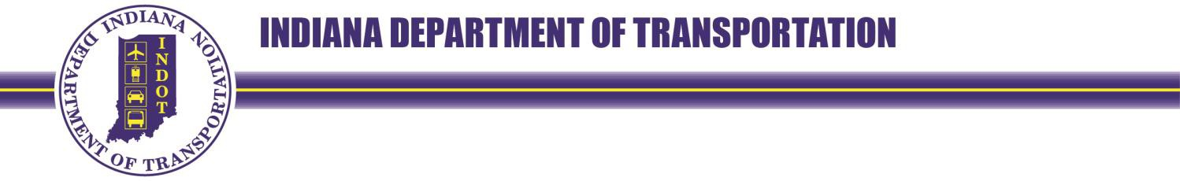
Date:
Project:
Code:
Parcel:
County:
Property Owner
Address
City, State, Zip

Dear PROPERTY OWNER,

The purpose of this notice is to inform you that the Indiana Department of Transportation (INDOT) needs to acquire property that you own, located at: 123 E State Road X, Somewhere, IN 12345, as part of a nearby transportation improvement project. We will be reaching out to you shortly with more information.

In order to expedite this process, please provide your contact information below and return this page with the included business reply envelope.

Preferred Name:
Phone Number:
Email address:
Mailing address:

Sincerely,

(Signature)
NAME, TITLE
AGENCY AND ADDRESS

Phone:
Email:
Agent of: The Indiana Department of Transportation

