Public Outreach Documentation Summary
[DATE]

Study Overview
Provide a brief overview of the study and key facts

Purpose of the Public Engagement
Detail why the public was engaged as part of this study and include dates engagement occurred

Outreach and Advertisement
Provide a summary of the outreach efforts including outreach type (e.g. public information meetings, media alert, INDOT press release) and corresponding dates

Stakeholder Advisory Committee
If established, provide details on the Stakeholder Advisory Committee’s purpose, members, meetings that occurred & their intent, and include any meeting materials / summaries as an Appendix to this document

Project Presentations
If any project presentations occurred, provide the meeting name, its date, and purpose. Include any meeting materials / summaries as an Appendix to this document

Agency Coordination
If any coordination meetings were held (e.g. with resource agencies, cultural resource stakeholders, federally recognized Tribes), provide the meeting name, its date, and purpose. Include any meeting materials / summaries as an Appendix to this document

Public Information Meeting Format
Provide dates and locations (if it was held virtually, please note it as such) the public information meetings took place as well as a detailed overview of the meeting delivery format, its agenda topics, key questions / feedback gathered, and any other pertinent information to include (e.g. meeting materials) as part of the Appendix

Public Meeting Attendance
Summarize public meeting attendees including total participants and key demographics (e.g., residents, business owners, community organizations)

Comment Summary
Provide a summary of the comments received as part of the outreach efforts
Appendix
[The appendices shared below are exemplary. This section should be updated to reflect the appropriate supplementary information for each respective Public Outreach event.]

Appendix A: INDOT Media Alert
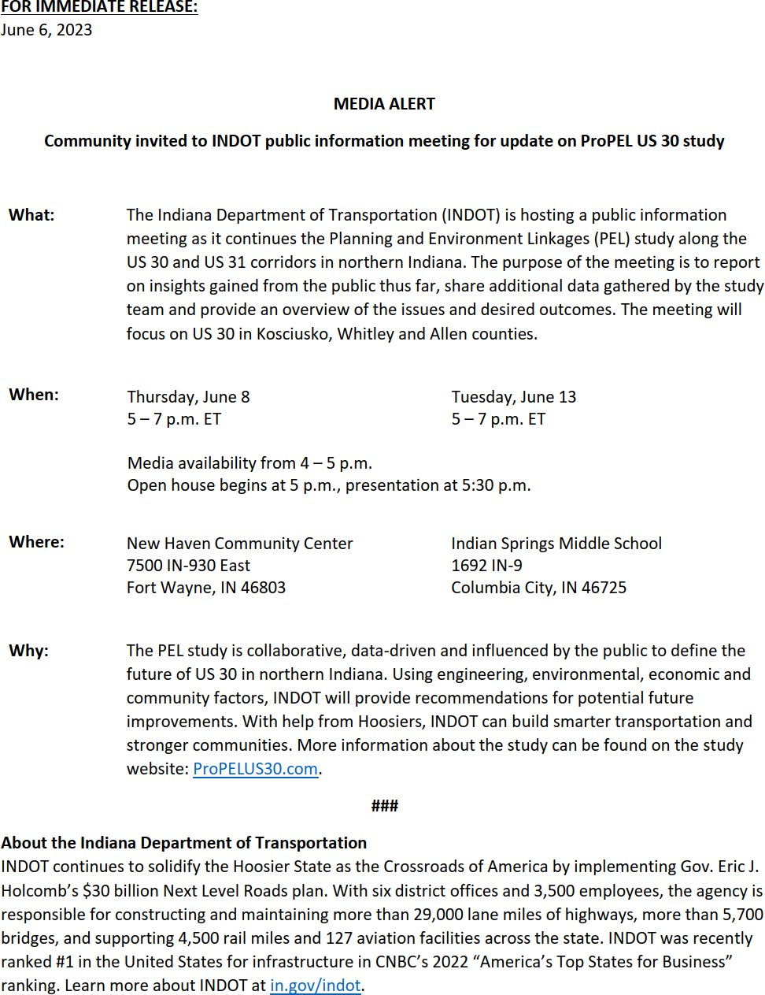

Appendix B: Social Media Posts
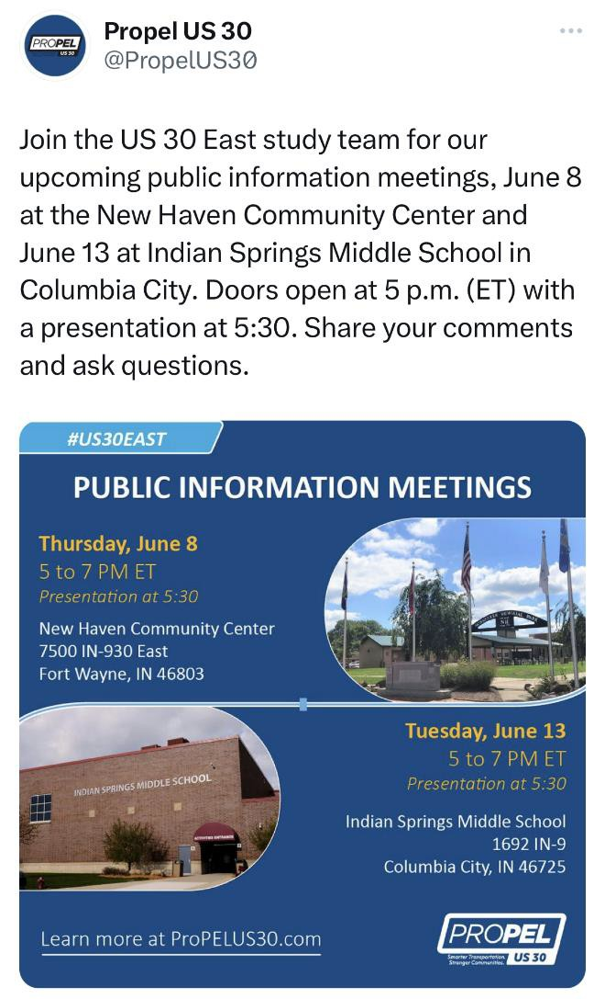
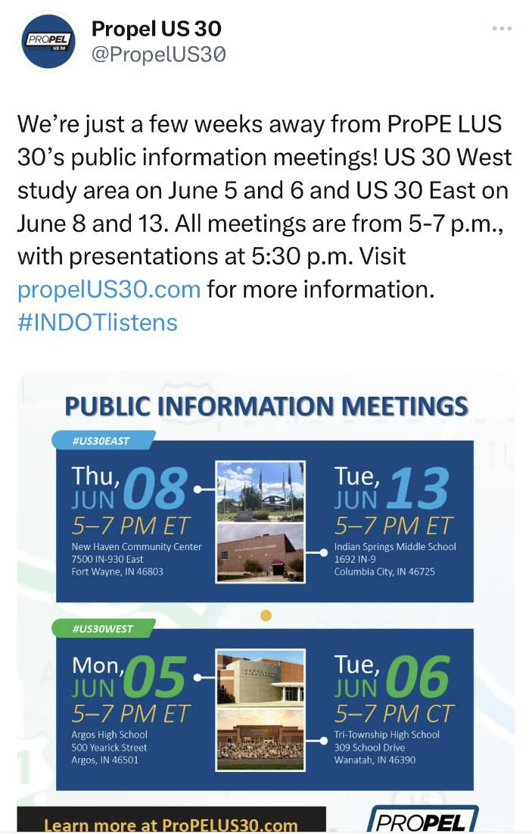
May 17, 2023
May 12, 2023

Appendix C: E-mail Blasts
June 23, 2023
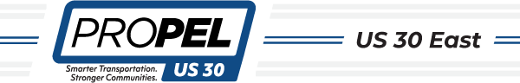
SUBJECT: ProPEL US 30 East Virtual Public Meeting Now Available

Interact with our Virtual Public Information Meeting!
The ProPEL US 30 East study team invites you to interact with our Virtual Public Meeting for the study’s draft Purpose and Need. Click on the link below and scroll through the VPIM to:
- Watch our presentation from the June 8 Public Information Meeting in New Haven
- Click through the draft Purpose and Need’s informational graphics, which were standing displays during the in-person Public Information Meetings
- Take a brief survey to provide us with your feedback on the draft Needs
- Rank each need in order of importance to you
- Submit your comments on the draft Purpose and Need Click here to experience the Virtual Public Meeting.
The public comment period for the draft Purpose and Need goes through Monday, July 31, 2023. Remember, your feedback is a vital part of shaping the ProPEL US 30 East study.
YOU can help us ProPEL Indiana forward!
The ProPEL US 30 East study team hosted two public information meetings earlier this month – on Thursday, June 8, in New Haven, and Tuesday, June 13, in Columbia City. More than 100 people attended them as our team presented the draft Purpose and Need for the Planning and Environment Linkage (PEL) study along US 30 in northern Indiana. Attendees also learned what feedback and insights we've heard so far f rom this diverse corridor community. In addition, we shared important data analysis that will continue to guide the study forward.

