Industrial Rail Service Fund

FY 2022 Grant Application Guidelines

Rail Programs Office- Multimodal Division

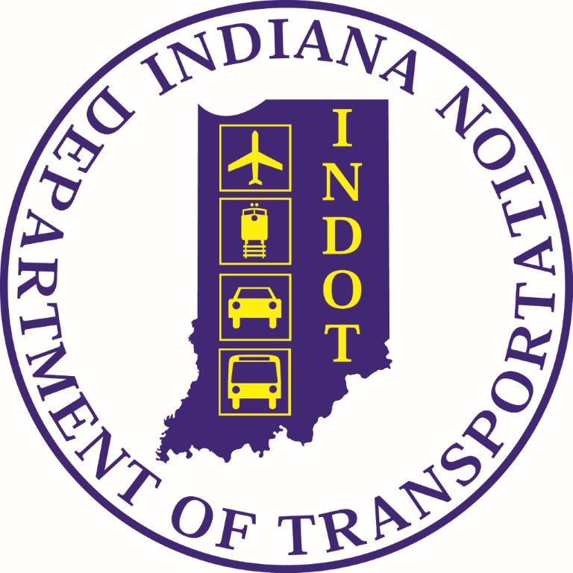

Contents
A. PROGRAM BACKGROUND 3
Statutory Authority 3
Goals 3
Definitions 4
B. APPLICATION PROCEDURE 4
Grantee Eligibility 4
Eligible Activities 4
Schedule 5
Grant Monitoring 5
General Information 5
C. APPLICATION 6
Project Outline/Application 6
Project Description 7
Management information 7
Project Benefit 7
Existing Economic Indicators 7
Other considerations 8
D. SCORING 8
E. PROJECT SELECTION 8
F. APPEAL PROCESS 8
G. GRANT AGREEMENT 9
H. PROJECT PAYMENT PROCESS 9
Payment 10
Scope Change 10
Project Close-Out 11
I. IRSF TIMELINE- FY2022 11

A. PROGRAM BACKGROUND
This brief background includes an overview of the program’s statutory authority, program goals, along with definitions of terms related to the IRSF program.

Statutory Authority
In 1982 Indiana Legislature enacted House Enrolled Act No. 1302 establishing the legislation in IC 8-3-1.7 which created the Industrial Rail Service Fund (IRSF). The program originally was set up to provide low interest loans to Class II and III railroads to purchase or rehabilitate real or personal property that will be used by the railroad in providing transportation services.
In 1995, the legislature modified the IRSF language to allow grants to be provided to Port Authorities for the rehabilitation of railroad infrastructure. Port authorities are limited to a grant award not to exceed 20% of the gross sales and use tax receipts deposited in the fiscal year preceding the fiscal year the grant is made. In 1997, this authority was extended to Class II and Class III railroads as well.
Revenue deposited to the fund is mandated by IC 6-2.5-10-1(4d). The fund receives a percentage of the state sales tax (0.031%) which is deposited into the IRSF account on a quarterly basis. Revenue also comes through repayment of IRSF loans as directed by IC 8-3-1.7-6. The Indiana Department of Transportation administers the fund.

Goals
INDOT’s current mission is to collaboratively plan, build, and maintain safe and innovative transportation infrastructure that enhances quality of life, drives economic growth, and accommodates new modes of transportation. In the 2019 Strategic Plan, INDOT’s vision is to be a leading innovator in transportation, with an exceptional workforce, that is driven by connecting Hoosiers with the world. INDOT’s core values are respect, teamwork, accountability, and innovation.
The IRSF program is for the upgrade of the Class II & III railroad physical plant to help maintain and increase business shipping levels on the rail line, and also to assist with funding needed for track infrastructure improvements related to new business development on the line.
The State of Indiana and by extension INDOT encourages the use of Veteran owned business (VBE), minority owned business (MBE), and women owned business (WBE) on state funded grants.

Definitions
Class I, Class II and Class III Railroads: These classifications differentiate various sizes of railroads based on the amount of annual revenue they generate. The Surface Transportation Board (STB) sets the dollar delineations and adjusts the amount accordingly.
Railroad Organization: A railroad will be evaluated as either an individual railroad or as part of a parent company or a holding group that operates railroads in Indiana. The entire portion of the parent company or holding group doing business in Indiana will be evaluated.
Railroad Port Authority: A railroad port authority is a railroad that is owned by a local government entity that has an interest in preserving rail service for the local community. Further information about Port Authorities is contained in I.C. 8-10-5-8.1.
286,000 pound capable track: This refers to a railroad that can handle 286,000-pound rail cars.
Excepted Track through Class 5 track: The class of railroad track according to its physical characteristics as required by the standards stipulated in FRA CFR Title 49 Part 213.

B. APPLICATION PROCEDURE
This document represents the procedure for selecting projects and distributing grant monies made available through the IRSF. It includes information on program eligibility, the schedule, general fund information, application procedures and the funding process.

Grantee Eligibility
Eligible applicants are limited to Class II and Class III freight railroads or Port Authorities; tourist, passenger or hobby railroads are not eligible. An applicant is not eligible if they are in arrears on any state of Indiana debt payment or have not filed their current years’ Annual Report pursuant to I.C. 8-3-1-1(b). The applicant cannot have any outstanding issues with the Department of Revenue or Department of Workforce Development.

Eligible Activities
Grants through the Industrial Rail Service Fund program can be used for the rehabilitation of railroad infrastructure or railroad construction. Railroads are limited to a grant award that does not exceed 75% of the total cost of the project. The railroad contribution may include funds from other State or Federal Agencies or entities. The maximum grant award for a railroad in fiscal year 2022 is $250,000.00. Internal railroad labor can go towards the railroad match of the grant and may not go towards the INDOT match. All material used for the IRSF project must be purchased within the grant term.
Port authorities are limited to a grant award not to exceed 20% of the gross sales use tax receipts deposited in the previous fiscal year. The grant amounts listed above are maximums and not guaranteed award amounts.

Schedule
The Rail Programs Office will receive applications from October 15, 2021 – November 15, 2021 (end of business day). For the complete FY22 IRSF timeline, please see page 11 of this document.

Grant Monitoring
Applicants receiving a grant are required to retain work and material reports for two years after completion of the project. The applicant is required to provide INDOT with any and all project-related reports which INDOT requests.
INDOT will conduct a site visit prior to the release of a purchase order for approved projects. A post inspection will be conducted prior to final payment. Additional inspections may occur.
The grant agreement allows INDOT to recover costs should the railroad, for whatever reason, discontinue operations. The rail office specific policy is for the grantee to continue operation as outlined in the Exhibit for a period of not less than five (5) years from the date of project completion. INDOT will request repayment of 20% per year for each year should the railroad cease operations during the five-year term.

General Information
Track and bridge improvement projects will be monitored by location to avoid duplicating a recent grant. Therefore, track improvement locations completed with FY22 IRSF funds will be eligible for a grant, in the same location, within 9 years. And bridge improvement locations completed with FY22 funds will be eligible for a grant in 15 years. These restrictions do not apply in the event of a natural disaster.
The review and scoring process occurs December 2021. Applications will be reviewed and the highest scoring projects will be funded until the available balance for this year is exhausted.

C. APPLICATION
All IRSF applications require submission through the Grant Rail Projects (GRIP) system. Each railroad may submit one application per fiscal year. Incomplete applications will not be considered. An applicant must submit a complete application through GRIP system to be considered for a grant. The Rail Programs Office reserves the right to reduce the project scope and grant award dollar amount.
IRSF applications require the following:
- Project Outline
- Project Description
- Project Benefit
- Management/Organizational Information
- Existing Economic Indicators
- Project Budget.
The IRSF grant application is available electronically through the Grant Rail Project (GRIP) system via Access Indiana and the INDOT Technical Applications Pathway (ITAP) at the following link: https://itap.indot.in.gov/login.aspx. Instructions to access ITAP and GRIP are located on the INDOT Rail Programs Office website http://www.rail.indot.in.gov/. The instructions will be sent to all potential applicants, as well.

Project Outline/Application
- Railroad Information: Railroad Name, Federal ID Number, & Mailing Address.
- Grant Application Contact information: Name, Job Title, Phone, & Email.
- Billing Contact Information: Name, Job Title, Phone, & Email.
- Project Manager Contact Information: Name, Job Title, Phone, & Email.
- Total Project cost, Railroad contribution/percent, Grant Request (INDOT share)/percent, and Total Requested Amount.
- Select project category: [tie and/or ballast replacement; rail replacement; bridge construction; rail spur or siding; other rehabilitation project]
- Project location: milepost to milepost and length of segment to be improved
- Freight traffic by commodity originated & terminated on segment improved

Project Description
The project description has three parts. Part one is a narrative of the proposed project. Include a description of the proposed project by milepost.
The second part is a project map.
Part three is a detailed Project Budget that includes each proposed item for purchase and its cost, the total project cost, the railroad contribution and requested INDOT contribution. This will be incorporated into the grant agreement as the Exhibit A, if selected for the IRSF grant. The contractor price quote should be included with the application, as well.

Management information
Provide an organizational chart including rail owner and applicant’s relationship, if not the same.

Project Benefit
List the specific (if any) impact this project will have on the safety of the employees, rail users and surrounding communities.
What impact will the project have on the economic development of the community?
What is the anticipated useful life of the improvement? Include calculations and assumptions made for the anticipated useful life of the improvement.
Provide a conservative estimate of the number of Indiana residents employed by the shippers on the line.

Existing Economic Indicators
Existing economic indicators include the annual rail cars moved per track mile for the last three years and type of railroad organization. The rail office will compile this indicator with data from the annual report submitted to our office. The number of IRSF grants received in the past four (4) years will be used as an existing economic indicator, as well.

Other considerations
This section includes compliance with filing requirements, the railroad safety performance according to the Federal Railroad Administration and the railroad contribution, compliance with State reporting requirements and railroad contributions.

D. SCORING
The score sheet is completed with information provided from the application, current railroad reports, rail system map, and FRA Accident Reports. The score sheet categories and their total point values are listed below.
- Project Description = Maximum Points (45)
- Existing Economic Indicators and Other Considerations = Maximum Points (69)
- Maximum Overall Score (45 + 69) = 114

E. PROJECT SELECTION
The review team consists of three members, two from the Rail Programs Office; the committee chair - the Senior Rail Planner, and a Code Enforcement Officer, and a State of Indiana employee.
Each application is reviewed and independently scored by each member using the IRSF grant evaluation criteria. Applications are then ranked based on their cumulative score. Funds are then awarded to the top-ranked applications until available funding is exhausted. A report with the list of the recipients, award amount, and a synopsis of each project application is prepared and submitted to the Manager, Rail Programs Office.
The Rail Programs Office will send award notifications and grant agreements to each awarded applicant. The Rail Programs Office will send notices to the other railroads announcing their project was not selected for funding. Grantees and award amounts will be posted to the INDOT website.

F. APPEAL PROCESS
An applicant not receiving approval may appeal the selection decision to the Manager, Rail Programs Office. The manager will review all appeals. The following steps is the process for filing an appeal.
- The applicant must send by certified mail, an appeal within 15 calendar days of receiving notification of INDOT’s decision. The appeal should be mailed to:

Ms. Venetta Keefe, Rail Programs Office Manager
Indiana Dept. of Transportation
100 N. Senate Ave, N758-MM
Indianapolis, IN 46204

- INDOT will conduct a preliminary review within five working days, and if necessary, request by certified mail additional information from the applicant.

- INDOT will allow five working days for receipt of additional materials.

- The Rail Programs Office Manager will make a final decision within 15 working days from the receipt of the appeal request, or within 15 working days from the receipt of additional materials, if required.

- INDOT will notify the applicant in writing within five working days of its final decision.

- The applicant may appeal INDOT’s final decision in accordance with Indiana Code 4-21.5-3-1 et seq.

G. GRANT AGREEMENT
The Senior Rail Planner works with the Contract Administration Division to prepare the current fiscal year grant agreement. The agreement Exhibit A is based upon the approved scope of work and the budget, which is incorporated into the grant agreement.
All grant agreements will be created using the Supplier Contract Management (SCM) system. The signature process will be electronic via DocuSign. Information will be given for this process for all grantees.
After receipt by INDOT it is routed through the state signatory process electronically, which should be a quicker process for grant execution. After final grant agreement approvals, the railroad will receive a copy of the executed grant agreement, purchase order, notice to proceed, and reimbursement instructions.

H. PROJECT PAYMENT PROCESS

Payment
Payment requests should include an invoice from the railroad, supporting documentation (i.e. vendor invoices, receipts, etc.), and a project spending report. The railroad invoice for reimbursement must have the Railroad’s address (on file with State of Indiana); including a written description of the work completed, final/progressive payment type, funding breakdown of INDOT/Railroad share of the total project cost, amount requested, amount spent to date, and the amount remaining. For help with invoices, please refer to the Reimbursement Instructions document that is sent with copy of the Grant Agreements.
Each reimbursement request is paid in proportion to INDOT’s approved share of the project, as indicated in the grant agreement exhibit. No payments will be made without a vendor bill or invoice. Railroad employee labor is eligible to be counted as part of the railroad match only. The railroad has approximately 15 months from the date of the purchase order to complete the project. Final payments will be made after a post project inspection is completed by a member of the Rail Office staff.
Each railroad must have on file with the State Auditor a current direct deposit form or a waiver request. Should your railroad bank information change, or the address where the payment should be sent, please submit an updated W9/direct deposit form to the Bridgette Hail, within the INDOT Rail Office. The payment will be rejected if this information is not current. Send an email to bhail@indot.in.gov to receive the current W9/Direct Deposit form, if needed.

Scope Change
In the course of completing the project, the railroad may determine changes or modifications to the scope of work are needed. These requests will not involve an increase in the amount of funding provided by INDOT.
This occurrence should not happen regularly. However, when needed, the railroad must send a letter to the Rail Programs Office Manager justifying the reason for the change. Scope changes that result in a more efficient use of resources are generally viewed favorably for approval. A significant change in material costs which allows the railroad to increase the amount of material purchased is an example of an acceptable change in scope. Requests to substantially change the scope of work are not allowed. The Rail Programs Office Manager has the authority to approve changes. If approved, an “approval to the change in scope of work notice” is sent to the railroad and put in the grant file.
If the total project cost exceeds the amount listed in the agreement; INDOT will not provide funding in excess of the grant award. Should the total project cost less than the amount listed in the agreement, INDOT will still pay its proportional share of the total project cost. Any balance remaining in the purchase order after the project is completed is returned to the IRSF account.

Project Close-Out
After the project is complete, the railroad must email a request for a project inspection. If the inspection documents the project has been completed based on the agreement exhibit, the final payment is made, and the purchase order is closed.

I. IRSF TIMELINE- FY2022
Solicit Applications Oct. 15, 2021 – Nov. 15, 2021

Review and Score Applications Early December 2021

Recommendations Approved December 16, 2021

Approval/Denial Notices Sent January 2022

Grant Agreement Signatory Process January/February 2022

Purchase Orders Generated March/April 2022

Grant Reimbursement Duration 18 – 19 months

