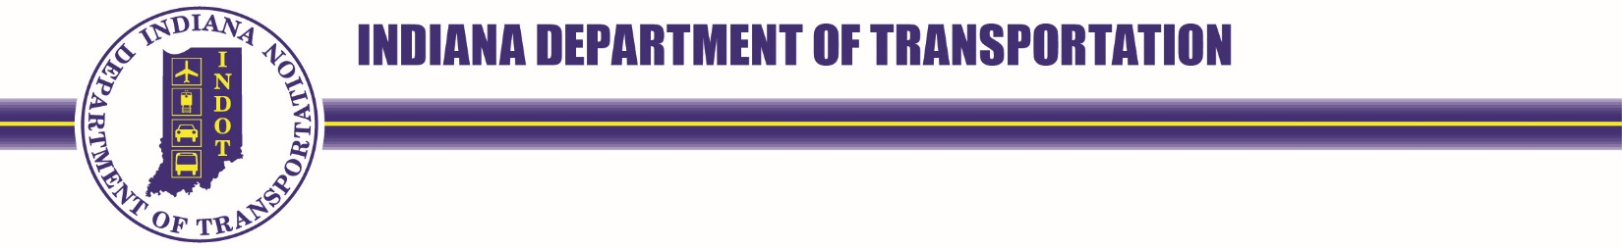
100 North Senate Avenue  Room N758-ES  Indianapolis, Indiana 46204 | PHONE: (855) 463-6848  FAX: (855) INDOT4U | Eric Holcomb, Governor  Michael Smith, Commissioner

LEGAL NOTICE PLANNED IMPROVEMENT DES. #: 1900330
The Indiana Department of Transportation (INDOT) has developed preliminary plans for a proposed State Road (SR) 246 small structure replacement over unnamed tributary (UNT) to Lick Creek, 7.39 miles west of SR 46, located in Owen County. The project extends 21 feet west and 21 feet east of the structure center. The project proposes to replace the small structures with a single-span reinforced concrete box structure. The project will also include, but is not limited to, construction of new wingwalls to minimize future erosion, and reconstruction of the drive in the northwest quadrant.
The maintenance of traffic plan for this project is to be a road closure at SR 246 during the construction period. The official detour will be SR 59 and SR 46. Access to all properties will be maintained throughout construction. Project stakeholders including local school corporation(s) and emergency services will be notified of potential closures and/or detours prior to any construction.
Construction of the project will require approximately 0.98 acre of new permanent right-of-way with an estimated cost of $566,000. Federal and state funds are to be utilized for the construction of the project.
The Federal Highway Administration and INDOT have agreed that there is no significant adverse impacts to the human and natural environment were found during the creation of this document.
Preliminary design plans, along with the CE are available for review at the following locations:
- Owen County Public Library (10 S. Montgomery Street, Spencer, IN 47460)
- INDOT Crawfordsville District Office (41 W. 300 N, Crawfordsville, IN 47933)
- On the INDOT website, INDOT: SR 246 Small Structure Replacement over Unnamed Tributary (UNT) to Lick Creek

All interested persons may request a public hearing be held and/or submit comments to the attention of Rachel Pluckebaum, Corradino, LLC, 200 S. Meridian Street, Suite 330 Indianapolis, IN 46225, or rpluckebaum@corradino.com on or before Thursday, November 24, 2022. In addition, project information, including the environmental document, may be mailed to interested persons upon request.
In accordance with the Americans with Disabilities Act (ADA), persons and/or groups requiring project information be made available in alternative formats are encouraged to contact the INDOT Crawfordsville District for the arrangement and coordination of services. Please contact Crawfordsville District Project Manager, Kaitlyn McDaniel, at 765-361-55610 or kamcdaniel@indot.in.gov.
This notice is published in compliance with: 1) Code of Federal Regulations, Title 23, Section 771 (CFR 771.111.(h)(1) stating, “Each State must have procedures approved by the FHWA to carry out a public involvement/public hearing program.”;2) 23 CFR 450.210(a)(1)(ix) stating, “Providing for the periodic review of the effectiveness of the public involvement process to ensure that the process provides full and open access to all interested parties and revise the process, as appropriate.”; 3) The INDOT Project Development Public Involvement Procedures Manual approved by the Federal Highway Administration on July 7, 2021.

