Bidder’s List Q&A
Date: January 10, 2025. Revised 1-21-2025.

Q: When I open the Bidders List Form on my computer, my screen seems to be frozen.
A: The form header must be filling your screen. This can happen on laptops or other small monitors. We’ve adjusted the file as much as possible, but you may still need to zoom in the screen view from 100% to a lower resolution. See the bottom right-hand corner of these screen shots:
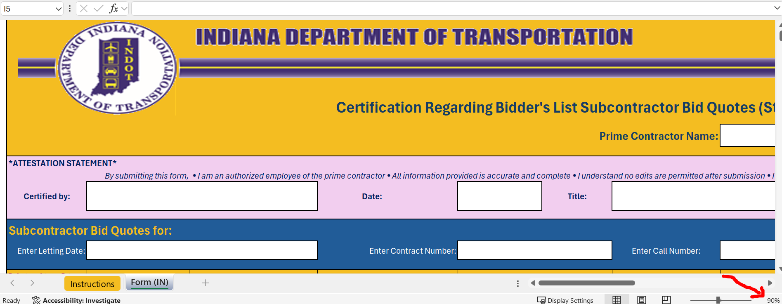

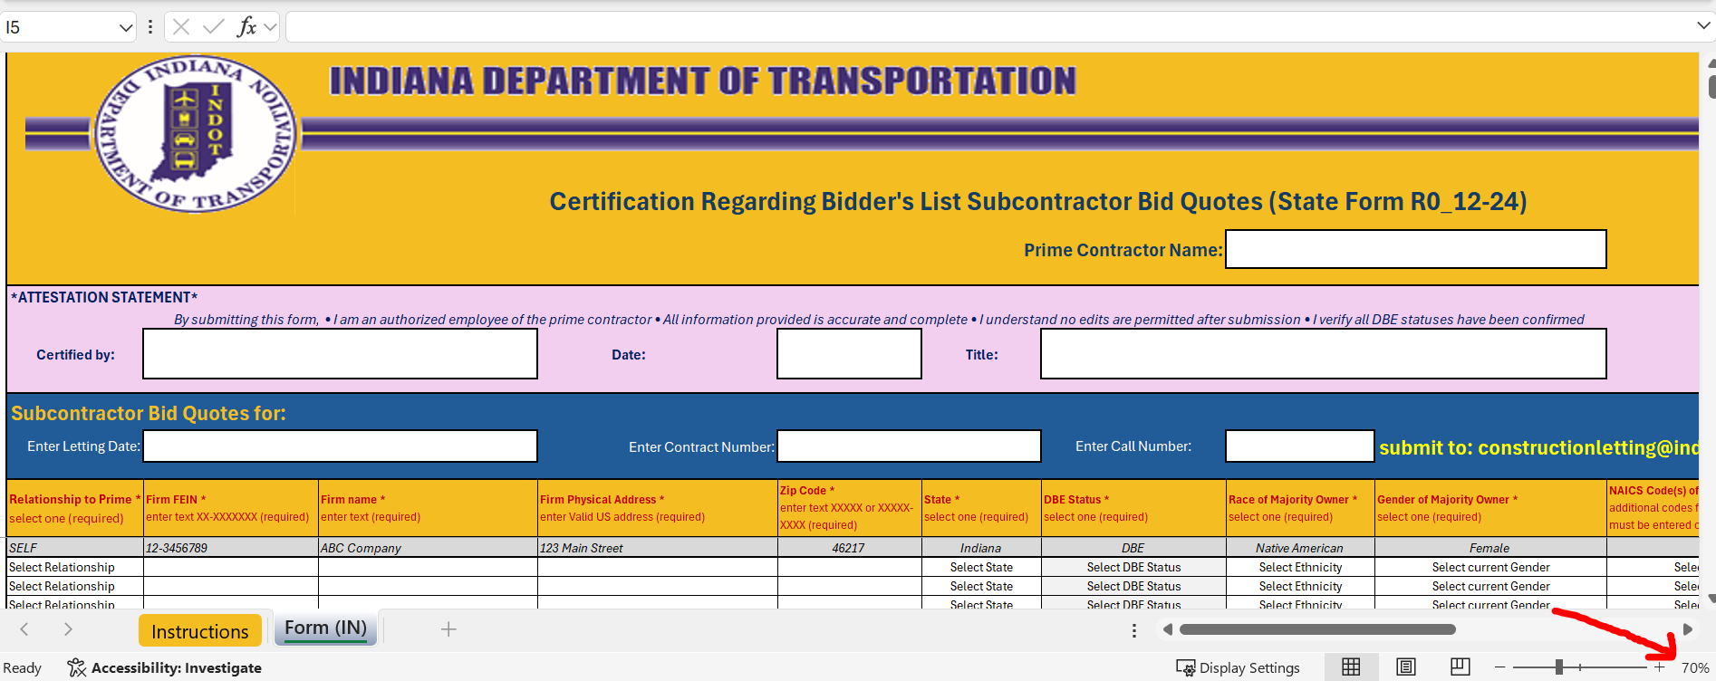

Q: My company has many possible names to use. These are “doing business as” names. Which should I use to fill out the bidders list form?
A: The name to use is the company name that you use when bidding.

Q: My subcontractor is only providing a PO for an address, is this OK to do?
A: A street address is preferred, but yes, this is OK. Instructions have been updated.

Q: Can I send more than one bidder’s list per e-mail to the Contractors Letting Email Inbox?
A: No, per the instructions for the submission performance bond and drug policy, only one file per message and there are protocols for the message line content. The contract number is in the message, only the file for the listed contract will be accepted. Anything else will be disregarded.
Recurring Special Provision (100‐C‐214) in the Contract Information Book (CIB) for submitting emails
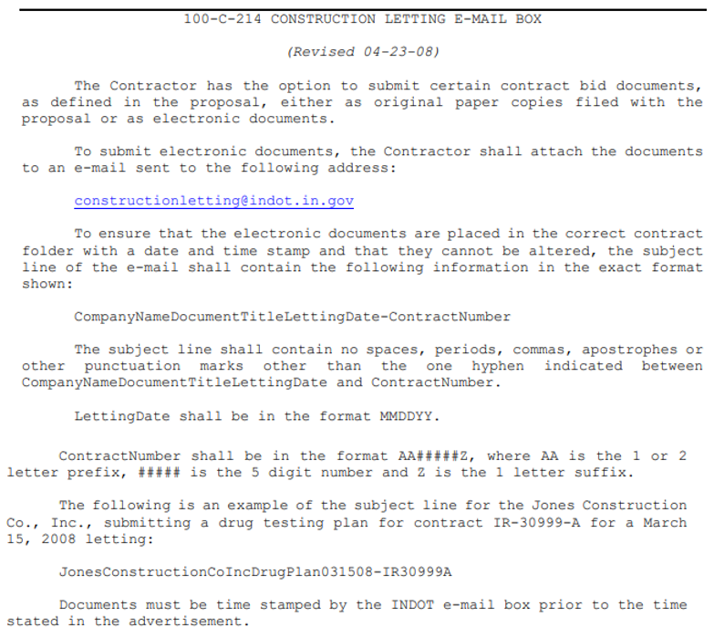

Q: Should I also send or attach subcontractor quotes or W-2’s, certifications, etc?
A: No, only send the Bidder’s list file

Q: I’m a subcontractor – do I submit this to the Construction Letting E-mail Inbox?
A: No, send information to the contractor that you are quoting with. Only the prime contractor who is submitting bids to INDOT send their files here.

Q: Will INDOT reject my bid if I don’t follow the email message line and file naming conventions in the submission instructions in RSP 100-C-214?
A: Not necessarily – but the risk of losing these documents or not knowing that they were submitted is high – which would lead to rejection.

Q: Is this required on 100% INDOT funded projects?
A: This is not required for 100% State funded projects.

Q: Does this new procedure ONLY affect contracts with DBE goals? I don't see anything in the documents that's referring to MBE/WBE/IVBE goal contracts?
A: See above. This requirement is only for federally funded projects indicated with DBE goals. Zero DBE goals are included. As shown in the CIB. MBE/WBE/IVOSB goals indicate 100% state funding.

Q: The NAICS code we fall under isn't accepted in the list. Please be sure that 541990 gets added as it won't let me add it in the freeform.
A: This was accepted when manually entered. Remember to click on OK when this message pops up: 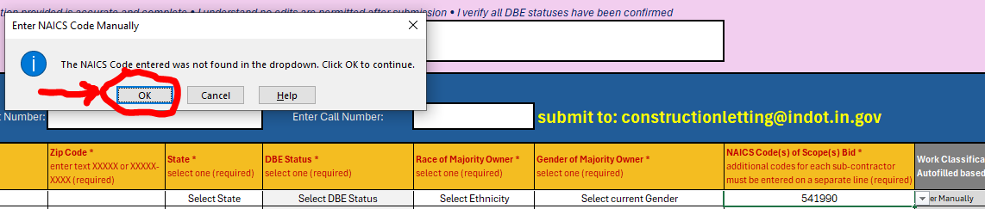

Q: Does the "Certified by" box need to be a copied signature, or will a typed name be a valid response?
A: A typed response is best.

Q: Where does page 2 go in the File Name?
A: At the end. Ex: DuncanConstructionBiddersList01152025-B12345A-page2

Q: When submitting the performance & payment bonds we do not use underscores between names/documents, so which is the proper submission name?
A: You are correct – I will update to match the instructions below:
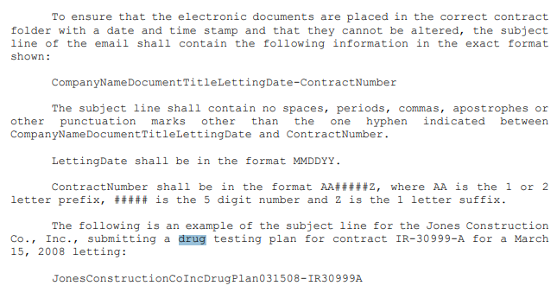

Q: Will USP's be added to every contract that is bidding on Jan 15th to make this directive a binding requirement?
A: This is an instruction to bidders which is binding.

Q: What if owners are 1 male 1 female and they are 50/50 ownership. What do u put for majority race? Also,
Q: How do you answer the race and gender question for non-DBE companies that have equal partners or public companies that do not have a single owner? Also,
Q: companies that are majority owned by another corporate entity? Also,
Q: How should the ethnicity / gender be completed for ESOP companies that don't have a majority owner? Also,
Q: What race/gender should we choose if our company is an ESOP?
A: We are seeking guidance from FHWA and may not have an answer prior to the January letting. Use race and gender associated with the reported FEIN. If there is no majority owner or if race and gender are not identified in the reported FEIN, then choose “other” until we receive guidance from FHWA.

Q: For a non-DBE subcontractor who is trying to meet a DBE goal through a supplier of materials, how is this captured?
A: This applies to the Affirmative Action Certificate and has not changed.

Q: As long as the form is filled out, are we able to modify or add to this excel spreadsheet to simplify the entry of data?
A: Please do not modify this file

Q: Sometimes GC's receive quotes prior to bid closing, but after they have submitted their bid. How should quotes that are received after the bid submittal be handled?
A: These were not in-play at the time of bid submission so do not need to be listed

Q: At some point will INDOT be able to generate a data base that can be used to pick contractors from in the form and auto populate sheet?
Or …similar to the DBE.in file that we have to pull into AASHTOWARE, will INDOT just create a sheet for ALL subs and haulers as a database to pull from? (the DBE.in file is being maintained by INDOT already)
Or can the information the primes are submitting be turned into a drop-down menu for future submissions, so we don't have to continue collecting this every month?
A: This is a planned improvement once the federal submission portal is developed and implemented. We’re unsure if these kinds of improvements will fit with their chosen protocols

Q: Are we to list all subcontractors that quoted on a particular contract or only the ones that we used in our bid price?
A: All subcontractors that quote to you must be listed.

Q: As a sub-contractor do I need to complete the form and submit per these instructions?
A: No, sub-contractors would only need to report this to a prime contractor. The prime is responsible for submitting the Bidder’s List to INDOT. It is the sub-contractor’s requirement to submit this information to the prime prior to the letting.

Q: If an electrical contractor also self performs concrete work (as an example pouring a pole base) do we need to list ourselves as a concrete contractor as well as an electrical contractor?
A: It is the work you are quoting to the prime

Q: Can INDOT just allow the contractor to add rows to the excel sheet instead of having multiple pages?
A: Not at this time but will be addressed in the next version when the federal reporting protocols are implemented.

Q: Do you need to add a line for each code if there are more than one code that reflects your work on the project?
A: Yes. Indicated on the instruction note on the form.

Q: What should a contractor do if the required information is requested but not received from the subcontractors? Should the subcontractor be listed with incomplete information or should the subcontractor be left off the list entirely?
A: This information is required to participate in an INDOT bid and the prime must make a reasonable attempt to collect.

Q: Will INDOT confirm that the prime contractor only must populate information for the quotes received directly to the prime? For instance, if the prime receives quote from subcontractors who are carrying suppliers and haulers, but these quotes were never sent directly to the prime, then the prime would only need to list the subcontractor on the sheet. Correct?
  - Exact example: seed & sod subs, guardrail subs, excavation subs, concrete subs, signing subs, striping subs, bridge subs, asphalt subs, etc.: all these subs get quotes for their scopes of work that the prime contractor may never receive.
A: Only submit information for firms that directly quoted to the prime. This is not looking for firms quoting to sub-contractors.

Q: We have subcontracts who will not provide their annual gross income, how would you like us to proceed?
A: This is required…We don’t need exact information. Ask them to choose one of the categories.

Q: This is only to list subcontractors, not DBE suppliers?
A: All subcontractors quoting to the prime are to be listed regardless of DBE status

Q: Let's say we have an immaterial item for the project (port-o-let, dumpster, etc.). Are we required to submit a vendor for every project material?
A: I do not think a dumpster or port-a-let would need to be reported as they are incidental to the project. Field offices, though, would not be considered an incidental item and should be reported.

Q: Do brokered hauling for material suppliers need to provide information to primes?
A: If by “brokered hauling” you mean a DBE that is going to haul something (rip rap, milling spoils, etc.) as a part of the project or a non-DBE that is going to do the same thing, then that should be reported at the time of bid to the best of your knowledge.

Q: Regarding gross annual receipts, is this projected or current and how up to date must these financials be?
A: Annual gross receipts is the value averaged over the firm's previous five fiscal years computed on a cash basis.

Q: Regarding the appropriate NAICS code, there does not exist an option for suppliers of materials who are producers; there only exists a code for wholesalers. Please advise which code should be chosen for producers/sellers of materials (i.e. aggregate/stone).
A: INDOT does provide guidance on which NAICS code apply. Please refer to NAICS.COM for guidance.

Q: Please confirm this form must include quotes from material suppliers, trucking vendors, etc. and not just subcontractors.
A: Material supplier information is not being requested at this time but may be in the future. Information is currently requested for anyone who could potentially participate in the contract as a prime contractor, subcontractor; or a service provider or hauler via rental-lease agreement. However, information for anyone providing a quote will be accepted.

Q: What will be INDOT’s approach to compliance, in the short term? For example, what happens if a sub/supplier/vendor fails or refuses to provide their FEIN or gross annual receipts to a prime contractor/bidder, but provides a quote? Is the quote they provided then non-compliant, and should we exclude their quote from the form, or can we still use the subcontractor’s quote in the bid? Will accuracy/completeness of the form affect award of the contract in any way? As the prime, we’re certifying this information…what happens if the subcontractor-provided information is incorrect?
A: The prime contractor submitting the bidder’s list is responsible for the accuracy and completeness of the information.

Q: How do we fill this form if we are a Joint Venture: The lead fills it out and lists only itself as Self and the partner as a Subcontractor? Or are both partners listed as Self on the Form? And in the Title do we list the JV Name as who is submitting bid and name it as the JV name when we submit to letting box?

A: Since there is a lead firm identified in a joint venture, then the lead firm would be on the lead line as the prime. Then add the other firm or firms in the JV as the sub(s). Using the JV name would be OK to use in the header and in the file and email instructions.

