Musk’s Starlink at center of shifting D.C. grant plan

Starlink’s elevated role in a massive rural broadband expansion effort has been a political lightning rod ever since the Trump administration rewrote federal rules last year that gave the business greater access to grants from the $42.45 billion Broadband Equity, Access and Deployment program.
Indiana appeared to close its portion of grant contract negotiations with Starlink on July 1. That’s when billionaire Elon Musk’s satellite internet service agreed to the state’s standard contract after controversially pressing for more favorable terms than the state’s 23 other BEAD award recipients.
But before construction could begin, Washington changed the rules again.
In mid-July, the National Telecommunications and Information Administration instructed states to revisit every location awarded to low-Earth-orbit satellite providers such as Los Angeles-based Starlink, removing addresses that either no longer qualify for BEAD funding under new mapping or are now reported as served by another broadband provider.
That directive would have eliminated up to half of Starlink’s $26.4 million BEAD grant in Indiana. Across the nation, up to 35% of the company’s BEAD-funded locations were subject to elimination, according to the Advanced Communications Law & Policy Institute at New York Law School.
But before the states could take action, the NTIA decided in late July that Indiana and others that already had reached a contract agreement with Starlink wouldn’t have to make such substantial cuts.
Megan Minor (IBJ file photo)
Now, Indiana Chief Broadband Officer Megan Minor estimates that the state will have to eliminate only about 500 of the 17,382 locations Starlink is contracted to serve.
The head-spinning turn of events marks yet another dramatic twist for a broadband initiative that has repeatedly shifted direction through two presidential administrations over five years, causing extended delays in the program’s goal to bring high-speed broadband internet to underserved communities.
Under President Donald Trump, the shifts have unfolded alongside an equally volatile relationship with Musk. The founder and CEO of Starlink’s parent company, SpaceX, Musk served as a close adviser to the president until their relationship soured last summer.
Now, it’s unclear how Starlink and Musk will react to the federal grant cuts across the country. SpaceX did not respond to IBJ’s requests for comment.
Minimal changes in Indiana make it less likely that Starlink will balk at a contract amendment, and the Indiana Broadband Office said it is prepared to move forward.
“It is still the expectation that we cover every single location that was eligible for BEAD,” Minor said.
But the bigger question for some critics is whether satellite service was the right choice for some rural Indiana locations in the first place.
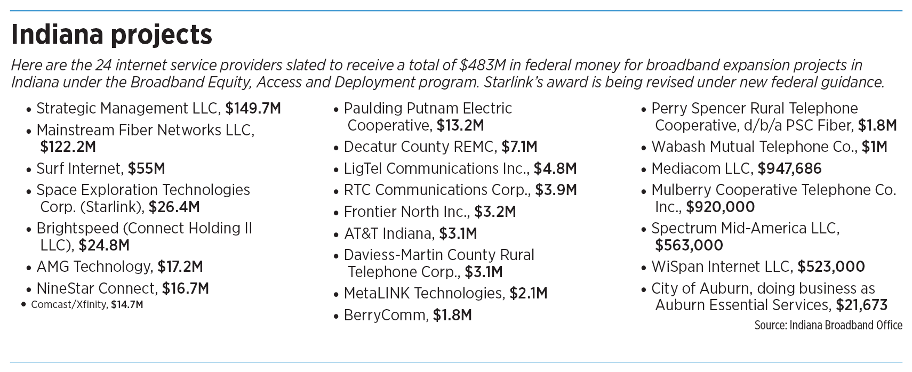
Satellite vs. fiber
Congress created BEAD in 2021 to close the nation’s remaining broadband internet service gaps, largely through construction of land-based fiber-optic networks believed to be capable of serving communities for decades.
After Trump took office in 2025, his administration ordered states to redo their grant competitions under a technology-neutral approach that placed satellite, fixed wireless and fiber on more equal footing.
The revised process significantly reduced the amount of federal funding needed to connect every business and household the government identified as eligible for BEAD by allowing lower-cost technologies such as satellite service to compete more successfully.
The Trump administration has estimated that the policy shift, combined with ongoing private broadband expansions, will save $21 billion in BEAD money nationwide and bring high-speed internet to hard-to-reach rural communities more quickly. Indiana estimates that it will dole out just $483 million in grants from its initial $868 million federal appropriation.
Story Continues Below

Supporters of the new policy note that it can cost $15,000 to $100,000 per mile to install a rural fiber network as opposed to $350 to $600 in upfront hardware costs for each satellite installation.
But critics argue that the lower costs aren’t worth the tradeoff because that decision denies some communities fiber-optic service that generally offers faster speeds, more responsive connections and virtually unlimited upgrade potential that will better meet internet needs far into the future.
In Congress, some Democratic lawmakers last year argued the changes would also disproportionately benefit Musk’s Starlink.
Frank Pallone (IBJ file photo)
“We know Elon Musk is salivating over the prospect of steering BEAD dollars to his companies,” U.S. Rep. Frank Pallone, D-New Jersey, said in March 2025 after the U.S. Department of Commerce announced its technology-neutral overhaul. “Musk is a grifter, and Republicans are going to just stand by and watch.”
Democrats later warned that the administration’s implementation of BEAD was departing from both the letter and intent of the bipartisan infrastructure law by weakening the program’s emphasis on scalable, future-proof broadband networks.
After the program went tech-neutral, fiber providers still overwhelmingly won the largest financial share of BEAD grants. Industry observers agree, however, that Starlink gained ground with the changes but not nearly as much as some early estimates predicted.
Wall Street analysts initially estimated the change could steer roughly $4 billion in federal broadband grants to Starlink. In the end, the satellite provider won $738.8 million in awards across 46 states and territories.
Starlink’s awards represented only about 1.7% of the BEAD program’s $42.45 billion appropriation. But because of the lower cost of satellite installation, the company’s grants would serve approximately 476,000 homes and businesses — more than any other provider, according to an analysis by Las Vegas-based IT consultancy the Brander Group.
In Indiana, Starlink was awarded the fourth-largest grant, $26.4 million, among 24 companies to provide service to about 14% of the state’s 123,000 BEAD-eligible locations.
Contract demands
In January, Starlink began pressuring Indiana and other states for changes in the standard BEAD contract that would exempt it from certain requirements.
SpaceX argued that several provisions had been written for traditional fiber construction projects rather than a nationwide satellite network.
The proposed contract rider would have:
• Allowed Starlink to accelerate portions of its grant payments.
• Limited a state’s ability to impose contractual damages beyond recovering grant funds.
• Reduced some financial reporting requirements.
• Modified certain labor, insurance and customer equipment obligations.
In a letter to the states, SpaceX warned that failure to allow the exemptions could make its participation in BEAD “untenable.”
The proposal quickly drew scrutiny in Washington. Congressional Democrats warned that allowing Starlink to renegotiate its obligations after the awards had been announced could undermine the integrity of the competitive bidding process. They urged the Commerce Department to ensure all providers remained subject to the same statutory requirements.
They also questioned whether states might be forced to rebid projects if SpaceX declined to sign standard agreements.
The Trump administration, despite championing a larger role for satellite providers in the BEAD program, sided against Starlink’s requested exemptions.
In February, the National Telecommunications and Information Administration, or NTIA, instructed states that BEAD contracts could not alter or waive requirements established by Congress, and Commerce Secretary Howard Lutnick said the proposed rider fell outside the statute.
Gradually, Indiana and a few other states began reaching agreements with Starlink that preserve the standard BEAD contract language.
Another twist
Then in mid-July, the NTIA directed states to revisit every location awarded to satellite providers such as Starlink and review them against new federal guidance.
Get updates onPolitical & Government Newssent to your inbox every Friday.
The Rundown
toggle to subscribe
Subscribe to The Rundown
Manage subscription here.
Some of the locations being removed from the BEAD program are not homes or businesses at all. New mapping shows barns, agricultural buildings and other locations were mistakenly identified as broadband-serviceable locations. State officials have said the new guidance also eliminated addresses that have since gained broadband service from another provider.
The NTIA told the government-tech trade publication Statescoop that the review is intended to ensure taxpayer dollars are “targeted to eligible locations and are not used where program support is unnecessary.”
The agency did not respond to emailed questions from IBJ asking why it ordered states to revisit satellite awards without directing a comparable review of fiber, cable or fixed wireless projects using the same updated mapping data.
“I don’t know that I have a good explanation,” Minor said.
By late July, federal guidance changed again for Indiana and the few other states that had reached a contract agreement with Starlink or another satellite provider. Those states would have to remove contracted locations affected by map changes but not eliminate addresses already served by another broadband provider.
Minor said she saw the move as a way to provide some certainty for providers who had already signed contracts. “When there is uncertainty, it draws out the timelines and can make some hesitant to continue their participation,” she said.
While the latest directive still reopens Indiana’s grant for Starlink, it does not halt the broader rollout of the state’s BEAD program.
Minor said the state continues to finalize grant agreements with the program’s other providers, and officials expect construction on some projects to begin in the coming weeks.
The future
For some broadband policy experts, questions extend well beyond Starlink’s final grant amount.
Christopher Ali (IBJ file photo)
Christopher Ali, a Penn State telecommunications professor who has spent more than a decade studying rural broadband policy, questioned whether taxpayer dollars should be used to substitute satellite for fiber when the goal is building infrastructure that will serve communities for decades.
He described the policy shift as a return to what he calls the “politics of good enough” — the notion that rural communities should settle for cheaper technologies that might meet today’s needs but fall short tomorrow.
“Is it good enough for right now? Yeah, sure it is,” Ali said of low-Earth-orbit satellite service. “Is it going to be good enough in five years? Not sure. Will it be good enough in 20 years? Definitely not.”
While Starlink has dramatically improved internet access for many rural residents, Ali said fiber’s virtually unlimited capacity makes it the stronger long-term investment. Communities connected by fiber, he argued, will be better positioned to attract businesses, support remote workers and capitalize on future applications such as telehealth and online education.
George Plisinski (IBJ file photo)
He said he would never advise rural residents to wait for fiber if Starlink can improve their internet service today. His concern, he said, is with public policy for the long haul.
“I worry when we’re putting government money towards a technology that is not good enough,” he said.
George Plisinski, vice president of engineering for Greenfield-based fiber internet provider NineStar Connect, said satellite service has its place in rural America, especially in states like Wyoming and Alaska with rugged terrains where houses are miles and miles apart.
But he argued that’s not the situation in Indiana and that fiber is more reliable, scalable and able to meet long-term needs.
“Fiber is the gold standard for broadband,” said Plisinski, whose company has been awarded a $16.7 million BEAD grant in Indiana.
Blair Levin (IBJ file photo)
Blair Levin, former executive director of the National Broadband Plan and now a policy analyst with London-based New Street Research, agreed that fiber remains the superior technology.
But whether rural households awarded satellite service under BEAD ultimately feel dis
advantaged will depend largely on how broadband technologies evolve, he said.
Levin predicted rural Americans eventually will be able to choose among fiber, satellite, fixed wireless and other technologies.
“Twenty years from now, there will be access everywhere from multiple providers, and we will forget the BEAD program,” he said.•

