Indiana Native American Indian Affairs Commission
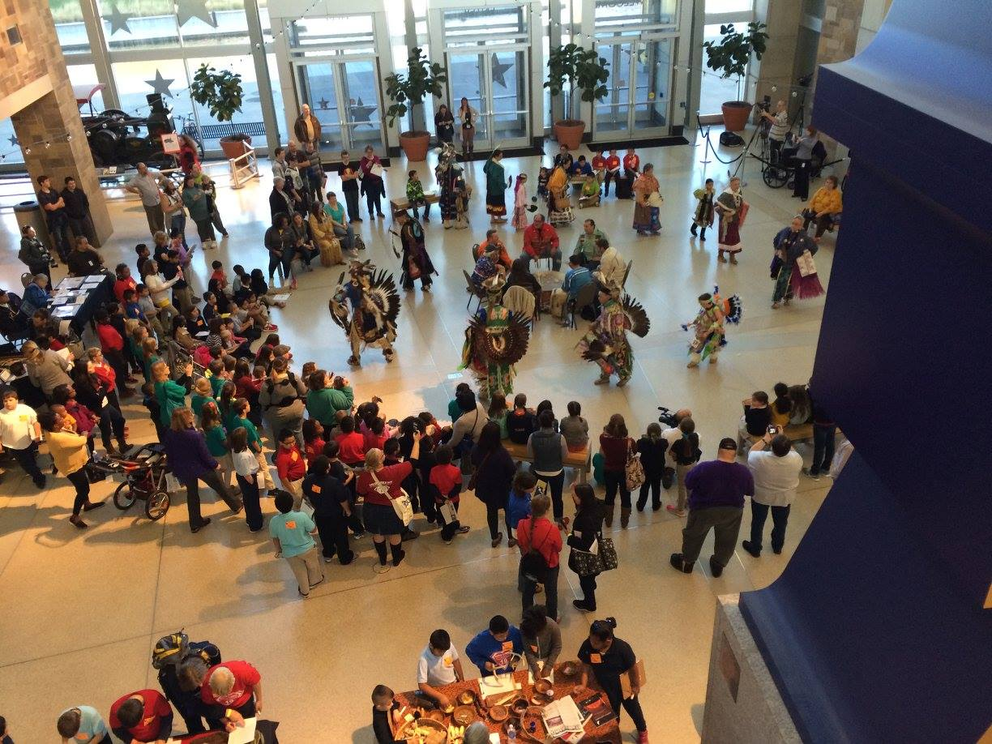
Native American Indian Days
Indianapolis Capitol
November 2nd, 2018
9:30am-2:00pm
Over 10 Native American Indians from various tribes will present their traditions, crafts and history.
To RSVP, please email MeLissa Williams, Director melwilliams@icrc.in.gov or call 317-234-4887.
Ask about the grant that can assist up to $250.00 per teacher for this and other field trips.

