OVERDOSE INVESTIGATIONS

May 12-14, 2026

South Bend Police Department
701 W Sample St. South Bend, IN 46601

POC: Don McCay, dmccay@indiana-hidta.org

This course is restricted to US military law enforcement personnel along with other local, state, and federal civilian law enforcement employees to include criminal analysts,
and corrections officers.
THERE IS NO COST TO ATTEND THIS COURSE.

This course will provide officers with the necessary knowledge and skills to safely and effectively respond to opioid drug overdoses. This course will educate officers how
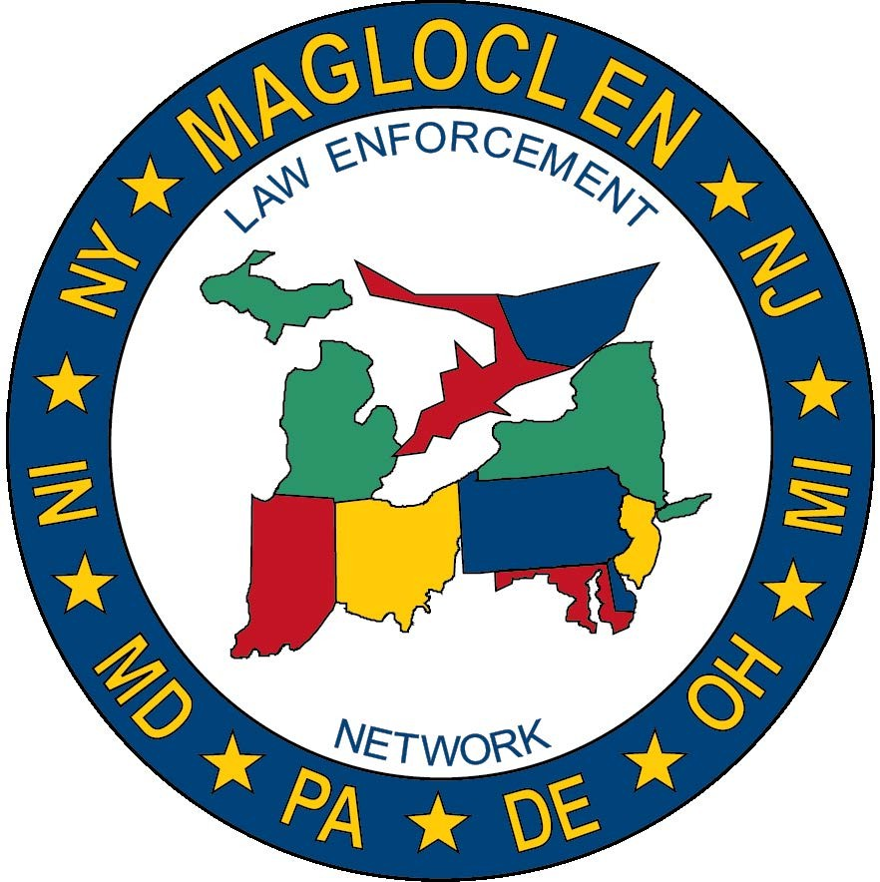
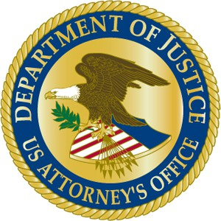
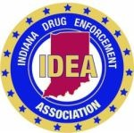
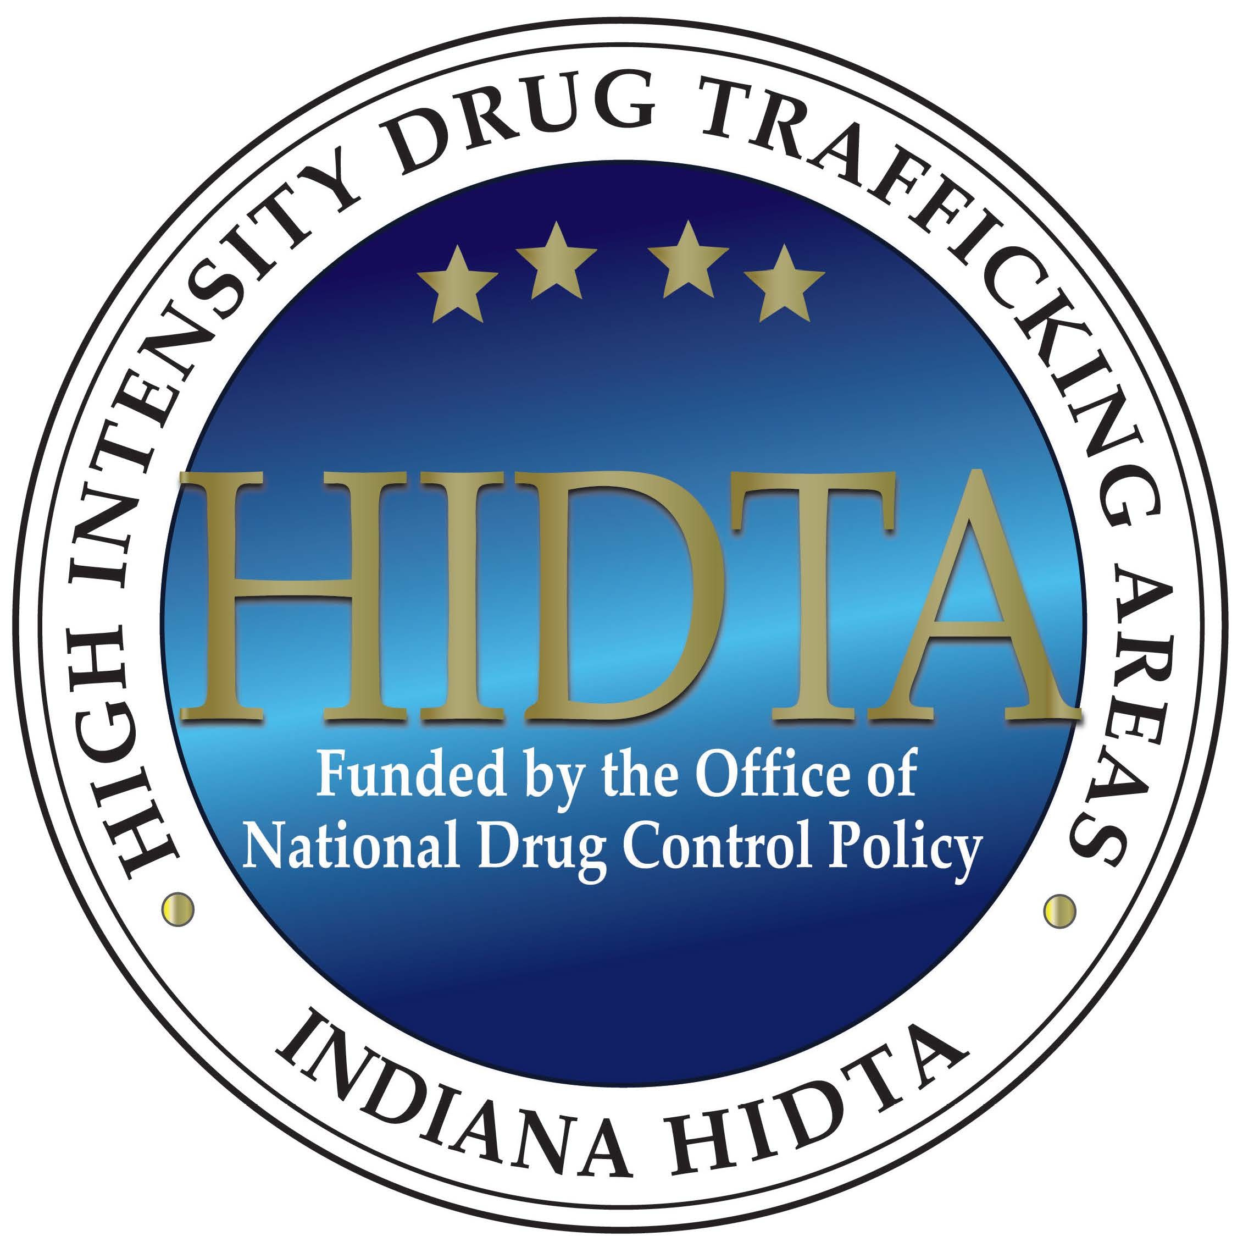
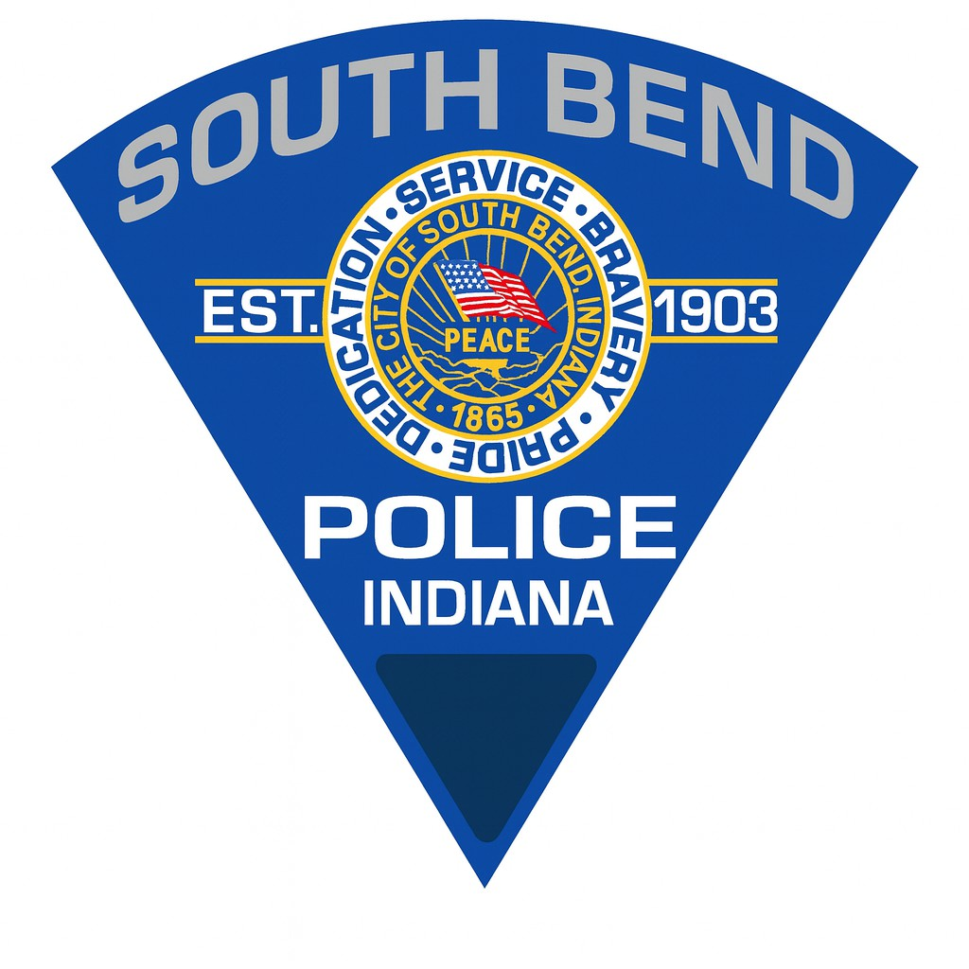
to preserve the crime scene of a drug overdose, gather information, conduct witness interviews, and collect evidence to determine the circumstances leading to the over-dose. There will also be instruction on post scene investigation techniques, conduct-ing suspect interviews, and the arrest process and prosecution of drug distributors.

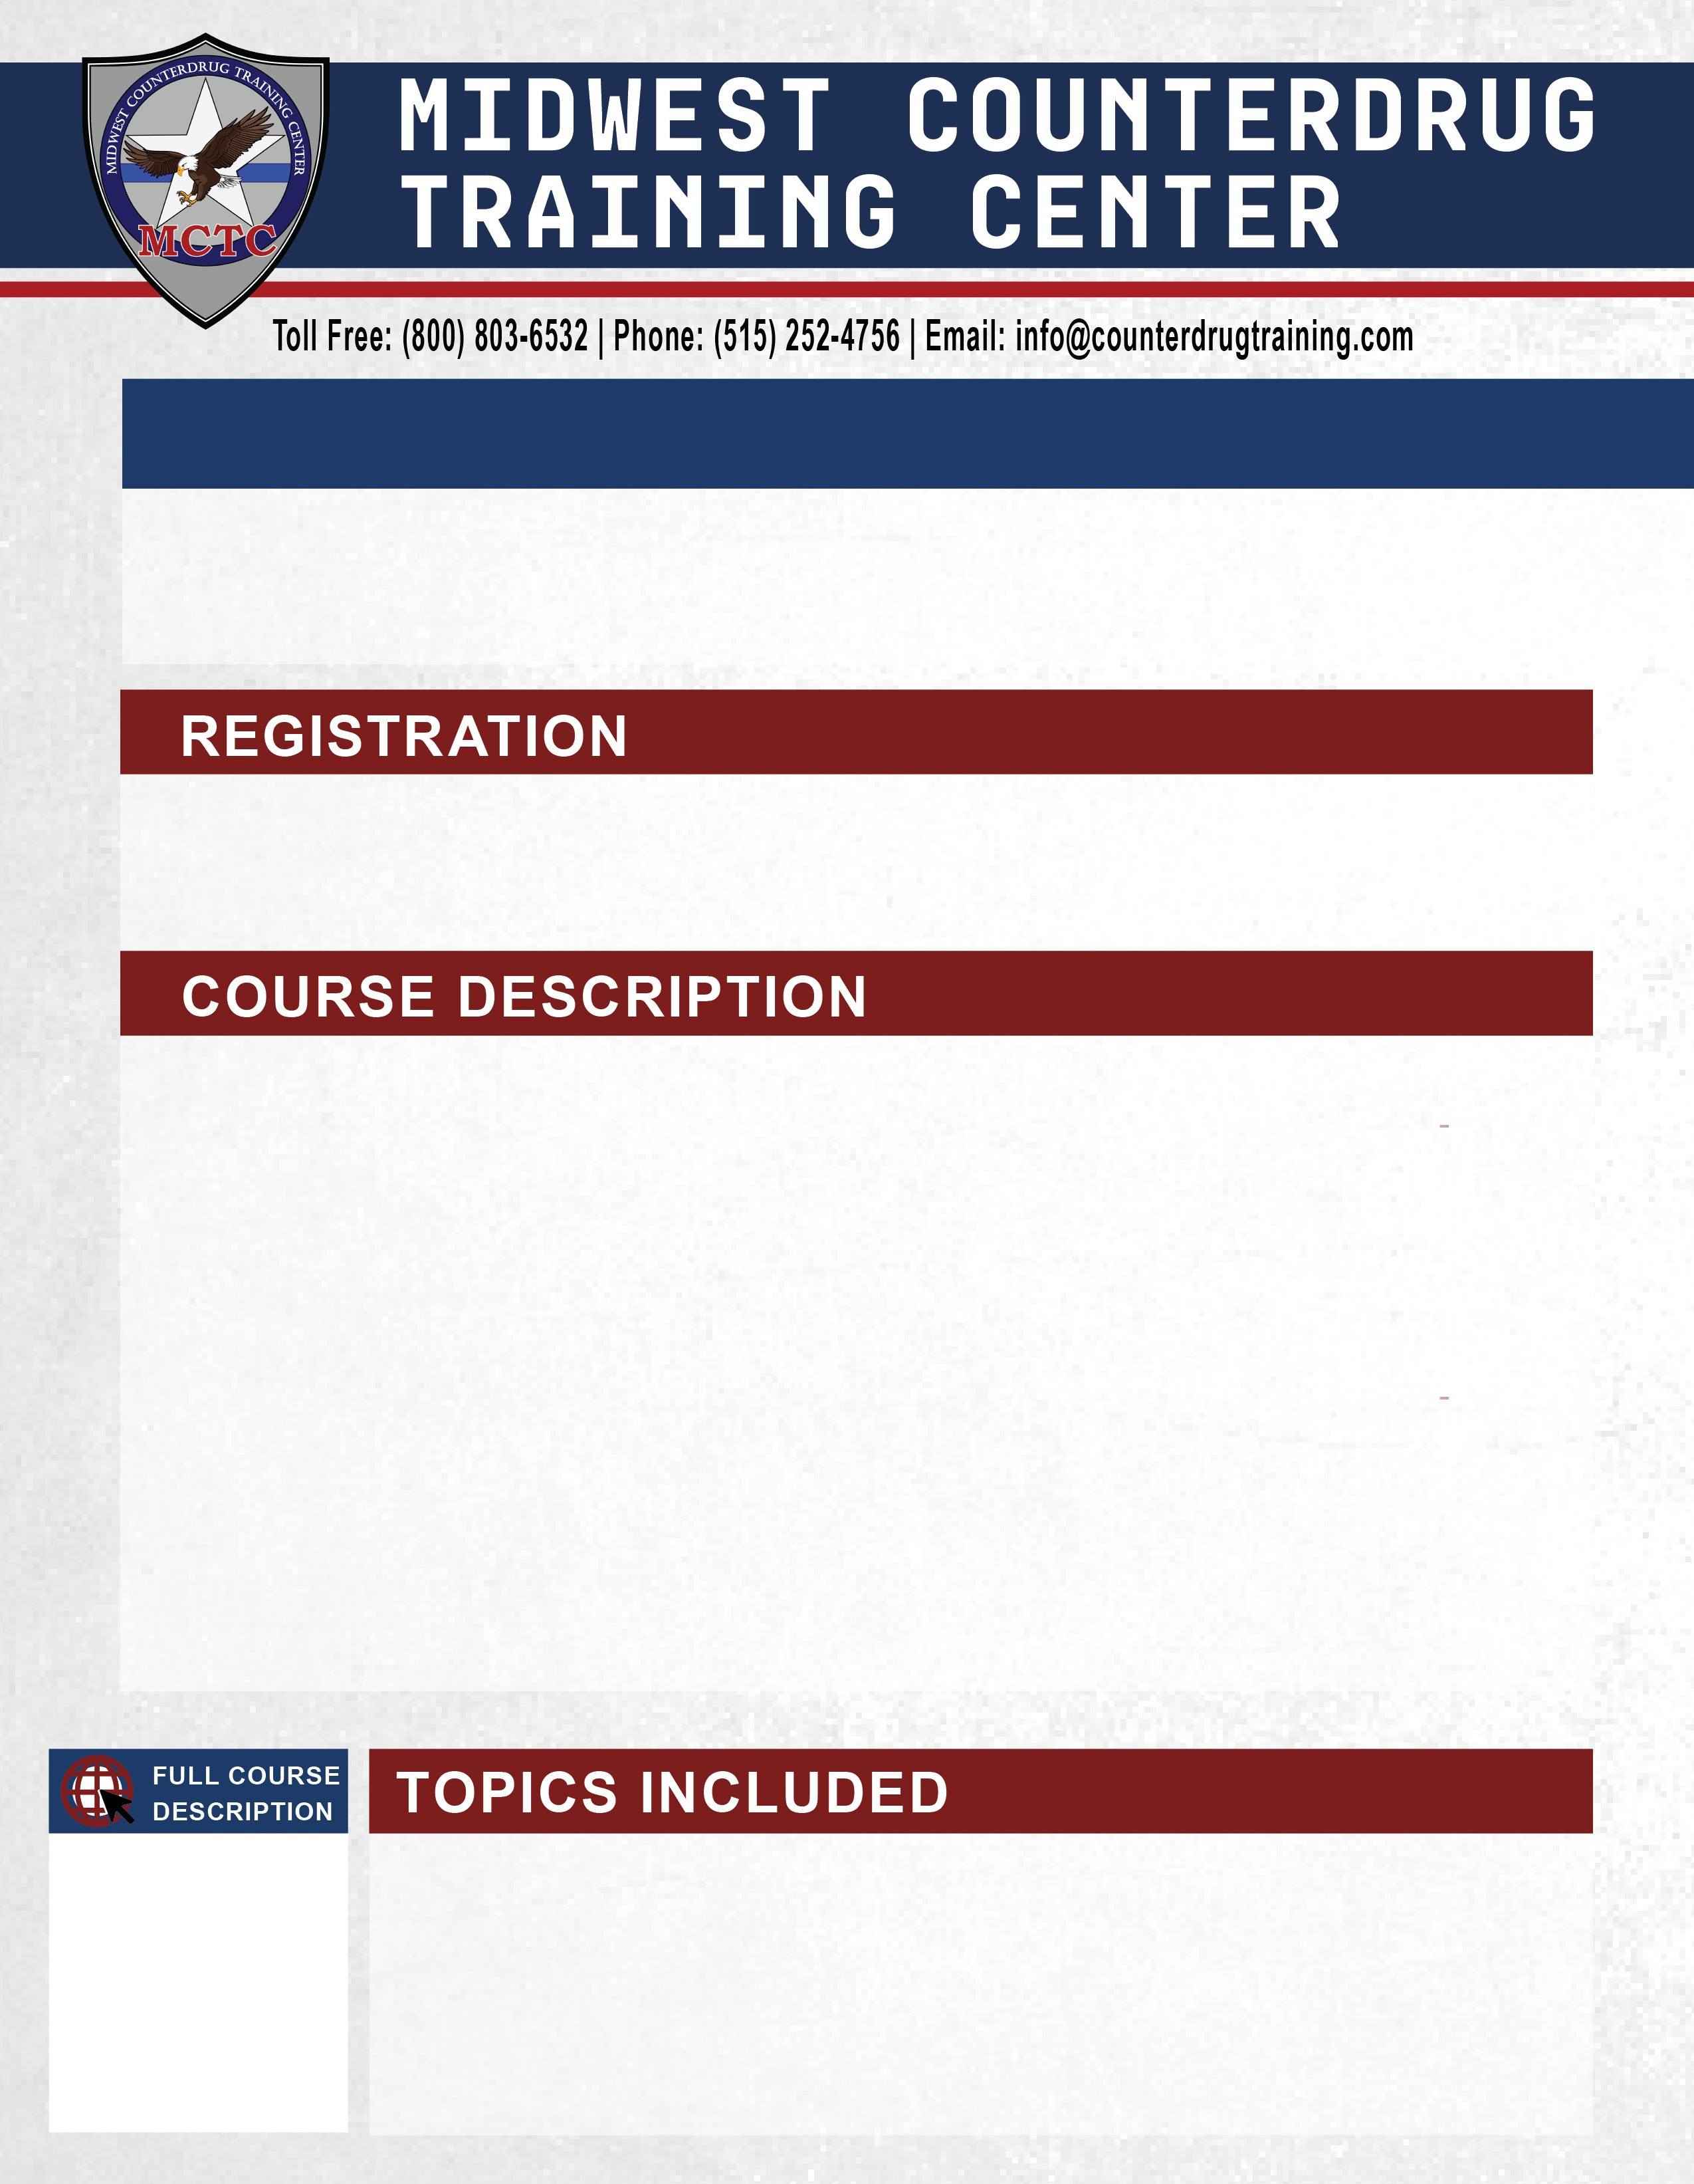
-Recognizing Drug Overdoses And Understanding Their Causes
-Identifying Basic Leads And Maintaining Crime Scene Integrity
-Proper Evidence Collection Techniques Critical To Investigations
-Selecting Appropriate Personal Protective Equipment For Over-dose Scene Investigations
-Safeguarding Against Opioid Exposure During Response Efforts
-Understanding Legal Authority For Searching Overdose Scenes
-Preserving Electronic Devices (Cell Phones, Computers, Tab-lets, Watches) To Prevent Data Loss
-Interview Techniques For Witnesses And Family Members To Identify Dealers/Distributors
-Conducting Interviews With Drug Distributors And Formulating Effective Questions

