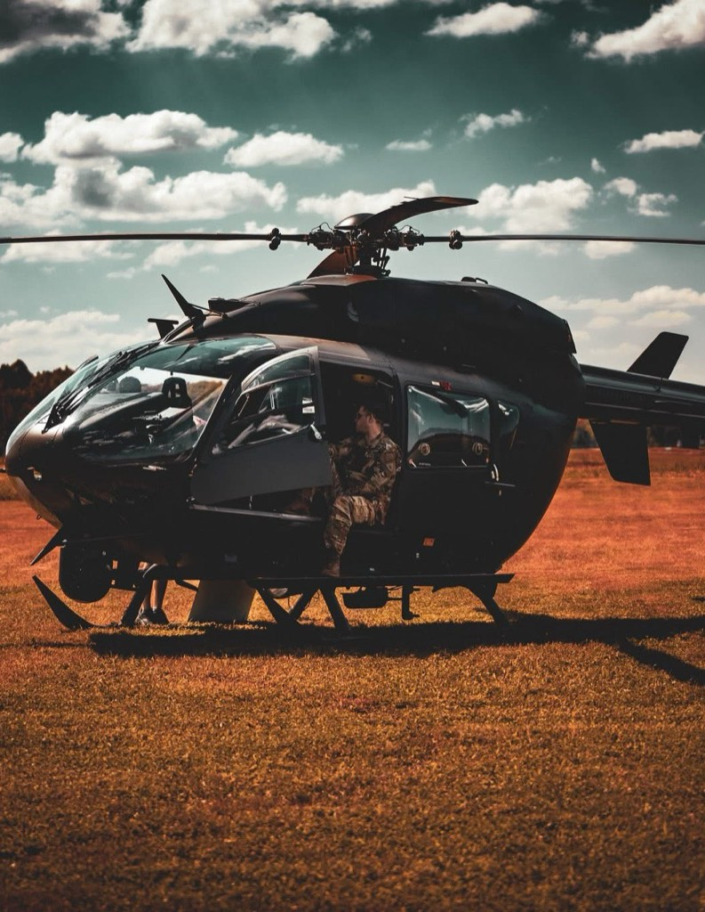
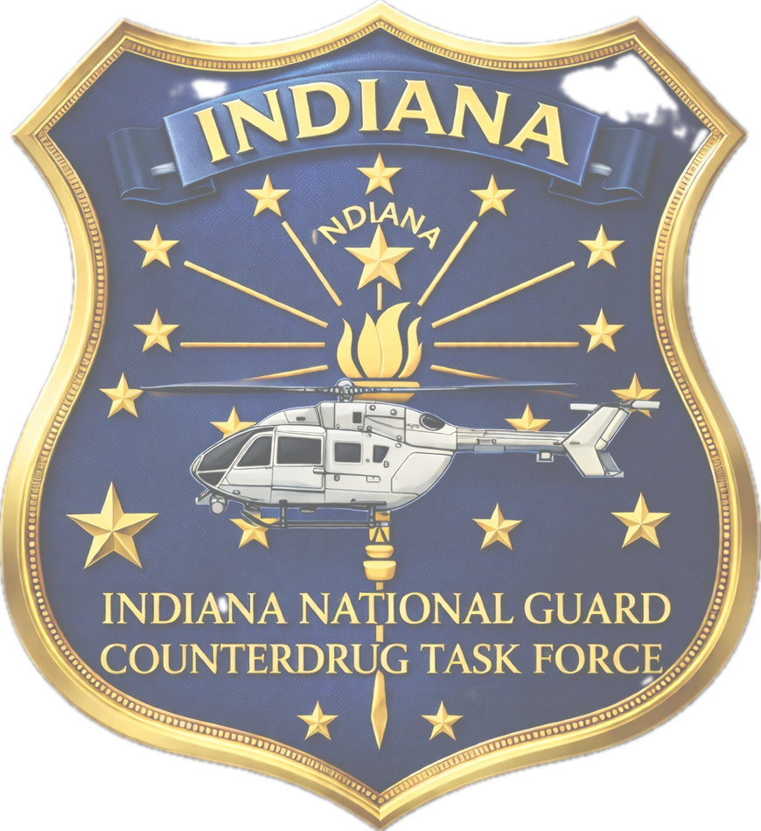

INDIANA AVIATION COUNTERDRUG SAFETY DAY
Sign In Starts at 0830 – 0900 May 12th, 2026
3319 N 100 W Shelbyville, IN 46176 Lunch Will Be Provided

Please register via QR code by 30 April 2026

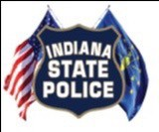
Law-enforcement training credit will be provided through I.D.E.A
