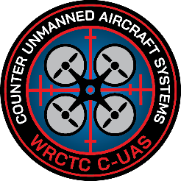
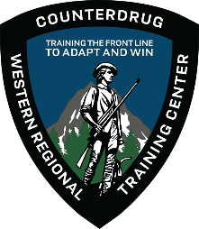
WESTERN REGIONAL
COUNTERDRUG TRAINING CENTER

COUNTER UNMANNED AIRCRAFT SYSTEMS (CUAS) FUNDAMENTALS TRAINING
Learn what you need to know about countering the drone threat!

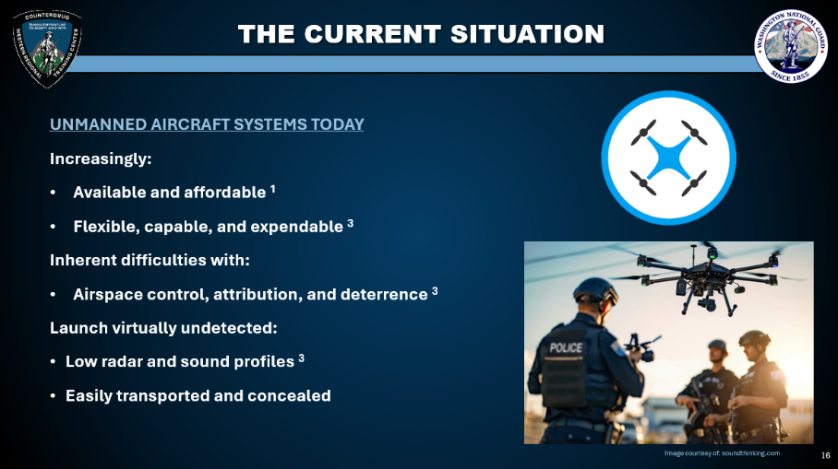
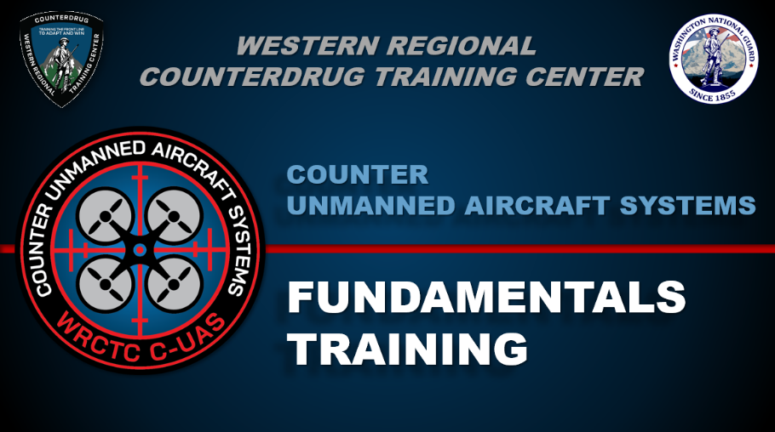
Who: Indiana HIDTA
What: WRCTC CUAS Fundamentals Training
Where: 3556 North Michigan Road, Shelbyville, IN 46176
When: August 5th, 2026. 8:00am - 4:00pm
Register now with the link below or QR code to the left!
https://www.wrctc.org/event/?eid=7f8ffbbc-2ee0-4737-9a9f-8d1e4076c4db
The WRCTC is now offering a FREE one-day, eight-hour course introducing the fundamentals of countering UAS. Topics covered during the course include:
- Fundamentals of UAS technology
- UAS types and capabilities
- Laws and regulations for drone operations
- U.S. Army Counter UAS principles
- Fundamentals of CUAS technology and processing


