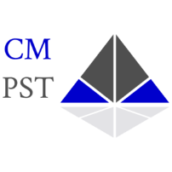
Sexual Assault Investigator’s Course (SAIC)

CM Public Safety Training, LLC

Course Information

Course: Sexual Assault Investigator’s Course (SAIC)
Course Dates: June 4-5, 2026, 0800-1700

Location: 7820 Broadway, Merrillville IN. 46410

Cost: $400

Contact: Michael DeHart (317) 403-8840, mddehart08@gmail.com

Student Registration Information

Name: Click here to enter text. Phone:Click here to enter text.
Email Address:Click here to enter text.

Agency:Click here to enter text.
Agency Address:Click here to enter text.

Contact at Agency: Click here to enter text. Phone:Click here to enter text.
Email Address:Click here to enter text.

Payment

Method of Payment:Click here to enter text.

The agency will be invoiced.

