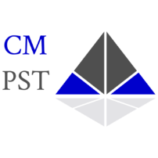
Evidence Based Interview and Interrogation

CM Public Safety Training, LLC

Course Information

Course: Evidence Based Interview and Interrogation

Course Dates: August 10-12, 2026, 0800-1700

Location: 186 Surina Way, Greenwood, Indiana 46143

Cost: $549

Instructor: Michael DeHart -(317) 403-8840, mddehart08@gmail.com

Student Registration Information

Name: Click here to enter text. Phone:Click here to enter text.
Email Address:Click here to enter text.

Agency:Click here to enter text.
Agency Address:Click here to enter text.

Contact at Agency: Click here to enter text. Phone:Click here to enter text.
Email Address:Click here to enter text.

Payment

Method of Payment:Click here to enter text.

The agency will be invoiced.

