[Editorial Forward: At the risk of ‘preaching to the choir’, I’m tired of undeserved ‘cop-bashing’ headlines. Although the general public supports police, we must be vigilant in protecting the public trust, and I offer the following toward that end.]

Why Public Confidence in Law Enforcement Remains High
By Tim J. Cain

Many of today’s police officers work in a socially hostile environment fomented by the main stream media and anti-police groups. They characterize police as lawless thugs driven by sadistic motives to harm people and violate their civil rights. This message is repeated so often, and sometimes with such force, that I fear that even I will start to believe it.

Fortunately, the right-minded citizens of our society are not so easily fooled. A recent poll by Reuters/Ipsos, commissioned by the Columbia Journalism Review, sought to assess public opinion regarding journalism as compared to other social institutions in America. This chart illustrated these findings:

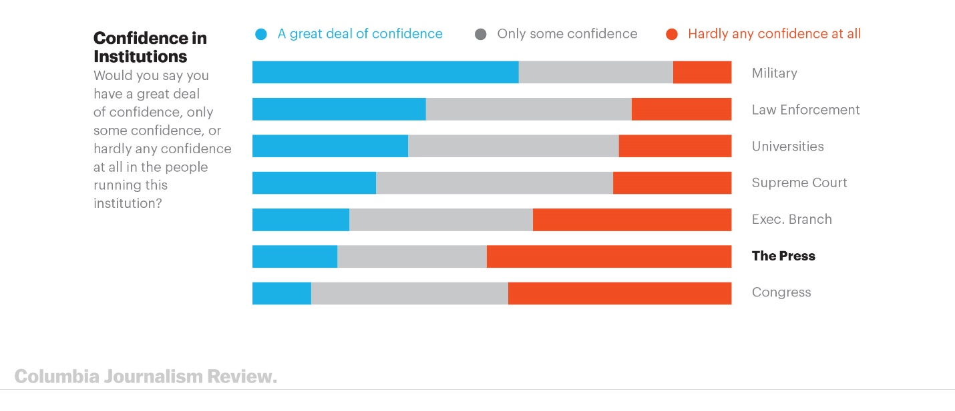
I cannot feign surprise at the ranking of the press as slightly more believable than Congress, but was gratified that law enforcement ranks second in level of confidence only to the United States Military. What can explain this steadfast confidence in law enforcement in the face of the main stream media’s onslaught?

Certainly, the collective wisdom of the American public is one reason, but that perception must be based on reality. The core reason is the professionalism of law enforcement.

“Confidence” means “faith or belief that one will act in a right, proper, or effective way”, thus the American public believes that law enforcement officers will resolve any situation encountered in a proper manner to bring about the most expeditious and fair resolution. This belief is, in turn, a direct result of police officers consistently acting in a professional way.

When police officers act with honor, integrity, character, and a sense of fairness in dealing with law breakers, the public notices. The assault on police integrity began with the shooting of Michael Brown by Ferguson, Missouri, Police Department Officer Darren Wilson on August 9, 2014, initiated a wholesale assault on police throughout America. Dubbed the “Ferguson Effect”, the attacks on police continued through the officer involved shootings of Tamir Rice in Cleveland on November 22, 2014; of Alton Sterling in Baton Rouge on July 5, 2016; of Philando Castille in Minneapolis on July 6, 2016; and many others. The “Ferguson Effect” also impacted non-shooting police/citizen encounters in the deaths of Freddie Gray in Baltimore on April 12, 2015, and of Sandra Bland in Texas on July 13, 2015.

In the majority of cases the police officers were exonerated, and only a few were convicted of homicide crimes:

“Criminal justice experts tell The Associated Press that fewer than 90 officers have been charged with murder or manslaughter for such shootings since 2005. Less than half were convicted or pleaded guilty to lesser charges. Even more rare is a guilty verdict on a murder charge: That has happened only five other times in the last 13 years in cases involving non-federal law enforcement officers — and four of those convictions were overturned, according to Bowling Green State University criminologist Phil Stinson.”

While I don’t ignore the impact of these cases on the individual officers involved, the institution of law enforcement weathered the storm because the officers acted in a consistently professional manner. This is the lesson taught to us by the United States Military during and after the Viet Nam war. Despite withering criticism and numerous acts of disrespect to individual veterans, the Military maintained its tradition of honor, integrity, and professionalism, and today the Military enjoys a renewed sense of respect and admiration.

And that is the lesson to be learned: endure the criticism, perform your duties as you were trained, and always act professionally, and the public will (continue to) support you.

This poll was conducted online by Reuters/Ipsos from December 7 to December 20, 2018, throughout the United States. It gathered responses from 4,214 adults, including 1,657 people who identified as Democrats and 1,505 who identified as Republicans. It has a “credibility interval,” a measure of the poll’s precision, of about 2 percentage points. Credibility interval = +/- 2% for total, +/- 3% for Democrats and Republicans, +/- 5% for Blacks and Hispanics.
Accessed 28 February 2019 at: https://www.cjr.org/special_report/how-does-journalism-happen-poll.php/.
https://www.merriam-webster.com/dictionary/confidence?src=search-dict-hed, accessed 28 February 2019.
Graham, D. A. (2015, October 26). The FBI Director's Troubling Comments on the "Ferguson Effect". The Atlantic.
In the cited cases, a grand jury refused to indict Darren Wilson, and a Department of Justice investigation found no civil rights violations committed by him; a grand jury refused to indict the officers involved in the Rice shooting; both the prosecuting attorney and the Department of Justice refused to bring charges against the officers in the Sterling shooting; although charged with various crimes by the prosecuting attorney, a jury found the officer involved in the Castille shooting not guilty; one hung jury and three not guilty verdicts prompted the prosecutor in the Gray case to drop all remaining charges against the officers; and a grand jury refused to indict the sheriff, and perjury charges against the arresting officers were dropped, in the Bland case.
Lauer, C. (2018, August 29). Associated Press. Retrieved from AP News: https://apnews.com/484a09b2571f479b9d49df0411797a0a.

