Resolution to Establish Minimum Standard for
Basic Academy Handgun Training and Qualification

R2025-26

At the regular public meeting of the Law Enforcement Training Board held on December 15, 2025, the Board’s majority adopts this minimum standard for basic academy handgun training and qualification.
This resolution repeals any outstanding handgun qualification courses of fire for basic law enforcement officer training.
These minimum standards will be permitted as of January 1, 2026, and will be mandatory for all basic training as of June 1, 2026.
The following minimum standards are adopted to ensure consistency, safety, and operational readiness for all law enforcement recruits:
- Mandatory Equipment for Course of Fire
- Issued Handgun
    - All basic recruits must use a handgun equipped with iron sights for basic training.
    - Basic recruits may use a handgun equipped with a Pistol Mounted Optic (“PMO”), if issued by the agency. Any recruit with an issued handgun containing a PMO must also have iron sights for basic training.
    - Recruits and their agency must ensure that all sight systems, including iron sights and any PMO, are properly “zeroed” prior to attending basic training.
    - Recruits and their agency must ensure that preventive maintenance has been completed prior to attending basic training, including installing a new PMO battery and proper torquing of all screws per the manufacturer’s specifications.
- Ammunition
    - All basic recruits must bring a minimum of one thousand two hundred (1,200) rounds of ammunition.
- Mandatory Basic Handgun Training
  - For each basic training session, the Officer-in-Charge must ensure that at least one instructor with training and experience in using a PMO is available, but not all instructors must have PMO training.
  - A minimum of eight (8) hours of basic training handgun instruction must be dedicated to using iron sights, regardless of what type of sighting system is issued.
  - Following the eight (8) hours of minimum iron sight instruction, the individual academy may determine the sight system required for the remainder of the training.
  - The basic handgun training must include malfunction drills for the following:
    - Type I (Failure to Fire),
    - Type II (Stovepipe or Failure to Eject),
    - Type III (Double Feed), and
    - PMO-specific malfunctions
  - The academies will no longer be required to provide shotgun training in basic training to allow for expanded handgun instruction.
- Standardized Qualification Course of Fire
  - Recruits must use the handgun and primary sight system as directed by their agency for all qualification attempts, meaning recruits issued a PMO as the agency’s primary sight system must qualify using the PMO, recruits issued a handgun with only iron sights must qualify using only iron sights.
  - In the event of a PMO failure during qualification, the recruit must continue and complete qualification using iron sights; no “alibis” will be granted for PMO malfunctions.
  - Staff and guest instructors may not repair PMO equipment during the qualification.
  - The qualification courses of fire must be completed during the same day and same session with limited time between qualification attempts. If the qualification is not completed within the same day and session, the recruit must start from the beginning.
  - The following standardized qualification course of fire will be followed by all basic training academies without modification to the stages of fire, the number of qualification attempts, or the minimum passing score:

50-Round Qualification Handgun Course
STAGE 1
3-yard line: 10 ROUNDS TOTAL split between two magazines, each containing 5 rounds. Two-handed, strong-handed firing.
- Shooter will start with one magazine of 5 rounds loaded, handgun holstered.
- When the target faces the first time, shooter fires 3 rounds in 5 seconds. Shooter will then scan and go to the low ready.
- When the target faces a second time, shooter will fire 2 rounds, conduct a combat magazine exchange, and then fire 2 rounds in a total of 12 seconds. Shooter will then scan and go to the low ready.
- When the target faces a third time, shooter will fire 3 rounds in 3 seconds.
- When stage of fire is completed, command will be given to cease fire, clear and holster all weapons.
STAGE 2
5-yard line: 10 ROUNDS TOTAL split between two magazines, each containing 5 rounds. One-handed firing only.
- Shooter will start with one magazine of 5 rounds loaded, handgun holstered.
- When the target faces the first time, shooter fires 5 rounds using strong hand only. Shooter will then conduct a two-handed combat reload, and fire 5 rounds using support hand only, in a total of 17 seconds.
- When stage of fire is completed, command will be given to cease fire, clear and holster all weapons.
STAGE 3
7-yard line: 10 ROUNDS TOTAL split between two magazines, each containing 5 rounds. Two-handed, strong-handed firing.
- Shooter will start with one magazine of 5 rounds loaded, handgun holstered.
- When the target faces the first time, shooter will take one step to the left, draw and fire 10 rounds, including a combat reload after the first 5 rounds, in a total of 20 seconds.
- When stage of fire is completed, command will be given to cease fire, clear and holster all weapons.
STAGE 4
15-yard line: 10 ROUNDS TOTAL split between two magazines, each containing 5 rounds. Two-handed, strong-handed firing.
- Shooter will start with one magazine of 5 rounds loaded, handgun holstered.
- When the target faces the first time, shooter will fire 5 rounds from the standing position, conduct a combat reload, then fire 5 rounds from the kneeling position, in a total of 25 seconds.
- When stage of fire is completed, command will be given to cease fire, clear and holster all weapons.
STAGE 5
25-yard line: 10 ROUNDS TOTAL split between two magazines, each containing 5 rounds. Two-handed, strong-handed firing.
- Shooter will start with one magazine of 5 rounds loaded, handgun holstered, and will be positioned behind a standing barricade.
- When the target faces the first time, shooter will fire 5 rounds from the strong side of the barricade, conduct a combat reload, then fire 5 rounds from the support side of the barricade, in a total of 40 seconds.
- All firing will be conducted with the handgun in the strong hand, two-handed firing.
- When stage of fire is completed, command will be given to cease fire, clear and holster all weapons.
** During Stage 5 only, the first round may be fired in single or double action mode.
SCORING
- Scoring Silhouette is below
- Possible Score: 100
- Passing Score: Recruit must achieve a minimum score of 80 points on three (3) consecutive targets to qualify. Failure to achieve a passing score on three (3) consecutive targets will be a failure of the qualification course. The recruit will have up to six (6) targets to achieve the three (3) consecutive passing scores.
CLASSIFICATIONS
To achieve an “Expert,” “Sharpshooter,” or “Marksman” classification, the average of the first three (3) scores will be taken. There will be no rounding of the average.
- EXPERT: 100-95.0
- SHARPSHOOTER: 94.6-90.0
- MARKSMAN: 89.6-85.0
- QUALIFIED: 84.6-80.0
If a recruit must use Targets 4, 5, or 6 to achieve the three (3) passing scores, they will be classified as “Qualified.”
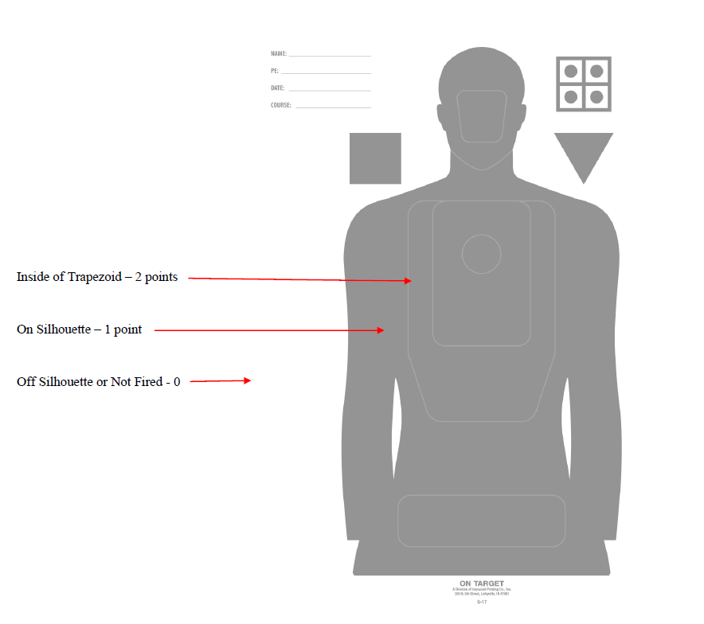
Passed and adopted on December 15, 2025.

Jonathan Whitham
Vice-Chairman, Law Enforcement Training Board

ATTEST:
Janice Hardwick
Secretary

