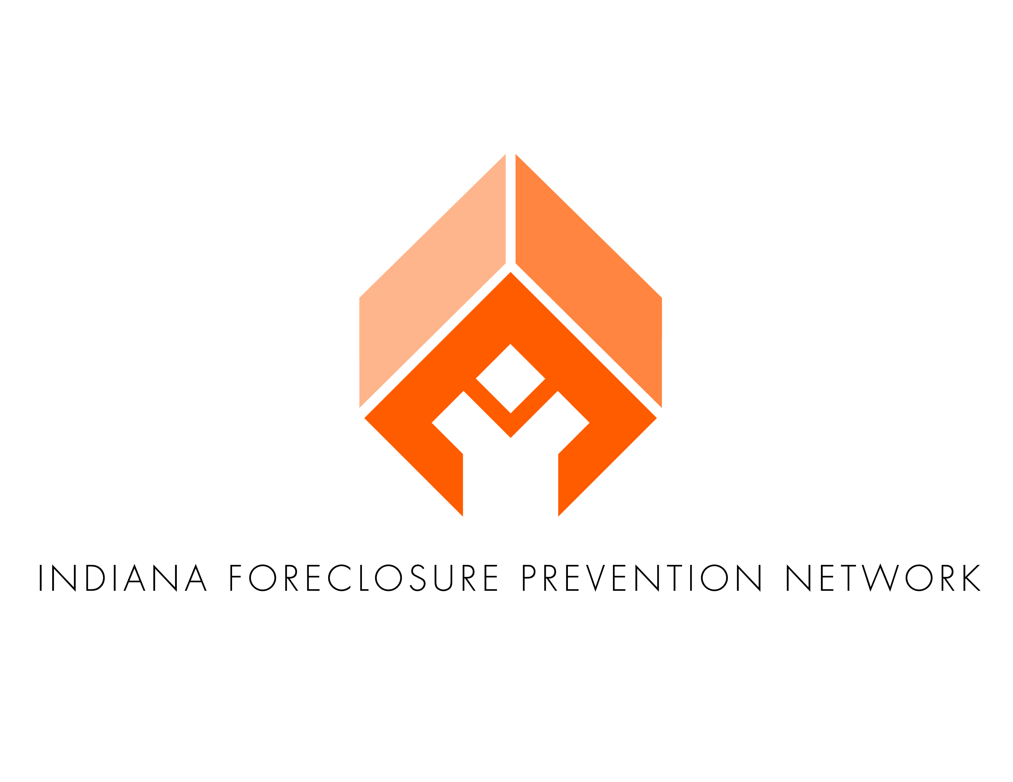



***Indiana’s Guide to IN HELPS:  
Homeownership, Foreclosure Prevention and Financial Education Certifications****updated 6.02.2014*

**Overview**

This manual details the requirements for becoming a state certified homeownership counselor, foreclosure prevention counselor and financial educator, as well as the requirements for maintaining certification through continuing education and recertification.

**About IN HELPS**

Indiana Housing Educators Licensing Procedures and Standards (IN HELPS) certifies housing counselors and financial educators who work with Hoosiers. IN HELPS provides accessible training programs for housing counselors to ensure state-consistent methods and concepts.

Housing counselors and financial educators provide objective information, advice, and guidance to all housing consumers for obtaining, maintaining, and retaining appropriate housing. They educate, collaborate, and negotiate with housing providers to address the needs of all housing consumers.

IN HELPS offers three fields of certification. Housing counselors may be certified in homeownership counseling, foreclosure prevention counseling, and financial education. Within each field, a housing counselor may be certified in one of three tracks. Housing counselors may be certified as an ***Intake*** ***Specialist,*** *a* ***Specialist***, or a ***Master***.

**About IHCDA**

The Indiana Housing and Community Development Authority (IHCDA) works with partner agencies throughout the State to serve the housing needs of Hoosiers by maximizing public resources and promoting sustainable communities. All Hoosiers should have the opportunity to live in safe, affordable, good, quality housing in economically stable communities. In 2002, IHCDA partnered with the Indiana Association for Community Economic Development (IACED) to start a statewide housing counseling certification program, named IN HELPS in 2010. Through IN HELPS, IHCDA has certified over 100 housing counselors.

The Indiana Foreclosure Prevention Network (IFPN), a part of IHCDA, uses these certifications to determine which housing agencies to partner with to facilitate the Hardest Hit Fund (HHF) and other IFPN initiatives. IFPN strives to preserve Hoosiers’ assets by preventing all Hoosiers from losing their homes, likely a family’s single largest asset, to foreclosure. **Therefore, in order to become an IFPN partner, at least one housing counselor must be certified as an IN HELPS Specialist in Foreclosure Prevention Counseling.**

**IN HELPS Certification and Recertification**

**Certification Fields**

IN HELPS offers certifications in three fields: Homeownership Counseling, Foreclosure Prevention Counseling, and Financial Education.

***Homeownership Counselors*** provide one-on-one or group counseling sessions, addressing the issues of homeownership. Homeownership Counselors must have knowledge of savings, credit, and debt barriers to homeownership. Homeownership Counselors perform mortgage readiness assessment, prequalification, credit report review, and action plan development.

***Foreclosure Prevention Counselors*** interact with homeowners in financial distress; negotiate with lenders; guide homeowners through the settlement conference process; enable homeowners to understand procedures regarding foreclosure and to educate homeowners to the pros and cons of refinancing and budgeting techniques.

***Financial Educators*** demonstrate a thorough understanding and refinement of the skills and techniques needed to provide effective financial counseling, education, and guidance to clients and families in the complex process of financial decision making. Financial Educators instruct clients in sound financial principles; assist clients in overcoming indebtedness; help clients identify and modify ineffective money management behaviors and guide clients in developing successful strategies for achieving their financial goals.

**Certification Tracks**

Each certification has three tracks for completion: ***Intake Specialist***, ***Specialist***, and ***Master***.

***Intake Specialists*** do not typically provide one-on-one counseling services. They assist other counselors with processing client files, setting appointments, and other day-to-day administrative tasks. **The Intake Specialist track is designed for individuals with little to no previous counseling experience**.

***Specialists*** provide one-on-one counseling services, but they do not yet provide intensive, complex counseling services. While Specialists tend to work independently, they are subject to some supervision or oversight within their organization. **The Specialist track is designed for individuals with one to two years of direct counseling experience.**

***Masters*** provide one-on-one counseling services at all levels of intensity and complexity. They require no supervision within their organization. **The Master track is designed for seasoned counselors, who have two or more years of direct counseling experience**.

IHCDA and IN HELPS encourage all counselors to strive for comprehensive certification, by both field and track. This will enable counselors to have the greatest information base to assist their clients.

**Certification Requirements**

When a counselor starts providing counseling services in a particular field or wishes to obtain a certification for job advancement, the counselor must submit a request by email to [www.helps@ihcda.in.gov](http://www.helps@ihcda.in.gov). Please provide all necessary information needed. A counselor pursuing a certification in a single field must complete all requirements within fifteen (15) months; in two fields, within (18) months; and in all three fields, within twenty-four (24) months. ***Counselors already pursuing a state certification as of the effective date of this manual must complete all remaining requirements within twelve (12) months***. Counselors employed with an IFPN or HHF agency when the agency becomes a partner agency must be state certified in Foreclosure Prevention Counseling (at any level) within the agency’s contract year. Employees hired or reorganized to provide foreclosure prevention counseling services during the contract term must be IN HELPS certified in Foreclosure Prevention Counseling (at any level) within one year from date of hire. Failure to meet these standards may result in partner contract termination. Agencies failing to meet this standard must mail an appeal letter, explaining why a particular counselor is qualified to render foreclosure prevention counseling services and why the agency should finish the contract term as an IFPN partner, to the IN HELPS Director. The IN HELPS Director’s determination is final. IFPN and HHF timing requirements supersede all other timing requirements.

**Administrative Requirements**

Individuals seeking state certification (all fields and tracks) must agree to adhere to the National Industry Standards Code of Ethics and Conduct for Homeownership Professionals. Please visit [www.homeownershipstandards.com](http://www.homeownershipstandards.com) to review the Code. Follow the instructions to adopt the Code.

***Individuals seeking specialist or master certification must submit to the IN HELPS Coordinator a professional résumé and two (2) letters of recommendation from professional references.***

**Course Requirements**

Below, the course requirements for each field and track are outlined. For Specialist tracks, there are multiple sets of courses a counselor may take to receive state certification. Counselors may select their preferred set of courses, but courses must be completed as indicated. **Substitutions are not permitted**. Courses labeled with “HO###” indicate courses taught by NeighborWorks. Courses labeled “el” (electronic learning) in subscript may be completed by attending the live instruction or by watching the webinar online and courses labeled with “el” in regular text are taught only as electronic learning courses. Courses labeled with IN HELPS will be offered by IHCDA, according to need, free of charge; IN HELPS courses in the Housing Counseling and Foreclosure Prevention Counseling Fields are directly applicable to housing counseling in Indiana.

**Homeownership Counseling Field**

**Intake Specialist Track**

1. HO102el Mortgage Lending Fundamentals for Homeownership Professionals
2. HO109el Foreclosure Basics

**Specialist Track (Option 1)**

1. HO109el Foreclosure Basics
2. HO110 Introduction to Homeownership Counseling
3. HO250 Housing Counseling Certification: Principles, Practices, and Techniques, Part I

**Specialist Track (Option 2)**

1. HO109el Foreclosure Basics
2. IN HELPS Pre-Purchase I
3. IN HELPS Pre-Purchase II

**Master Track**

1. HO211 Credit Counseling for Maximum Results
2. One of the following:
   1. HO360 Homeownership Counseling Certification for Program Managers & Executive Directors
   2. HO229 Homebuyer Education Methods: Training the Trainer
3. IN HELPS Master Pre-Purchase

**National Certification**

IN HELPS recognizes certain national certifications as satisfying the course requirements for state certification in Homeownership Counseling. Counselors who hold the certifications listed below with the respective organizations have satisfied the course requirements for the ***Specialist*** Track:

**National Association of Housing Counselors and Agencies, Inc. (NAHCA)**

* Certified Professional Comprehensive Housing Counselor
* Certified Professional Housing Counselor Specializing in Homeownership

**National Foundation for Credit Counseling (NFCC)**

* Housing Counseling Certification

**National Council of La Raza (NCLR) Homeownership Network Learning Alliance (NHNLA)**

* Housing Counselor Certification

**NeighborWorks Center for Homeownership Education and Counseling (NCHEC)**

* Pre-Purchase Homeownership Education Certification AND Post-Purchase Homeownership Education Certification

Counselors who hold the certifications listed below with the respective organizations have satisfied the course requirements for the ***Master*** Track.

**National Council of La Raza (NCLR) Homeownership Network Learning Alliance (NHNLA)**

* Advanced Housing Counselor Certification
* Housing Counseling Management Certification

**Foreclosure Prevention Counseling Field**

**Intake Specialist Track**

1. HO102el Mortgage Lending Fundamentals for Homeownership Professionals
2. HO109el Foreclosure Basics

**Specialist Track (Option 1)**

1. HO109el  Foreclosure Basics
2. IN HELPS Mortgage Foreclosure I
3. IN HELPS Mortgage Foreclosure II

**Specialist Track (Option 2)**

1. HO109el Foreclosure Basics
2. HO 345 Foreclosure Intervention and Default Counseling Certification, Part I
3. IN HELPS Mortgage Foreclosure I

**Specialist Track (Option 3)**

1. HO109el Foreclosure Basics
2. One of the following certifications:

i. National Council of La Raza (NCLR) Homeownership Network Learning Alliance (NHNLA) Foreclosure Counselor Certification (requires completion of Foreclosure Prevention: Fundamentals of Foreclosure Prevention)

1. National Foundation for Credit Counseling (NFCC) Housing Counseling Certification
2. IN HELPS Mortgage Foreclosure II

**Master Track**

1. HO211 Credit Counseling for Maximum Results
2. One of the following courses:
   1. HO307 Advanced Foreclosure: Case Study Practicum
   2. HO320 Developing and Implementing an Effective Foreclosure Program
   3. HO321 Developing Effective Loss Mitigation Negotiation and Sales Skills
   4. HO322el Using Effective Practices to Improve Your Foreclosure Counseling Programs
   5. HO346el Understanding and Applying Foreclosure Intervention and Loss Mitigation Tools
3. IN HELPS Bankruptcy I
4. IN HELPS Bankruptcy II
5. IN HELPS Mortgage Foreclosure in a Nutshell

**National Certification**

IN HELPS recognizes certain national certifications as satisfying the course requirements for state certification in Foreclosure Prevention Counseling. Counselors who hold the certifications listed below with the respective organizations have satisfied the course requirements for the ***Specialist*** Track.

**NeighborWorks Center for Homeownership Education and Counseling (NCHEC)**

* Foreclosure Intervention and Default Counseling Certification

**Financial Education Field**

**Intake Specialist Track**

1. HO102el Mortgage Lending Fundamentals for Homeownership Professionals
2. HO130el Understanding Credit Reports and Credit Scores

**Specialist Track (Option 1)**

1. HO130el Understanding Credit Reports and Credit Scores
2. One of the following courses:

i. HO209 Financial Fitness: Teaching Financial Management Skills

ii. HO209el Delivering Effective Financial Education

1. IN HELPS Credit Counseling in Today’s Market

**Specialist Track (Option 2)**

1. HO310 Financial Coaching: Helping Clients Reach Their Goals
2. IN HELPS Basic Financial Education
3. IN HELPS Credit Counseling in Today’s Market

**Master Track**

1. HO211 Credit Counseling for Maximum Results
2. HO370 Advanced Financial Coaching: Helping Clients Reach Their Goals
3. IN HELPS Advanced Financial Education

**National Certification**

IN HELPS recognizes certain national certifications as satisfying the course requirements for state certification in Financial Education. Counselors who hold the certifications listed below with the respective organizations have satisfied the course requirements for the ***Specialist*** Track:

**National Foundation for Credit Counseling (NFCC)**

* Consumer Credit Counselor Certification
* Educator Training Certification

**National Council of La Raza (NCLR) Homeownership Network Learning Alliance (NHNLA)**

* Financial Counseling Certification

**NeighborWorks Center for Homeownership Education and Counseling (NCHEC)**

* Financial Capability Certification (projected availability: August 2013)

**Continuing Education Units (CEUs)**

IN HELPS certifications are valid for the remainder of the year in which the certification is granted, plus three years. For example, state certifications received on February 23, 2014, and October 19, 2014, will both expire on December 31, 2017.

In order to retain an IN HELPS certification, counselors must complete twelve (12) continuing education units (CEUs) every year, beginning January 1st of the year following the year the counselor became certified with IN HELPS. For example, the counselor certified on February 23, 2014, must complete 0 CEUs in 2014; 12 CEUs in 2015; 12 CEUs in 2016; and 12 CEUs in 2017. **Four (4) CEUs per year must be completed by attending trainings offered by IN HELPS.**

One hour of training equates to one (1) CEU. Typically, an entire day of training equates to six (6) CEUs. All courses offered by NCHEC, NHNLA, and IN HELPS carry CEU credit. However, required courses for IN HELPS certifications do not carry CEU credit unless the course requirements for the particular certification were satisfied without the course. For example, if a counselor completes HO345, the counselor will not receive CEU credit unless the counselor is already a Specialist in Foreclosure Prevention Counseling or the counselor has selected Option 1 or Option 3 to become a Specialist in Foreclosure Prevention Counseling.

Trainings and courses approved and denied for CEU credit will be listed under the “Training Resources” tab in counselors’ Partner Accounts (see page 10 for how to access a Partner Account) by the end of 2014. If a particular training or course is not listed as approved or denied, counselors must submit an IN HELPS CEU Approval Request Form at Appendix A, page 11.

While IN HELPS encourages housing counselors and financial educators to seek professional development opportunities as frequently as possible, **only six (6) CEUs may be carried over to the following year**. For example, if a counselor earns 22 CEUs in 2014, 12 CEUs will be applied to 2014, and 6 CEUs will be applied to 2015. Four CEUs will not be afforded any credit. The carry-over policy will be strictly enforced to ensure that housing counselors and financial educators earn CEUs every year. Regulations as well as products and services, alter from year to year. Attending trainings every year ensures that counselors stay abreast with industry changes. To also achieve the goal of professional development, counselors may attend trainings and courses already completed, but may not do so within one year of completion. For example, if a counselor attended HO252 Effective Group and Telephone Foreclosure Counseling Strategies on February 22, 2013, and again on August 15, 2013, CEU credit would only be given for the February 2013 class. However, if the same counselor attended HO252 in May 2014 instead of in August 2013, they would earn CEU credit for the February 2013 and May 2014 courses, and they could take the course again for CEU credit after May 2015.

**If an IN HELPS certified individual fails to earn the requisite CEUs during any given year, IN HELPS will revoke the certification. The previously certified individual will be required to complete the certification process again to regain an IN HELPS certification.**

**Recertification Exam**

In order to be recertified by IN HELPS for another three (3) years, a housing counselor or financial educator must pass the recertification exam for his or her respective IN HELPS certification. A counselor has two (2) attempts to pass the recertification exam and must answer 80% of the questions correctly in order to pass.

Beginning on the November 1 prior to the expiration date of a certification, a counselor may request the study guide for the recertification exam for the applicable certification by emailing the IN HELPS Coordinator at [www.helps@ihcda.in.gov.](mailto:helps@ihcda.in.gov) So long as the counselor has completed the requisite CEUs for the particular certification, the IN HELPS Coordinator will provide the counselor an electronic study guide for the recertification exam for the applicable certification.

The IN HELPS Coordinator will provide the counselor the recertification exam along with the electronic study guide. Due to the format of the recertification exam, counselors should complete the exam either by printing it out, writing the answers on the exam, scanning the exam, and emailing it back to the IN HELPS Coordinator, or by typing the answers directly into an email to the IN HELPS Coordinator. The counselor will have ten (10) business days from the day the IN HELPS Coordinator sends the electronic study guide to complete the recertification exam. The counselor must send the completed recertification exam to the IN HELPS Coordinator by close of business (5:00 pm) on the tenth business day.

If the counselor fails to return a completed recertification exam by the tenth business day or fails to pass, the IN HELPS Coordinator will notify the counselor of the need for a second attempt. The counselor will have an additional 10 days from the date the IN HELPS Coordinator notifies the counselor to submit a passing recertification exam. If the counselor again fails to return a completed recertification exam within 10 business days or fails to pass, IN HELPS will not recertify the individual.

**NOTE: Although IN HELPS recognizes certain national certifications as satisfying the course requirements for state certification in all three fields, once a counselor is certified with IN HELPS, a counselor must satisfy IN HELPS recertification requirements to maintain IN HELPS certification; recertification with another organization will not translate to recertification with IN HELPS.**

**Submissions to IN HELPS Coordinator**

All submissions of completed course requirements and CEUs must be emailed to the IN HELPS Coordinator at [www.helps@ihcda.in.gov](http://www.helps@ihcda.in.gov) within sixty days of course/training completion. To properly submit it, a counselor or designated office administrator must email a certificate of completion, signed and dated by the sponsoring organization to the IN HELPS Coordinator. Counselors may not report completed course requirements and CEUs for other counselors. After submission, the appropriate credit will be inputted into the counselor’s Partner Account.

**Partner Account**

Every individual pursuing an IN HELPS certification or already certified by IN HELPS will be assigned a Partner Account. To access the Partner Account:

* visit <http://www.877GetHope.org/login/>
* scroll to the bottom of the page
* click on “Partner Login”
* when prompted, enter the correct login information
* click “Login” or press [Enter]

The IN HELPS Coordinator will supply each counselor with a Username and initial password, which should be changed to a unique password upon first login. The IN HELPS Coordinator cannot retrieve passwords for the Partner Account. Therefore, if a password is forgotten, a counselor must email the IN HELPS Coordinator to have the password reset.

After logging in, the counselor will be redirected to “My Account” with “Overview” as the header. In “My Account,” a counselor can review which required courses must still be completed to become IN HELPS certified and how many CEUS the counselor must complete in any given year to retain an IN HELPS certification as well as access important resources.

**Email Listserv**

Any individual may request to be added to the IN HELPS Counselors email listserv by emailing the IN HELPS Coordinator at [www.helps@ihcda.in.gov](http://www.helps@ihcda.in.gov). The IN HELPS Counselors listserv is operated by the IN HELPS Coordinator and IN HELPS Director. IN HELPS uses the IN HELPS Counselors listserv to notify counselors of upcoming courses and trainings offered by IN HELPS, as well as for IN HELPS and other IHCDA program updates.

**Appeals**

An individual may appeal a certification denial or revocation and a CEU credit denial to the IN HELPS Director. To appeal, individuals must mail written rationale along with supporting documentation to the address below:

IHCDA

Attn: IN HELPS Director – Appeal

30 S Meridian St, Ste 1000

Indianapolis, IN 46204

**APPENDIX A: Request for CEU Approval Form**

Counselor Name: ______________________________________________________________

E-mail Address: ______________________________________________________________

Employer Name: ______________________________________________________________

Employers

Address: ______________________________________________________________________

Training Information:

Organization Providing Training: ___________________________________________________

Training Topic: _________________________________________________________________

Trainer(s) Names: _______________________________________________________________

Location of Training (city, state):­­­­­­­­­­­­­____________________________________________________

Length of Training: ______________________________________________________________

Training Date: __________________________________________________________________

CEUs Obtained: _________________________________________________________________

*Please attach a brief description of the training and its learning objectives. Additionally, please attach the training certificate, training agenda, or other proof of attendance*.

**SIGNATURE**: ______________________________________________**DATE**:_________________