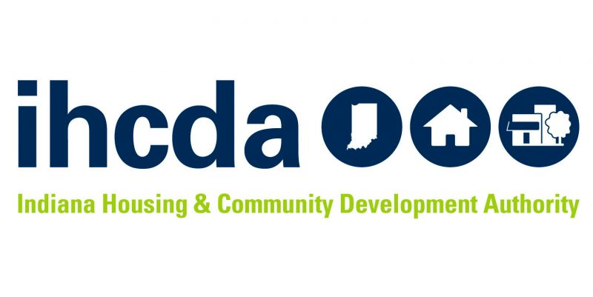

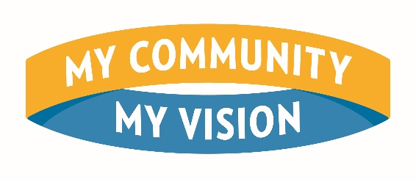

2022-2023 Program Year
Overview and Application Requirements

My Community, My Vision is a program from Indiana Housing and Community Development (IHCDA) designed to connect high school students across Indiana to each other and their neighborhoods, towns, and cities. In collaboration with the Indiana Philanthropy Alliance (IPA) Youth Council program and the Association of Indiana Municipalities (AIM) Mayoral Youth Council program, five selected cohorts of students across the state will participate in four months of workshops, planning, and fundraising for a place-based community project they would like to see come to life in their town or city.
Utilizing the features of IHCDA’s crowd-granting CreatINg Places program, students who successfully strategize, plan, and raise a fundraising goal of between $5,000 and $50,000 towards their community project will receive a matched grant from IHCDA.

Program Requirements
High school youth council groups, alongside their foundation or local unit of government sponsor, will work throughout the course of a semester to determine a project, craft a budget, develop a fundraising goal and strategy, and raise the needed funds for all materials during a thirty-day fundraising campaign. Throughout the semester, students will be required to participate in three in-person workshops hosted by IHCDA, where they will learn about place-based community development, project planning, fundraising strategies, and stakeholder engagement. Each workshop will prepare students to brainstorm and reach their project goal, as well as providing networking and leadership opportunities. In the final workshop, students will present their work and success to their peers and Indiana's community development leaders.
Students will be responsible for committing weekly time towards planning their community project and fundraising campaign, as well as travel to in-person workshops and any fundraising events. Selected youth council leaders and their supervisors will be required to attend weekly update sessions, and groups will be tasked with building and managing a crowd-funding page with IHCDA's partner Patronicity. Both IHCDA and Patronicity will provide guidance, technical support, troubleshooting, and other assistance throughout the course of the program. The MCMV Program will take place from January through May 2023.
The foundation or local unit of government sponsor will also act as the fiscal sponsor for the student-led project, and all raised funds and matched funds will be received by the sponsor at the end of the fundraising campaign. Sponsors will have one year to use the funds and complete the project.
The Commitment
- Three state-wide meetings, including a kick-off, a mid-semester meet up, and an end of year celebration
- Group supervisor check in with MCMV staff 1x per week; students work with supervisor on a weekly or bi-weekly basis to complete tasks
- Completion of Patronicity crowdfunding page, including project name, location, description, budget, and elements
- Fundraise a goal of between $5,000 and $50,000 during the 30-day campaign challenge
- Supervisors/Sponsor entities will be responsible to complete the project in one year after grant funds are received
Tentative Program Timeline
- August 12th, 2022 Program Application Released
- October 4, 2022 Program Webinar and Q&A
- November 7th, 2022 Application Deadline
- November 30th, 2022 Selected Teams Announced
- January 21st, 2023 Kick Off Workshop Event in Indianapolis
- February 25th, 2023 Check In Workshop Event (Location TBD)
- March 2023 Fundraising Campaigns Launch
- April 2023 Fundraising Campaigns Close
- May 6, 2023 Final Presentation Event in Indianapolis

Application Documents and Requirements
Each group applying to the MCMV Program for the 2023 Program Year is required to submit:
- An essay
- Signed commitment pledges for all participants
- Signed photographic consent and release form for all participants
- Application form with student roster
The application essay should be no longer than 5 pages and include the following information:
- Community description, including demographics, strengths, and needs
- Potential project and/or project location ideas
- Description of youth council, including number of students, name and position of supervisor, and any identified student leaders
- Youth council and supervisor’s experience in fundraising and group projects
- Student participation plan (gathering times/locations, description of roles, student and sponsor responsibilities, etc.)
- Implementation plan following fundraising (if and how students will be involved following the fundraising, how project will be completed in a one-year timeline, etc.)
- Why students want to participate in the program
Application Scoring Rubric
- Essay Requirements (24 points possible) + Threshold Requirements (21 points possible) + Bonus Points (1 point possible) = 46 points possible max
- Essay Requirements Points: Range from 1 to 4 (with 1 being not included at all to 4 being a thorough and insightful answer)
  - Community description
  - Youth council description
  - Past experience
  - Student participation plan
  - Implementation plan
  - Student statement
  - Threshold Requirements Points: Did you follow submission requirements? Three points each for:
    - Essay submitted
    - Submitted application form with student roster
    - Official AIM or IPA youth council program
    - Submitted signed commitment form from the sponsor (either local unit of government or community foundation)
    - Signed commitment from each adult leader
    - Signed commitment from each student
    - Submitted photo consent form for each participant
  - Bonus Point: One extra point will be awarded if groups include any project ideas or locations where their project could be built
46 possible points total

Up to five youth council groups will be chosen to participate in the program. Participating groups who are successful in their crowd-funding campaign at the end of the program will receive a matched grant from IHCDA to be used towards their community project. To be considered for the program, application materials and essay must be submitted via IHCDA OneDrive Folder no later than 5 pm Eastern Time on November 7, 2022. To set up a OneDrive folder, please email IHCDA Placemaking and ERR Manager, Meagan Heber, at mheber@ihcda.in.gov.
IHCDA will hold an informational webinar/question and answer session virtually on Tuesday, October 4th. To receive an invite for the webinar or for any questions, please reach out to Meagan Heber by email or by phone.
(317)234-3727
mheber@ihcda.in.gov

