CSBG Carryover and Closeout

Carryover Report
When CAAs receive their allocation of CSBG funds, they have the rest of that federal fiscal year to spend the funds, plus an additional federal fiscal year, before the funds are recaptured by IHCDA and eventually by HHS. If a CAA has not spent all of their funds by the end of the first federal fiscal year (by September 30), any funds left to be spent in the second year are considered Carryover Funds.
Carryover Funds must be tracked separately from funds spent in the first federal fiscal year for reporting purposes (specifically Module 1 of the Annual Report).
For that purpose, if a CAA does not spend all of their funds by September 30 in the contract’s first year, they are required to complete a carry-over report that separates what they spent in the first federal fiscal year from what is remaining to be spent in the second federal fiscal year. IHCDA staff will then use the report to create new budget line items on the award in IHCDAOnline for CAAs to claim against.
The Carryover Report has no other impacts on IHCDA or CAA operations; CAAs should not worry about having carryover after September reflecting negatively on their agency.

To submit the Carryover Report, please do the following:
- Submit your last claim for all funds expended between January 1 and September 30 by November 15.
- Submit a Carryover Report to csbg@ihcda.in.gov after the last claim for September is submitted.
- Once IHCDA receives and approves the Carry-Over Report, the carry-over budget lines will be set up.

A step-by-step guide on the carryover process is provided below

STEP 1: Submit your last claim for expenditures from January 1 - September 30 in IHCDAOnline by November 15. Below is an example of a CAA that would have carryover:

A CSBG award agreement in the amount of $269,087.32 with the following final claim amounts:
Total admin claims $28,256.81
Total agency provided services claims $119,980.55
Admin balance becomes the admin carry-over amount $14,743.19
Direct services balance becomes carry-over amount $106,106.77

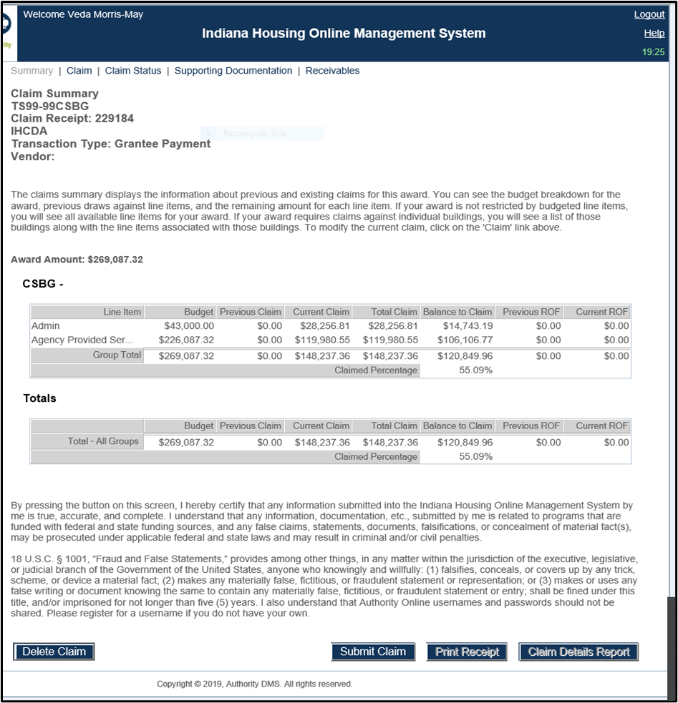
STEP 2: Submit Carryover Report by November 15. After the final claim is made for September expenses, the CAA would submit a carry-over report to csbg@ihcda.in.gov. Below is a sample Carryover Report using the same numbers from the above example:

Once both steps are completed and the Carryover Report is approved, IHCDA will set-up CSBG Carryover budget lines on your award and edit the CSBG budget lines down to what was spent from the start of the award term on January 1 until September 30. Any remaining funds (the balance) will be moved to “CSBG Carryover” lines. Below is an example using the amounts provided above.

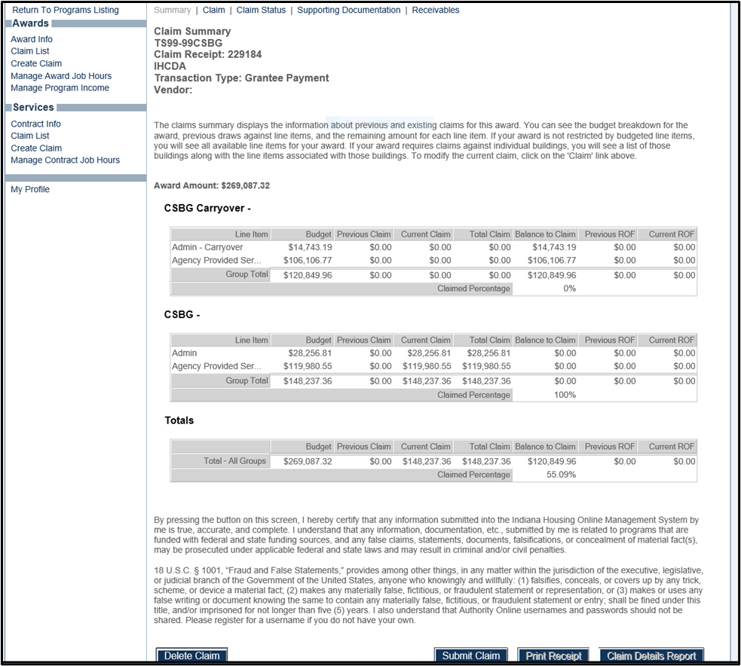

Please note that once the CSBG Carryover line items are set up, the CAA will not be able to make claims on the regular CSBG budget lines.

The CAA can then continue to make claims on a monthly basis until all carryover funds are expended, submitting budget modifications as needed, using the process outlined in the Guide to CSBG Agreements, Budgets and Amendments.

Close-out Report
CAAs have until September 30 of the second year that the CSBG grant agreement covers to spend all of that agreement’s funds. Once all funds have been expended, including Carryover, CAAs must make the final claim and submit the Closeout Report by November 15 of the second year of their agreement to access 2021 funding. For example, 2021 awards would submit their Closeout Report by November 15, 2022.

The completed Close-out Report should be emailed to CSBG@ihcda.in.gov. Once the Close-out Report is received, IHCDA will approve and email a copy of the Approved Close-out Report back to the CAA.

IHCDA requires the following items in addition to confirmation of what a CAA spent on Admin and Direct Program expenses:
- The total direct program expenses must be broken down by the programs that were supported by CSBG funds. When a CAA provides the list of programs and the amount that went to each program, the total should match the Direct Program amount provided in the table above.
  - TIP 1: please include the name of the state or federal program somewhere in the program title you list in this table. Ex: If your “Housing” program is actually your agency’s HCV program, please put “HCV,” “HCV Supplement,” or “Housing (HCV).”
  - TIP 2: if your agency normally combines two federal or state programs under one title, please separate them for this report. Ex: if your agency’s “Housing” program includes HCV and Weatherization, please list those separately on this report.
- Agencies must identify any program income that was earned during the period that the CAA was claiming against the relevant award.

New for the 2021 program year, IHCDA requires that for each program that receives CSBG funds, that the most recent annual budget for that program must also be provided. This way IHCDA can see the proportion of the program’s budget that CSBG supports. The entire program operating budget should be reported, not just administration or program costs, since all costs associated with a particular program are considered Direct Program Costs under CSBG rules.

Below is a sample Close-out Report showing that all funds have been expended and claimed.

The next award will not be opened for claims until IHCDA staff receive the Closeout Report, so it is important that the report is sent to csbg@ihcda.in.gov as soon as possible after the final claim is submitted in order for a CAA to have consistent access to CSBG funds.

