Guide to CAA Subgrantee Budgets, Amendments and Budget Modifications

CSBG Award Budget
Once an ED signs their grant agreement, the CAA must submit a budget based on the total funds received as indicated in the Attachment A of their Agreement.
For example, if Indiana Community Action Agency received $65,271 for the 1st quarter allocation, the budget submitted would total $65,271.00.
Below is a copy of a blank budget form. The CAA will initially only complete the Regular Budget line items (top table). After September 30 of the agreement’s first year, any remaining funds will be moved to the carry-over line items (bottom table) via the Carryover Report. The “amount increase or decrease” column is only to be used for amendments (funds being added) and budget modifications (funds moving from admin to program, or vice versa). The “revised budget” column will automatically update to show what should now be entered into IHCDAOnline to be claimed against, as will the “revised budget percentage” to help ensure the CAA does not go over the admin cap.
TIP: CAA staff only need to edit boxes that are white. If a box is shaded blue/grey, it will automatically update or be completed by IHCDA staff.
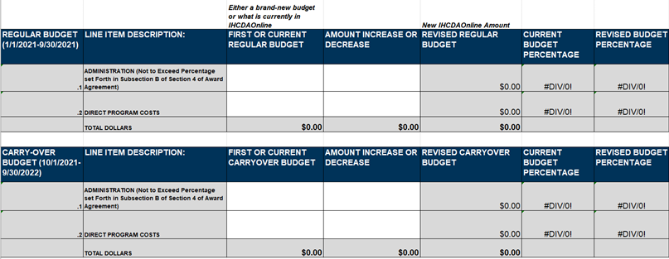
Carry-Over Budget
Regular Budget
Below the tables where CAAs enter their current and updated budget information is a table where the overall budget breakdown is automatically calculated. When working off the regular budget only, this table should show the same numbers. This table becomes important when working off the carry-over budget; then it will combine the regular budget and carryover budget to show the overall award (specifically in the revised budget column) and overall breakdown between admin and program line items.
Overall Budget
The cap on administrative expenses is on the overall award, so the revised administrative line item in this table is the one CAAs need to keep an eye on.
There are three ways to receive and/or access the budget form:
- The budget form will be attached to the 1st Quarter (Original Contract) Grant Agreement.
- The budget form will be emailed directly to the CSBG Manger and the finance person of each CAP.
- The Budget form will be located on the IHCDA CSBG Website as an Appendix to the program manual.

The budget lines are Administration and Direct Program Cost. The maximum amount that a CAA can spend on Administration is a percentage set by IHCDA, which is identified in the body of the grant agreement. For the 2021 program year, that percentage is 20%.

In the example above, the CAA could budget up to $13,054.20 (20% of $65,271) on administrative costs.
Below is a sample budget form that was submitted by Indiana Community Action Agency for their 1st Quarter allocation which is a part of the Regular Budget Line Item:
$ 12,000 18% is on the Administrative Line Item
$ 53,271 82% is on the Direct Program Cost Line Item
$ 65,271 is the total Allocated Amount for 1st Quarter

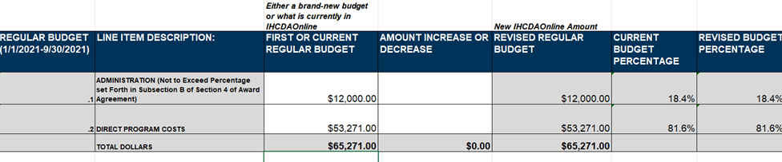
CAA’s must use the IHCDA-provided form for their budget and send it to the CSBG Community Analyst at csbg@ihcda.in.gov with information provided at the bottom of the budget about the CAA staff person who is submitting it; signatures are no longer required. Once received, the Analyst will review and approve the budget. Once the budget is approved, it will be entered into IHCDAOnline for the CAA to claim against. CAAs will not have access to their funds from a new award or award amendment until their corresponding budget form has been received by IHCDA staff.

Submitting Claims
Claims for reimbursement must be submitted though the IHCDAOnline system. Beginning April 1, 2021, all CSBG claims must include the IHCDA-provided Claims Cover Sheet, provided as Appendix L to the CSBG manual.
For all expenses over $1,000, additional supporting documentation must be included with the claim.
For more information about how to access CSBG awards and submit claims in IHCDAOnline, please see “Appendix M_CSBG Claims Resource,” as well as the Partner’s Guide to IHCDAOnline, listed here: https://online.ihcda.in.gov/AuthorityOnline/Links.htm

Agreement Amendments
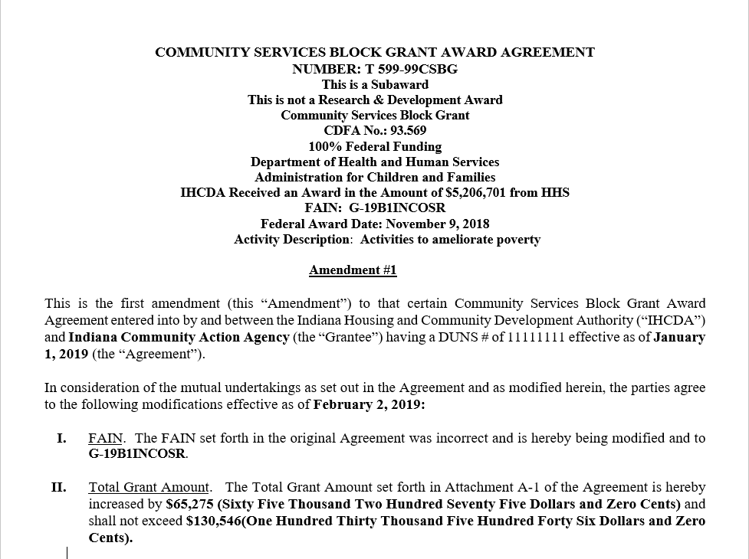
Amendments to a CSBG Agreement can happen for several reasons, but the most common is that OCS has released a new distribution of CSBG funds to IHCDA, and IHCDA must allocate those funds to the network. When IHCDA does receive those funds and the corresponding award letter, IHCDA staff will email the network to inform them about new funds and amendments to be signed, and then send the individual amendments for e-signature. The amendments will look like this:
In the example above Indiana Community Action Agency received an additional $65,275 for the 2nd Quarter in February 2019. This would require an Amendment to the Original Contract, making their overall award $130,546.
Just like with the original agreement, a new budget form will need to be completed by the CAA, following the same process outlined above. Below is an example showing the Amendment 1 Budget for Indiana Community Action Agency. Since they have already established a budget, the amounts for the Amendment 1 budget would be added to Amount Increase of Decrease column.
$ 10,000 added is on the Administrative line item
$ 55.275 added is on the Direct Program line item
$ 65,275 total added is the total Amount for the award
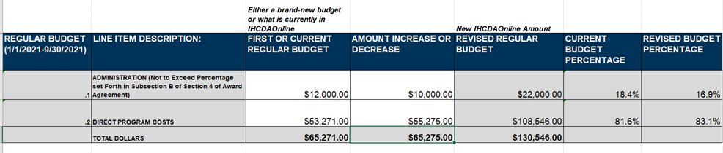
Total Award
Amendment addition
Amendment 1 Budget

Budget Modifications
CAAs can submit a budget modification at any time to move funds from one line item to another, as long as they continue to follow administration percentage guidelines.
In the example below Indiana Community Action Agency wants to move $5,012 from Administrative Funds to Direct Program Cost. They would submit the following Budget Form as Modification #1:
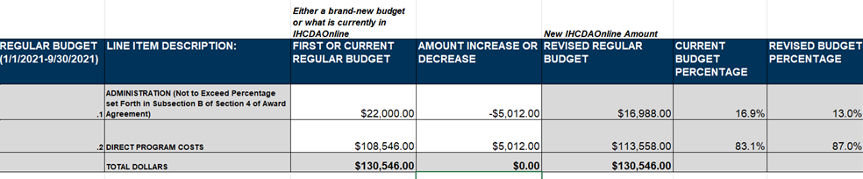

Once the CSBG Analyst receives the Budget Modification, reviews, and approves it, the new amounts will be entered into IHCDAOnline for the CAA to claim against. A copy of the approved budget will be emailed to the CAP.

