2020 IDOI CLE Agenda 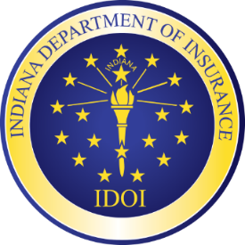
October 1, 2020
Microsoft Teams Live Event
7:45 – 8:00 Registration and Set-up for First Session

8:00 - 8:30 Welcome and Updates on NAIC Current Issues
Commissioner Stephen W. Robertson, IDOI

8:30 - 9:00 Are There Skeletons in the Closets of Your New Home?
What Your Policy Will and Will Not Cover
Jonathan Handsborough, Title Director/RREAL Database Administrator, IDOI

9:00 - 10:00 Corporate Governance, ERM and ORSA
Steve Hazelbaker, President, Noble Consulting

10:00 - 11:00 Ethics
Jennifer Cooper, State Ethics Director, Indiana Office of Inspector General Claire Szpara, Attorney and Ethics Officer, IDOI
11:00 - 11:30 Adventures in Dedicated Funds, Part II: More Adventures in Dedicated Funds with Legal and Procedural Discussions about the Indiana Mine Subsidence and Patient’s Compensation Funds
Ed Fujawa, Deputy General Counsel, IDOI

11:30 - 12:00 The Impact of COVID-19 on Litigation
Susan Forray, Principal & Consulting Actuary, Milliman

12:00 - 12:30 Registration and Set-up for Second Session

12:30 - 1:00 Hot Topics in Enforcement
Steve Embree, Bail & Security Director, IDOI

1:00 - 2:00 Legislative Panel
Hon. Eric Bassler, Chair, Insurance and Financial Institutions Committee
Hon. Martin Carbaugh, Chair, Indiana House Insurance Committee
Hon. Mike Gaskill, Member, Insurance and Financial Institutions Committee
Hon. Matthew Lehman, Indiana House Majority Leader

2:00 - 3:00 Artificial Intelligence
Amy Beard, General Counsel, IDOI
3:00 - 4:00 Dispassionate Update on Status of Federal ACA Litigation
William G. Schiffbauer, Partner, Schiffbauer Law Office

