Your solution for ordering items not found on the punch-out or custom orders. eVMI quotes also act as templates for repetitive orders.
QPA #13090
eVMI
(Electronic Vendor Managed Inventory)

If you are in need of items that are not found on the punch-out contact a local Fastenal store in person or by phone and ask them to enter an eVMI for you. After giving the item information to the store employee they will enter a quote, notify you of the number, and post it on the eVMI site as shown below.

A. After entering the PeopleSoft Fastenal Punch out click on eVMI in the upper right hand corner.
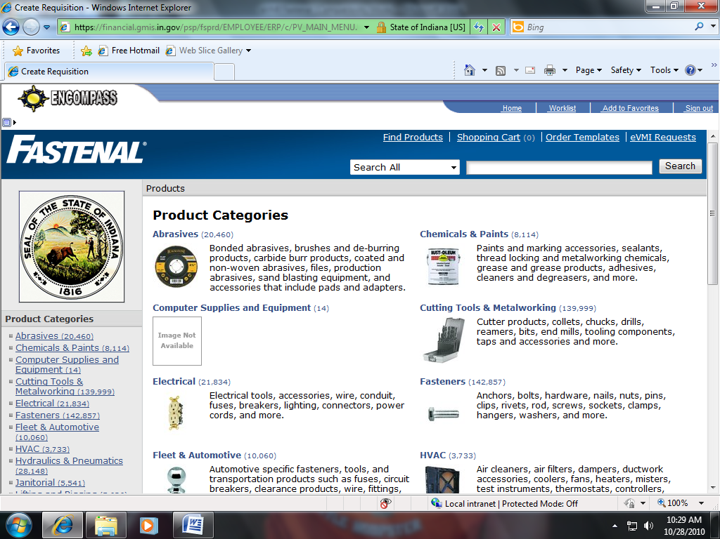
A

B. Enter in the search field the quote number that was provided by the local Fastenal store that you contacted and click search, then click on the blue quote number.
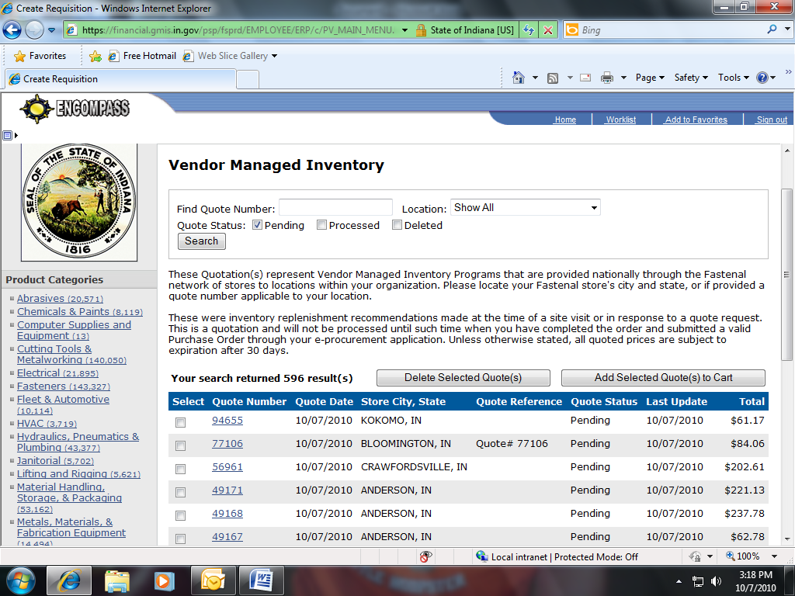
B
C. The quote with pricing will appear for you to view. You can then click add to cart and all the items listed on the quote will now show in your shopping cart. You can edit your order if needed and click check out.
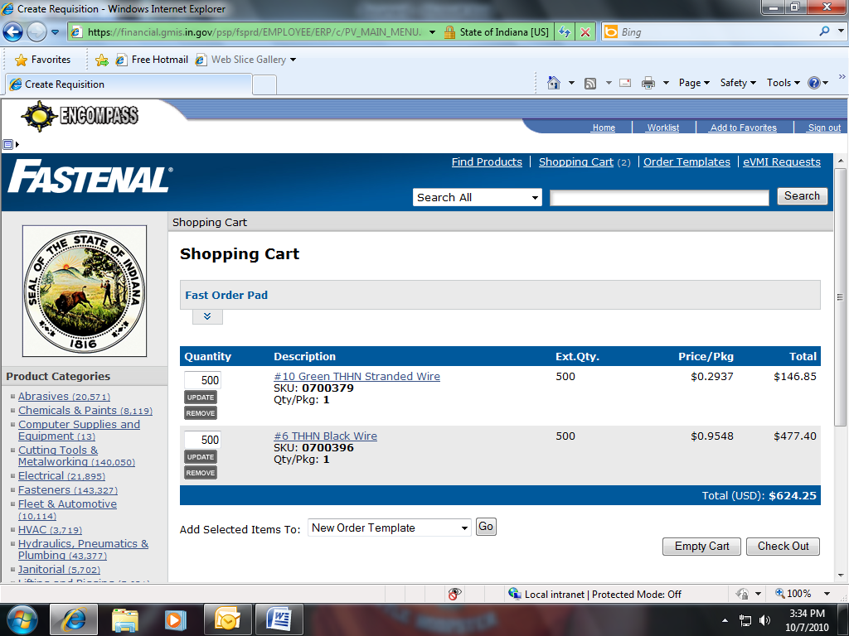
C
Once you click check out you can then select “Complete Check Out”, you will be brought back into PeopleSoft in order to finish the requisition process.
Your eVMI quote will remain in the system for future use as a template. To use the eVMI option as template, check the processed box in the main screen before searching for the quote number. The item numbers and pricing are always up to date, and you can purchase the items again by selecting them from your eVMI quote number.

