How to check a bidder’s Buy Indiana certification

Step 1:

You will need to navigate to the Bidder Profile in PeopleSoft. The navigation is Sourcing>Bidder Information. Once you have completed the navigation you will be at the following page.

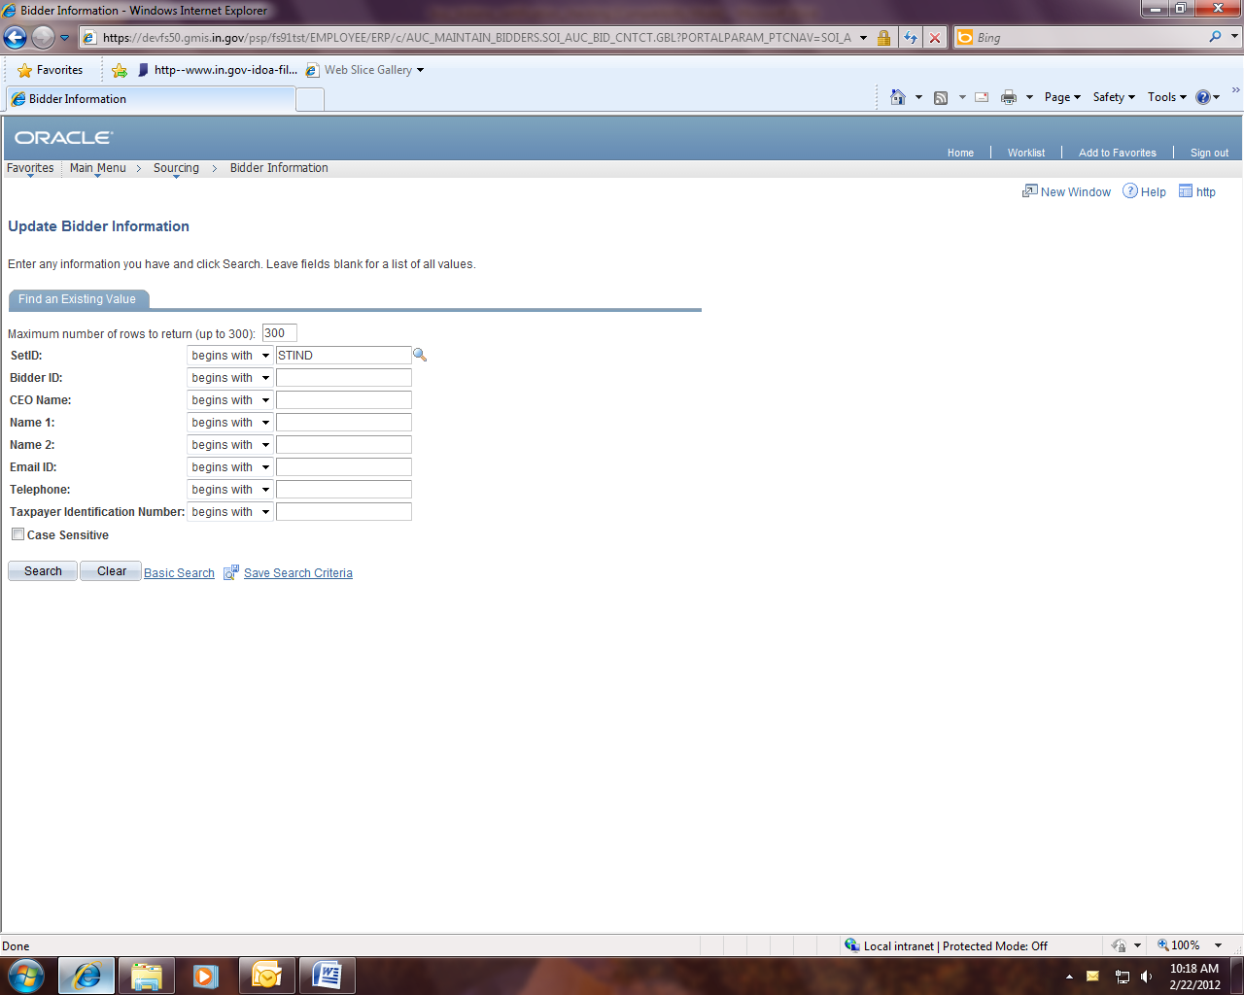

Step2:

To search for a Bidder you can put part of the vendor’s name in the “Company Identification Number” field and change the drop down box to “contains” and then click the “Search” button. You can also search by any of the criteria you may have using the same process.

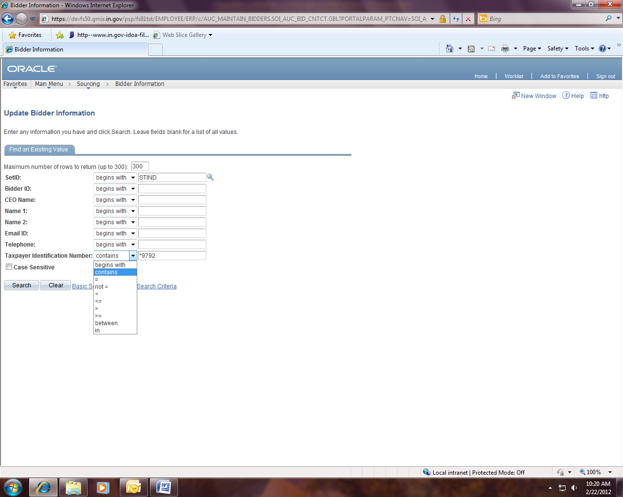

Step 3:

Once you have obtained all the Bidders returned, you must click on the desired Bidder to see their profile. Once you are in the correct Bidder profile you will need to click on the Buy Indiana tab to see their Buy Indiana certification and if they have verified that certification.

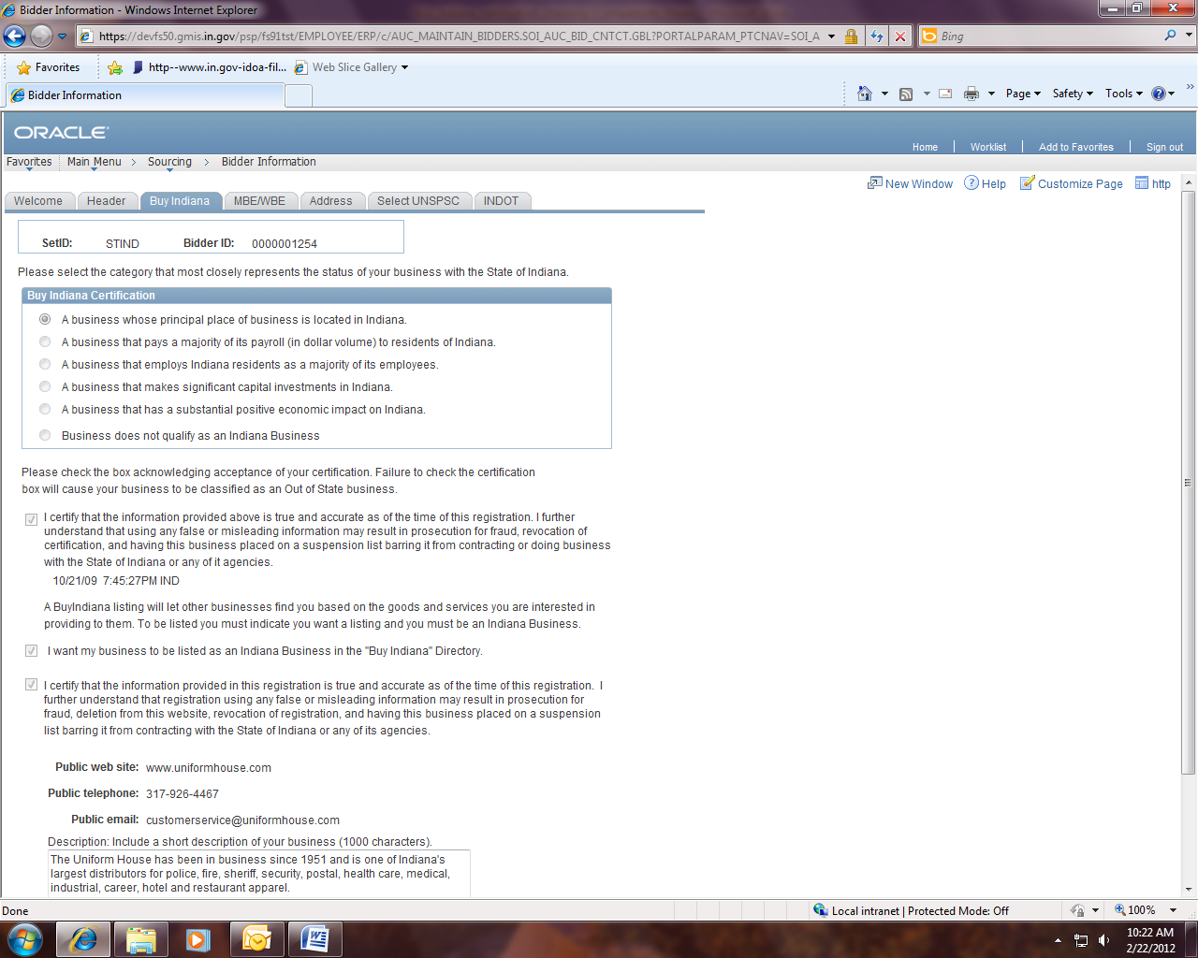

If both the Buy Indiana Certification (one of the circles is filled in) and the verification are completed (check mark in the box and then a date and time underneath the first paragraph), then the Bidder is certified for the Buy Indiana preference. To be certified as an Indiana business the Bidder must have chosen one of the first five selections in the Buy Indiana Certification. If they chose the sixth selection, they are considered an Out of State Bidder.

If the company does not have a Bidder Profile or needs to update their profile, you must contact them to have them complete the registration and certification process which can be accessed through http://www.in.gov/idoa/2464.htm

